Portfolio Submission  GIRAS MATAHARI  Front-End UI/UX Developer  A graduate of Software Engineering Technology (D3) and Informatics (S1) with a focus on UI/UX Design and Front-End Development. I am drawn to designing interactive interfaces and intuitive user experiences — building products that are not only visually considered, but genuinely easy to use. I have worked as a Metaverse Developer at the Center of e-Learning and Open Education, Telkom University, and in the Information Technology Division of PT LAPI ITB, contributing to real digital products across web, mobile, and immersive media. |  | 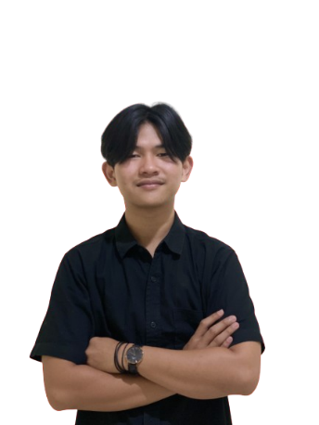

Contact  Email : girasm22@gmail.com  Phone : +62 821 1621 8252 (WhatsApp)  Location : Indonesia | Links  LinkedIn : linkedin.com/in/girasmatahari  Instagram : instagram.com/giras._  Portfolio : Giras Matahari | Front-End UI/UX Developer

Core Skills
Design : UI/UX for Web & Mobile (Figma) · User Research · Wireframing & Prototyping · Design Systems · Logo Design
Build : HTML5 · CSS3 · JavaScript (ES6+) · Tailwind CSS · PHP · Laravel · Livewire · Vue.js · MySQL
Other : Unity · C# · Android Studio · Kotlin · Firebase · AR / VR · Microsoft Office

Projects Included in This Portfolio
# | Project | Category | Type | My Role
1 | SCFS — Trevora  Supply Chain Financing System | Web Application | Work Assignment | Front-End UI/UX Development
2 | SIPETAM  Cemetery Plot Reservation System | Web Application | Work Assignment | Front-End UI/UX Development
3 | Tel-U Metaverse  Virtual Campus Application | Mobile · AR & VR | Work Assignment (Internship) | UI/UX Designer
4 | Home Workout App  Fitness Companion Application | Mobile Application | Academic — Final Year Project | UI/UX Designer
5 | Hotel Sawunggaling  Hotel Monitoring Dashboard | Web Application | Work Assignment (Internship) | Front-End UI/UX Development
All five projects listed above were group projects. My specific role and contribution in each one is described on the following pages.
Project 01

SCFS — Supply Chain Financing System (Trevora)
Web Application | 2026
WORK ASSIGNMENT GROUP PROJECT

Summary
Trevora SCFS is a supply chain financing platform that brings three parties — campus canteens, their suppliers, and a non-bank financial institution — into one financing ecosystem, so a canteen can operate without its own working capital while suppliers are guaranteed payment and every transaction is recorded in real time. My work was to translate a genuinely complex financial mechanism into an interface that each of those very different users could understand and trust.

Project Type, Team & My Role
Work assignment — a client product project delivered with the team at PT LAPI ITB, not a class assignment. This is a GROUP PROJECT. I worked as the Front-End UI/UX Development in a cross-functional team alongside back-end and front-end developers, responsible for end-to-end user flows, information architecture, wireframing, high-fidelity design in Figma, and the design system implemented in Laravel, Livewire, and Tailwind CSS.

Impact I Made
- I designed one product for three fundamentally different mental models — a canteen owner thinking about stock, a supplier thinking about getting paid, and a financier thinking about risk — giving each a dedicated view over a single shared transaction record.
- I designed the purchase-order approval and financing queue so the status of every order (funded, under review, queued) is legible at a glance, replacing the spreadsheet-and-chat coordination the process previously relied on.
- I delivered a reusable component library — type scale, colour tokens, form states, and table patterns — which let developers build consistently and cut the design-to-development back-and-forth.

What I Learned
- Designing a multi-party financial system taught me that good UX here is mostly about making state visible: every user must instantly see what happened, what is waiting on them, and what comes next.
- I learned to design within the constraints of a real technology stack, so that components are ones developers can genuinely reuse rather than beautiful screens that are expensive to build.
- I learned that in products involving money, trust is a design problem — confirmation, traceability, and plain language matter more than visual sophistication.

Tools & Technology
Figma · Laravel 12 · Livewire 4 · Tailwind CSS · JavaScript (ES6+) · MySQL · Redis · Vite

Visuals
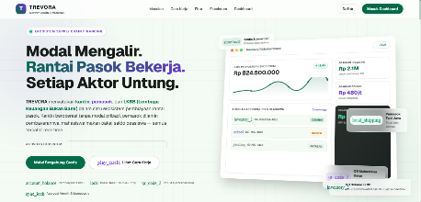  Product landing page — the ecosystem explained to three audiences | 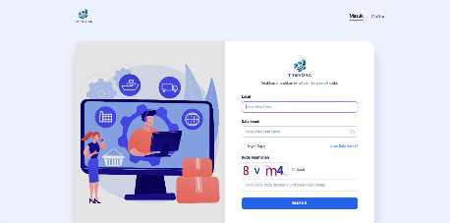  Authentication with security verification | 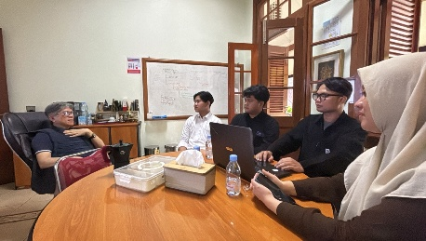  Design and development working session
Project 02

SIPETAM — Cemetery Plot Reservation System
Web Application | 2026
WORK ASSIGNMENT · INTERNSHIP GROUP PROJECT

Summary
SIPETAM (Sistem Pemesanan Tanah Makam) is a web application built for ITB Memorial Park that digitises cemetery management end to end — block and plot administration with real-time availability, next-of-kin and deceased records, plot reservation, staged payment processing with printed receipts, and financial reports exportable to PDF and Excel. It replaced an almost entirely paper-based process with a role-based digital system.

Project Type, Team & My Role
Work assignment — an internship project in the Information Technology Division of PT LAPI ITB, delivered for the client ITB Memorial Park (PT Ganesa Jaya Sejahtera). This is a GROUP PROJECT. I worked as the Front-End UI/UX Development alongside the development team, responsible for gathering requirements with the client, designing the information architecture for three separate user roles, wireframing every module, and delivering the high-fidelity interface design.

Impact I Made
- I designed role-based dashboards for three distinct users — Admin, Finance, and Manager — so each sees only what is relevant to their responsibility, shortening staff onboarding and reducing the risk of incorrect data entry.
- I designed the plot availability visualisation that lets staff read occupancy across blocks at a glance, replacing a manual ledger check that previously had to be done record by record.
- I designed the staged payment flow — down payment, instalment, full settlement — with explicit status indicators and receipt output, so the financial position of every reservation is unambiguous to both staff and family.

What I Learned
- I learned to design for a sensitive human context. The people using this service are grieving, so clarity, respectful wording, and preventing mistakes matter far more than visual flourish.
- I learned how role-based access and tiered approval workflows shape an interface — the same module must communicate different capabilities to different people without becoming confusing.
- I learned to design for users with limited digital literacy, which pushed me towards plain language, larger targets, and explicit confirmation before any irreversible action.

Tools & Technology
Figma · PHP · JavaScript · HTML · CSS · MySQL

Visuals
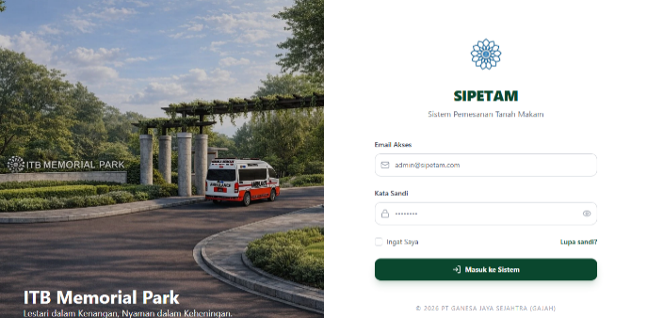  SIPETAM access screen for ITB Memorial Park | 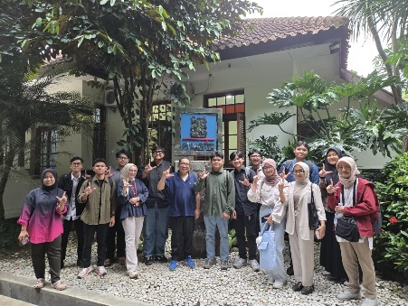  The internship team at PT LAPI ITB
Project 03

Tel-U Metaverse — Virtual Campus Application
Mobile Application · AR & VR | 2023
WORK ASSIGNMENT · INTERNSHIP GROUP PROJECT

Summary
Tel-U Metaverse is a virtual campus application for Telkom University combining Augmented Reality (AR), Virtual Reality (VR), and geolocation, letting prospective and current students explore the campus remotely and interact with its points of interest. The experience is gamified — users collect points and appear on a leaderboard — so exploring the campus feels like play rather than a tour.

Project Type, Team & My Role
Work assignment — developed in my role as Metaverse Developer at the Center of e-Learning and Open Education (CeLOE), Telkom University, held while I was still an active student. This is a GROUP PROJECT. I worked as the UI/UX Designer in a team including 3D artists and Unity developers, designing the application interface, navigation model, in-world UI overlays, and gamification screens, and producing the prototypes used to validate the flow before implementation.

Impact I Made
- I made an unfamiliar interaction paradigm approachable. Most users had never navigated a 3D environment, so I designed a simple two-dimensional overlay and a short onboarding sequence that let first-time users move around confidently without prior VR experience.
- I designed the gamification layer — points, leaderboard, and progressive discovery — giving users a reason to keep exploring instead of leaving after the first location.
- I delivered clickable prototypes early, letting the team correct the user journey before committing to expensive 3D and Unity production, which avoided significant rework later.

What I Learned
- Designing for immersive media is fundamentally different from designing flat screens. Depth, user comfort, motion sickness, and text legibility at distance all became real constraints I had never had to consider before.
- I learned the value of prototyping as risk reduction: where a single 3D asset can take days to produce, a prototype costing hours can save weeks of wasted work.
- Collaborating with Unity developers taught me to communicate design intent in terms of engine capabilities and performance budgets, not just visual specification.

Tools & Technology
Figma · Unity · C# · Mozilla Hubs · Augmented Reality · Virtual Reality · Geolocation

Visuals
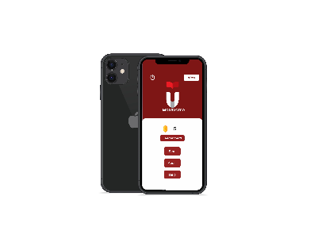  Main menu with points and leaderboard | 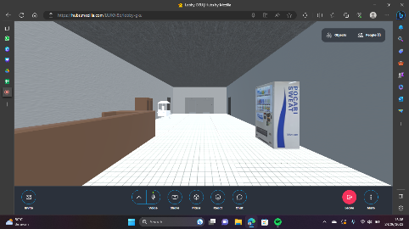  Virtual campus environment | 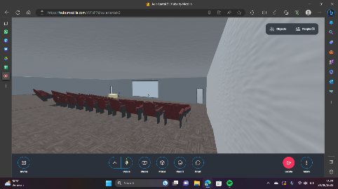  Exploration and points of interest
Project 04

Home Workout App — Fitness Companion
Mobile Application | 2023
ACADEMIC · FINAL YEAR PROJECT GROUP PROJECT

Summary
Home Workout is a mobile application that helps users stay fit at home through guided, equipment-free daily routines with intuitive progress tracking. It was designed around motivation rather than content, because the real problem was never a shortage of exercises — it was people giving up after the first few days.

Project Type, Team & My Role
Academic assignment — developed as my final year university project (Skripsi / Tugas Akhir). This is a GROUP PROJECT. I worked as the UI/UX Designer, responsible for the user research, defining the application flow, wireframing, high-fidelity design in Figma, and preparing the design specification the team implemented in Android.

Impact I Made
- I researched why people abandon home workouts and translated the findings directly into the product: short sessions, visible streaks, and immediate progress feedback instead of an exhaustive exercise catalogue nobody finishes.
- I designed a low-friction entry flow so a user can begin a workout in very few taps, removing the hesitation point where most users previously dropped off.
- I delivered a complete and consistent design system, letting the team build the Android application without ambiguity about spacing, states, or component behaviour.

What I Learned
- I learned that designing for behaviour change is its own discipline. Motivation, habit formation, and perceived effort influenced my decisions far more than aesthetics did.
- I learned to test my assumptions instead of trusting my own taste — several features I was personally attached to were removed once users showed they simply did not use them.
- I learned to work within platform conventions (Material Design and Android navigation), which taught me that following an established pattern is usually kinder to the user than inventing a new one.

Tools & Technology
Figma · Android Studio · Kotlin · Firebase · Material Design

Visuals
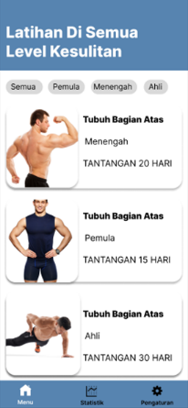  Workouts grouped by difficulty level | 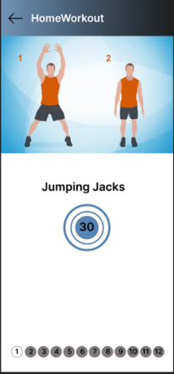  Guided exercise with timer | 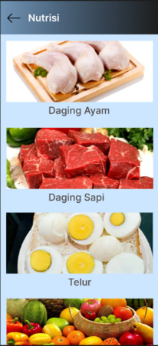  Nutrition guidance | 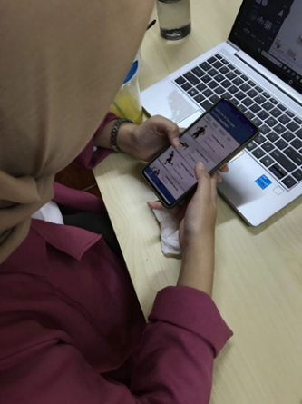  Testing the app on a real device
Project 05

Hotel Sawunggaling — Hotel Monitoring Dashboard
Web Application | 2025
WORK ASSIGNMENT GROUP PROJECT

Summary
A web-based operations dashboard for Boutique Hotel Sawunggaling that shows room availability and status, today's guests and reservations, and housekeeping progress in a single real-time view. It gives the front office, housekeeping, and management one shared picture of the property instead of three separate ones.

Project Type, Team & My Role
Work assignment — a client project for Boutique Hotel Sawunggaling, delivered together with the team at PT LAPI ITB. This is a GROUP PROJECT. I worked as the Front-End UI/UX Development, responsible for observing the hotel's existing manual workflow, designing the dashboard layout and room status system, and producing the interface design the development team implemented.

Impact I Made
- I designed a single-screen dashboard where staff read the state of the entire property — rooms available, occupied, reserved, and being cleaned — in one glance, replacing a room-by-room lookup.
- By placing housekeeping status in the same view as room and guest information, I removed much of the constant radio and telephone checking between the front office and housekeeping teams.
- I designed a role-aware navigation structure separating front office tasks from management functions such as approvals, staff, and room master data, keeping each user's daily screen uncluttered.

What I Learned
- I learned how to design for real-time operational contexts, where information density and glanceability matter far more than decorative styling.
- I learned to treat colour as data rather than decoration, and to keep status distinguishable for users with colour vision deficiency by always pairing colour with a label.
- I learned to study an existing manual workflow before proposing a digital one — the staff's habits contained operational knowledge that no requirements document had captured.

Tools & Technology
Figma · PHP · Laravel · Vue.js · CSS · SQL

Visuals
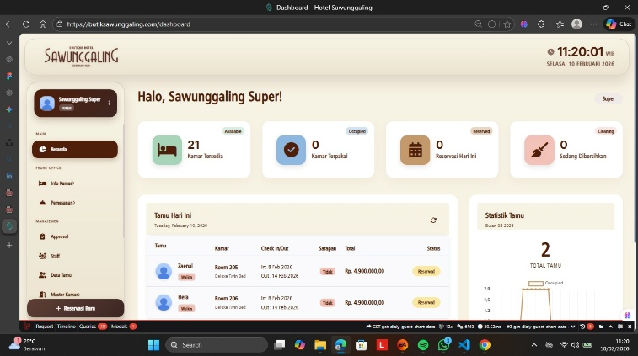  Operations dashboard — room status, today's guests, and guest statistics | 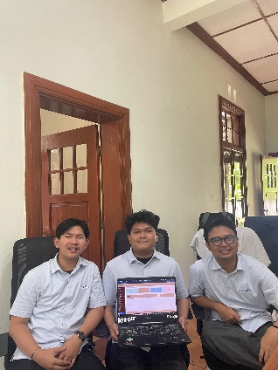  Presenting the delivered dashboard with the team
In Closing

What These Projects Have in Common
Across these five projects I have consistently worked at the point where design meets implementation: understanding a real problem, shaping it into an interface people can use without instruction, and handing it to a development team in a form they can actually build. The domains could hardly be more different — supply chain finance, cemetery administration, an immersive campus, a fitness habit, and hotel operations — but the discipline stayed the same: observe carefully, reduce what the user has to think about, and validate before building.
Working on client projects taught me to design under real constraints; working on an academic project taught me to justify every decision with research; and working on an AR/VR product taught me that I am comfortable designing for a medium I have never designed for before. I am open to new challenges, I adapt quickly, I work well within a team, and I am committed to producing solutions that deliver genuine value to the people who use them.

Contact
Email : girasm22@gmail.com  Phone : +62 821 1621 8252 (WhatsApp) | LinkedIn : linkedin.com/in/girasmatahari  Portfolio : Giras Matahari | Front-End UI/UX Developer
Thank you for taking the time to review my portfolio. — Giras Matahari

