1. Executive decision summary
CivicConnect should be implemented as a layered modular monolith: a React browser interface communicates with one Node.js/Express application, which stores transactional data in PostgreSQL. The backend remains one deployable unit while enforcing internal boundaries for Identity and Access, Request Management, Workflow, Audit and History, Reporting, and Administration. This structure gives the three-person team clear responsibilities without introducing the network, deployment, observability and distributed-data overhead of microservices.
The decision directly answers the Milestone 1 deferment of architecture, database, framework and hosting choices. It also addresses the small-team, limited-schedule and low-cost constraints while preserving a deliberate path to later extraction if measured load, independent deployment needs or organisational growth justify it.
Layering separates presentation, business logic and infrastructure through defined interfaces, while a modular structure aims for high cohesion within modules and low coupling between them. These properties support maintainability, testability and controlled evolution (Sharma, Kumar and Agarwal, 2015; Skiada et al., 2018).
A monolith is proportionate for the current workload and team because single-machine evaluations show that a monolith can outperform microservices, while microservice boundaries add orchestration, data consistency and resource costs that may outweigh their benefits for smaller systems (Blinowski, Ojdowska and Przybyłek, 2022).
Decision outcome: Select the layered modular monolith now. Defer microservices and an external message broker. Reconsider only when measurable evidence shows that a module needs independent scaling or release autonomy.

2. Milestone 1 baseline review
Milestone 1 established the stakeholder needs, scope, prioritised requirements, measurable acceptance criteria, constraints, risk register and initial traceability foundation. It deliberately deferred authentication, architecture, database, frameworks and hosting to Milestone 2. The architecture work below keeps the responsive web scope and does not reopen deferred external notifications or other excluded features.
M1 baseline item | Continuity into M2 | M2 evolution / decision | Evidence status
RD-10 technology and architecture deferment | Must now be resolved through research and ADRs | Resolved by ADR-ARCH-001 and ADR-TECH-001 | Research complete; team approval pending
CON-001: three-person team | Architecture must be understandable and operable by a small team | One backend deployable, one database, explicit internal modules | Proposed
CON-002/003: schedule and low cost | Avoid unnecessary infrastructure and coordination overhead | No microservices, broker or distributed datastore in M2 | Proposed
CON-004: responsive web application | Preserve browser-based scope | React UI over HTTPS/JSON API | Proposed
CON-005: measurable quality | Quality claims must be testable | ASRs and architecture tests are defined below | Planned evidence
CON-006: security and privacy | Least privilege and data protection remain mandatory | Central authentication/authorisation middleware and RBAC policy | Proposed
CON-008: compare technology options | Selection requires evidence and trade-offs | Alternatives compared in Sections 4 and 6 | Complete
RISK-001: unfamiliar stack | Learning curve can threaten delivery | Shared JavaScript runtime reduces language switching; PoCs gate confirmation | Open — mitigation planned
NFR-007/008: integrity and auditability | No partial records; complete actor/action/time history | PostgreSQL transactions and append-only audit path | Proposed
NFR-012: maintainability | Reviewed and checked changes | Module rules plus protected-main CI workflow | Planned evidence

3. Architecture-significant requirements and quality drivers
An architecture-significant requirement (ASR) is a requirement whose satisfaction materially changes structure, technology, boundaries or deployment. The quality drivers below were derived from the M1 FRs, NFRs, constraints and risks rather than treated as generic desirable qualities. Web systems need explicit attention to quality and reliable, rapid updates; architecture should therefore make those qualities visible and verifiable (Offutt, 2002; CivicConnect Team, 2026a).
ASR | Source and measurable expectation | Architectural response | Priority / trade-off
ASR-01 Security and privacy | NFR-001/002; 100% of unauthorised access attempts denied; no sensitive content in prohibited views, logs or errors | Central authentication middleware; role-policy service; least-privilege checks at API and service boundaries; log redaction | Critical. Extra checks are accepted over marginal latency.
ASR-02 Integrity | NFR-007; zero duplicate references; failed operations create no partial request or unmatched history | PostgreSQL transaction for request + initial history; uniqueness and foreign-key constraints; rollback on failure | Critical. Strong consistency is selected over eventual consistency.
ASR-03 Auditability | FR-017 and NFR-008; actor, action, record and time captured for all required events | Dedicated audit/history module; append-only writes in the same transaction where correctness requires it | Critical. Storage growth is accepted and managed through retention/indexing.
ASR-04 Performance and scale | NFR-003; 10,000 requests / 50 concurrent users; 95% core actions <2s; summaries <5s | Stateless API where practical; indexed queries; pagination; measured React bundle; database connection pool | High. Optimise after profiling, not by adding distributed services prematurely.
ASR-05 Maintainability and testability | NFR-009/012; each Must Have linked to a test; reviewed changes and automated checks | Layered modules; dependency rules; unit/service/API tests; CI quality gates | High. Some interface boilerplate is accepted to preserve boundaries.
ASR-06 Availability and recovery | NFR-010/011; 99% production availability; daily backups; RPO ≤24h; RTO ≤4h | Health endpoint; automated deployment rollback; scheduled backups and restore rehearsal | Should. Single instance is acceptable initially if monitoring and recovery evidence exist.
ASR-07 Accessibility and responsiveness | NFR-005/006; WCAG 2.2 AA; 360/768/1280px on named browsers | Reusable accessible React components; responsive layout; automated and manual accessibility checks | High. UI consistency takes priority over one-off page customisation.
Role-based access control associates privileges with roles and scales access-policy administration across many users. CivicConnect should therefore keep role and permission decisions in one policy component while still checking record-level context where a simple role is insufficient (Bacon, Moody and Yao, 2002).
Security must remain traceable from requirements into design, implementation and verification activities. A security mapping approach is useful because it converts broad security expectations into operational steps and auditable evidence (Lee et al., 2025).

3.1 Quality scenarios used for architecture evaluation
Driver | Stimulus and environment | Required response | Measure / evidence
Security | A community user requests a staff-only endpoint in normal operation | API rejects before business operation; no sensitive payload is returned | 403 response; security test; redacted log entry
Integrity | Database failure occurs after the request insert but before initial history insert | Whole unit of work is rolled back | No request row and no orphan history row; integration test
Performance | 50 concurrent users submit/search within a database of 10,000 requests | System remains responsive under defined workload | 95th percentile <2s for core actions; load-test report
Maintainability | A new request category rule is introduced | Change stays inside the Request/Workflow modules and associated tests | No new cross-module dependency; CI passes
Recovery | Primary database data is lost after the daily backup | Service is restored within agreed objective | Restore completed ≤4h; data loss ≤24h; drill record
Accessibility | Keyboard-only user completes request submission at 360px viewport | All controls operable and errors announced | WCAG test record; browser/view evidence

4. Architecture alternatives and selection

4.1 Alternatives
Alternative A — Unstructured monolith. One application and database with no enforced module or layer boundaries. It is quick to start but encourages business logic in routes and direct data access across features. This increases architecture erosion and makes changes harder to isolate.
Alternative B — Layered modular monolith. One deployable application with explicit presentation, application/domain and persistence layers plus feature-aligned modules. It preserves simple deployment while allowing internal responsibilities to be tested and evolved independently.
Alternative C — Microservices. Identity, requests, workflow, audit and reporting become separately deployed services with network APIs and potentially independent storage. It offers release and scaling autonomy but adds failure modes, monitoring, deployment and data-consistency work.
Modularity is strengthened by high internal cohesion and limited dependencies between modules. Poor modularity is associated with architectural technical debt, so the selected approach needs enforceable boundaries rather than merely naming folders (Skiada et al., 2018).
Criterion | Weight | A: unstructured monolith | B: modular monolith | C: microservices
Fit for three-person team and schedule | 20% | 4 — simple but risky to maintain | 5 — simple deployment with clear ownership | 1 — high operational overhead
Security and privacy control | 15% | 3 — possible but easily scattered | 5 — central policy with bounded modules | 3 — more network/service surfaces
Integrity and auditability | 15% | 4 — one transaction possible | 5 — one transaction plus dedicated audit module | 2 — distributed consistency required
Maintainability and testability | 20% | 2 — boundaries erode | 5 — cohesive modules and test seams | 4 — isolated services, but contract testing needed
Performance at M1 target | 10% | 5 — no network hops | 5 — no internal network hops | 3 — serialization and network overhead
Scalability beyond initial target | 10% | 2 — coarse-grained scaling | 4 — vertical/replica scaling; extraction path | 5 — independent scaling
Deployment, observability and cost | 10% | 5 — one unit | 5 — one unit and one DB | 1 — multiple services and pipelines
Weighted result | 100% | 3.45 / 5 | 4.90 / 5 — selected | 2.65 / 5
The score is a project decision aid, not a universal ranking. It reflects current CivicConnect constraints and the M1 workload. Empirical comparison found that a monolith on one machine outperformed microservices and that vertical scaling could be more cost-effective than horizontal scaling in the tested conditions. Microservice benefits should therefore be earned by an actual need for independent scaling or deployment (Blinowski, Ojdowska and Przybyłek, 2022).
Selected alternative: Alternative B — layered modular monolith. Alternative C is deliberately deferred, not prohibited. A later ADR may extract one module after load tests, change-frequency evidence and operational capacity justify the boundary.

5. Selected architecture

5.1 System context
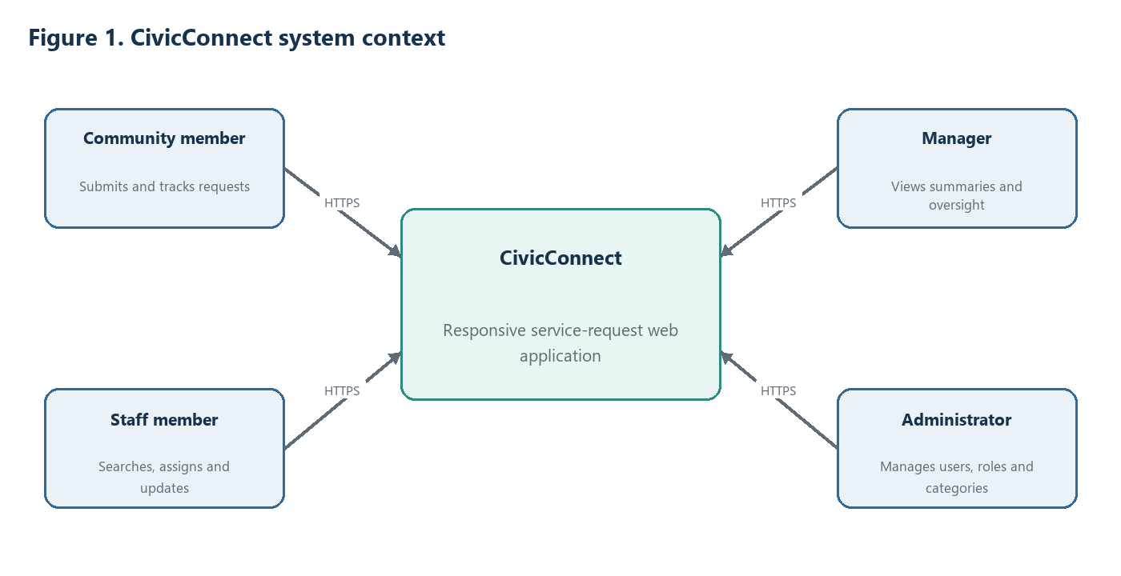
The four user groups interact with the same responsive web application. External notification services remain outside the M2 baseline.

5.2 Container and deployment view
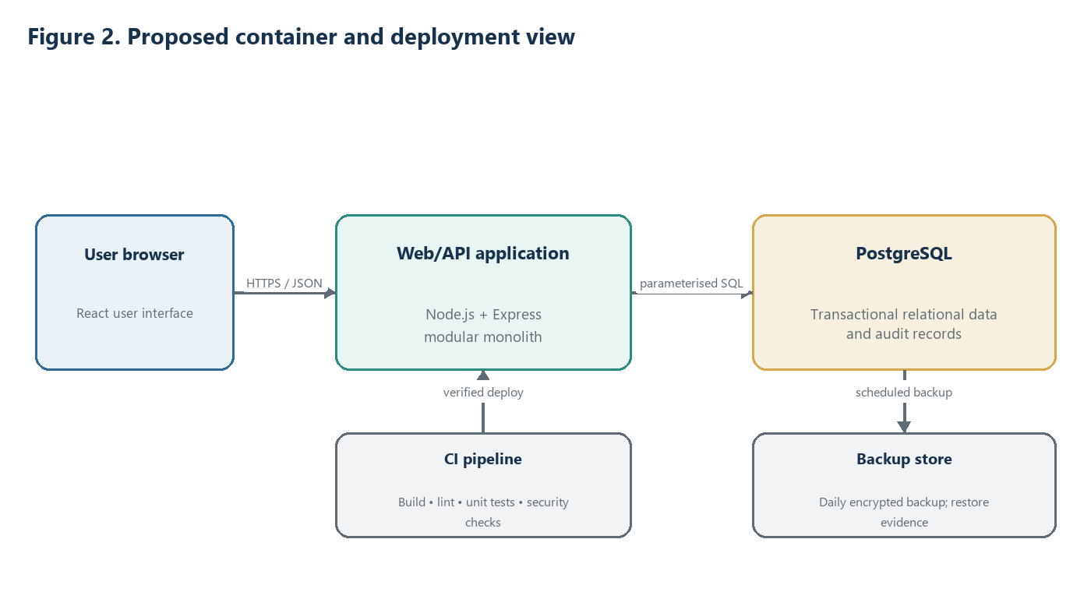
The proposed runtime has three primary containers: browser UI, one backend application and one relational database. CI and backup storage provide delivery and recovery controls.
The client–server and layered styles fit browser applications and separate the presentation, business and infrastructure responsibilities. Clear interfaces allow each layer to change with less impact on the others and support more focused debugging and maintenance (Sharma, Kumar and Agarwal, 2015).

5.3 Internal module view
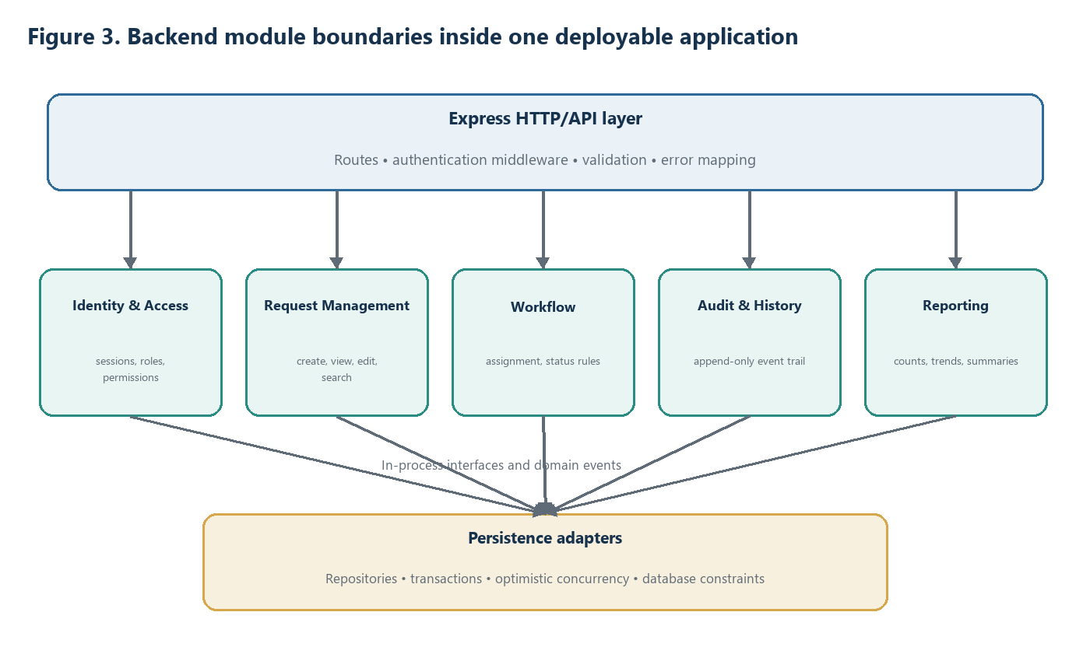
Modules communicate through in-process interfaces and domain events; they do not call another module’s tables directly.
Module | Owns | May depend on | Must not do
Identity & Access | Authentication state, users, roles, permissions | Shared security primitives | Expose password/session secrets or embed feature rules
Request Management | Request creation, details, reference number, requester view | Identity, category contract, audit event contract | Write workflow or audit tables directly
Workflow | Assignment, status transitions, staff actions | Identity, request contract, audit event contract | Permit invalid transitions or bypass authorisation
Audit & History | Immutable actor/action/record/time entries; timeline queries | Identity identifiers and domain-event contracts | Mutate prior events through ordinary application paths
Reporting | Read models, counts, ageing and trends | Approved read interfaces/views | Become the source of truth for operational records
Administration | Users, roles, categories and routing configuration | Identity and request configuration contracts | Change live data without audit capture

5.4 Integrity-critical request creation
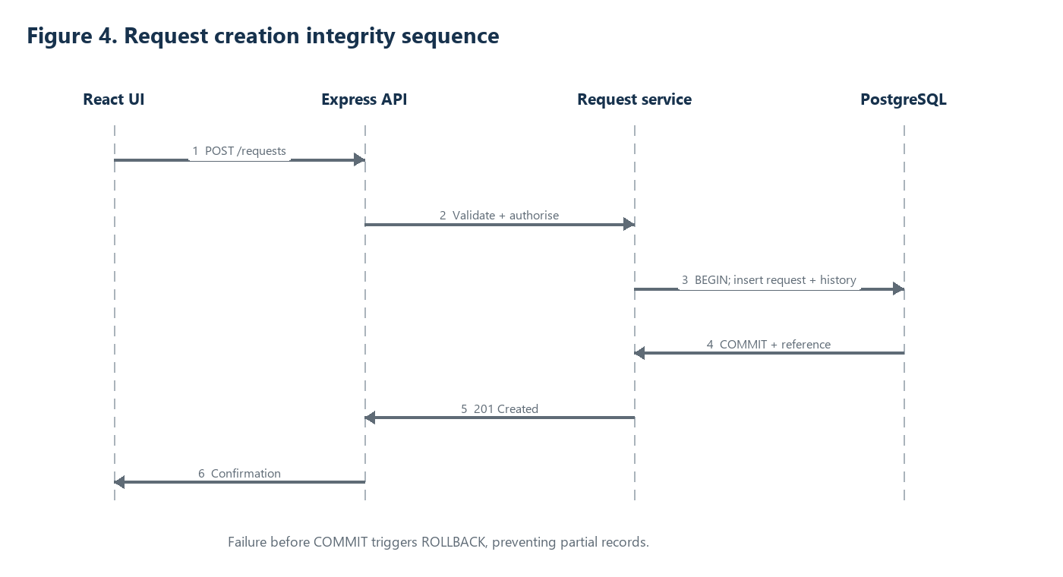
The request row and first history record form one atomic unit of work.
A PostgreSQL transaction treats the operations as one unit: either all changes are committed or none are retained. Primary/foreign keys and uniqueness constraints enforce relationships and prevent duplicate identifiers at the database boundary (Douglas and Douglas, 2005).

5.5 Architecture rules
- React components call the backend only through documented HTTP endpoints; they never connect directly to PostgreSQL.
- Express routes perform transport concerns and delegate business decisions to services; routes do not contain persistence logic.
- Every protected use case checks authenticated identity and permission before reading or changing restricted data.
- A module accesses its own data through its repository or service interface. Cross-module table access is prohibited.
- Integrity-critical changes and their mandatory audit entry share one database transaction.
- Domain events remain in-process in M2. An external broker requires a new ADR and an outbox/retry design.
- Reporting uses indexed, paginated queries or database views and may not weaken the transactional source of truth.
- Runtime secrets are supplied through protected configuration; they are never committed to the repository.

6. Technology stack decision

6.1 Stack fit and proportionality
Layer | Selected technology | Alternatives considered | Decision basis and constraints
Frontend | React | Server-rendered templates; alternative React-like frameworks/meta-frameworks | Chosen team stack for a responsive, interactive UI. Bundle size and initial rendering must be measured because a baseline React SPA can ship more client-side JavaScript; optimisation is evidence-driven (Lonka, 2023).
Backend | Node.js + Express | PHP backend; multiple independently deployed services | Node.js performed better than PHP in the supplied benchmark study. Express keeps the HTTP layer small; business rules remain framework-independent (Odeniran, Wimmer and Rebman, 2023).
Database | PostgreSQL | Document-oriented NoSQL database | CivicConnect has strongly related users, requests, assignments, statuses and audit records. Relational integrity and transaction consistency match NFR-007/008; NoSQL flexibility is not the dominant need (Sahatqija et al., 2018).
Architecture | Layered modular monolith | Unstructured monolith; microservices | Provides one deployment and transaction boundary with maintainable internal seams. Microservices are deferred until measurable independent-scaling or deployment needs exist (Blinowski, Ojdowska and Przybyłek, 2022).
Using JavaScript across the React and Node.js layers can reduce language switching for the three-person team, but it does not remove the need for framework, database and security learning. RISK-001 therefore remains open until small proofs of concept demonstrate authentication, transaction handling, deployment and CI within the M2 schedule (CivicConnect Team, 2026a).

6.2 Version and compatibility control
The research evidence supports technology categories, not current package versions. Exact versions must therefore be fixed from the team’s implemented repository rather than invented in this document. The following evidence is required before the PED v2.0 baseline is signed:
Item | Required baseline evidence | Status
Node.js runtime | Exact runtime version in deployment configuration and CI log | Planned
Express, React and supporting packages | package.json plus lockfile committed on the reviewed branch | Planned
PostgreSQL server and driver | Deployment configuration plus successful migration/connection evidence | Planned
Browser compatibility | Test record for latest two Chrome, Edge and Firefox versions at 360/768/1280px | Planned
Hosting compatibility | Repeatable deployment instructions, health check and rollback evidence | Planned
Baseline gate: Do not write “implemented” or “verified” in the final PED until the linked evidence exists. If the repository already contains these files, replace “Planned” with the exact path and commit or pull-request reference.

7. Architecture Decision Records

ADR-ARCH-001 — Select a layered modular monolith
Field | Record
Status | Proposed for team approval; target status: Accepted in PED v2.0
Context | CivicConnect has a three-person team, limited schedule/cost, a relational workflow, strong integrity/audit needs and a modest initial workload. M1 deferred architecture to M2.
Options | Unstructured monolith; layered modular monolith; microservices.
Decision | Use one Node.js/Express deployable with explicit layers and feature modules. Use in-process interfaces/events between modules.
Rationale | Strong transaction boundary and simple deployment fit the constraints; module boundaries support maintainability and an extraction path.
Consequences | Independent module deployment is unavailable initially. Boundary discipline and architecture tests are required to prevent a “big ball of mud”.
Revisit trigger | A module shows sustained, measured scaling pressure; releases are blocked by coupling; or ownership grows beyond the current team.
Linked evidence | ASR-01–07; RISK-001; CON-001–003/008; architecture comparison; RTM rows in Section 8.

ADR-TECH-001 — Select React, Node.js/Express and PostgreSQL
Field | Record
Status | Proposed for team approval; target status: Accepted in PED v2.0
Context | The chosen stack must support a responsive browser UI, measurable API performance, relational integrity, auditability, low cost and a small team.
Options | React or server-rendered UI; Node.js/Express or PHP backend; PostgreSQL or document-oriented NoSQL.
Decision | Use React in the browser, Node.js with Express for the API and PostgreSQL for persistent data.
Rationale | The supplied evidence supports Node.js performance for the compared workloads, while relational transactions and constraints fit the request workflow and audit model.
Consequences | React bundle and rendering performance must be measured; Node.js CPU-heavy work must not block request handling; database schema migrations require review.
Version control | Exact supported versions are recorded in manifests/lockfiles and deployment evidence before baseline sign-off.
Linked evidence | NFR-003/007/008/012; RISK-001; Odeniran, Wimmer and Rebman (2023); Sahatqija et al. (2018); Douglas and Douglas (2005).

ADR-MOD-001 — Enforce feature-aligned module boundaries
Field | Record
Status | Proposed for team approval
Context | A monolith without boundaries can accumulate technical debt and scatter security, validation and persistence logic.
Decision | Adopt the modules in Figure 3 and permit interaction only through exported application interfaces or in-process domain events.
Enforcement | Folder/module ownership; dependency rule checks; code review checklist; unit/service/API test separation.
Consequences | Some interfaces appear more formal than direct calls, but changes become easier to locate, test and review.
Linked evidence | NFR-009/012; CON-001/007; Skiada et al. (2018); Koziolek (2011).

8. RTM evolution and evidence plan
The M1 traceability chain is extended from stakeholder need and requirement into ASR, component, ADR and verifiable evidence. Current evidence is labelled honestly: research and design records can be complete while code-level evidence remains planned.
Requirement | ASR / component | Architecture decision | Acceptance / verification evidence | Current status
FR-001 Authenticate users | ASR-01; Identity & Access | ADR-ARCH-001 / ADR-MOD-001 | Automated valid/invalid/session tests; unauthorised endpoint suite | Planned
FR-002 Enforce roles | ASR-01; Identity & Access + API middleware | ADR-MOD-001 | Role-permission matrix; 100% prohibited cases return 403 | Planned
FR-011 Submit request | ASR-02/03; Request + Audit | ADR-TECH-001 | Integration test proves request and initial event commit together | Planned
FR-015 Update assignment/status | ASR-01/02/03; Workflow | ADR-MOD-001 | Transition, concurrency, permission and audit tests | Planned
FR-017 View history | ASR-03; Audit & History | ADR-ARCH-001 | Timeline test with actor/action/record/time for each event | Planned
NFR-003 Performance | ASR-04; UI/API/Reporting/DB | ADR-ARCH-001 / ADR-TECH-001 | 10,000 records; 50 concurrent users; p95 thresholds | Planned
NFR-007 Integrity | ASR-02; PostgreSQL + services | ADR-TECH-001 | Rollback, unique-reference and foreign-key tests | Planned
NFR-008 Auditability | ASR-03; Audit module | ADR-MOD-001 | Required-event coverage report; tamper-path review | Planned
NFR-011 Recovery | ASR-06; PostgreSQL/backup | ADR-TECH-001 | Backup log and timed restore rehearsal meeting RPO/RTO | Planned
NFR-012 Maintainability | ASR-05; all modules/CI | ADR-MOD-001 | PR approvals, automated checks and dependency-rule result | Planned

8.1 End-to-end trace example: request creation
Trace step | Evidence / decision
Stakeholder need | Community member needs one reliable channel and a reference for follow-up.
Requirement | FR-011 Submit Request; NFR-007 Integrity; NFR-008 Auditability.
ASR | ASR-02 requires atomic persistence; ASR-03 requires complete event history.
Architecture | React form → Express API → Request service → PostgreSQL transaction; audit entry in the same unit of work.
ADR | ADR-ARCH-001 and ADR-TECH-001.
Verification | API/integration test creates request + initial history; injected failure proves rollback; uniqueness test proves no duplicate reference.
Repository evidence to link | Planned: route/service test path, migration containing constraints, CI run and pull request.

9. Risks, trade-offs and forward engineering
Risk / trade-off | Ripple effect | Control / next evidence | Owner / status
RISK-001 stack unfamiliarity | Learning delays could consume architecture and test time | Time-box authentication, transaction, React and deployment PoCs; record results in ADR-TECH-001 | Whole team / Open
Architecture erosion | Direct imports and table access could turn modular monolith into an unstructured monolith | Dependency rule, module ownership and review checklist | Member 1 / Planned
Single database/runtime failure | Simple deployment creates concentrated availability risk | Health monitoring, rollback, daily backup and timed restore rehearsal | Deployment owner / Planned
React initial-load performance | Large client bundle can weaken mobile experience | Bundle measurement, code splitting, pagination and measured rendering strategy | Frontend owner / Planned
Node.js CPU-bound work | Heavy synchronous processing can delay unrelated requests | Keep handlers non-blocking; profile reporting; move genuinely heavy work to controlled background execution only if measured | Backend owner / Planned
Audit data growth | Complete event history increases storage and query cost | Indexes, pagination, retention decision and query plan review | Data owner / Planned
Deferred microservices | Coarse deployment prevents independent scaling | Maintain module seams; revisit ADR only on measured trigger | Architect / Accepted trade-off
Software architecture strongly influences how quickly and correctly a system can be understood, changed, tested and maintained over its life. Architecture evaluation should therefore use concrete change scenarios and measurable evidence rather than rely only on initial implementation speed (Koziolek, 2011).
Distributed web-service auditing must correlate activity across heterogeneous components and workflows. Keeping CivicConnect as one deployable application reduces that correlation problem for M2, although audit records still require complete actor, action, record and time context (Bates et al., 2017).

9.1 Deliberate deferments
Deferred item | Why it is deferred | Trigger to reconsider
Microservices | No demonstrated independent scaling/deployment need; overhead conflicts with team, schedule and cost constraints | Measured bottleneck or release/ownership independence that cannot be solved proportionately
External message broker | In-process events meet current use cases and keep transaction/error handling visible | Reliable cross-system asynchronous integration becomes in-scope
Separate reporting database | 10,000-record target does not justify replication and consistency overhead | Production query load harms transactional service despite indexing/optimisation
Server-side React rendering/meta-framework | CivicConnect is an authenticated operational app, not a public content/SEO product; extra server/build complexity is not yet justified | Measured initial-render failure against the agreed performance target
External notifications | Explicitly deferred in M1 scope baseline | Approved scope change with stakeholder value, privacy and delivery evidence

References
Bacon, J., Moody, K. and Yao, W. (2002) “A Model of OASIS Role-Based Access Control and Its Support for Active Security”, ACM Transactions on Information and System Security, 5(4), pp. 492–540.
Bates, A., Butler, K., Cable, P., Hassan, W.U., Dobra, A., Reaves, B., Moyer, T. and Schear, N. (2017) “Transparent Web Service Auditing via Network Provenance Functions”, Proceedings of WWW 2017, Perth, Australia.
Blinowski, G., Ojdowska, A. and Przybyłek, A. (2022) “Monolithic vs. Microservice Architecture: A Performance and Scalability Evaluation”, IEEE Access, 10. doi:10.1109/ACCESS.2022.3152803.
CivicConnect Team (2026a) SEN381 Project Milestone 1: CivicConnect Project Engineering Document v1.0. Supplied project document.
CivicConnect Team (2026b) SEN Assignment 2: Engineering Decisions. Supplied project document.
Douglas, K. and Douglas, S. (2005) PostgreSQL, 2nd edn. Sams.
Koziolek, H. (2011) “Sustainability Evaluation of Software Architectures: A Systematic Review”, QoSA+ISARCS 2011, Boulder, Colorado.
Lee, J. et al. (2025) “Software Security Mapping Framework: Operationalization of Security Requirements”, arXiv:2506.11051v1.
Lonka, T. (2023) Improving the Initial Rendering Performance of React Applications Through Contemporary Rendering Approaches. Master’s thesis. Aalto University.
Odeniran, Q., Wimmer, H. and Rebman, C.M. Jr. (2023) “Node.js or PHP? Determining the Better Website Server Backend Scripting Language”, Issues in Information Systems, 24(1), pp. 328–341. doi:10.48009/1_iis_2023_128.
Offutt, J. (2002) “Quality Attributes of Web Software Applications”, IEEE Software, 19(2), pp. 25–32.
Sahatqija, K., Ajdari, J., Zenuni, X., Raufi, B. and Ismaili, F. (2018) “Comparison between Relational and NoSQL Databases”, MIPRO 2018/DS-DC.
SEN381 Milestone 2 Brief (2026) CivicConnect Project Milestone 2. Supplied assessment brief.
Sharma, A., Kumar, M. and Agarwal, S. (2015) “A Complete Survey on Software Architectural Styles and Patterns”, Procedia Computer Science, 70, pp. 16–28.
Skiada, P., Ampatzoglou, A., Arvanitou, E.-M., Chatzigeorgiou, A. and Stamelos, I. (2018) “Exploring the Relationship between Software Modularity and Technical Debt”, 44th Euromicro Conference on Software Engineering and Advanced Applications.

