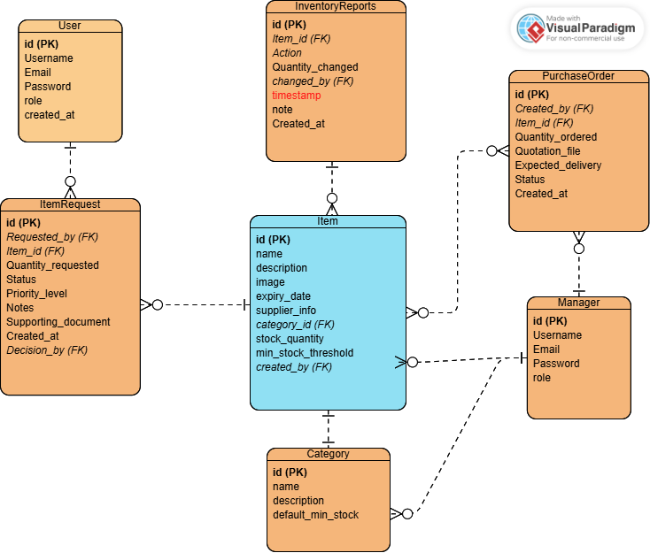

User: Teacher (Username, Email, Password, Role)
ItemRequest: One Teacher requests many items
Item: requested by Teacher which is handled through ItemRequest
InventoryReports: holds information on all items available or unavailable
Manager: Procurement Officer, Inventory Manager (Username, Email, Password, Role)
PurchaseOrder: Inventory Manager is able to create purchase orders and Procurement officer is able to view and track the purchase orders
Category: items are put into a certain category, Category is managed and filtered by Manager

