**תכנות ותכן מונחה עצמים**

**046271**

**דו"ח הגשה – תרגיל בית רטוב 3**

**מתן צחור 208936989**

**פז וולף 206555138**

**שאלה 1**

מצורפים שני קבצים נוספים המכילים:

1. מסמך דרישות עבור מערכת ניהול הספרייה - Requirements Document.
2. מסמך הנחות על הדרישות – Assumptions.

**שאלה 2**

1. השחקנים הלוקחים חלק המערכת הם:
2. Library Manager – The owner of the system, manages most of the system.
3. Library Customers – Any person that register to the library and can use its functionalities.
4. External Borrowing System – An external software that manages the borrowing for the library.
5. External Email System – An external software that have emails using capabilities.
6. Other Libraries – Other libraries systems for cross borrowing.

תיאור Use-Cases אפשריים במערכת:

1. **Actor: Library Manager**
   1. Name: Log in  
      Description: A Manager inputs their credentials on the system login page. The system verifies the credentials: it displays an error message if they are invalid, or grants access to the restricted admin section if they are valid.
   2. Name: Log out  
      Description: A Manager initiates a logout request. The system logs them out and redirects them to the main page, where no administrative data or actions are accessible.
   3. Name: Add New Book  
      Description: A Manager navigate to the book adding page. The system prompt to enter details for a new book into the system, including title, author, publication year, category, description, number of copies, publisher, and genre.
   4. Name: Mark \ Unmark Book as Rare  
      Description: In a book managing page, the manager mark a book as “rare”, or unmarks the book as “rare”.
   5. Name: Update Book  
      Description: The manager prompts the system to update details of the book such as missing information or wrong information, or number of available copies.
   6. Name: Return Book  
      Description: The manager can mark a canceled borrowed book as available for borrowing after it is returned to the library.
   7. Name: Register Library  
      Description: A manager adds new library to the system, including their details and conditions for book loans between libraries.
   8. Name: Track Book Borrowing Status  
      Description: The Manager prompt the system to view the status of a given book borrowing, The system shows if borrowed or available.
   9. Name: View Customer Book Borrowing History  
      Description: The Manager prompt the system to view the Borrowing History of a given book. The system provides a list of the borrowing history of the book in the library.
   10. Name: Edit external libraries  
       Description: The manager prompt the system to edit the external libraries list and their details.
   11. Name: View Inter-Library Loans  
       Description: The Manager prompt the system to view all books borrowed from other libraries by customers of the library, or any book borrowed from this library by other library customers.
   12. Name: Update Suppliers  
       Description: Update the list of book suppliers, including contact information and details of books supplied.
   13. Name: Update From Supply  
       Description: When a given supply arrives, The admin uploads the supply content to the system. The system updates it’s data base based on the information given in the supply content.
   14. Name: Send Notification to Customers  
       Description: Manager prompt the system to send updates and reminders to customers regarding their borrowed books, including return dates.
2. **Library Customer**
   1. Name: Register with Library  
      Description: Create an account with the library by providing personal details and login credentials.
   2. Name: Log in  
      Description: A customer inputs their credentials on the system login page. The system verifies the credentials: it displays an error message if they are invalid, or grants access to the customer if they are valid.
   3. Name: Log out  
      Description: A customer initiates a logout request. The system logs them out and redirects them to the main page.
   4. Name: Browse Book Catalog  
      Description: The customer prompt the system to access and search through the library’s catalog of available books.
   5. Name: Borrow Book  
      Description: The customer request to borrow a book through the system, handled by an external software system. After a book is borrowed, the system will send email reminders for return dates once a week.
   6. Name: Cancel Book Borrowing  
      Description: The customer request to cancel a pending or active book borrowing request.
   7. Name: Update Personal Details  
      Description: The customer request to modify personal account information, such as email address or phone number.
   8. Name: Track Book Borrowing Status  
      Description: The Costumer prompt the system to view the status of a given book borrowing, The system shows if borrowed or available.
   9. Name: View Book Borrowing History  
      Description: The Customer prompt the system to view his Borrowing History. The system provides a list of the borrowing history of the customer in the library.
3. **Other Libraries**
   1. Name: Request Books  
      Description: Request to borrow books from other libraries through the system.
   2. Name: Return Books  
      Description: Return books borrowed from other libraries, ensuring proper updates in the system.
   3. Name: View Inter-Library Loans  
      Description: The Library prompt the system to view all books borrowed from other libraries by customers of those libraries, or any book borrowed from this library by other library customers.
4. תיאור מפורט עבור ה-Use-Cases המבוקשים:

**Name:** Borrow Book

**Goal:** Borrow an available book from the library by a customer.

**Actors:** Customer

**Preconditions:** The book exists in the system and available in the system.

**Description:**

1. The user prompt the system he would like to borrow a book that exists in the system.

2. The system checks if the book is available to borrow from this library.

3. If the book is not available in this library, the system checks if the book is available in other libraries connected to the system.

4. If the book is available in this library or any other libraries, the system prompts the user where he can come pick up the book.

5. If the book is not available in any place in the system, the borrow option will not be available in the first place.

6. The system send an email with details about returning dates to the customer’s email address using the external email system.

**Postconditions:** The book is marked as borrowed by the customer and details of the pick-up are given. Email with borrow details sent to the customer.

**Variations:** If the customer is trying to borrow a “rare” book, the system will allow it only under predefined circumstances, and will only be available for <MAX_TIME_RARE> days.

**Exceptions:**  
1. In case the customer has already borrowed <MAX_BORROWED> books, the system will not allow it to borrow another one.

**Goal:** Show Library Book Catalog

**Actors:** Customer, Manager

**Preconditions:** The user is registered and logged into the system.

**Description:**

1. The user prompt the system he would like to browse the book catalog.

2. The system will collect the book catalog from this library and from connected libraries.

2. The system will show the book catalog to the user and gives him filter options.

3. If the user ask for filtering, the system will provide the corresponding catalog filtered.

**Postconditions:** The catalog is shown to the user with filters applied.

**Variations:**

1. If the user is a manager, more filtering option are available, such as filtering by supplier.

**Exceptions:**  
None

1. 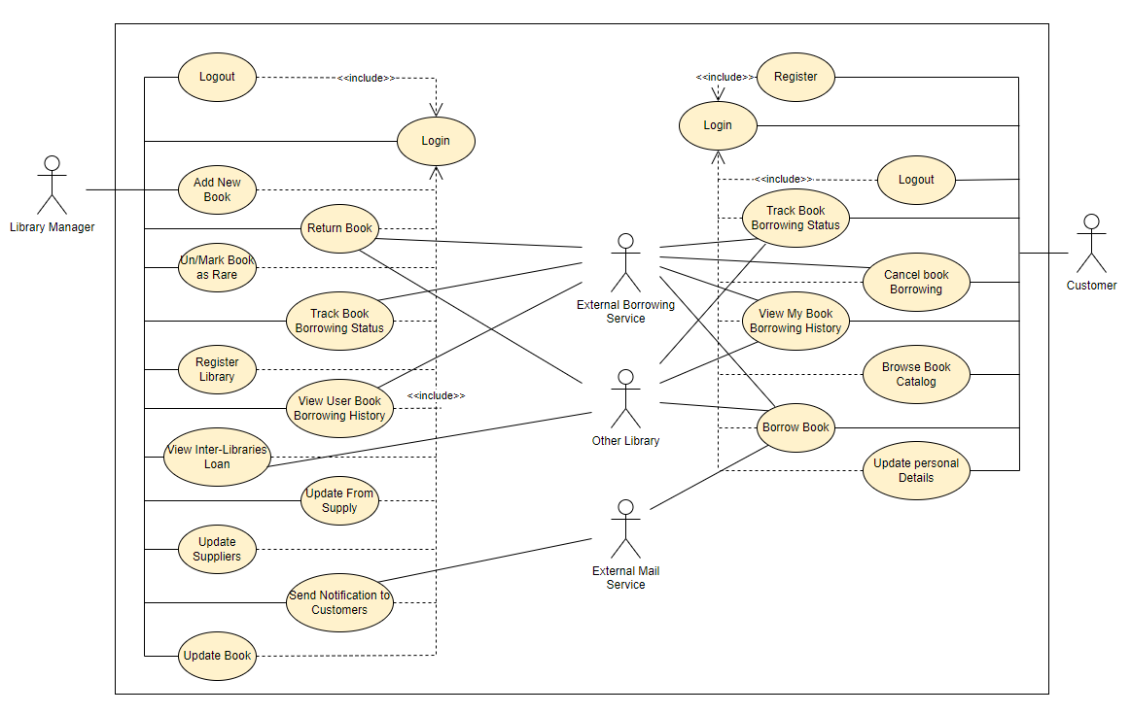Use-Cases Diagram עבור המערכת:

**שאלה 3**

1. 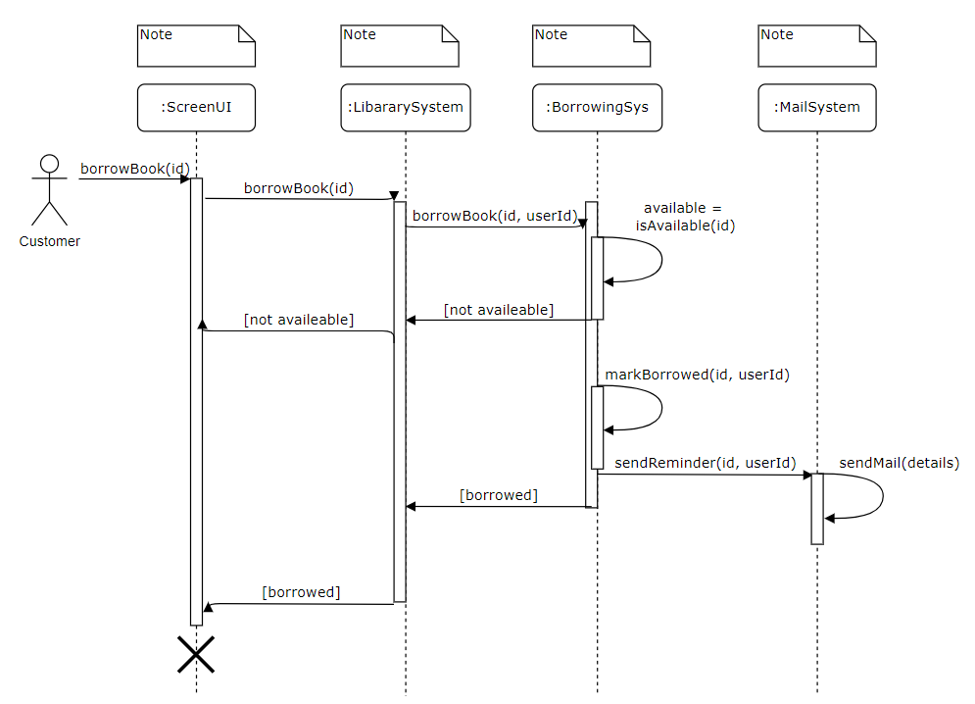בהנחה שמערכת ההשאלה החיצונית יודעת לבדוק בעצמה אם הספר זמין בספרייה שלנו או בספריות האחרות המקושרות למערכת:
2. 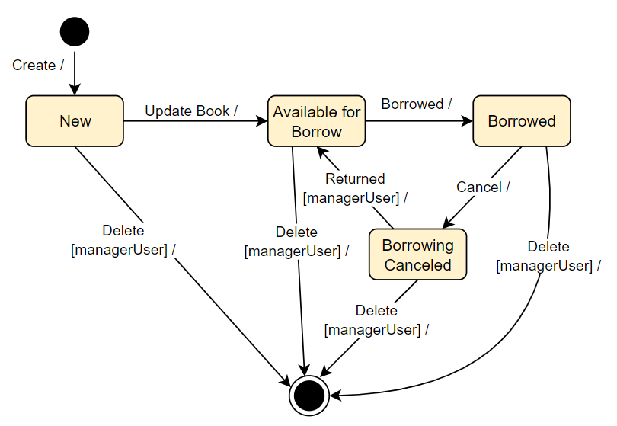

**שאלה 4**

|  |  |
| --- | --- |
| Represent the library system that manages the library stock and users. | LibrarySystem |
| Representing an abstract user of the system | User |
| A User realization, representing a Manager user of the system, that have extra “privileges”. | Manager |
| A User realization, representing a Customer user of the system. | Customer |
| Struct representing a book. Holding book’s details. | Book |
| Struct representing a Supplier. Holding supplier’s details. | Supplier |
| Representing a distant Library that is part of the system, and can cross borrow with this system’s library. | ExternalLibrary |
| Representing the external email system that the library system uses for emailing capabilities. | ExternalEmailSystem |
| Representing the external borrowing system that the library system uses to manage all it’s book borrowing and cross libraries borrowing. | ExternalBorrowingSystem |

