
ADA University
School of Information Technologies and Engineering

A1. Normalization

Name: Matanat Heydarli 18080
Project: Relational Database Normalization and ER Diagram Design

Summary
This paper outlines the process of normalizing an ICPC contest database to enhance data integrity, reduce redundancy, and enhance query performance. It begins with the preprocessing of the dataset initially to have its attributes represented uniformly and prepared for analysis. The normalization process is performed in three stages: 1NF, eliminating redundancy values and making attributes atomic; 2NF, eliminating partial dependency by decomposing the database into entities such as Team, Contest, Problem, Member and Team Contest Performance; and 3NF, eliminating transitive dependency by making entities such as Regional Contest, University and Coach explicitly dependent on the Contest entity. In addition, the paper stresses the application of candidate keys, primary keys, and foreign keys in validating logical entity relationships.
From the analysis, the conclusion is that normalization results in a well- organized, scalable, and efficient database model that can support correct queries effectively as well as future expansion. One of the improvements in the future would be to implement the normalized schema on a relational database management system for further enhancement of accuracy, usability, and efficiency of the data.

Structure of File

Term | Definition
Summary | Summarize the document by outlining the key findings  and the improvements achieved through the normalization process.
Introduction | Gives an overview of problems and structure of dataset.
Normalization stages | Explain the process of converting the data into 1NF, 2NF, and 3NF, detailing the identification of candidate keys  and superkeys.
Entity-Relationship  Diagrams | Shows the structure of entities and relationships in 2NF  and 3NF
Communication  with ChatGPT | Link to ChatGPT interaction to show how ChatGPT solved  the same problem
Comparison with  ChatGPT | Comparing the ChatGPT’s approach and student’s  approach to problems

Conclusion | Provides summary of the findings and proposes potential future improvements.

- İntroduction

This file contains unnormalized ICPC (International Collegiate Programming Contest) contest information with such fields as Team Name, University, Contest Name, Year, Location, Regional Director, Regional Budget, Contest Sponsor, Prize Pool, Problems, and etc. To make the data more organized, readable, and efficient to query from, we need to normalize data into 1NF, 2NF, and 3NF, and accordingly sketch out Entity–Relationship (E-R) diagrams.
During normalization, we will identify candidate keys and super keys, which are required for data integrity as well as maintaining uniqueness. Candidate keys help us pick the most suitable primary keys for each table, while super keys may have additional attributes that still uniquely represent records. Creating these keys helps to structure database properly and reduce redundancy.The information contains attributes for universities, teams, competitions, and results of their performance.
Columns mostly contain:
Team Information: University, Founded Year, Team Name,Team ID,University City,Country,Established Year,Type,Region,
Member Information: Email, Member Name, Major, Year of Study,ID
Contest Information: Sponsor, Year, Location, Contest Name, Regional Details, Prize Pool
Problems: Difficulty, Category, Problem Name, Author
Performance: Final Rank, Prize Money, Penalties, Solve Times, Problems Solved

The database, at first glance, is messy and holds duplicate records in which the same information is being utilized in multiple rows. Normalization prevents this by:
- Splitting multi-valued or repeating attributes (1NF),
- Preventing partial dependency so attributes are dependent on the entire key (2NF),
- Removing transitive dependency so attributes are dependent on the key only and nothing else (3NF).

This creates a properly designed relational database with each of the entities (Team, University, Contest, Problem, Member, Region, etc.) being well defined, consistent and with less duplication so proper queries and analysis can be made.

Error check
First of all, as I got hint about character encoding based problem, I started searching for any error. To check it, I tried in different ways:
- I verified the encoding of the dataset file using Notepad++. I opened the .CSV file in the text editor and looked at the bottom of the window, where Notepad++ displays the current encoding setting. Having verified it, I made sure that the file was already in UTF-8 encoding.
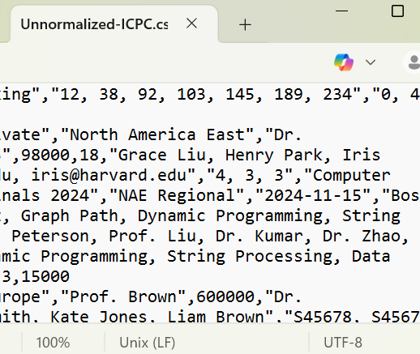

- Secondly, I asked for the dataset of most frequently faced characters which get miscoded most often when files are being copied between systems. Some typical examples of these are: "\", "\", "", -, ©, ®, ™. I went through the dataset thoroughly for such characters and made sure that none of them were there. All the characters were properly displayed when encoded in UTF-8, so no changes needed to be made.
- I also verified the dataset programmatically using Python. Since Python opens
.txt files as UTF-8 by default, I attempted to open the .CSV file with some of the most widely used encodings (utf-8, latin1, cp1252) in order to verify if decoding errors would appear. Additionally, I verified the loaded data for suspect

replacement characters (like �) or non-ASCII/UTF-8 characters.After conducting all these tests, the file loaded without any issues and there were no corrupt characters. Text fields such as university names, venues of contests, and problem names were all rendered okay. This guaranteed that the dataset was clean and was not affected by issues of character encoding.

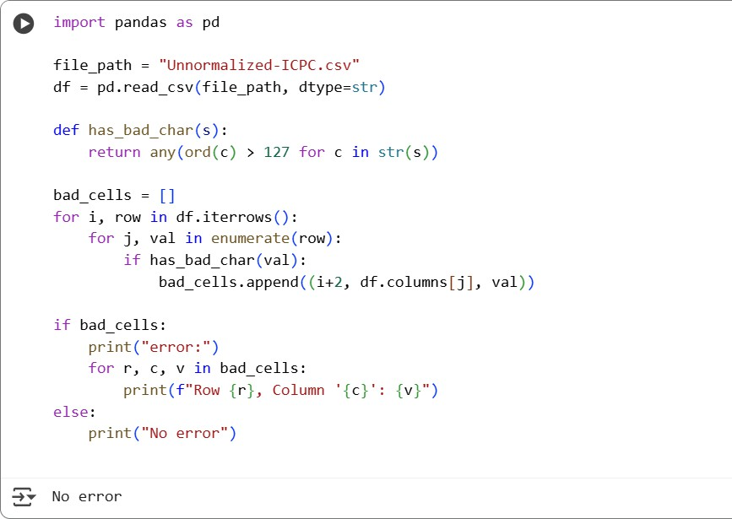

So, I could not find any problem of character encoding, I decided to search for any other sort of mistake. When reviewing the data in Excel, I realized there was a data quality issue with the Coach_Phone column. Phone numbers such as +44- 1865-555-104 were not properly read by Excel as phone numbers but instead as algebraic expressions. For example, +44-1865-555-104 was calculated as -2480, and it was the same with other global numbers.A problem here is that Excel automatically treats any cell beginning with + or - as a numerical formula rather than text.

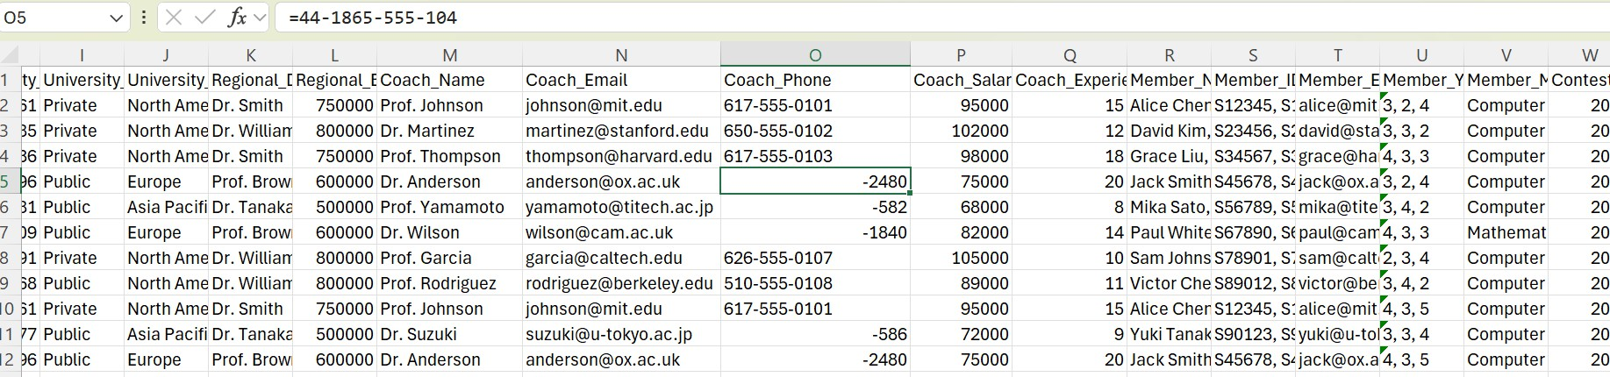
To fix this, I simply removed the leading = sign from the formula bar so that the phone number was being saved as plain text. With this change, the phone numbers displayed properly +44-1865-555-104 instead of -2480.
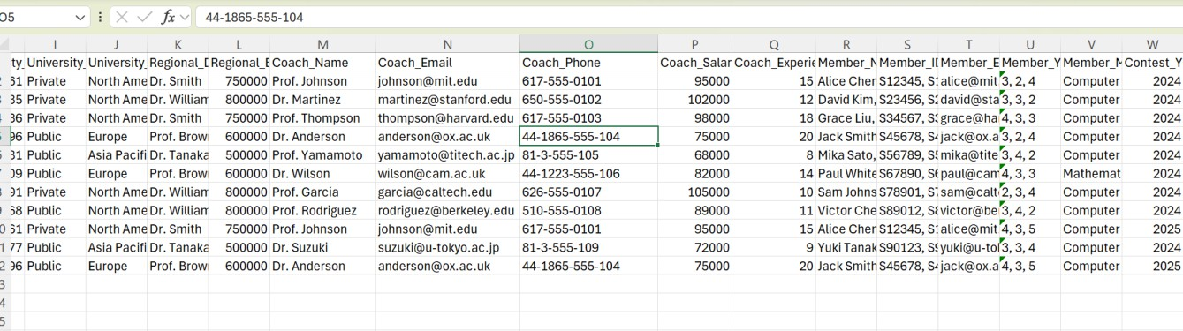

Normalization stages
1st Normal Form

A relation is in 1st Normal Form if:
  - All attributes are atomic (no repeating groups or lists inside a single column)
  - Each record is unique (no duplicate rows)]

In the ICPC dataset Member_Names, Member_IDs, Member_Emails, Member_Majors,Regional_Location, World_Finals_Location, Problem_Names, Problem_Difficulties, Problem_Authiors, Problem_Categories, Solve_Times and Penalties contain multiple comma-separated values inside a single cell. This means that a single row is storing information about multiple members, multiple problems solved by the same team, which is not atomic and that violates 1NF.
This is the original data set (I deleted other parts to show only problematic parts)

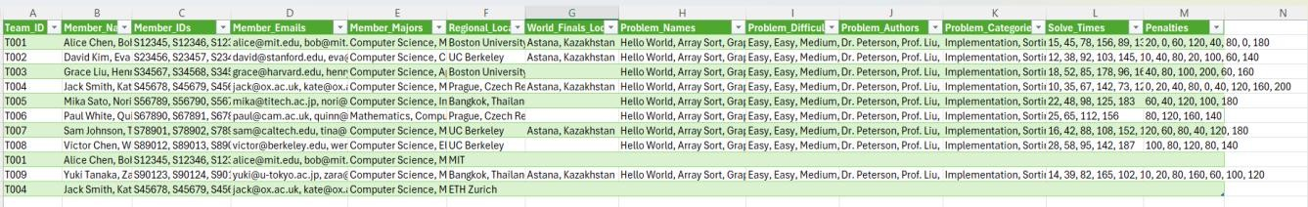
To bring this table to 1st Normal Form, rows that contain many values should be splited into separate rows and we splited attributes so each rows is about each question solved by team . It will show information about team itself and information about problems in seperated excel files as there are a lot of information and excel file is big it is not visually easy to show and understand. As a result, it will look like that
Team_Info
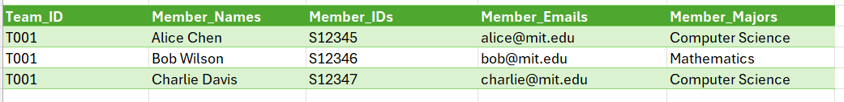

Problems
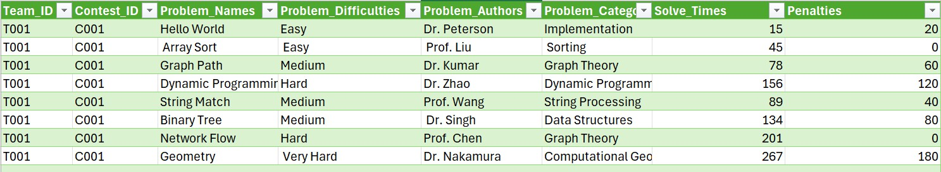

But if we wanted to show them together on one table it would look like that:
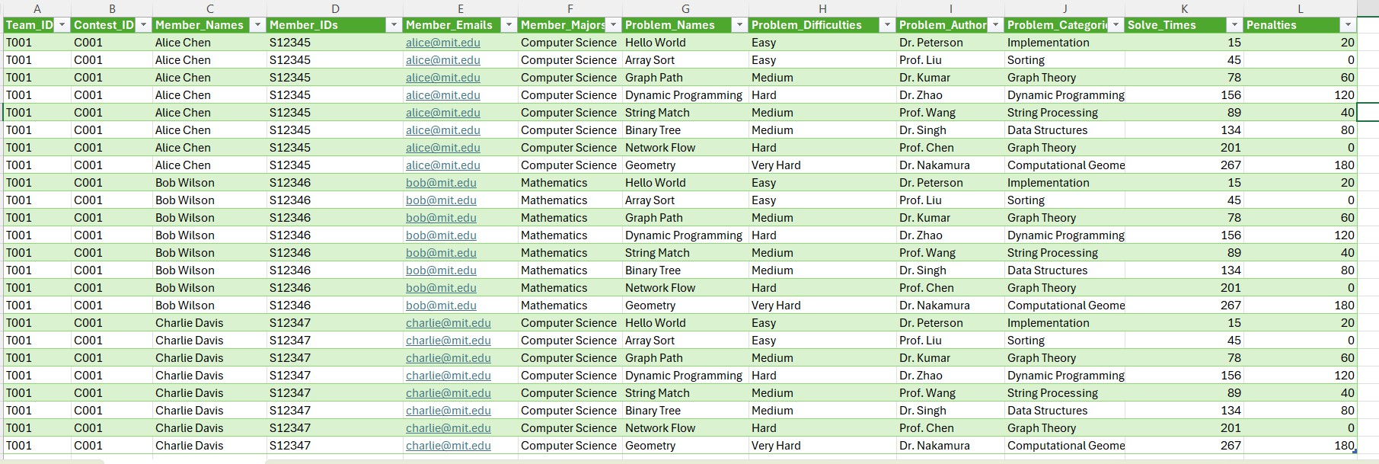

Superkeys and candidate key

A superkey is any set of attributes that can uniquely identify a row but may also include extra, non-essential attributes.

  - {Team_ID, Contest_ID, Problem_Name,Member_ID} (This combination
uniquely identifies a team’s attempt on a specific problem in a specific contest.)

{Team_ID, Contest_ID, Problem_Name, Member_ID,Solve_Time} (Adding
Solve_Time still uniquely identifies a row, but Solve_Time is extra.)

{Team_ID, Contest_ID, Problem_Name,Member_ID, Penalty} (Adding
Penalty still uniquely identifies a row, but Penalty is extra.)

  - {Team_ID, Contest_Id,Probelem_Name,Member_ID Final_Rank, Prize_Money} (holds uniqueness but includes extra attributes.)

Candidate key is the minimal superkey which uniquely identifies a row with no unnecessary attributes.
{Team_ID,Contest_ID, Problem_Name,Member_ID}-this is the minimal unique identifier for the relation Team_Problem_Solution because Team_ID alone is not enough (team enters many contests) and (Team_ID, Contest_ID) is not sufficient (a team solves multiple problems per contest). Adding Problem_Name still does not make it unique because multiple members of the same team may attempt or contribute to solving the same problem. So I add Member_ID.

2nd Normal Form

To achieve the 2nd Normal Form (2NF), I had to eliminate partial dependencies by ensuring that every non-key attribute was dependent on the entire primary key, and not a part of it. In the 1NF structure, contest, university, team, coach, and member details were stored redundantly in several rows, thus duplicating and wasting storage space. In order to solve this issue, I divided the dataset into individual tables, each representing a unique entity: Contest Team, Member, Problem, and Team_Contest_Performance.

The first table, Team Table contains attributes like Team_Id, Team_Name, Team_Founded_Year,University_Name,University_City,University_Country,Unive rsity_Established_Yearm, university_Type,University_Region,Regional_Director, regional_. Team information like Team_Name and Founded_Year were copied with member information in 1NF. I extracted these into a separate table with the teams entered only once with Team_ID as Primary Key (PK) and the foreign keys back to University_ID and Coach_ID to mark the relationships.

The second table, Member Table, has information about individual members like Member_ID, Name,Email, Year, and Major. I chose a Member_ID as Primary Key (PK) so that team information is not duplicated for every member.
The third table, Contest Table, contains contest-wide data such as Contest_ID,Regional_Contest, Contest_Name, Contest_Year, Regional_Sponsor, Contest_Prize_Pool,Regional_Date,Regional_Location,Regional_Max_Teams,Worl d_Finals_Location, and World_Finals_Date. This information has been centralized to avoid duplication between teams and problems. Contest_ID and Regional_Contest are the Primary Key (PK).
The fourth table, Problem Table, holds contest problem information such as Problem_Name, Difficulty, Author, and Category. Since problems are referenced against contests, Contest_ID is used as a Foreign Key (FK). Each problem has a unique Problem_ID as the Primary Key (PK).

The final table, Team_Contest_Performance, was included to store performance values like Problems_Solved, Solve_Times, Penalties, World_Finals_Qualified,Final_Rank, and Prize_Money. They are connected to the contest as well as the team, and hence a composite primary key (Team_ID, Contest_ID) has been applied to identify the record of each performance uniquely. This will ensure that a team's performance in a specific contest is stored correctly only once.

By organizing the database in this way, redundancy was avoided and all non-key attributes now benefit from full dependency on their relative primary key.
Primary Keys (PKs) was employed to establish relationships with referential integrity.
This schema is more effective and consistent, allowing direct querying of contest results, team performance analysis, and redundant-free storage of contest details. The resulting ER diagram for 2NF successfully encapsulates these relationships with one-to-many relationship
between Team-Member, many-to-many relationships between Team- Contest,Team-Problem.Final E-R diagram looks like that:

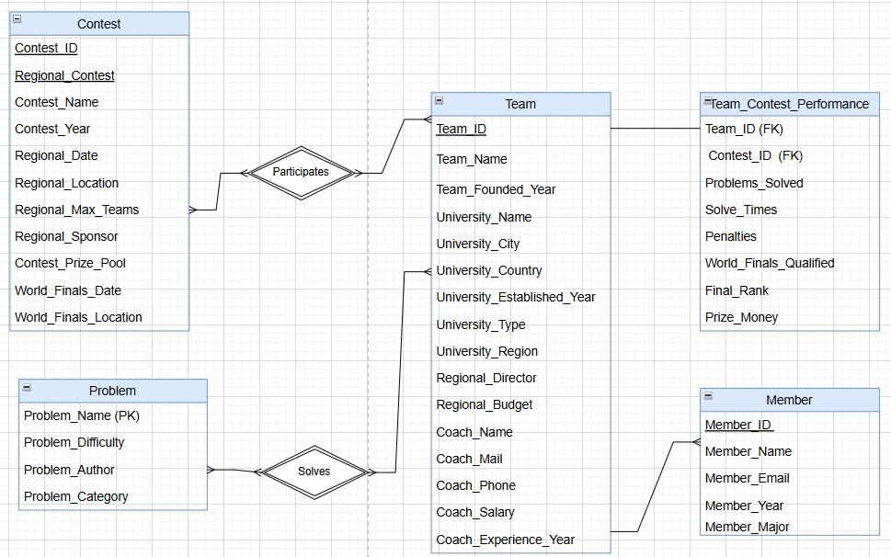

3rd Normal Form

As we brought the database into the Second Normal Form (2NF), we had all non- key attributes totally functionally dependent on the complete composite primary key. 2NF has nothing to do with, though, transitive dependencies.In order to meet the requirement of Third Normal Form (3NF), we need to eliminate all these transitive dependencies such that every non-key attribute will be dependent on the primary key alone.
Even in the 2NF organization of our database, there were a few non-key attributes left behind in the Team and University tables, though they were not functionally dependent on Team_ID. For example, certain university and coach information — such as University_City, Coach_Email, Coach_Phone, etc. were also present in the Team table, though these informations are not directly dependent on Team_ID.

To remove such transitive dependencies and meet 3NF requirements, we introduced new tables and moved attributes as described below:
University-related attributes (University_City, Country, Type, etc.) were moved to a new University table with University_Name as the primary key.

Coach-related attributes (Coach_Email, Phone, Salary, Experience) were moved to a new Coach table with Coach_Name as the primary key.
The Team table subsequently contains only Team_ID, Team_Name, Team_Founded_Year, and references (foreign keys) to Coach and University. This redesign places all non-key attributes directly in relation to Team_ID, the primary key of the Team table.

This avoids anomalies and logically has the data. For example, Coach_Email is now in relation with Coach_Name (in the Coach table), not Team_ID — which is in accordance with 3NF by eliminating the transitive dependency.

There were certain tables that were already well-defined in 2NF and required no alteration for 3NF:
The Problem table had attributes like Problem_Difficulty, Problem_Author, and Problem_Category, which all directly depended on the primary key Problem_Name. There were no transitive dependencies here.
The Team_Contest_Performance table featured a composite key (Team_ID, Contest_ID) and stored performance details (e.g., Solve_Times, Final_Rank, Penalties), all of which directly depend on the composite key. This table, therefore, was not normalized from 2NF to 3NF.

The Member table (storing team member details) was well-normalized, too, with the primary key as Member_ID. All personal and academic data are directly related to that ID.
These transformations put the database design into 3NF standards, delivering: No repeating or multi-valued attributes (covered in 1NF),
No partial dependencies (covered in 2NF),
And no transitive dependencies (covered in 3NF).

This 3NF structure is more effective in maintaining data integrity, minimizes redundancy, and is easier to work on as the database grows.

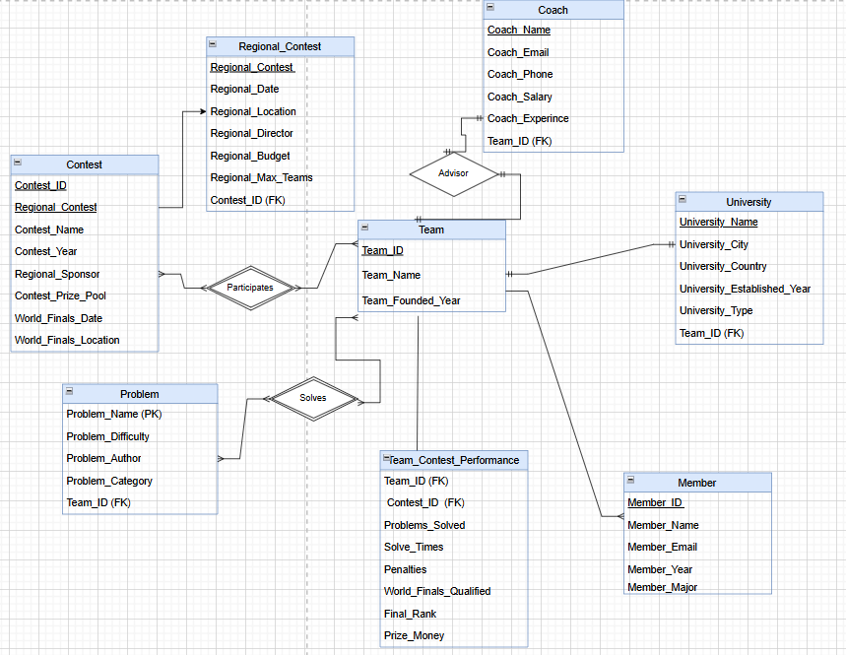

Communication with ChatGPT
https://chatgpt.com/share/68dd63ab-1e9c-8008-ad81-112e3d7f0a32

Comparison with ChatGPT

Diagnosing error

My method ensures a more reliable and comprehensive check, safeguarding data integrity before proceeding with normalization.Instead of relying only automatic scan, I performed programmatic validation, inspected the dataset with Notepad++, and manually verified for widely faced problematic characters. This allowed me to identify confirm whether there was error or not. Moreover, I
discovered an error in the checking function that ChatGPT’s approach overlooked, but I was able to detect and correct it(excel was presenting phone numbers as int value). Therefore, My approach to solving character encoding issues is more thorough and precise than ChatGPT.

- Normal Form

In 1st Normal Form ChatGPT and I identified the columns that are not atomic and decided to separate it. However, I decided not to split attributes like Team, Member, Problems, Contest from very beginning. I do not think that it is needed in 1NF that it can be done in 2NF.
Primary and Candidate keys

I had a lot of disaggrement with ChatGPT in this part. This is because ChatGPT suggested , Team_Id + Contest_ID as candidate key which i do not agree with it. I suggested Team_ID + Contest_ID+ Member_ID+ Problem_Name as candidate key as it uniquely defines dataset.

- Normal Form
In my solution university information (name, city, country, established year, region, budget) is stored inside the Team entity but ChatGPT suggested to create univeristy entity for 2NF. University is dependent on Team_ID, actaully it creates transitive dependency which is not problem for 2 NF it can be handled during 3 NF.Also, proposed solution combines Team_ID + Member_ID for member entity which creates complexity, because member table can be identified by just member_id.

I would like to mention one improvement for my solution, we could separate World_Finals_Location and Regional_Location into city and country to make the data more structured and easier to use for future implementation.
3rd Normal Form

Similarly, experience, phone, and email coach-related properties are stored in one particular Coach table within both designs. However, our diagram enforces a clear "Advisor" relationship between Coach and Team, which is semantically correct and maintains referential integrity, especially where a single coach may advise multiple teams. In terms of monitoring performance, ChatGPT creates Problem_Attempts and Performance tables with composite keys, which is structurally right. But my 3NF design introduces unified Team_Contest_Performance table that properly groups performance measurements into a single logically coherent whole associated with team entry in a contest.

In addition, my Member table is shorter and correctly related to Team through a foreign key, with neither transitive dependencies nor overkill redundancy.
ChatGPT proposes the same structure but does not clearly define the relationship cardinality or functional dependencies between Team and Member. Our E-R diagram ensures that all non-key columns depend solely on their respective primary keys, relationships are well-established, and data redundancy is brought down to zero—entirely following the rules of the Third Normal Form.

Conclusion

The file presents how the normalization process extensively enhanced the database's scalability, efficiency, and integrity through eliminating redundancy and proper logical data attribute relationships. By applying 1NF, 2NF, and 3NF, the dataset was better organized to produce accurate, consistent, and interpretable data retrieval. The report highlights the importance of careful key selection, detection of encoding errors, and careful structuring of tables. Some potential steps would be to load these normalized tables into a sample database, to increase data detail, accuracy, and query performance even further.

References
http://support.learnupon.com/hc/en-us/articles/360004744778-Character-encoding-in- CSV-files-troubleshooting

Silberschatz, A., Korth, H. F., & Sudarshan, S. (2019). Database system concepts (7th ed.). McGraw-Hill Education.

