Final task :

Matan turjeman 313598005

I used <https://supabase.com/> as a way to upload and retrieve file

First task:

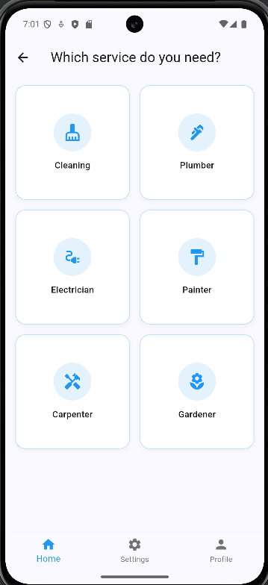

Second task children book:  
  


