CSD310

Luis Padilla

10/17/22

GitHub Repository Setup

1. Link to your GitHub repository
   1. <https://github.com/Matarisvan>
2. Screenshot of your GitHub repository

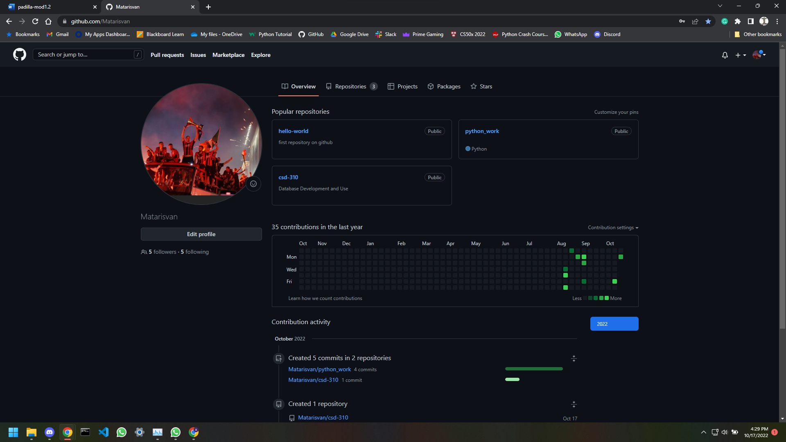

1. Screenshot of your local directory (properly formatted).

