CSD310

Luis Padilla

10/28/22

Data Models

**ERD:**

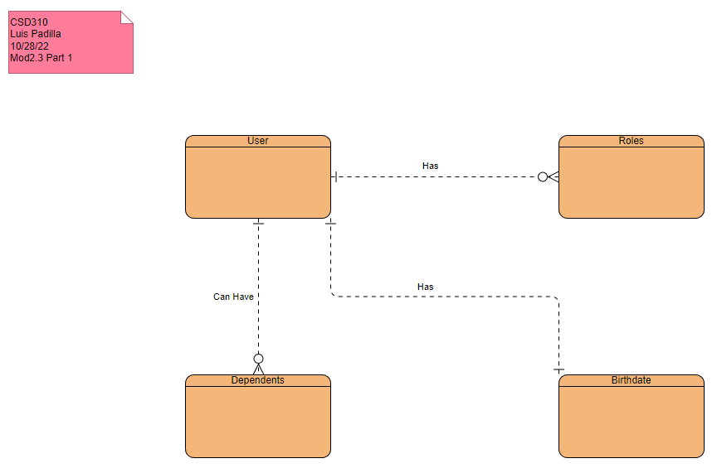

**NoSQL Data Structure:**

