CSD310

Luis Padilla

11/22/22

MySQL Install

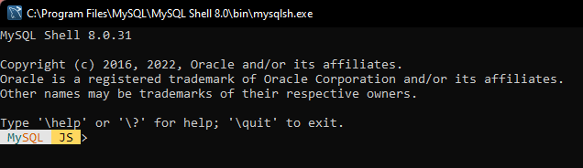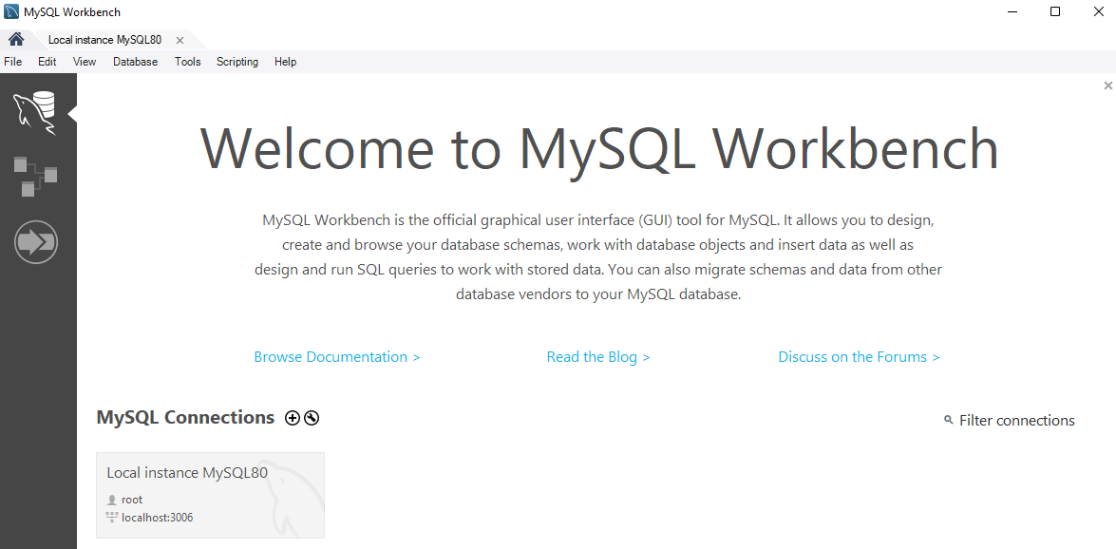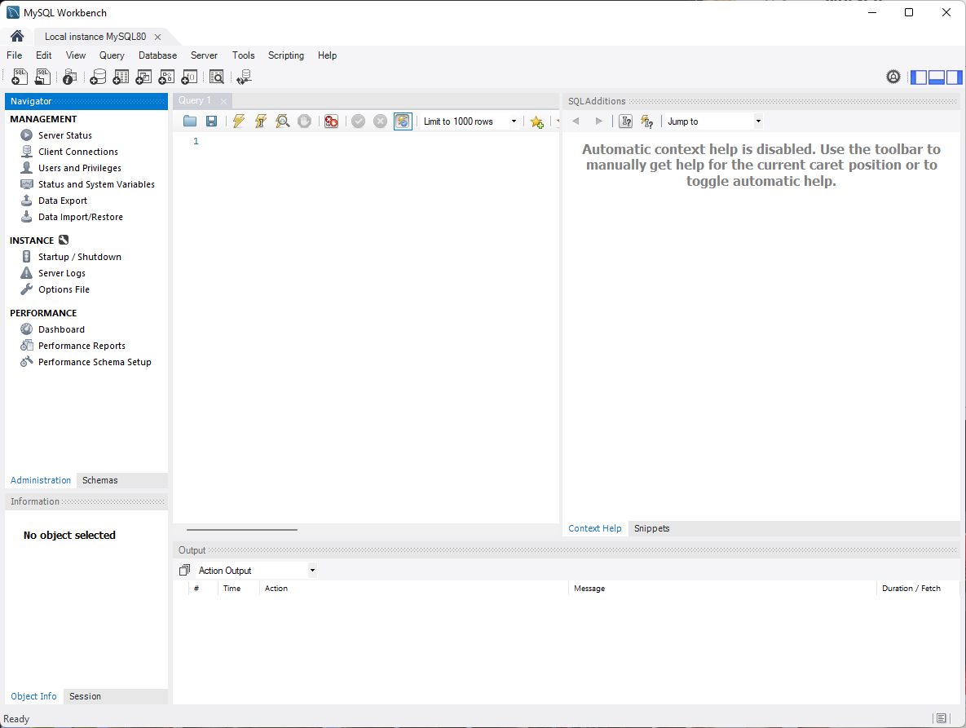

I accidentally cleared the output before screenshotting, but when I run the syntax, you can see the database exists when looking at the output.

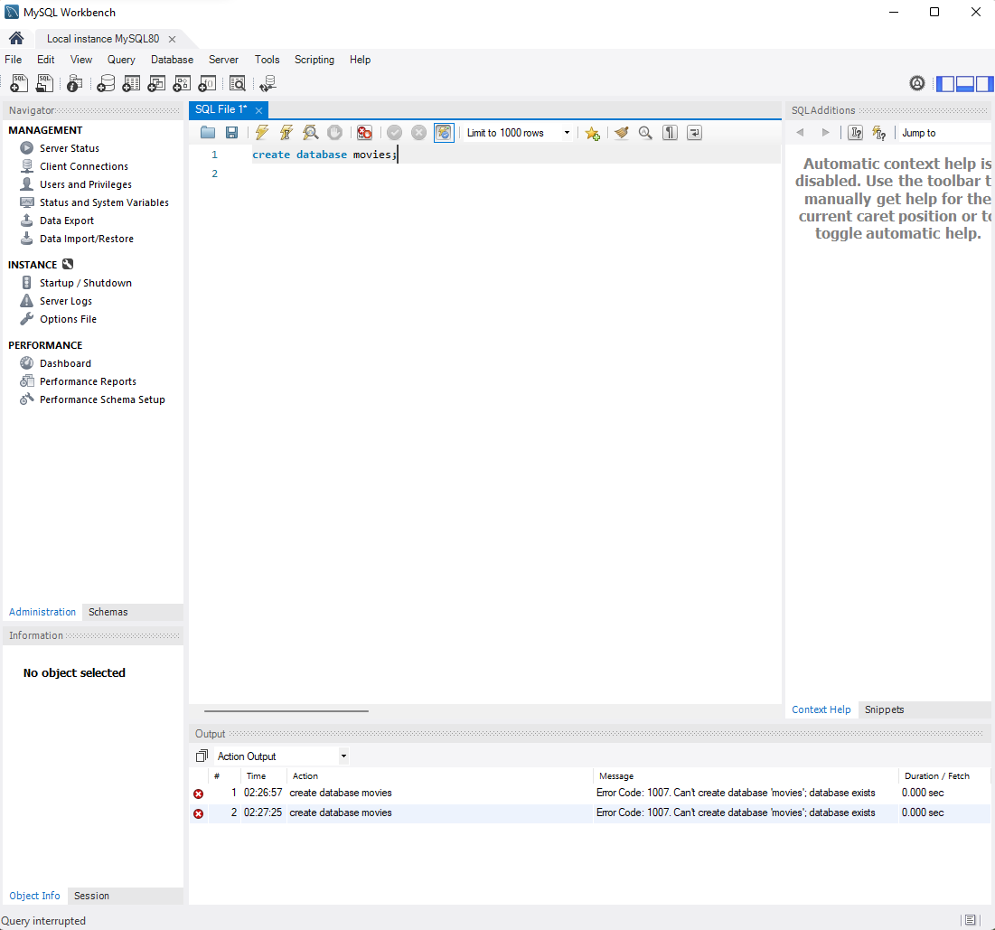

“show databases;” command

