CSD310

Luis Padilla

11/22/22

MySQL Functions

Function 1: LOWER

* This can be used when wanting to change a string to lowercase
* 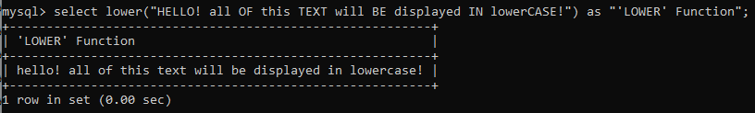

Function 2: CONCAT

* Used to add 2 or more expressions together. Could be used to add different columns into one bigger column
* 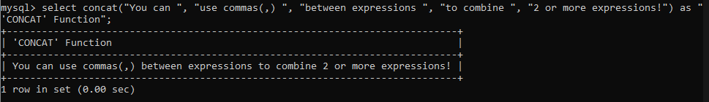

Function 3: FORMAT

* Used to format a number to show the desired number of decimal places
* 