Csd340

Luis Padilla

8/7/23

Assignment 1.2 GitHub Repository Setup

1. <https://github.com/Matarisvan/csd340>
2. 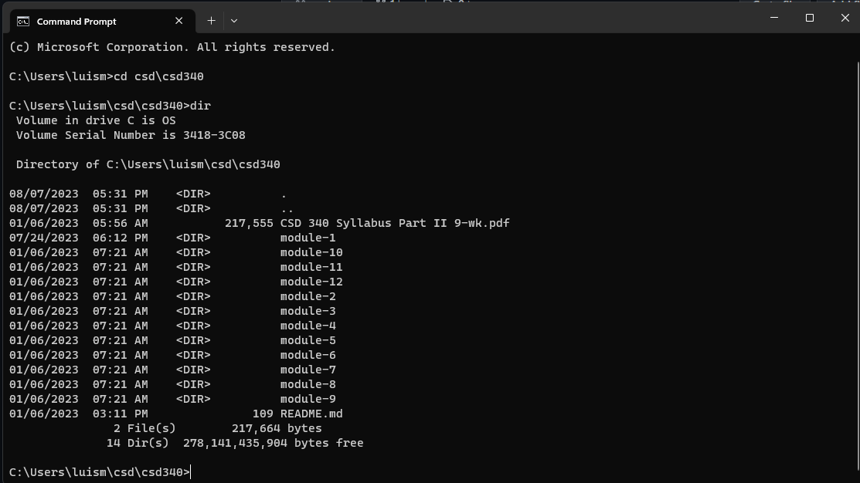
3. 