Luis Padilla

CSD340

8/7/23

Assignment 1.3 - Building a Web Page Exercise, Part 1

1. 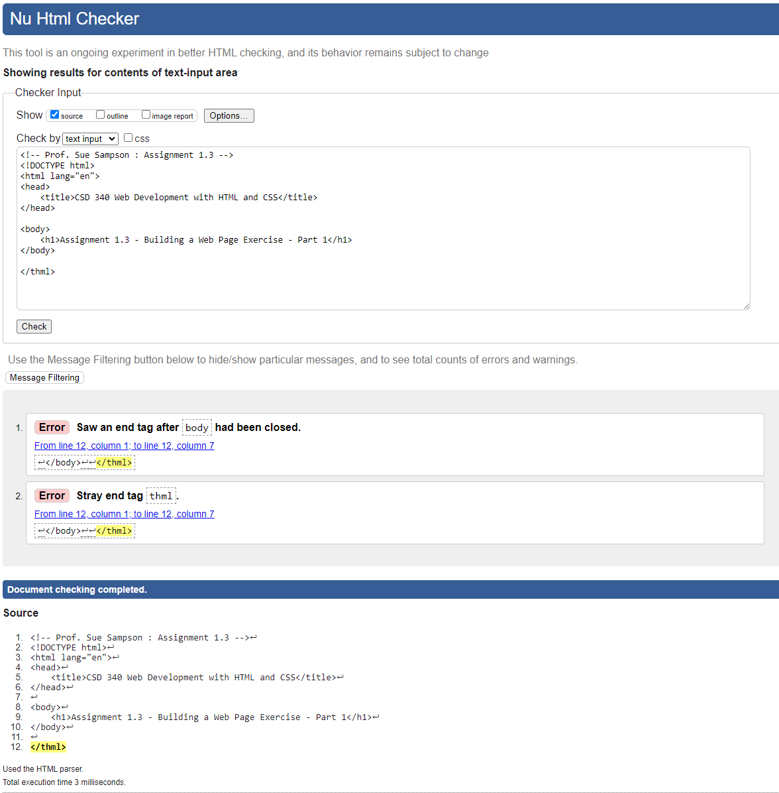
2. 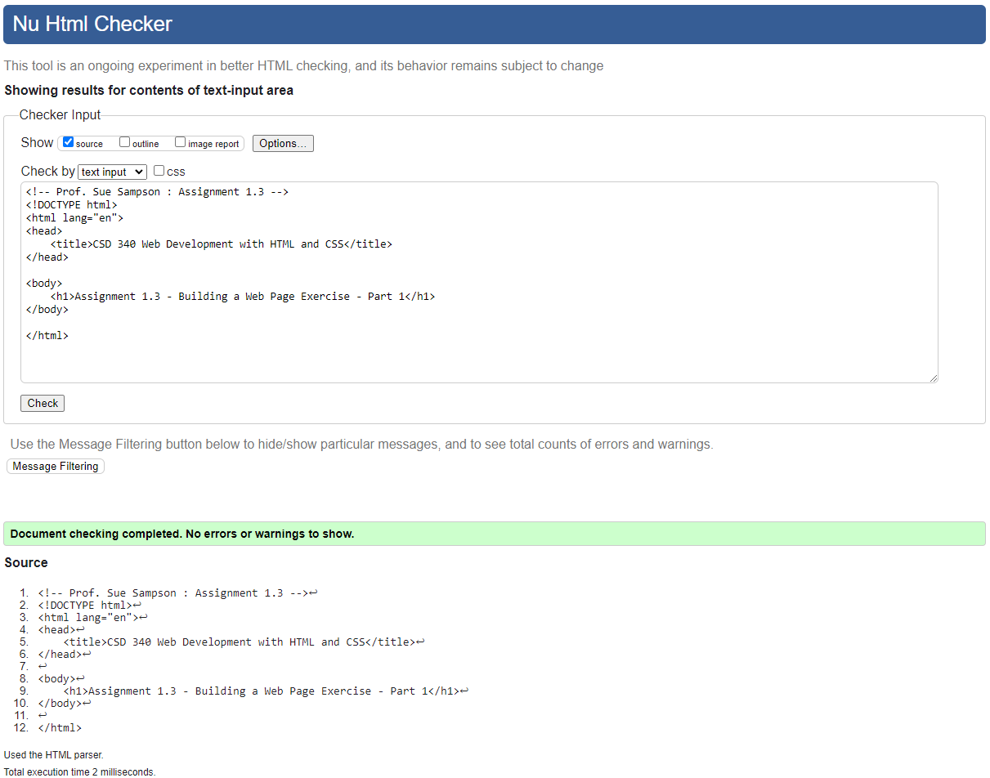
3. 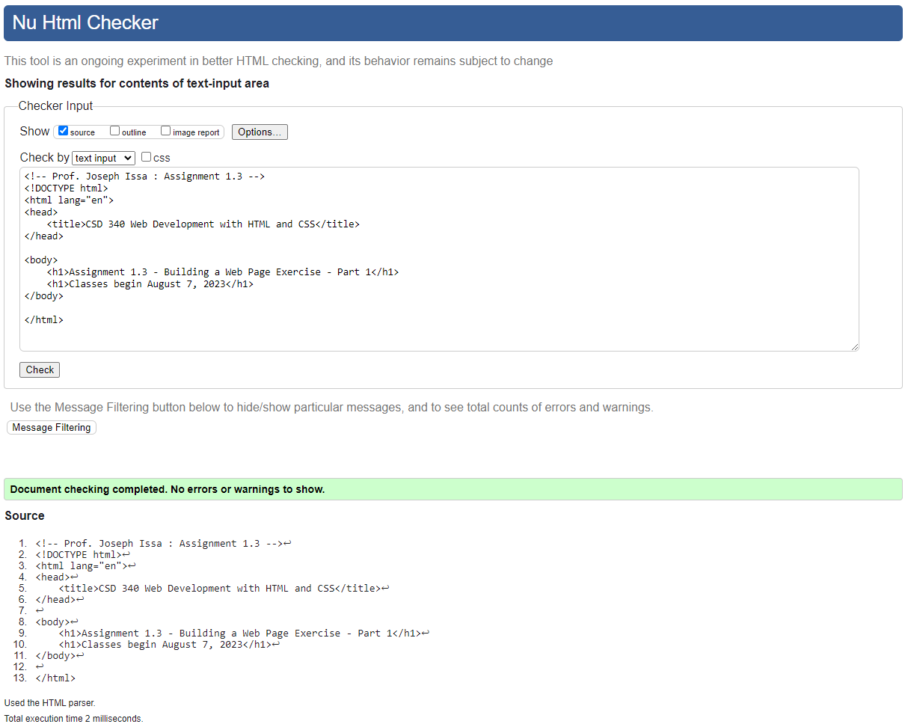
4. 