Luis Padilla

CSD340

8/19/23

Assignment 3.2

HTML Validation:

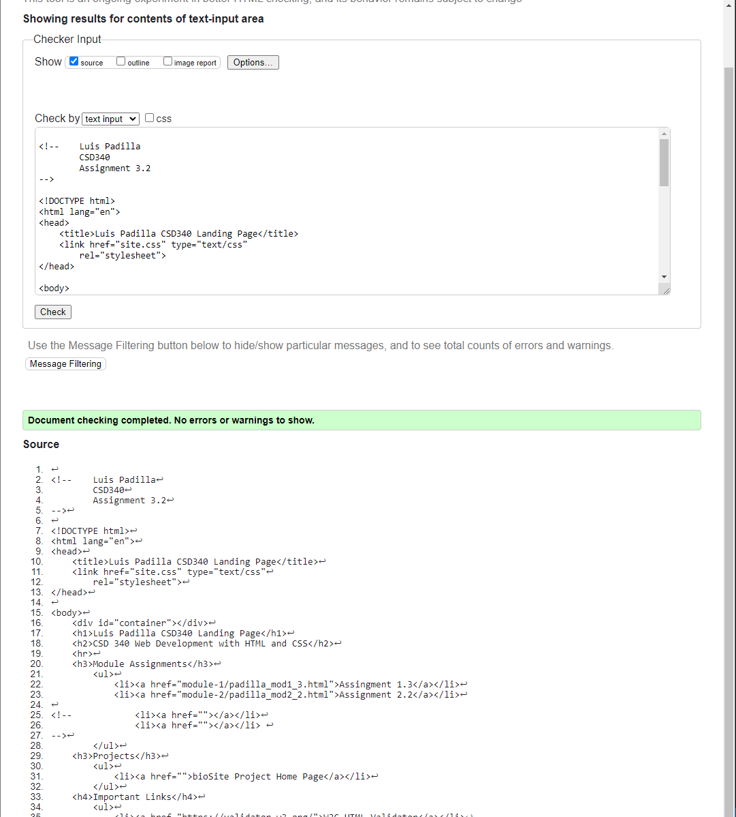

CSS Validation:

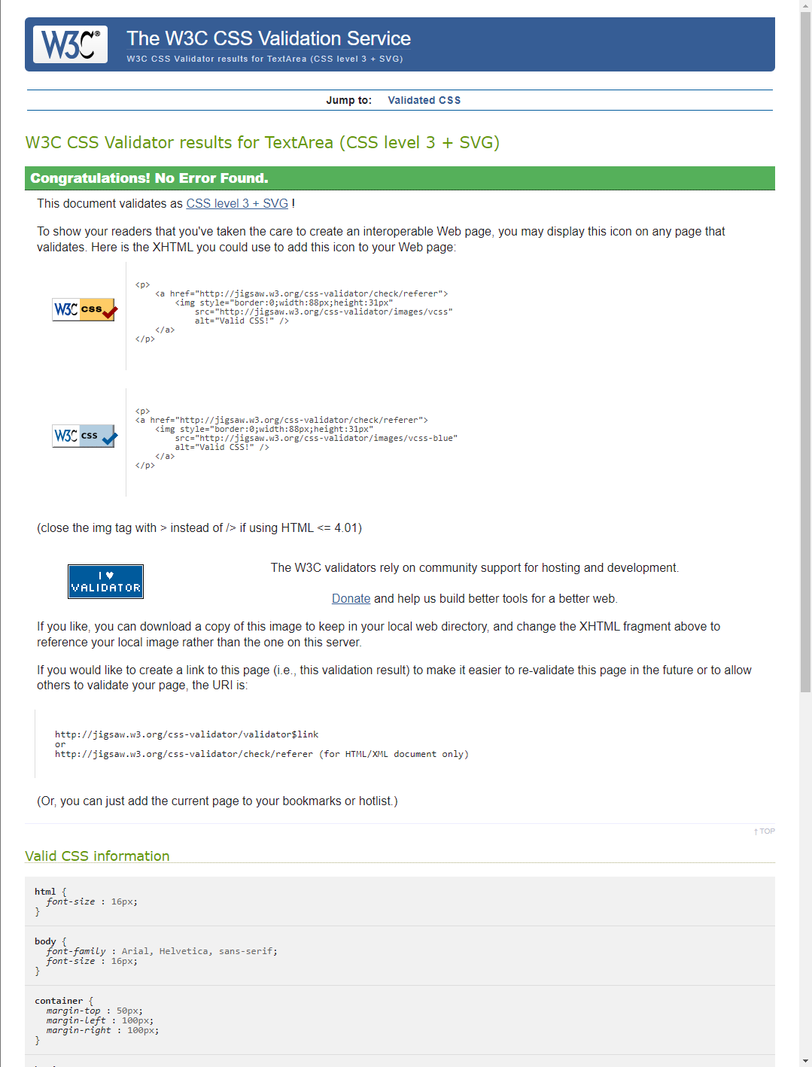

Index.html:

