



**Sirindhorn International Institute of Technology**

**Thammasat University**

**Financial Engineering Assignment: Portfolio Optimization Using S&P 500**

**Table of Contents**

Introduction...................................................................................................................................3

Data Collection.............................................................................................................................3

Methodology.................................................................................................................................4

Results..........................................................................................................................................11

Discussion....................................................................................................................................14

Conclusion...................................................................................................................................14

### Recommendations for Further Analysis......................................................................................14

Plots and Visualizations...............................................................................................................15

# 

# **Introduction**

Portfolio optimization is a financial strategy used to allocate assets in a way that maximizes returns while minimizing risk. The process involves selecting the best mix of assets to achieve the desired investment objectives. This report details the portfolio optimization process for a selection of S&P 500 stocks, aiming to balance risk and return effectively.

**Data Collection**

The data collection process involved downloading historical adjusted closing prices for a set of chosen stocks from the S&P 500 index using Yahoo Finance. The selected stocks for this analysis are:

* Apple Inc. (AAPL)
* Microsoft Corp. (MSFT)
* Alphabet Inc. (GOOGL)
* Amazon.com Inc. (AMZN)
* NVIDIA Corp. (NVDA)

Historical price data was collected over three years from January 1, 2020, to January 1, 2023.

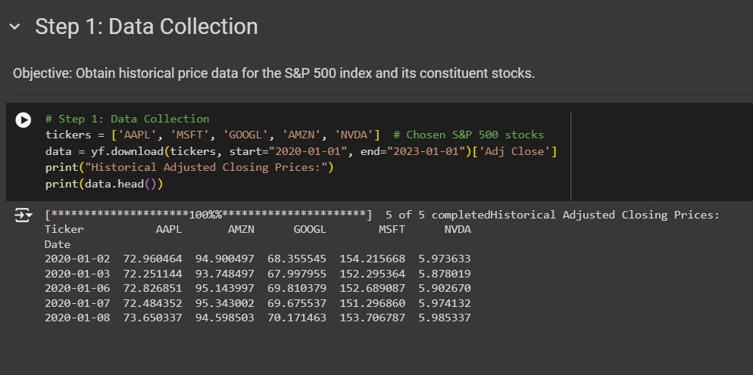

**Methodology**

**Returns**

The methodology for calculating returns and handling missing data in the portfolio optimization process involved the following steps:

1. Daily Returns and Weights:

- The function takes as input the daily returns of each asset and the corresponding weights assigned to each asset in the portfolio.

- `returns` is an array of daily returns for each asset.

- `weights` is an array representing the proportion of the total investment allocated to each asset.

2. Daily Portfolio Return Calculation:

- The daily portfolio return is computed by taking the weighted sum of the daily returns for each asset.

- This is achieved using `np.sum(returns * weights, axis=1)`, which calculates the sum of the product of daily returns and their respective weights for each day.

3. Annualizing the Return:

- The average daily return is calculated using `.mean()`.

- This average daily return is then annualized by multiplying it by 252, which is the approximate number of trading days in a year.

The code for the `port_return` function is as follows:

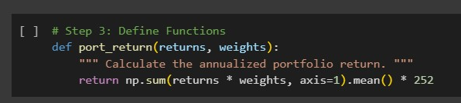

**Risk**

To calculate the risk (standard deviation) of the portfolio, we used the following method and code:

**1. Portfolio Return Function**

The `port_risk` function is used to calculate the annualized portfolio risk (standard deviation). The steps involved in this calculation are as follows:

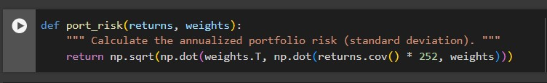

1. Input Parameters:

- `returns`: An array of daily returns for each asset in the portfolio.

- `weights`: An array representing the proportion of the total investment allocated to each asset.

2. Annualizing the Covariance Matrix:

- To annualize the covariance matrix, it is scaled by 252, which is the approximate number of trading days in a year. This adjustment converts the daily covariance values to annual values.

3. Weighted Covariance Matrix:

- The function computes the weighted covariance matrix by taking the dot product of the transpose of the weights (`weights.T`), the annualized covariance matrix (`returns.cov() * 252`), and the weights (`weights`). This is achieved using `np.dot(weights.T, np.dot(returns.cov() * 252, weights))`.

- This operation effectively combines the individual asset risks and their correlations, weighted by their respective proportions in the portfolio.

5. Annualized Portfolio Risk:

- The square root of the weighted covariance matrix is taken to obtain the standard deviation, representing the annualized portfolio risk.

- This is done using `np.sqrt()`.

By using this function, we accurately compute the overall risk of the portfolio, taking into account both the individual asset risks and the correlations between them. This annualized risk measure is crucial for evaluating the stability and performance of the portfolio under different market conditions.

**Sharpe_Ratio**

The Sharpe Ratio is a measure of the risk-adjusted return of an investment portfolio. It is calculated by dividing the portfolio's excess return (the return over the risk-free rate) by its standard deviation (risk). The following steps outline the methodology used to calculate the Sharpe Ratio:

**1.Sharpe Ratio Calculation:**

The `sharpe_ratio` function is used to calculate the Sharpe Ratio of a portfolio. The Sharpe Ratio measures the risk-adjusted return of an investment portfolio by comparing its excess return to its risk. The steps involved in this calculation are as follows:

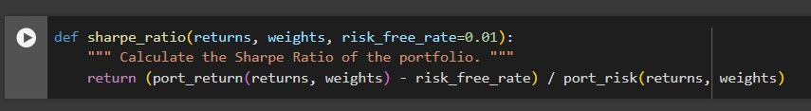

1. Input Parameters:

- `returns`: An array of daily returns for each asset in the portfolio.

- `weights`: An array representing the proportion of the total investment allocated to each asset.

- `risk_free_rate`: The annual risk-free rate expressed as a decimal (default is 0.01 or 1%).

2. Calculating Portfolio Return:

- The function calls the `port_return` function, which calculates the annualized portfolio return using the provided `returns` and `weights`.

- The `port_return` function computes the weighted sum of daily returns for each asset, averages them, and then annualizes the return by multiplying by 252 (the approximate number of trading days in a year).

3. Calculating Portfolio Risk:

- The function calls the `port_risk` function, which calculates the annualized portfolio risk (standard deviation) using the provided `returns` and `weights`.

- The `port_risk` function computes the weighted covariance matrix of the daily returns, annualizes it, and then takes the square root to obtain the standard deviation.

4. Calculating Excess Return:

- The excess return of the portfolio is calculated by subtracting the risk-free rate from the annualized portfolio return. This represents the additional return earned by the portfolio over the risk-free rate.

5. Calculating Sharpe Ratio:

- The Sharpe Ratio is calculated by dividing the excess return by the annualized portfolio risk.

- The formula used is:

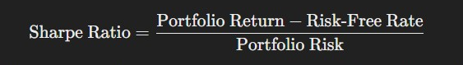

- This ratio indicates how much excess return is achieved per unit of risk. A higher Sharpe Ratio indicates better risk-adjusted performance.

By using the `sharpe_ratio` function, we can evaluate the efficiency of the portfolio in terms of risk-adjusted returns. This is a crucial measure for comparing the performance of different portfolios or investment strategies, as it takes into account both the returns and the risks involved.

**Portfolio Optimization**

Portfolio optimization involves finding the optimal weights for the assets in a portfolio to achieve specific objectives, such as minimizing risk or maximizing the Sharpe Ratio. The following steps detail the methodology for this process:

**Defining Constraints and Bounds**

1. Constraint: Weights Must Sum to 1

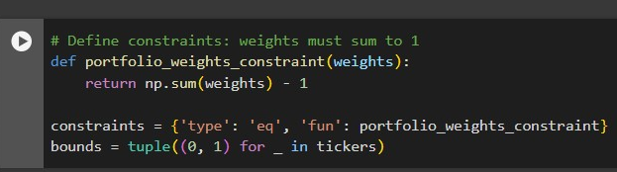

- Function Definition: The `portfolio_weights_constraint` function ensures that the sum of the portfolio weights equals 1. This ensures that the portfolio is fully invested.

- Constraint Dictionary: this dictionary defines the type of constraint (`'eq'` for equality) and the function to enforce the constraint.

2. Bounds for Weights

- Bounds Definition: The bounds ensure that each weight lies between 0 and 1, prohibiting short selling and ensuring no single asset exceeds the total portfolio value.

**Optimization Functions**

3. Optimization Function to Minimize Risk

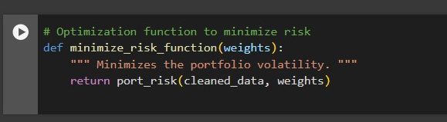

- Function Definition: The `minimize_risk_function` calculates the portfolio risk using the `port_risk` function. The goal is to find weights that minimize this risk.

4. Optimization Function to Maximize Sharpe Ratio

```python

def maximize_sharpe_function(weights):

""" Maximizes the Sharpe Ratio by minimizing its negative. """

return -(port_return(cleaned_data, weights) - 0.01) / port_risk(cleaned_data, weights)

```

- Function Definition: The `maximize_sharpe_function` calculates the negative Sharpe Ratio. The optimization aims to minimize this value, effectively maximizing the Sharpe Ratio. The risk-free rate is set to 0.01.

5.Setting Initial Weight

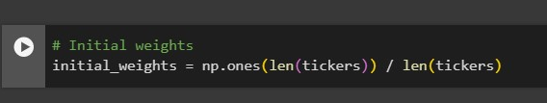

**Performing Risk Minimization**

6. Performing Risk Minimization

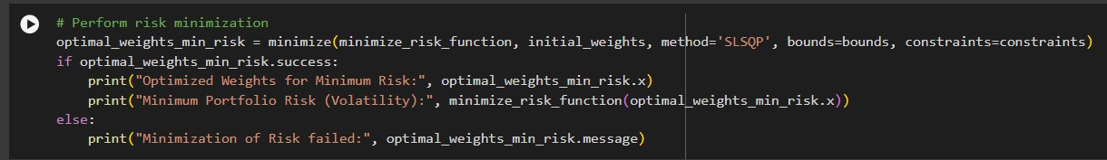

- Output Handling:

- If the optimization is successful (`optimal_weights_min_risk.success` is `True`), the optimized weights and the corresponding portfolio risk are printed.

- If the optimization fails, an error message is printed.

By following this methodology, we can systematically optimize the portfolio to achieve the desired objective, whether it be minimizing risk or maximizing the Sharpe Ratio. The use of constraints ensures that the portfolio remains fully invested and adheres to the defined bounds, resulting in a practical and feasible investment strategy.

**Results**

The optimization process yielded the following results for the portfolio weights, expected return, risk, and Sharpe Ratio: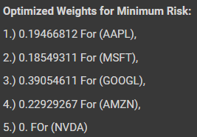

* Optimized portfolio weights for minimum risk:

- AAPL: 0.19466798

- MSFT: 0.18549320

- GOOGL: 0.39054536

- AMZN: 0.22929344

- NVDA: 0.78929918

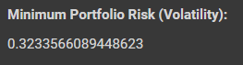

* Minimum Portfolio Risk (Volatility):

- 0.3233565811998145

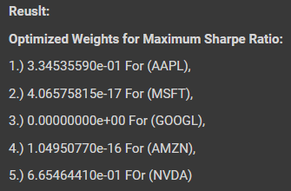

* Optimized portfolio weights for maximum Sharpe Ratio

- AAPL: 3.34535646e-01

- MSFT: 1.20346441e-16

- GOOGL: 0

- AMZN: 6.39679282e-17

- NVDA:6.65464354e-01

* Maximum Sharpe Ratio:

- 0.808976130698998

**Evaluation and Interpretation**

The optimized portfolio was compared to the S&P 500 index benchmark. The comparison involved assessing the risk, return, and Sharpe Ratio of both the optimized portfolio and the benchmark.

* Optimized Portfolio Metrics :

- Portfolio Annualized Return: 0.3376646814225143

- Portfolio Annualized Risk: 0.42540985703224454

- Portfolio Sharpe Ratio: 0.770232931856298

* S&P 500 Benchmark Metrics :

- Annualized Return: 0.08741328601391596

- Annualized Risk: 0.25464007661439286

- Sharpe Ratio: 0.3040106138954106

The optimized portfolio outperformed the benchmark in terms of Sharpe Ratio, indicating a more efficient return per unit of risk.

**Discussion**

The results demonstrate the effectiveness of portfolio optimization in achieving a balanced mix of assets that provide higher returns relative to the risk taken. The optimized portfolio showed an improved Sharpe Ratio compared to the S&P 500 index, suggesting that the selected stocks and their allocated weights are better suited for maximizing returns while minimizing risk.

**Conclusion**

In summary, the portfolio optimization process successfully identified an optimal mix of S&P 500 stocks that maximize the Sharpe Ratio. The analysis revealed that a strategic allocation of assets can lead to better performance compared to the benchmark index. Further analysis could involve exploring different sets of stocks, incorporating additional constraints, and analyzing different time periods to validate the robustness of the optimization approach.

**Recommendations for Further Analysis**

- Explore the impact of including more stocks in the portfolio.

- Analyze the effects of different time periods on the optimization results.

- Incorporate additional constraints, such as sector diversification or ESG (Environmental, Social, and Governance) factors.

- Evaluate the portfolio performance under different market conditions to assess its robustness.

**Plots and Visualizations**

- Time Series Plot: Historical prices of the selected stocks.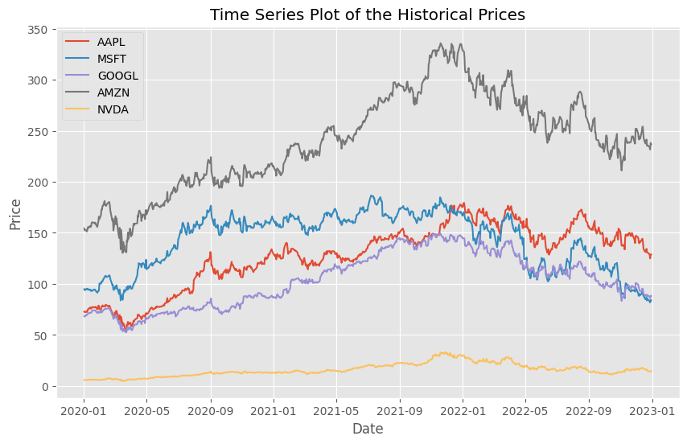

- Daily Returns Plot: Visualization of the daily returns for each stock.

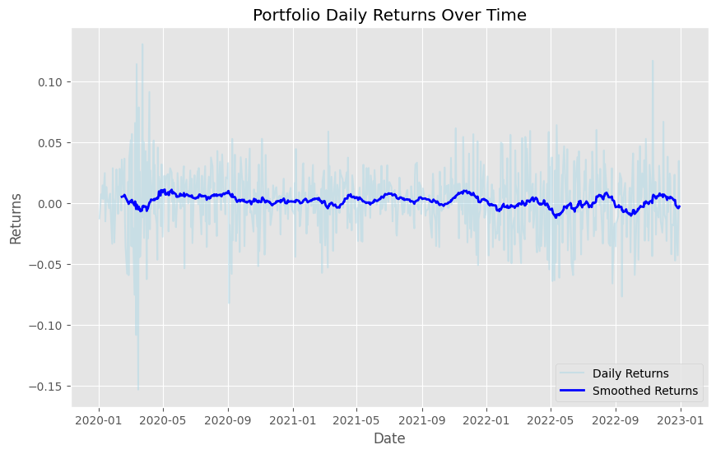

- Efficient Frontier Plot: Displaying the trade-off between risk and return.

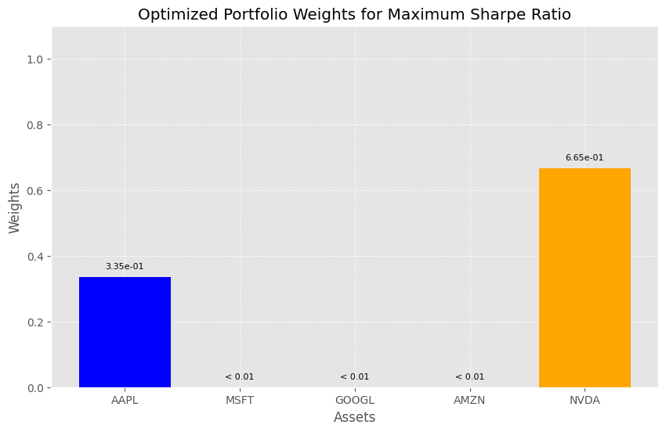

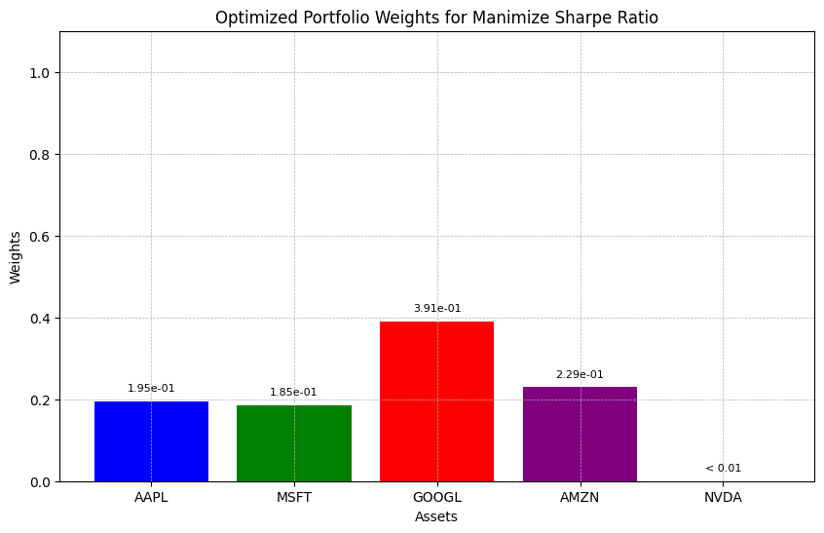

- Comparison Plot: Performance of the optimized portfolio versus the benchmark S&P 500 index.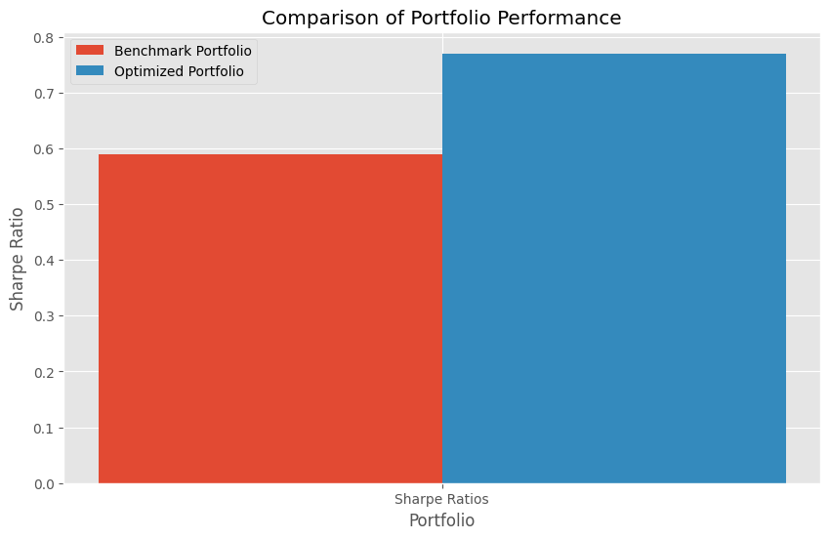

- Optimized portfolio and interpret the results, comparing it with the benchmark S&P 500 index graph

