**The Untangle Java program**

The untangle program generates an inter-connected grid of lines and scrambles the points and then the user has to solve the puzzle by dragging the points, so that none of the lines intersect.

Untangle was built using the NetBeans 8.2 IDE.

Included in this repository are the java files and the form files (which are the Netbeans form layout files)

**Running the program**

To create your first untangle puzzle, select the number of point (10-200), press Create.

Below is a screen shot of a 25 point puzzle.

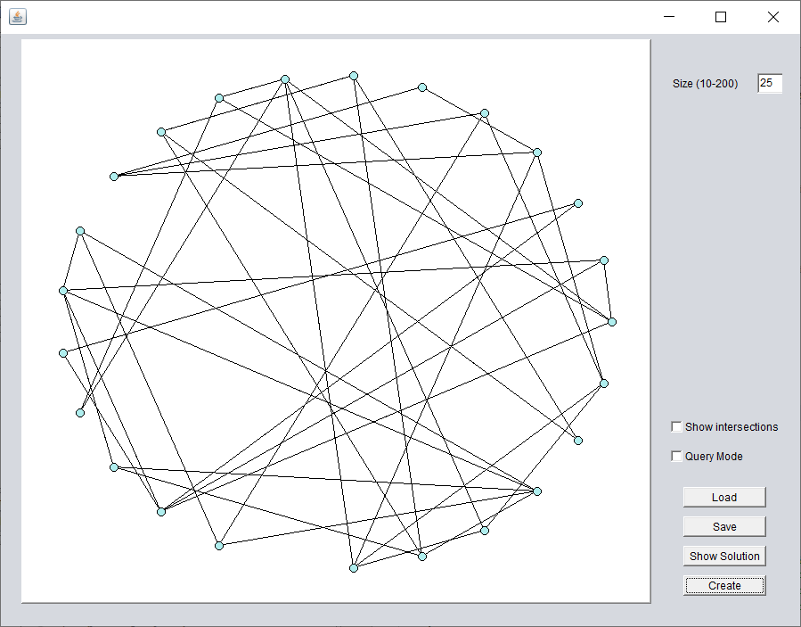

Example 25-point puzzle

Press the show solution to show the original grid that the program generated. This solution isn’t permanent (i.e. you can press the show solution again and it will return to the puzzle in it’s unsolved state). Below is a screen shot of the original grid.

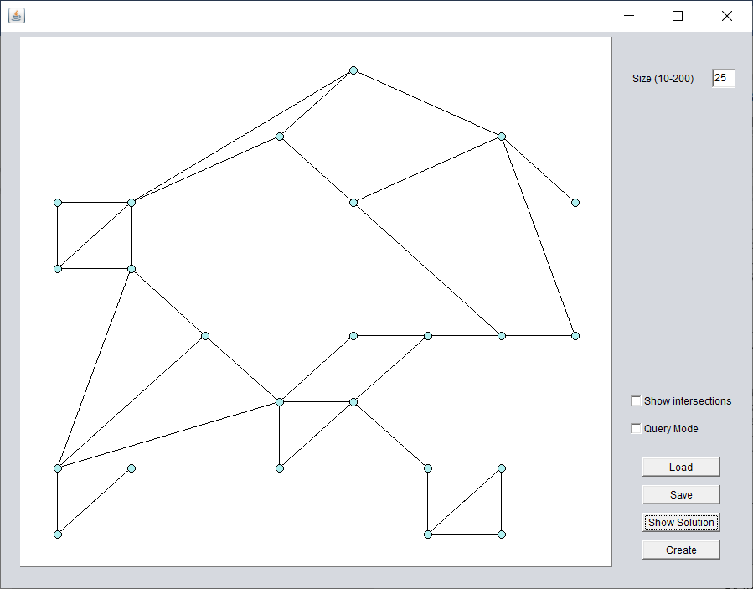

Shown Solution

**Solving the Untangle**

You can click and drag any point to its new location. When you click a point, it will change colour and all the points which are connected to that point will turn red.

You can also move or multiple points, by clicking at any point on the panel (not a point) where you want the top left corner of a box to be the dragging the mouse to the bottom right. This will mark a box on screen and if there is at least 1 point in the box, the points will be selected.

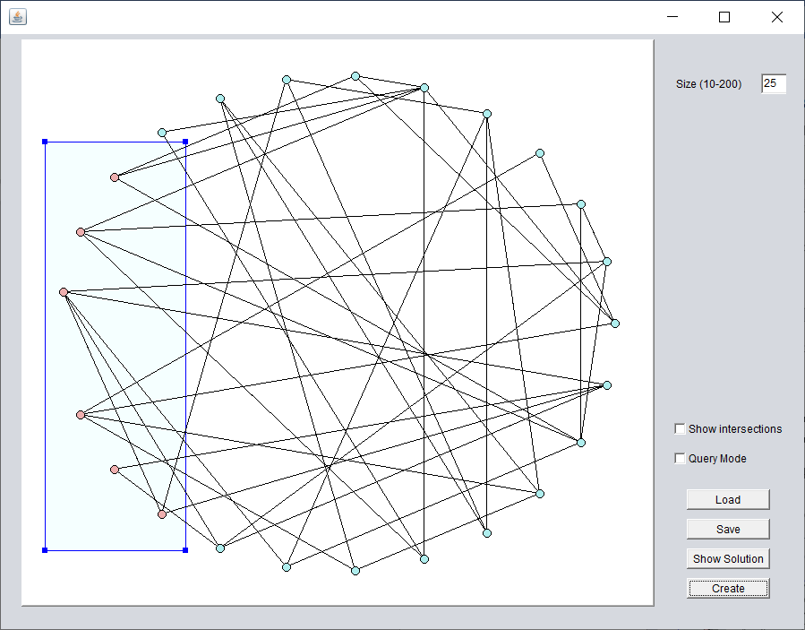

Example with area selected.

You can them click and drag any one of the 4 corners to move all points in the box.

This is useful particularly on larger puzzles for example if you have

* Started too close to an edge
* To make space to work (for example you may want to clear half the screen to work in)
* Of the points are too close or too far apart
* To reverse the orientation of a set of points

For example the same area above, after dragging the bottom left handle to the right of the bottom right handle, thus clearing space on the left

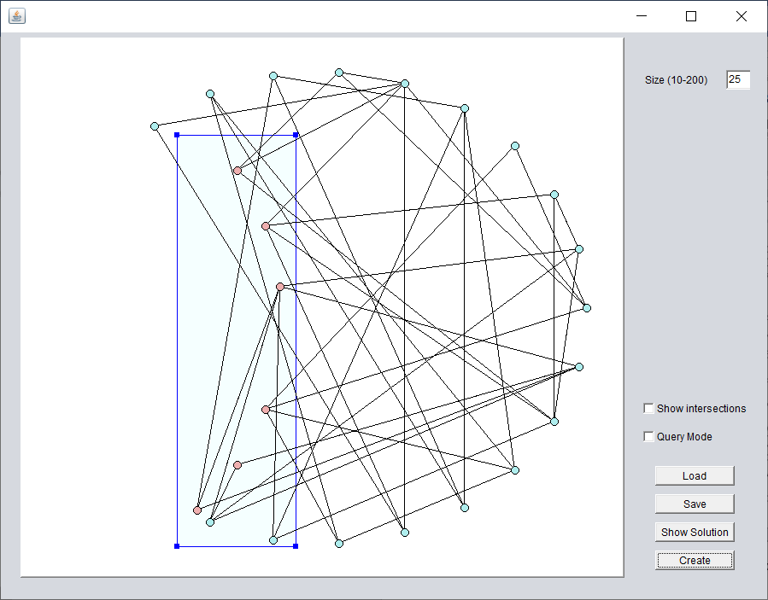

Untangle handle dragged

The show intersections check box will draw all lines which cross another line in red and will display a count of the total number of line cross-overs. Below is a partially solved 200 point puzzle with this option set.

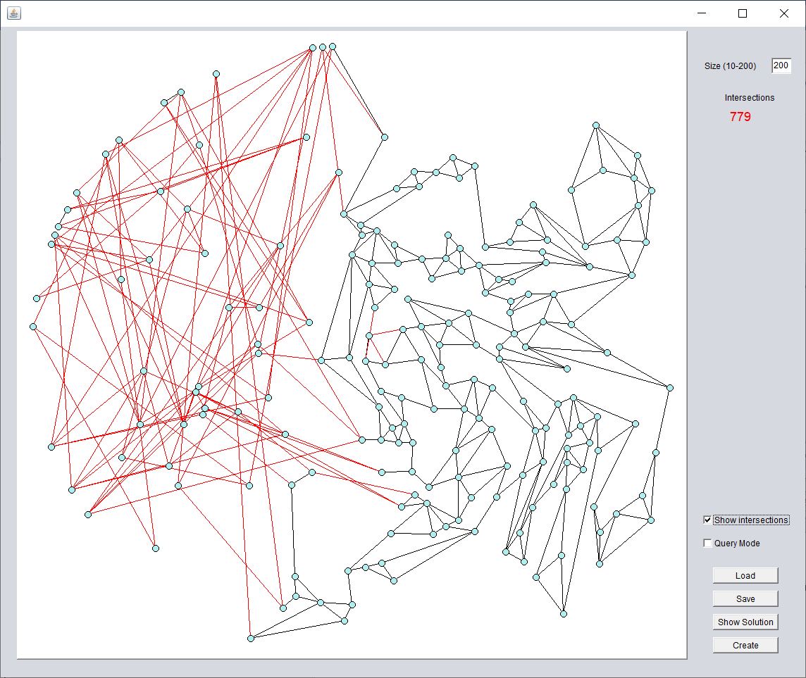

Partially solved grid with show intersections

The query mode is similar to show solution except that when you click a point, instead of dragging it will show the solution and highlight the point shown.

The Save and Load button allow you to save and load the state of the grid so you don’t have to do the whole puzzle in one sitting

When no lines intersect a congratulations message will be displayed and all the points will turn green.

The 2 screenshots on the next page show the a fully solved 200 point puzzle and the original grid

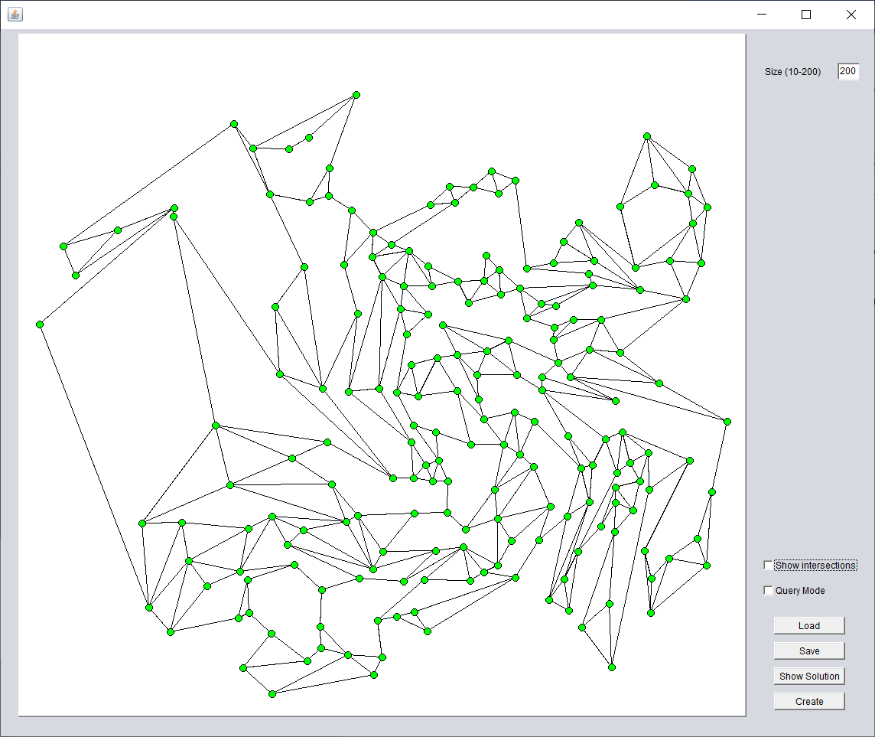

200-point puzzle (my solution)

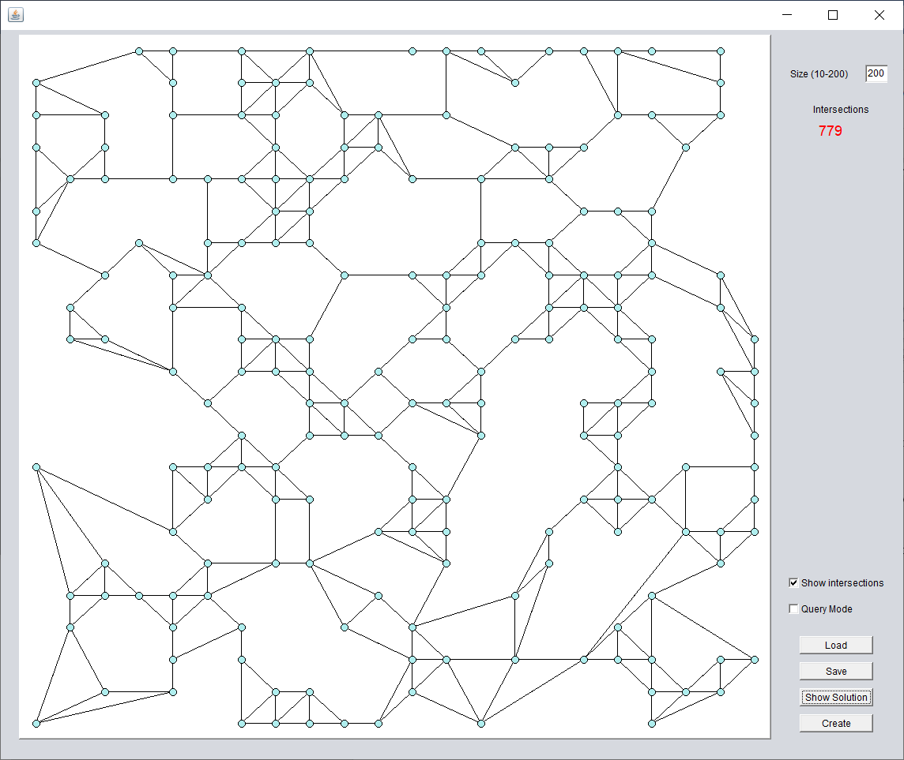

200-point puzzle (original grid)