**The Maze Java program**

The maze program generates a maze including a solution line and provides a 3D representation.

The 3D view requires JOGL (Java Open Graphics Library) to work, the 2D view is written is normal Java and will work without JOGL, but the 3D mode won’t work. Maze was built using the NetBeans 8.2 IDE.

**OpenGL License**

The OpenGL license states that the following disclaimer must be provided when the software is distributed.

THIS SOFTWARE IS PROVIDED BY THE COPYRIGHT HOLDERS AND CONTRIBUTORS "AS IS" AND ANY EXPRESS OR IMPLIED WARRANTIES, INCLUDING, BUT NOT LIMITED TO, THE IMPLIED WARRANTIES OF MERCHANTABILITY AND FITNESS FOR A PARTICULAR PURPOSE ARE DISCLAIMED. IN NO EVENT SHALL THE COPYRIGHT HOLDER OR CONTRIBUTORS BE LIABLE FOR ANY DIRECT, INDIRECT, INCIDENTAL, SPECIAL, EXEMPLARY, OR CONSEQUENTIAL DAMAGES (INCLUDING, BUT NOT LIMITED TO, PROCUREMENT OF SUBSTITUTE GOODS OR SERVICES; LOSS OF USE, DATA, OR PROFITS; OR BUSINESS INTERRUPTION) HOWEVER CAUSED AND ON ANY THEORY OF LIABILITY, WHETHER IN CONTRACT, STRICT LIABILITY, OR TORT (INCLUDING NEGLIGENCE OR OTHERWISE) ARISING IN ANY WAY OUT OF THE USE OF THIS SOFTWARE, EVEN IF ADVISED OF THE POSSIBILITY OF SUCH DAMAGE.

**Getting the JOGL libraries and building the application**

More information is about JOGL is available at <https://jogamp.org/>

The maze program was developed on Windows 10 on Netbeans, so the instructions below are for that OS. The instructions should be similar for other IDEs.

On Netbeans create an application called “Maze” and replace sources with the contents of the “src” directory with the sources provided. You will need to import the JOGL libraries.

To get the program working with JOGL, create a directory called "lib" in the same location as your JAR file and copy the required file into that directory. JOGL is cross platform, so should work with other systems. The libraries for all operating systems can be downloaded from:

<https://jogamp.org/deployment/jogamp-current/archive/jogamp-all-platforms.7z>

This is quite a large download and contains the libraries for all platforms. Open in 7-zip or similar and go to the jar directory and select the file for your OS

For Windows 10 the required Jar files are

* gluegen-rt.jar
* gluegen-rt-natives-windows-amd64.jar
* jogl-all.jar
* jogl-all-natives-windows-amd64.jar

In Netbeans, right-click on the Libraries directory and select Add Jar, for each of the 4 files above.

You should now be able to build and run Maze.

To run outside of Netbeans, create as a JAR file. Copy the jar and create a “lib” directory in the same location, copying the 4 files above to the “lib” directory.

I have included the pre-built jar file and lib directory for Windows, to make it faster to try the program without building.

**Running the program**

You should be ready to start up the program.

To create your first maze simply select the "Rectangular" or "Circular", select the width/height (or layers/radials) for circular and press Create.

The algorithm used to generate the maze will always generate a maze with a unique solution. Click the "Show Solution" check box to see the solution path as a red line.

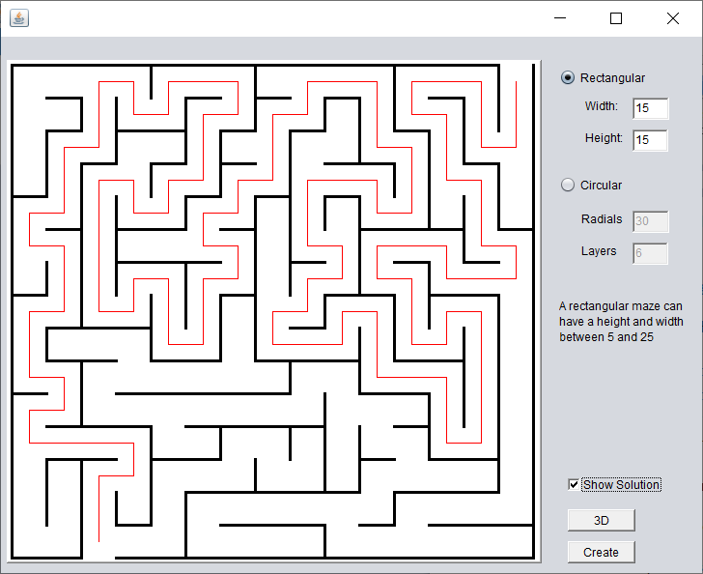

Example 15x15 rectangular maze with solution

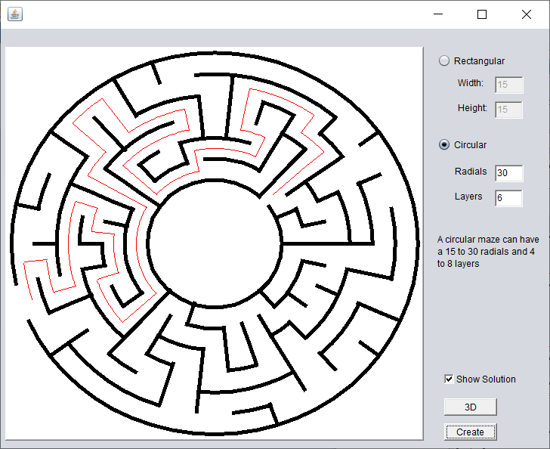

Example circular 30 radial x 6 layer maze with solution

**Navigating the Maze**

You will see when you have generated the maze the "3D" button will be enabled. If you press the button (and JOGL is available), the program will generate a 3D version of the maze and place you at the entrance. For the rectangular maze, the entrance is at the bottom, for a circular maze the entrance is the centre.

You can now use the "Up" cursor key to move forward, "Left" and "Right" cursor keys to move left and right.

If you are stuck, you can use the "Show me the way to go home" check box, which will show a green line from your current position to the exit. Note: If you do not see the line immediately, you are probably heading in the wrong direction, just turn until the line is visible.

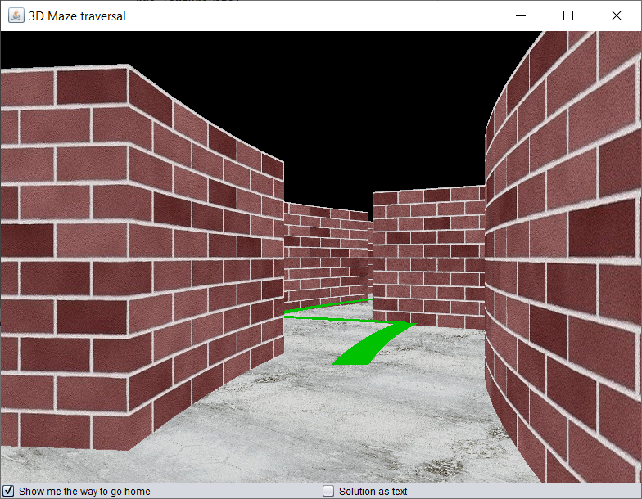

Example 3D view (circular) with solution line

If you check the “Solution as text” checkbox as well the instructions appear as text e.g. “Turn Left” or “Go Forward” in the bottom left corner of the display view.

On completion you will get a "Congratulations" pop up and the view will move to a view of the maze from above.

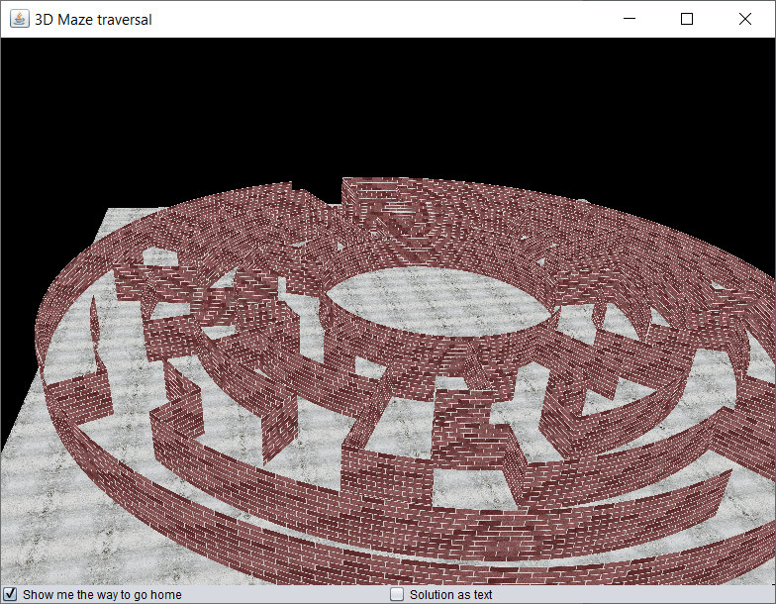

Example view on completion