Settings > Compiler… > Custom variables

Add a variable named ‘libs4mingw’

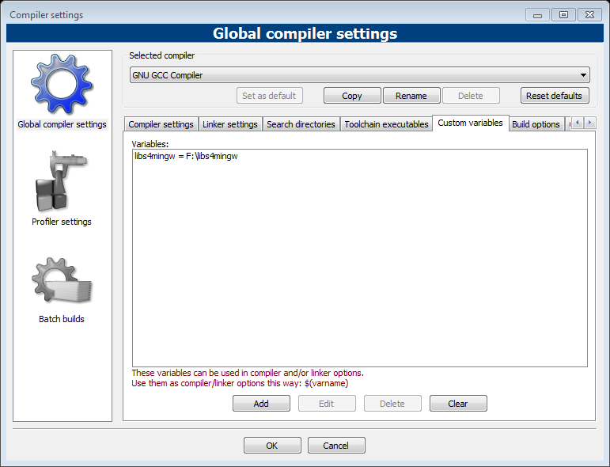

You can check below settings.

Project > Build options… > Search directories

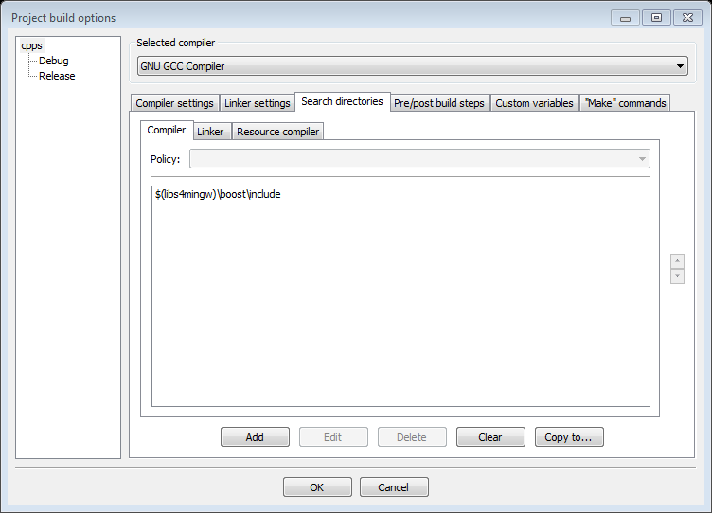

Debug

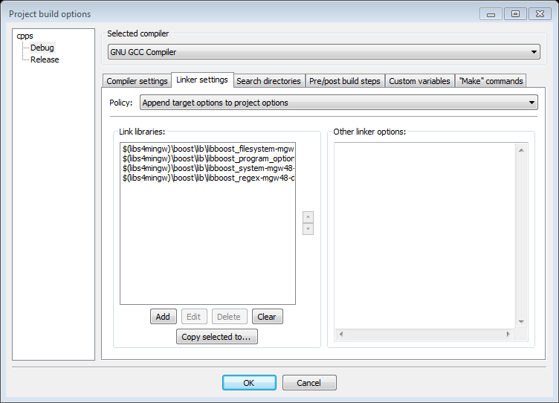

Release

