Part 2:

1.

2.

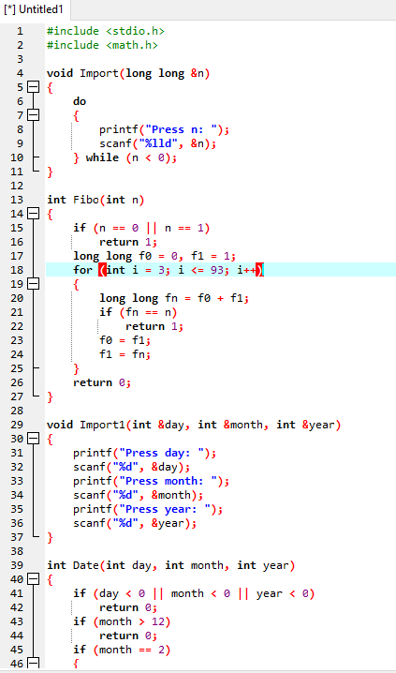

Part 1:

1.

a)

b)

c)

2.

a)

b)

