**Software Design Documentation**

**Software Title:** Refund Portal

**Current Date:** 19th May 2021

**Authors:**

* James
* Awais
* Joshua
* Ahmed

**Functional Description & Overview**

Create a refund portal where it makes it much easier for staff and students to handle refunds, where it is on the student to fill in the form. With interface where the staff can see and handle requests.

## Software Design Considerations

### **Assumptions**

* Link to refund portal will be sent to student by staff
* Email to say that application has been received send automatically after form is submitted and accepted.
* We won’t have access to the university database, and will have to use our own schema

### **Dependencies**

* Node JS
* Express
* SQL
* EJS

### **Constraints**

### **General Guidelines**

* Use forms for handling data
* Designs to be ‘signed off’ before coding
* Provisional documentation to be all completed before coding
* Use Aria markup for accessibility
* Error messages be short and simple

### **Objectives**

* Student can submit refund application
* Student is sent email automatically saying that application has been received
* Staff can review applications using interface
* Staff can accept or deny refund requests
* Email is sent to staff letting them know that there are requests to review

### **Methodology**

## User Interface

**Form:**

Examples of refund portals we found:

<https://firstgroup-refunds.fastrailticketing.com/>

<https://transpennineexpress-refunds.fastrailticketing.com/?station=Grimsby%20Town&smartcard=no>

Might be good to look at, maybe it would be good to adapt from this.

**Interface:** 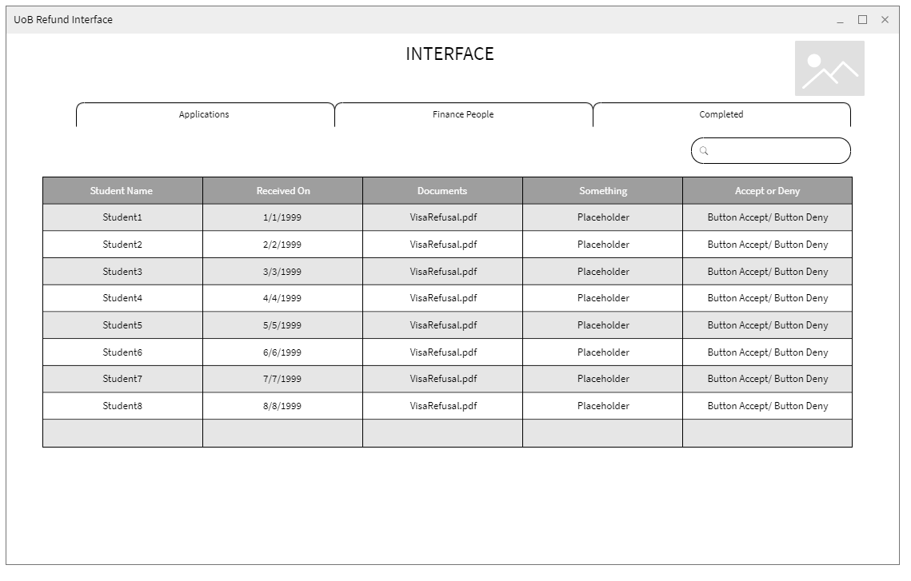

## System Architecture

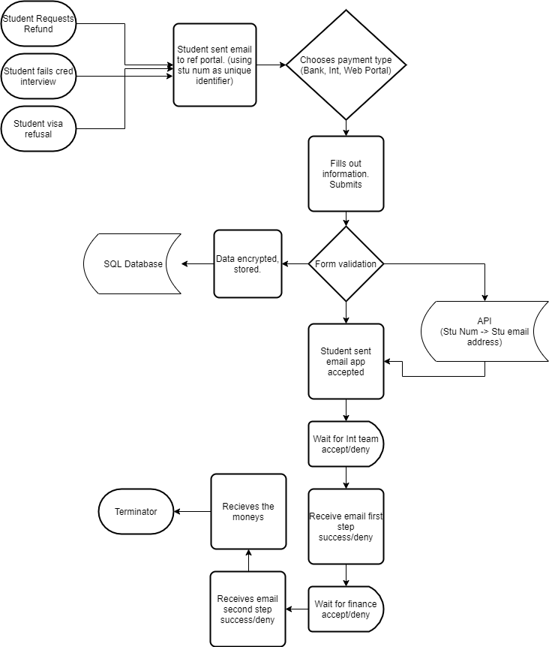

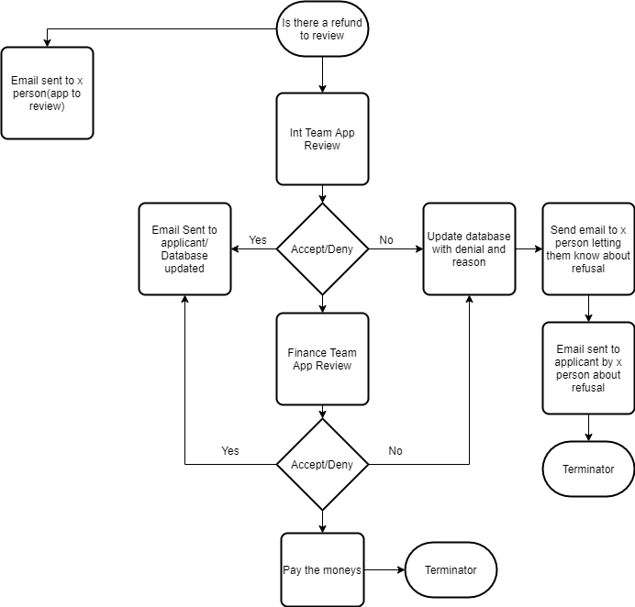

## Glossary

Define jargon, terms and concepts as necessary and depending on who will be reading your document.

## Additional Comments, Documents or Information

Enclose any key information that was not accounted for in your software design document so far. Feel free to add media, documents, links, videos and the like.