Abstract preparation guidelines for Grandmaster 2023
(Bold, 12 point, Arial)

A. Author,¹ P. Presenting,² and C. Corresponding*² (11 point, Arial)
¹ Department, University, City, Country
² Research Center, City, Country
(10 point, Italic, Arial)
*corresponding author: name@institute.com (10 point, Arial)

Following this template, one-page abstract should be prepared in A4-size with 3 and 2.5 cm margins at top and bottom, respectively, and 2 cm margins on both sides. The abstract must include the title of the paper, name of the author(s), affiliation(s), address(es) and e-mail address of the corresponding author. Underline the presenting author. Place a blank line between the title and author(s). The main text should be typed with single-spaced and 11-point Arial font. References should be at the end of the abstract. When referring to them in the text, the reference number should be indicated by brackets [1]. Abstracts can be submitted on the homepage in Word doc format with the file size less than 1 MB. The deadline of the submission is June 30, 2023.
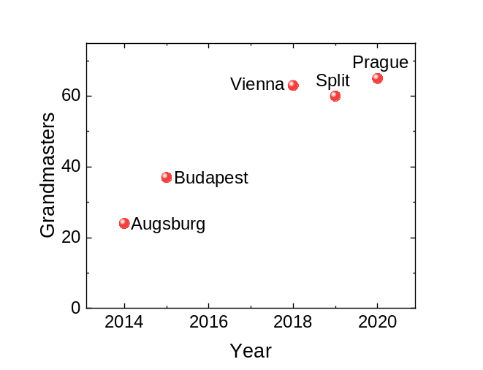Fig.1. Number of participants of the previous workshops. At maximum one figure of 7 cm width can be placed in the abstract with a short caption. (10 point, Arial)

[1] A. Author, B. Author, and C. Author, Phys. Rev. B 104, 100001 (2022).

