Data Mining Lab-1
MohitKumar-23IT3028

Question-1:
Code:

records=[45, 52, 48, 55, 60, 58, 62, 65, 70, 68, 72, 150]
n=len(records)
mean=0
for i in range(len(records)):
mean=mean+records[i]

print("mean:",mean/len(records))

#2nd task for median
median=0

records.sort()
if(len(records)%2==0):
#means our array has even number of records
median = (records[n//2 - 1] + records[n//2]) / 2
else:
median = records[n//2]
print(f"Median: {median}")

#task 3 is for mode calculation

from collections import Counter
mode_data = Counter(records)
mode = mode_data.most_common(1)
if mode and mode[0][1] > 1:
print(f"Mode: {mode[0][0]}")
else:
print("No mode")

#code for range

range_val = max(records) - min(records)
print(f"Range: {range_val}")

#calcuation for variance:
variance = sum((x - mean) ** 2 for x in records) / len(records)
print(f"Variance: {variance:.2f}")

#calcualtion for standard deviation

import math
std_dev = math.sqrt(variance)
print(f"Standard Deviation: {std_dev:.2f}")

sorted_rec=records.sort()

sorted_sales = sorted(records)
#calculation for IQ:
q1 = sorted_sales[int((n+1)*0.25) - 1] if (n+1)*0.25 % 1 == 0 else (sorted_sales[int((n+1)*0.25) - 1] + sorted_sales[int((n+1)*0.25)]) / 2
q3 = sorted_sales[int((n+1)*0.75) - 1] if (n+1)*0.75 % 1 == 0 else (sorted_sales[int((n+1)*0.75) - 1] + sorted_sales[int((n+1)*0.75)]) / 2
iqr = q3 - q1
print(f"IQR: {iqr}")

Output:
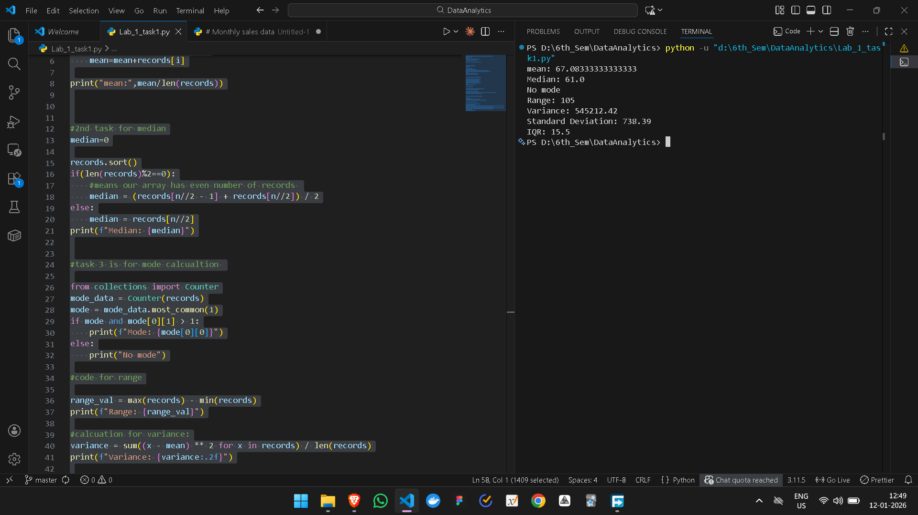

Question-2:

hours = [2, 3, 5, 7, 9, 11, 12, 15]
scores = [55, 60, 68, 75, 80, 85, 88, 92]

n = len(hours)

mean_hours = sum(hours) / n
mean_scores = sum(scores) / n

covariance = sum((hours[i] - mean_hours) * (scores[i] - mean_scores) for i in range(n)) / n
print(f"Covariance: {covariance:.2f}")

var_hours = sum((x - mean_hours) ** 2 for x in hours) / n
var_scores = sum((y - mean_scores) ** 2 for y in scores) / n
import math
std_hours = math.sqrt(var_hours)
std_scores = math.sqrt(var_scores)
pearson = covariance / (std_hours * std_scores)
print(f"Pearson correlation: {pearson:.2f}")

Output:
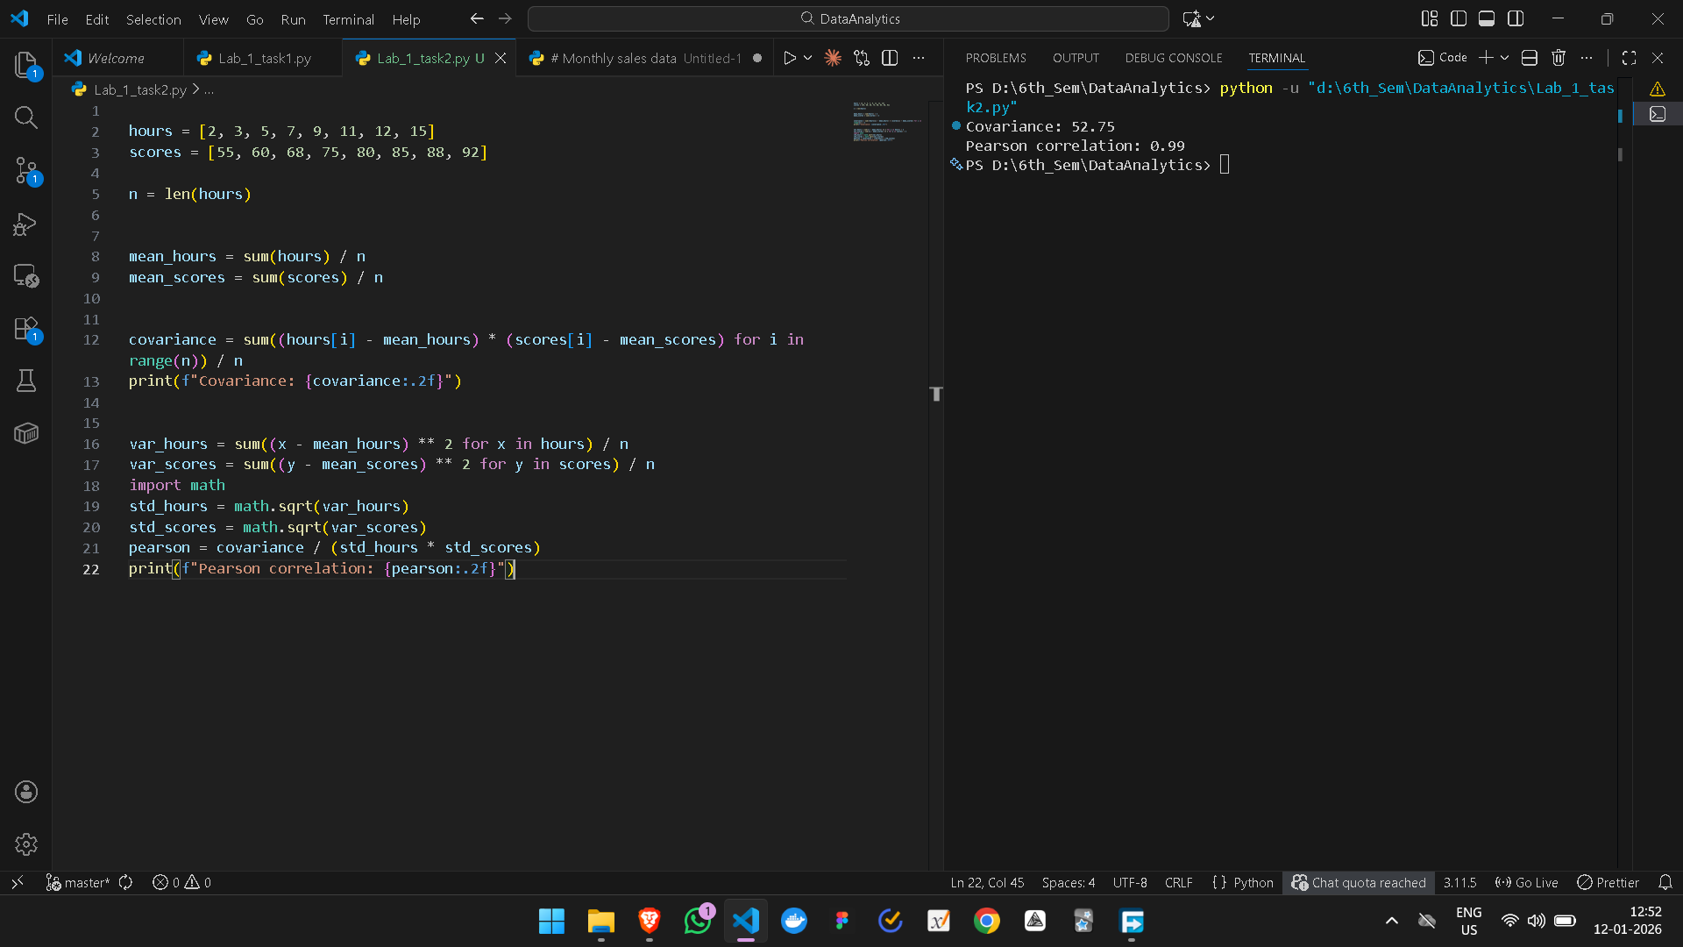

Question3:
import matplotlib.pyplot as plt

sales = [45, 52, 48, 55, 60, 58, 62, 65, 70, 68, 72, 150]

plt.figure(figsize=(10, 6))
plt.hist(sales, bins=10, edgecolor='black', color='skyblue')

plt.title('Histogram of Monthly Sales (in $1000)', fontsize=14, fontweight='bold')
plt.xlabel('Monthly Sales ($1000)', fontsize=12)
plt.ylabel('Number of Months (Frequency)', fontsize=12)
plt.grid(True, alpha=0.3, linestyle='--')

plt.show()

Output:
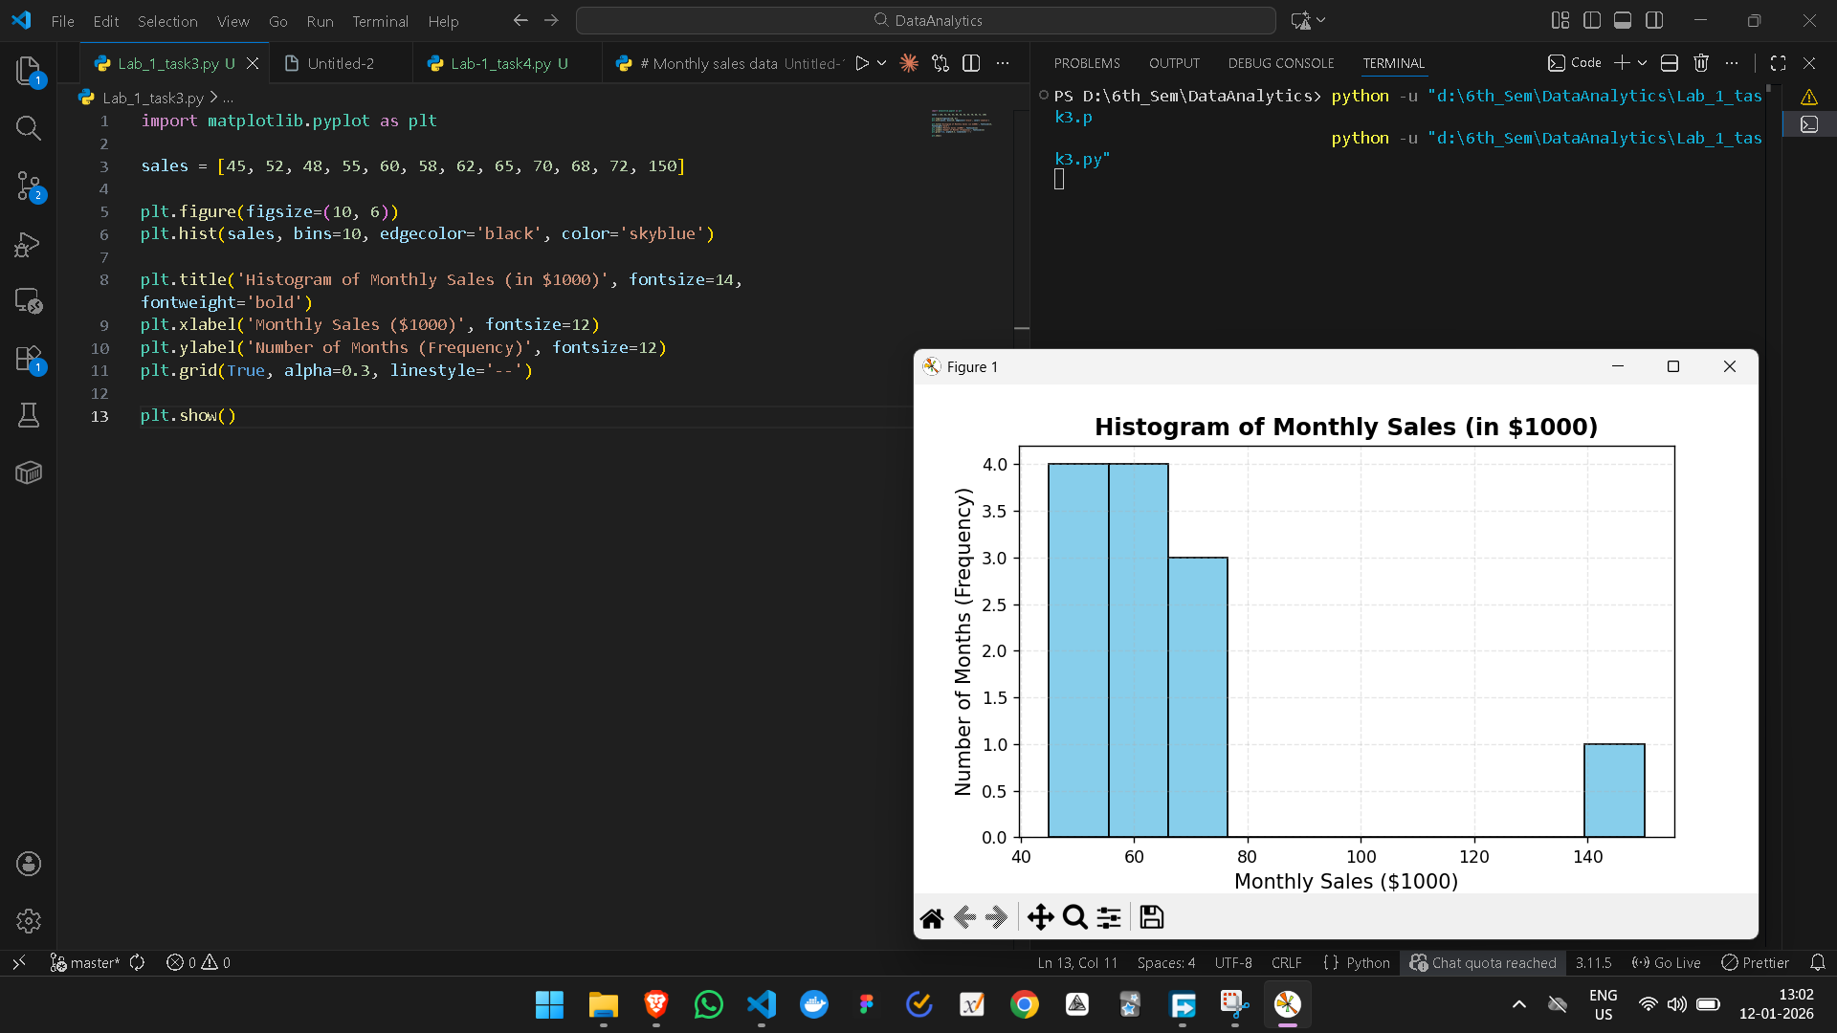
Question-4:
Code:
import matplotlib.pyplot as plt

sizes = [1500, 1800, 1200, 2200, 1400, 2000, 1700, 1300, 1900, 1600]
prices = [300000, 350000, 250000, 450000, 280000, 400000, 320000, 260000, 380000, 310000]

plt.figure(figsize=(10, 6))
plt.scatter(sizes, prices, color='teal', s=100, alpha=0.7)

plt.title('Relationship between House Size and Price', fontsize=14, fontweight='bold')
plt.xlabel('House Size (square feet)', fontsize=12)
plt.ylabel('House Price ($)', fontsize=12)
plt.grid(True, alpha=0.3)

plt.show()

Output:
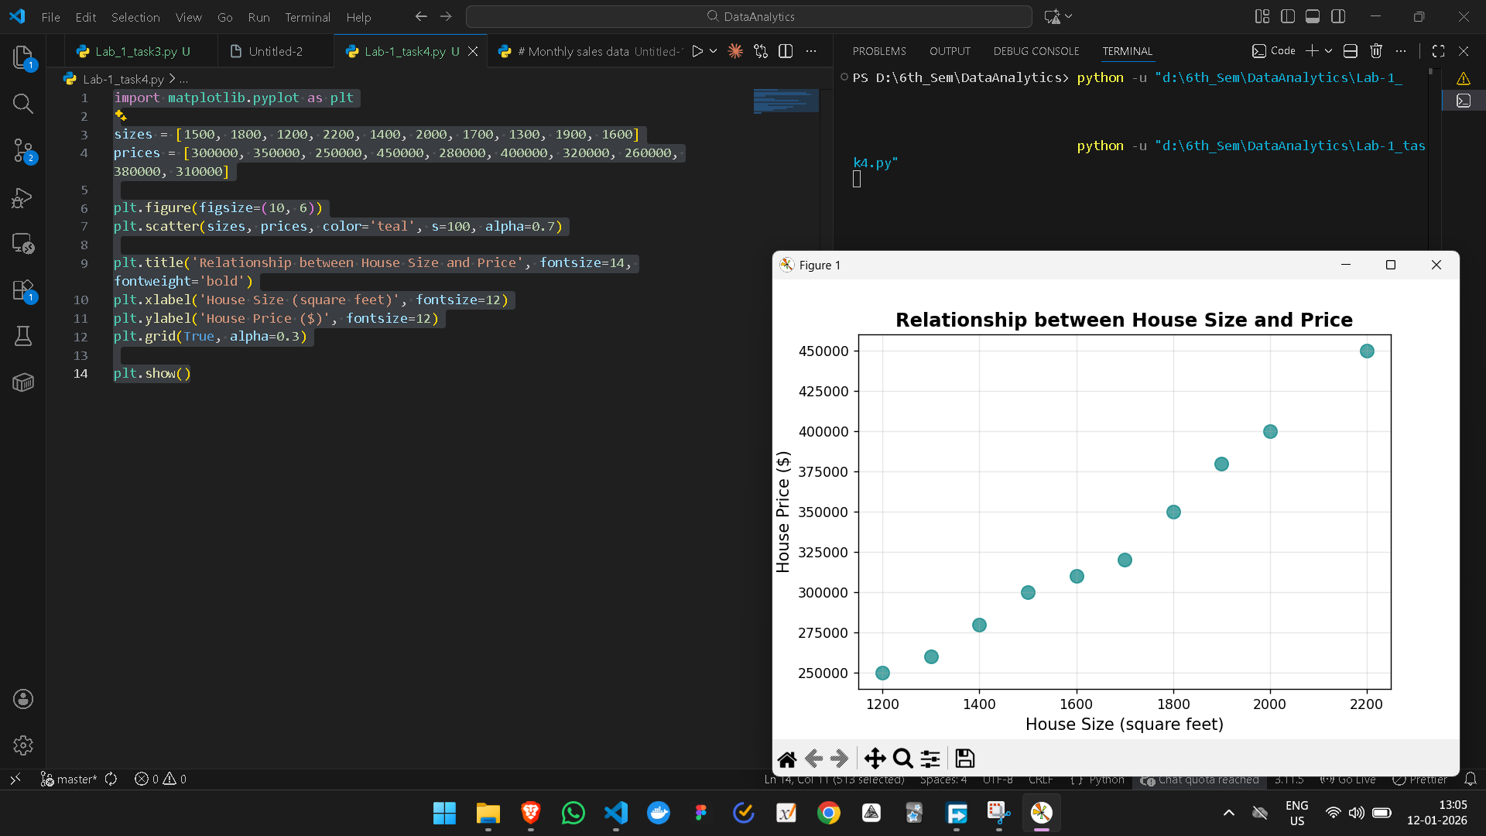

Question-5:
Code:
import matplotlib.pyplot as plt

stores = ['A', 'B', 'C', 'D', 'E', 'F']
total_sales = [177.3, 207.6, 156.0, 231.1, 192.2, 171.0]

plt.figure(figsize=(10, 6))
bars = plt.bar(stores, total_sales, color='cornflowerblue')

plt.title('Total Weekly Sales by Store (in $1000)', fontsize=14, fontweight='bold')
plt.xlabel('Store', fontsize=12)
plt.ylabel('Total Sales ($1000)', fontsize=12)
plt.grid(axis='y', alpha=0.3)

# Add value labels on top of bars
for bar in bars:
yval = bar.get_height()
plt.text(bar.get_x() + bar.get_width()/2, yval + 2, f'{yval:.1f}', ha='center')

plt.show()

Output:
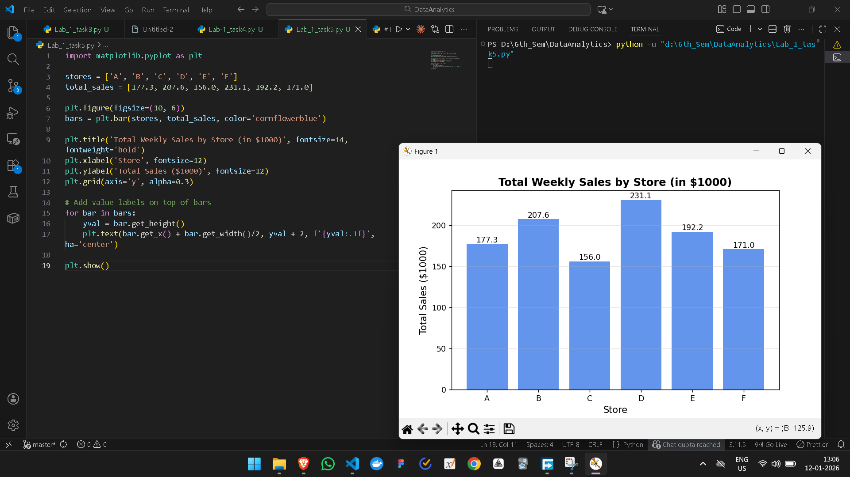
Question-5-b:
Code:
import matplotlib.pyplot as plt
import numpy as np

stores = ['A', 'B', 'C', 'D', 'E', 'F']
wed_sales = [18.5, 22.1, 16.9, 24.8, 20.2, 18.3]
sat_sales = [45.8, 52.1, 39.5, 58.3, 48.7, 42.9]

x = np.arange(len(stores))
width = 0.35

fig, ax = plt.subplots(figsize=(11, 6))
ax.bar(x - width/2, wed_sales, width, label='Wednesday', color='mediumseagreen')
ax.bar(x + width/2, sat_sales, width, label='Saturday', color='tomato')

ax.set_title('Wednesday vs Saturday Sales Comparison Across Stores', fontsize=14, fontweight='bold')
ax.set_xlabel('Store', fontsize=12)
ax.set_ylabel('Sales ($1000)', fontsize=12)
ax.set_xticks(x)
ax.set_xticklabels(stores)
ax.legend(title='Day of Week')
ax.grid(axis='y', alpha=0.3)

plt.tight_layout()
plt.show()

Output:
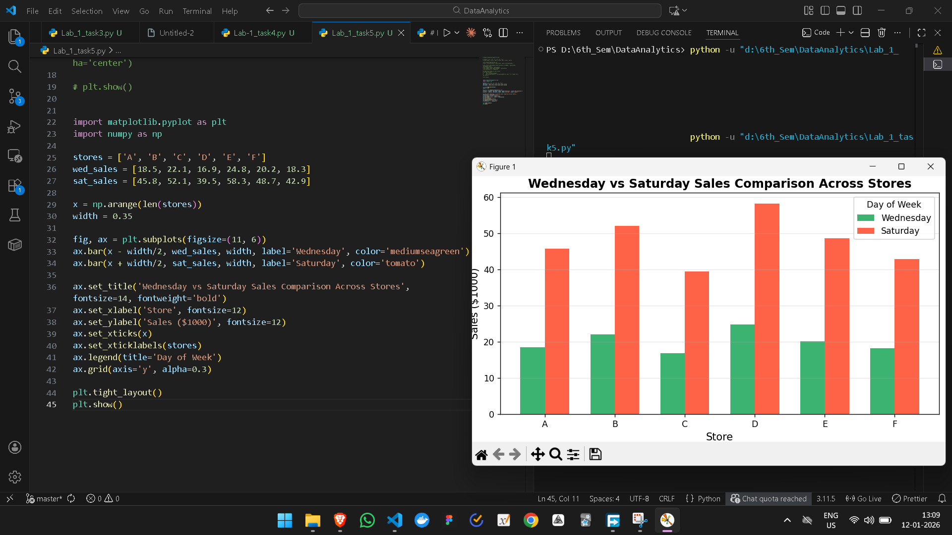

Question-5-c:
Code:
import matplotlib.pyplot as plt
import numpy as np

stores = ['A', 'B', 'C', 'D', 'E', 'F']
wed_sales = [18.5, 22.1, 16.9, 24.8, 20.2, 18.3]
sat_sales = [45.8, 52.1, 39.5, 58.3, 48.7, 42.9]

x = np.arange(len(stores))
width = 0.35

fig, ax = plt.subplots(figsize=(11, 6))
ax.bar(x - width/2, wed_sales, width, label='Wednesday', color='mediumseagreen')
ax.bar(x + width/2, sat_sales, width, label='Saturday', color='tomato')

ax.set_title('Wednesday vs Saturday Sales Comparison Across Stores', fontsize=14, fontweight='bold')
ax.set_xlabel('Store', fontsize=12)
ax.set_ylabel('Sales ($1000)', fontsize=12)
ax.set_xticks(x)
ax.set_xticklabels(stores)
ax.legend(title='Day of Week')
ax.grid(axis='y', alpha=0.3)

plt.tight_layout()
plt.show()

import matplotlib.pyplot as plt
import numpy as np

categories = ['Grocery', 'Dairy', 'Meat & Poultry', 'Bakery', 'Beverages', 'Others']
store_a = [35, 20, 15, 12, 10, 8]
store_b = [32, 22, 16, 14, 9, 7]
store_c = [38, 18, 14, 13, 11, 6]

x = np.arange(3)
bottom = np.zeros(3)

fig, ax = plt.subplots(figsize=(10, 7))

colors = ['#4e79a7', '#f28e2b', '#e15759', '#76b7b2', '#59a14f', '#edc948']

for i, cat in enumerate(categories):
ax.bar(x, [store_a[i], store_b[i], store_c[i]], bottom=bottom, label=cat, color=colors[i])
bottom += [store_a[i], store_b[i], store_c[i]]

ax.set_title('Product Category Distribution by Store (Percentage)', fontsize=14, fontweight='bold')
ax.set_ylabel('Percentage of Total Sales (%)', fontsize=12)
ax.set_xticks(x)
ax.set_xticklabels(['Store A', 'Store B', 'Store C'], fontsize=11)
ax.legend(title='Category', bbox_to_anchor=(1.02, 1), loc='upper left')

plt.tight_layout()
plt.show()

Output:
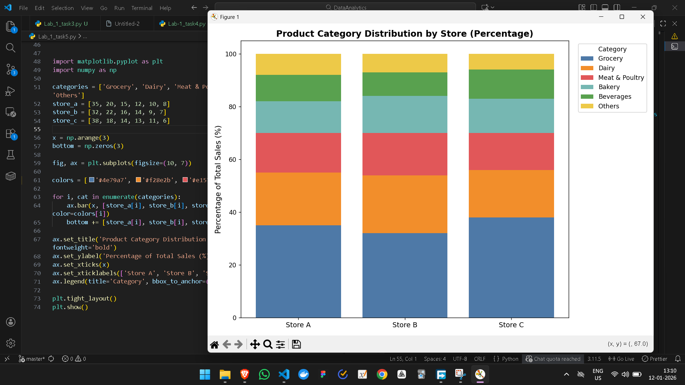

Question-6:
Code:
import matplotlib.pyplot as plt

platforms = ['TikTok', 'Instagram', 'YouTube', 'Facebook', 'Twitter/X', 'Others']
percentages = [32, 28, 22, 10, 5, 3]
colors = ['#ff0050', '#e1306c', '#ff0000', '#1877f2', '#1da1f2', '#aaaaaa']

plt.figure(figsize=(6, 6))
plt.pie(percentages, labels=platforms, autopct='%2.5f%%', startangle=90, colors=colors, shadow=True)

plt.title('Market Share of Social Media Platforms\n(Among 1,000 Internet Users Aged 18–35)', fontsize=10, fontweight='bold')
plt.axis('equal')

plt.show()

Output:
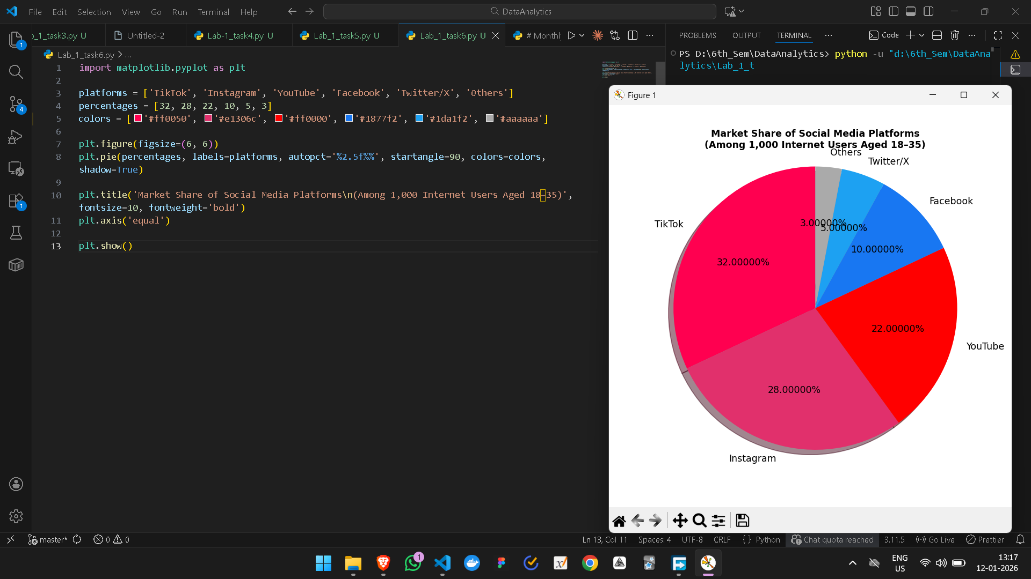

Question-6-b:
Code:
import matplotlib.pyplot as plt

activities = ['Watching Videos', 'Creating Content', 'Messaging', 'Shopping']
percentages = [60.2, 23.1, 11.1, 5.6]
colors = ['#ff6b6b', '#4ecdc4', '#45b7d1', '#96c93d']

fig, ax = plt.subplots(figsize=(9, 9))

wedges, texts, autotexts = ax.pie(percentages, labels=activities, autopct='%1.1f%%',
startangle=90, colors=colors, pctdistance=0.85)

centre_circle = plt.Circle((0, 0), 0.70, fc='white')
fig.gca().add_artist(centre_circle)

plt.title('How Typical TikTok Users Spend Their Daily Time\n(108 minutes total per day)', fontsize=14, fontweight='bold')
plt.axis('equal')

plt.show()

Output:
