MPC-MAP Assignment No. X - Report

Author: Matej Mikula

Date: 29/03/2026

Task 1

Lorem ipsum dolor sit amet, consectetur adipiscing elit. Pellentesque faucibus, mi eu pellentesque venenatis, ligula leo tincidunt mauris, in tempus lectus erat eget purus. Fusce quis urna dolor. Phasellus tristique felis justo, vel consectetur magna luctus a. Nulla pharetra magna non pellentesque vestibulum.

Task 2

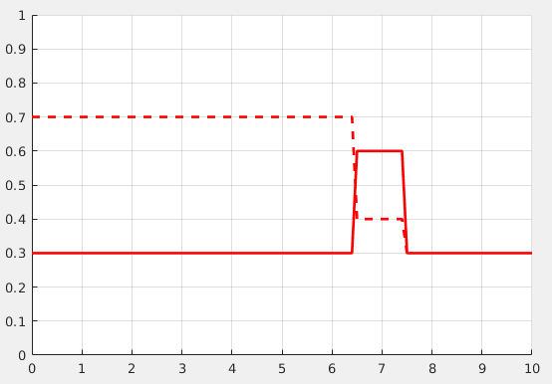
Lorem ipsum dolor sit amet, consectetur adipiscing elit. Pellentesque faucibus, mi eu pellentesque venenatis, ligula leo tincidunt mauris, in tempus lectus erat eget purus. Fusce quis urna dolor. Phasellus tristique felis justo, vel consectetur magna luctus a. Nulla pharetra magna non pellentesque vestibulum.
Figure 1 - Lorem Ipsum

Task 3

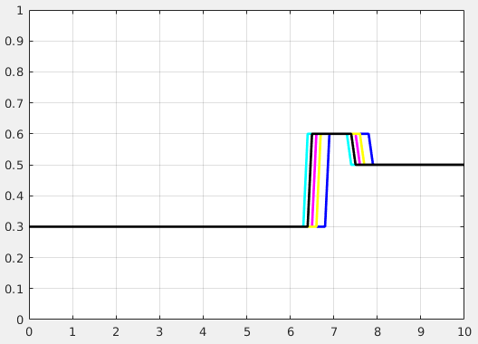
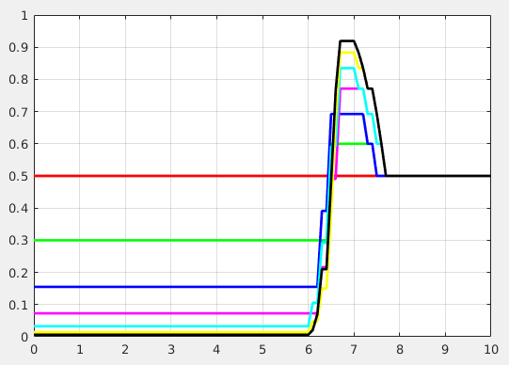
Lorem ipsum dolor sit amet, consectetur adipiscing elit. Pellentesque faucibus, mi eu pellentesque venenatis, ligula leo tincidunt mauris, in tempus lectus erat eget purus. Fusce quis urna dolor. Phasellus tristique felis justo, vel consectetur magna luctus a. Nulla pharetra magna non pellentesque ve
Figure 2 - Lorem Ipsum

Task 4

Lorem ipsum dolor sit amet, consectetur adipiscing elit. Pellentesque faucibus, mi eu pellentesque venenatis, ligula leo tincidunt mauris, in tempus lectus erat eget purus. Fusce quis urna dolor. Phasellus tristique felis justo, vel consectetur magna luctus a. Nulla pharetra magna non pellentesque vestibulum.
Figure 1 - Lorem Ipsum

Task 5

Pri pohybe robota riadeného len na základe časových intervalov je možno pozorovať neopakovatelnosť trajektórie pohybu. Dosiahnutie cieľu je do značnej miery náhodné.
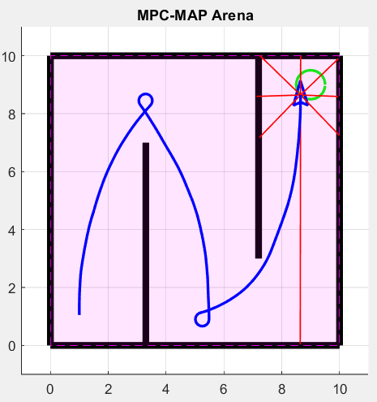

Figure 1 - Lorem Ipsum

