Business Analysis

This system is used by:

- The administrator which introduces and updates information about the ads notes

- The users that access the system in order to post ads notes

Every user needs to create an account in order to access the website. There are 2 types of account: basic (for people who intent to post ads notes) and premium .

Users with basic account can buy an upgrade which consists of being able to share their ads notes. Sharing a note consists of adding other users as friends using their account name and then giving them access to see the notes that you shared. When creating a note the user can choose a name for its ad, upload pictures and add description.Also the user can duplicate a note ,edit and delete it. Then they can put all their posted notes in a notebook and search a note using a tag.

The actor is the Client and the agent is the Admin.

Business Rules:

- Every user needs to create an account in order to access the website

-We have 2 types of accounts:basic (for people who intent to post ads notes) and premium (for people which shares the notes).

-User can upgrade their basic account with the premium.

- only users with premium account can share notes

***Business Use Case Diagram***

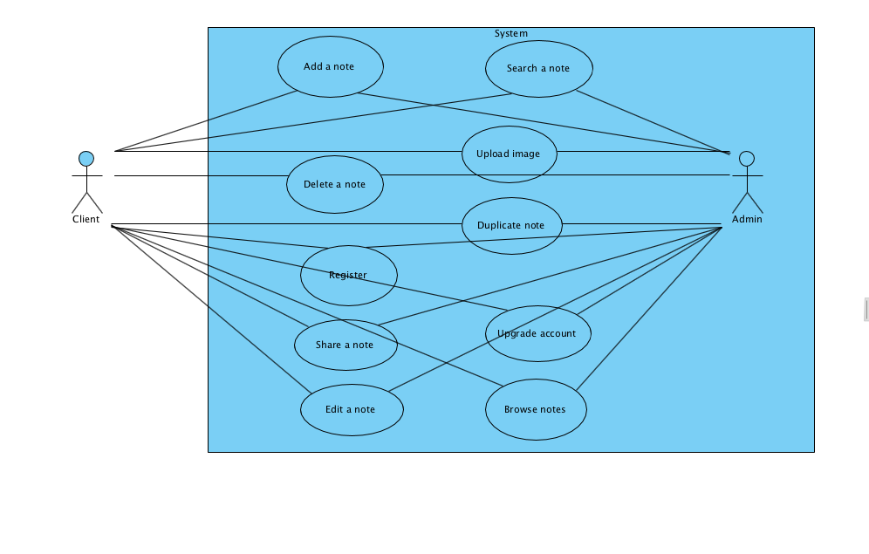

***Activity Diagrams***

1. Add a note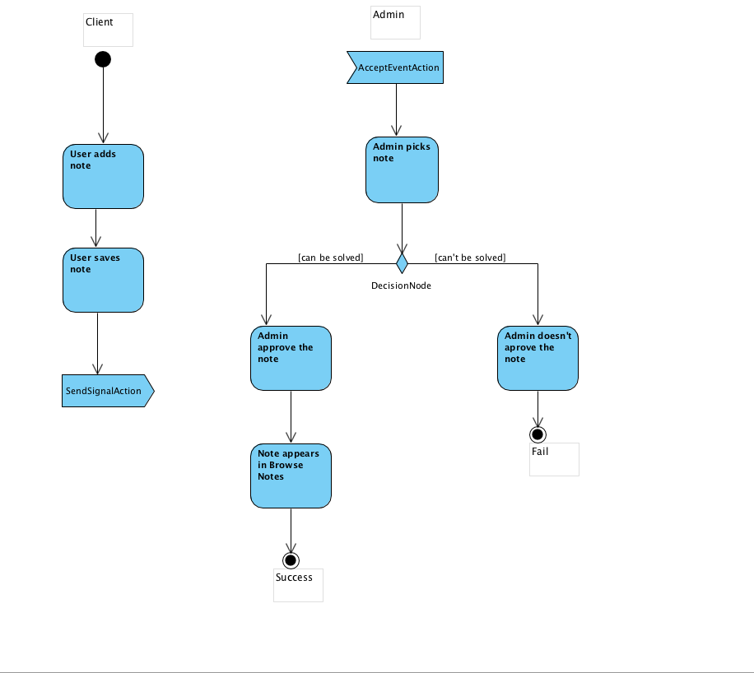
2. Delete note

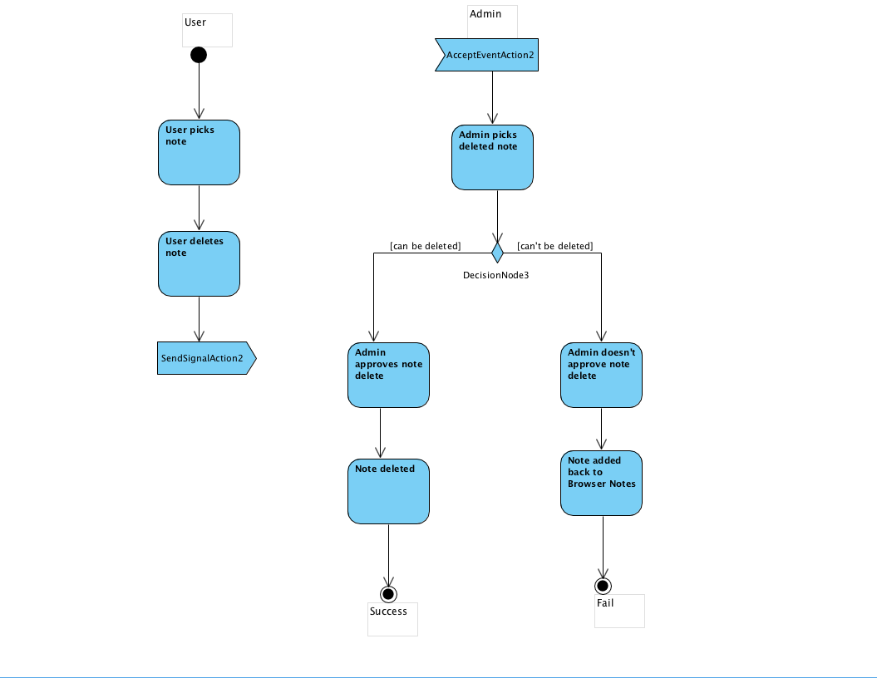

1. Register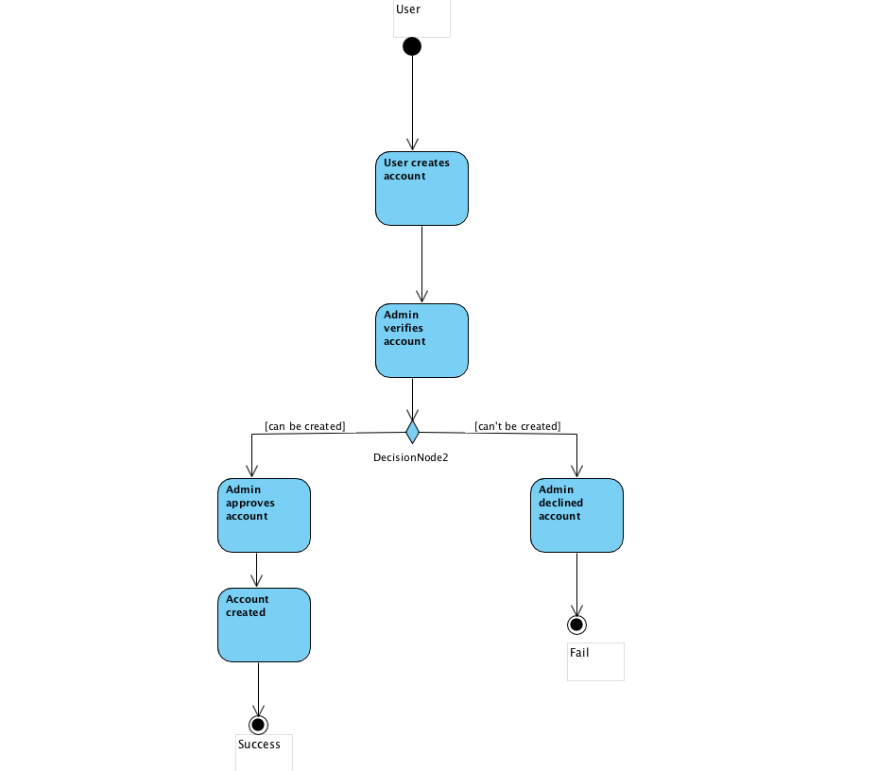
2. Share a note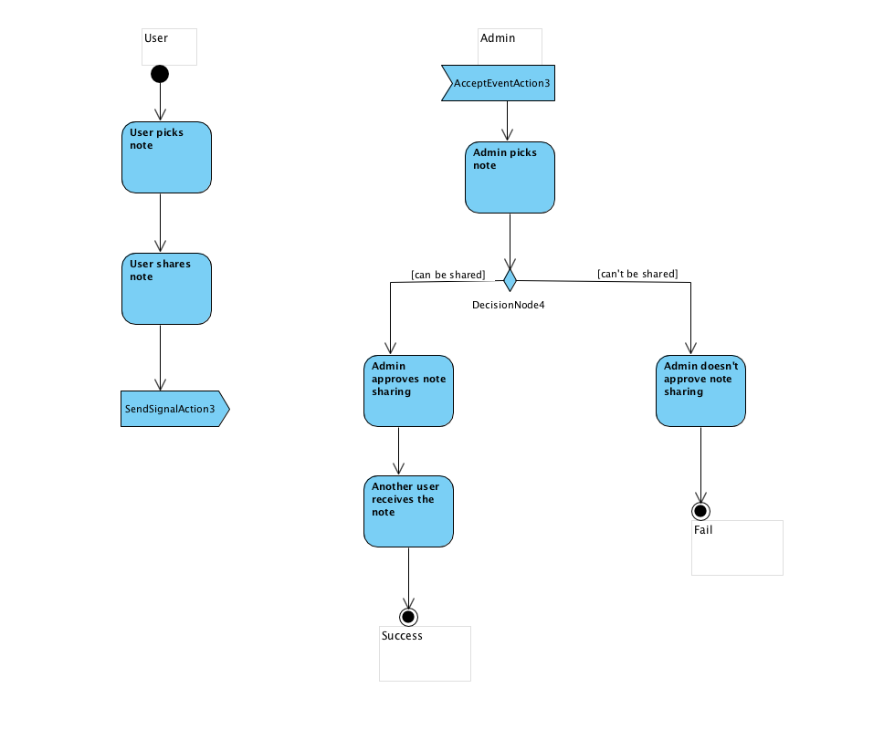
3. Edit note

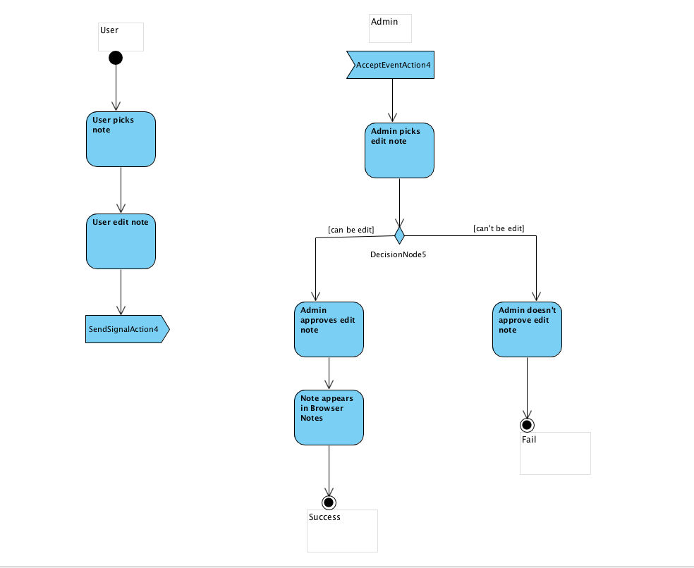

1. Search a note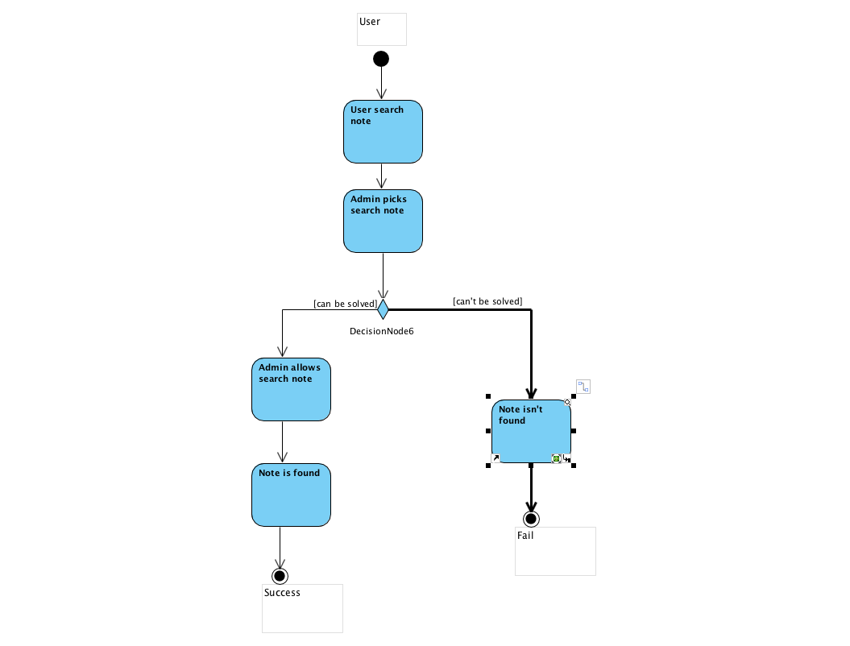
2. Upload image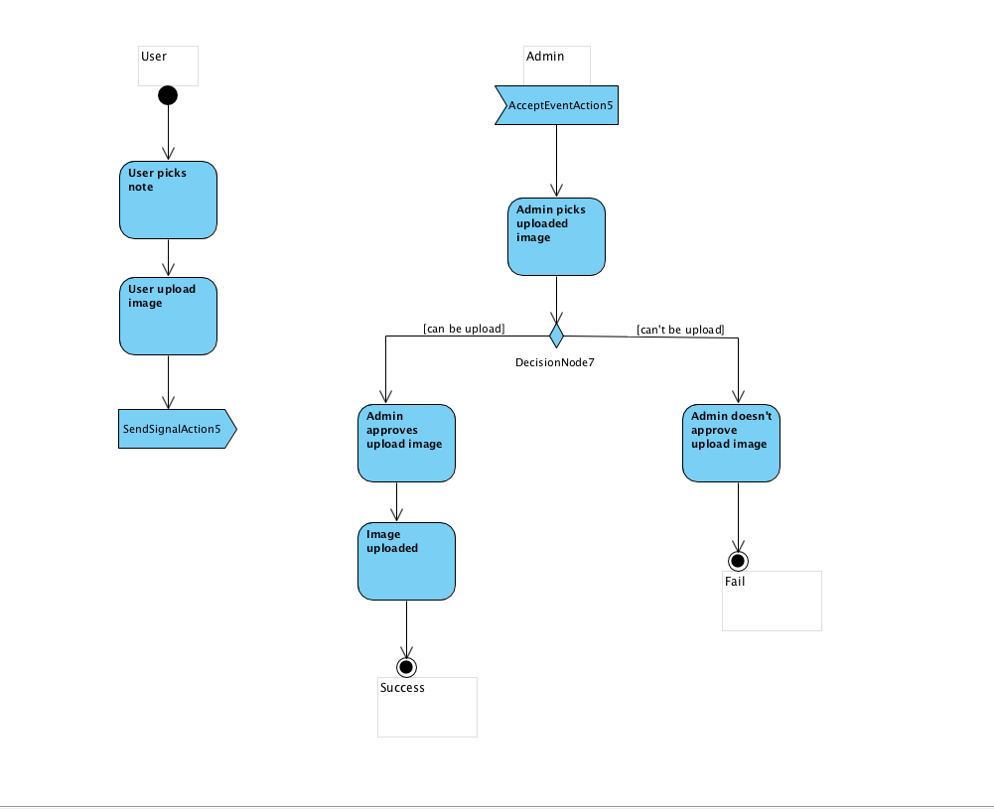
3. Duplicate note

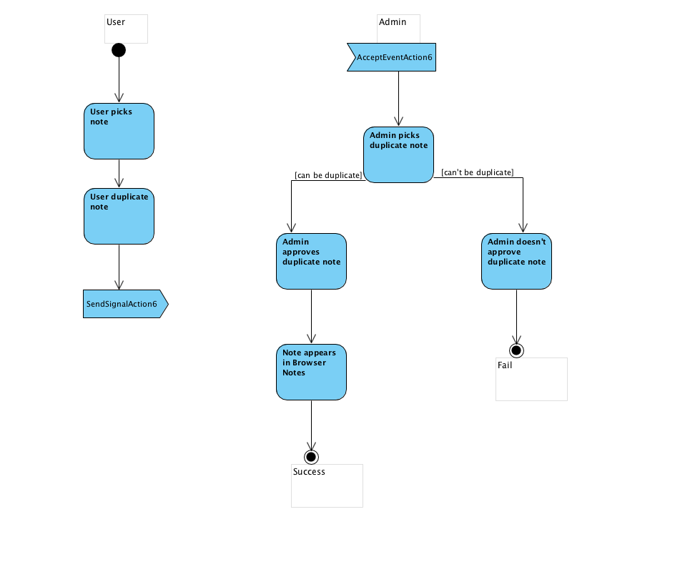

1. Upgrade account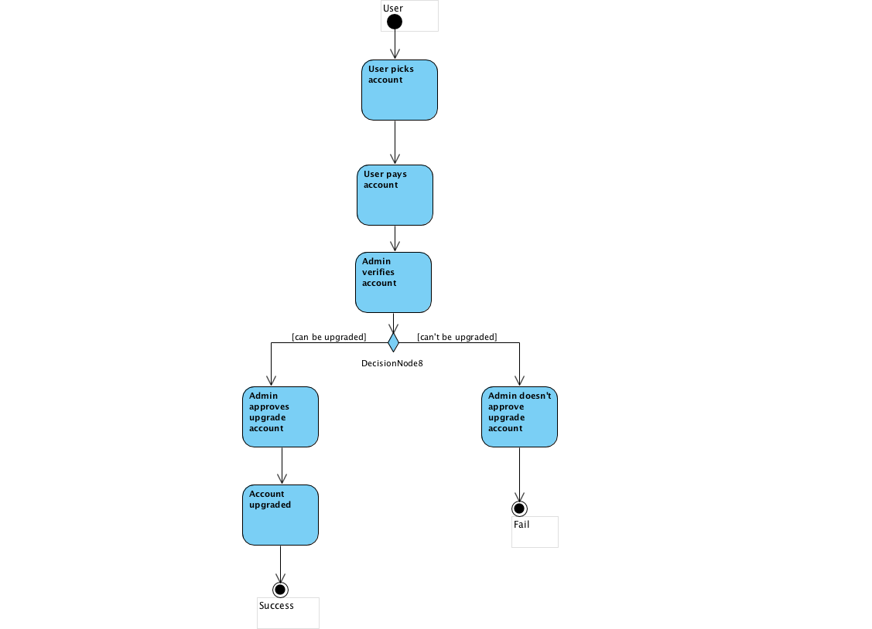
2. Browse notes

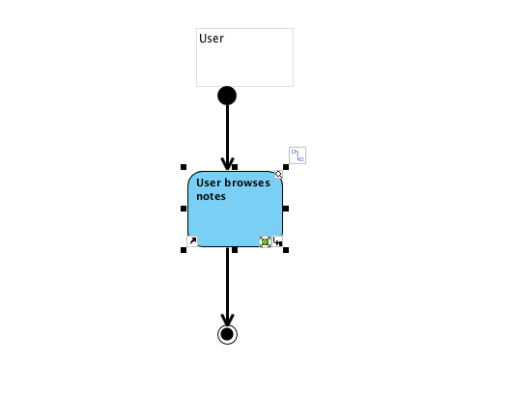

**Domain model Diagram**

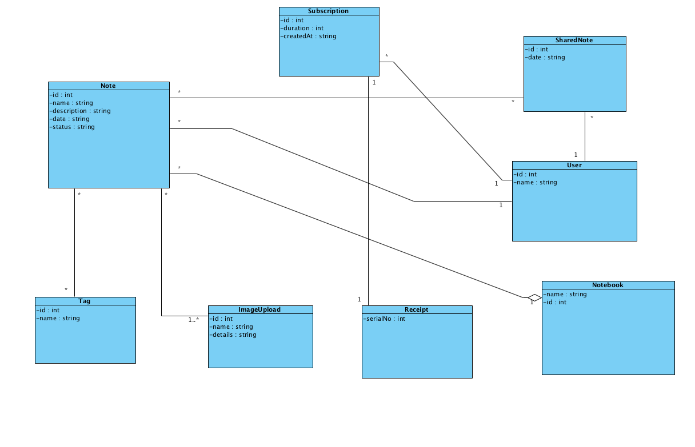

**System Sequence Diagrams**

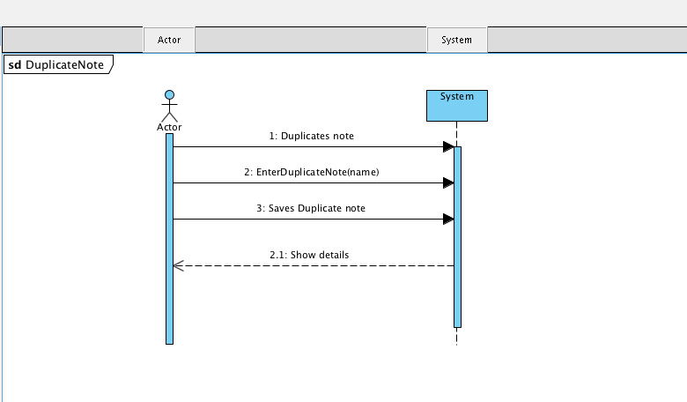

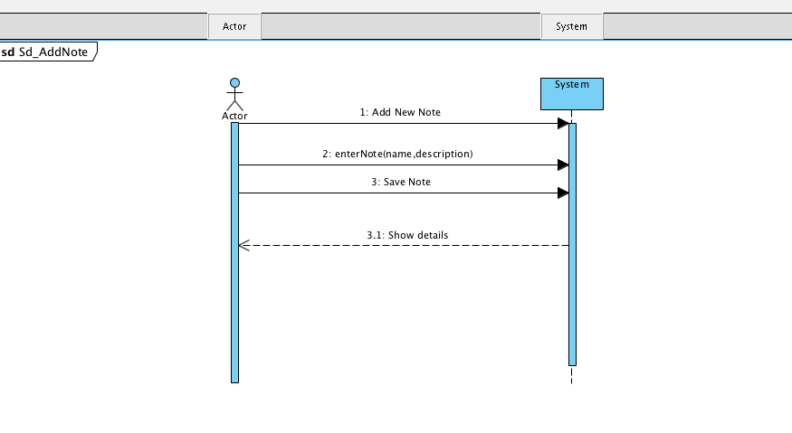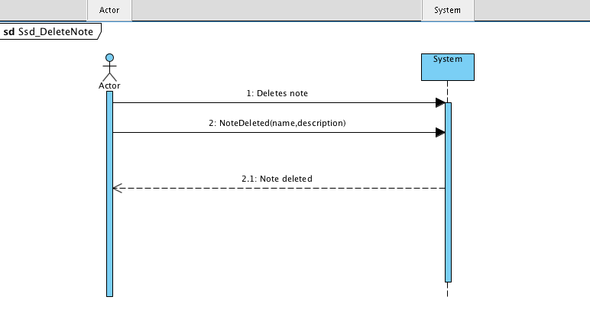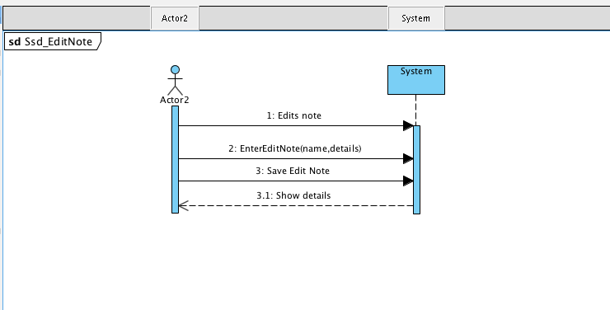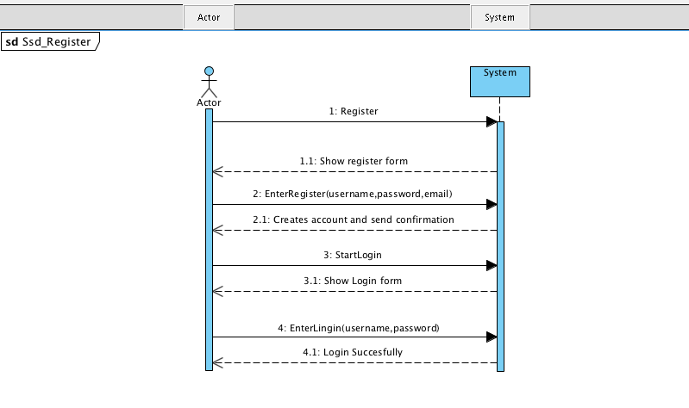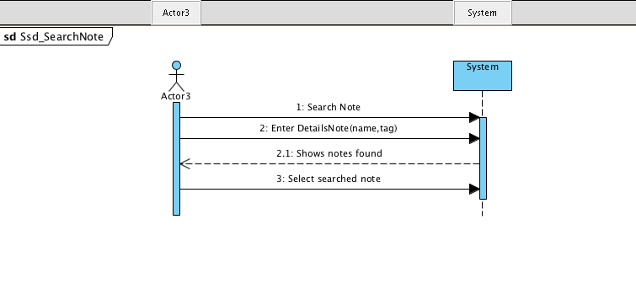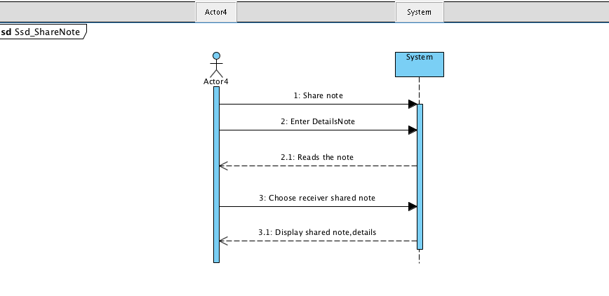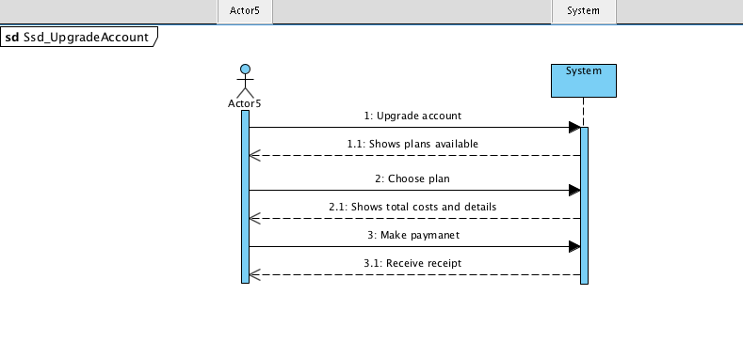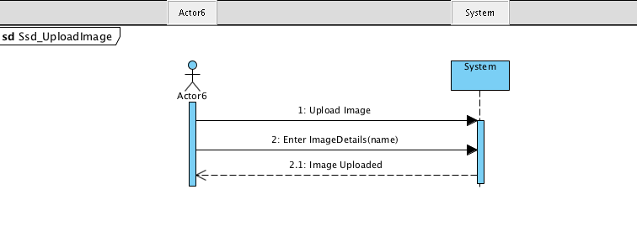

Requirments Analysis

With the help of software use case diagram we obtained the ***functional requirments***:

1.Client adds notes

* + - Clients can add notes if they have an account.When you create a note the user can choose a name for its ad, upload pictures and add description.
    - Clients can add all their notes in a notebook

2. Clients can delete a note

3.Client registers

* Clients needs to make an account in order to use the website(to adds notes).

4.Client shares note

* Clients can share notes with other users but they need to upgrade the basic account to premimum one,you can add other users as friends using their account name and giving them the permission to see your notes.

5.Client edits note

6.Client can searchs and browse notes

* Clients can search a note using a tag

7.Client can upload an image

8.Client duplicates note

9.Client upgrades account

* Clients have the opportunity to choose from 2 different types of accounts:basic and premium.Basic for people which intent just to adds notes,delete them,edit and duplicate it or you cand buy premimum having the chance to share your notes with other users.

***Non-function requirments***

* Usability: its a pretty simple and basic application ,in 5 minutes you can find all the features.
* Accesibility:for people with diminished vision-contents has audio indication, high contrast.
* Performance:maximum duration of 300ms.
* Capacity:as many clients is need
* Aviability:24/7
* Robustness:---

**Software Use Case Diagram**

* 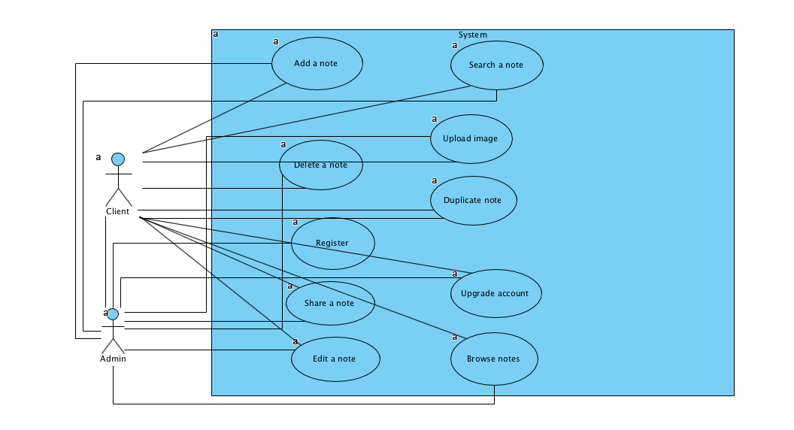

***Use Case Description***

1. *Share Notes*

|  |  |
| --- | --- |
| User case name | *Share Notes* |
| Scope | It bounds the system under design |
| Level | User-Goal |
| Primary Actor | Client |
| Stakeholders and interests | Users |
| Preconditions | System is running |
| Success Guarantee | The notes are shared |
| Main Success Scenario | The other user receives the notes shared |
| Extensions | System fails,user don’t receive the notes |
| Special Req | User needs a premium account in order to share notes |
| Technology/Data Variantion List | String ,doubles |
| Frequency of Occurence | frequent |
| Misellaneous | ---- |

Client System

1.Share a note 2.Read the note ,details

3.Enter Details Notes 4.Display shared notes

5.Choose user receiver of shared notes

Operation Contract

Name Indicate Details(name,description)

UC:Share note

Preconditions: a new share note is requested

Post Conditions: The possibility to share notes is available just for those which have premimum account.

1. *Upgrade Account*

|  |  |
| --- | --- |
| User case name | *Upgrade Account* |
| Scope | It bounds the system under design |
| Level | User-Goal |
| Primary Actor | Client |
| Stakeholders and interests | Users |
| Preconditions | System is running |
| Success Guarantee | Receipt |
| Main Success Scenario | User choose pemimum account,confirms the payment and receive the receipt |
| Extensions | System fails,user don’t receive the premimum account. |
| Special Req | User needs a premium account in order to upgrade the basic one |
| Technology/Data Variantion List | String ,doubles |
| Frequency of Occurence | frequent |
| Misellaneous | ---- |

Client System

1.Upgrade account 2.Shows plans available

3.Choose plan 4.Display shared notes

5.Confirm payment 6.Show total costs and details

7.Receive receipt

Operation Contract

Name: Indicate Details(name)

UC:Upgrade account

Preconditions: a new upgrade account for user is requested

Post Conditions: The upgrade account is possible only for those who confirms the payment.

1. *Add a note*

|  |  |
| --- | --- |
| User case name | *Add a note* |
| Scope | It bounds the system under design |
| Level | User-Goal |
| Primary Actor | Client |
| Stakeholders and interests | Users |
| Preconditions | System is running |
| Success Guarantee | Note added |
| Main Success Scenario | User add a note to all notes |
| Extensions | System fails,user don’t receive the note all notes. |
| Special Req | User needs to have at least a basic account in order add notes in their list |
| Technology/Data Variantion List | String ,doubles |
| Frequency of Occurence | frequent |
| Misellaneous | ---- |

Client System

1.Add a note 2.Read the note ,details

3.Enter name and description of note 4.Note added to the list

5.Save add to all notes

Operation Contract

Name Indicate Details(name,description)

UC:Add note

Preconditions: a new add note is requested

Post Conditions: The possibility to add notes just if you have an account.

1. *Delete a note*

|  |  |
| --- | --- |
| User case name | *Delete a note* |
| Scope | It bounds the system under design |
| Level | User-Goal |
| Primary Actor | Client |
| Stakeholders and interests | Users |
| Preconditions | System is running |
| Success Guarantee | Note deleted |
| Main Success Scenario | User delete a note,note added to trash |
| Extensions | System fails,user don’t delete the note |
| Special Req | User needs to have at least a basic account in order delete notes from their list |
| Technology/Data Variantion List | String ,doubles |
| Frequency of Occurence | frequent |
| Misellaneous | ---- |

Client System

1.Delete a note 2.Verifies that it can be deleted

3.Confirms to delete 4.Note added to trash

5. User receives delete confirmation

Operation Contract

Name Indicate Details(name)

UC:Delete note

Preconditions: Note deleted is requested

Post Conditions: The possibility to delete notes just if you have an account.

1. *Register*

|  |  |
| --- | --- |
| User case name | *Register* |
| Scope | It bounds the system under design |
| Level | User-Goal |
| Primary Actor | Client |
| Stakeholders and interests | Users |
| Preconditions | System is running |
| Success Guarantee | Account created |
| Main Success Scenario | User creates account and confirm |
| Extensions | System fails(incorrect details),user doesn’t create an account |
| Special Req | ---- |
| Technology/Data Variantion List | String ,doubles |
| Frequency of Occurence | frequent |
| Misellaneous | ---- |

Client System

1.New account 2.Verifies that the details

3.Confirms creation 4.Generates account

5. User receives permission to log in

1. *Edit a note*

|  |  |
| --- | --- |
| User case name | *Edit a note* |
| Scope | It bounds the system under design |
| Level | User-Goal |
| Primary Actor | Client |
| Stakeholders and interests | Users |
| Preconditions | System is running |
| Success Guarantee | Note edited |
| Main Success Scenario | User edits a note,note added to all notes |
| Extensions | System fails,user don’t edit the note |
| Special Req | User needs to have at least a basic account in order edit notes from their list |
| Technology/Data Variantion List | String ,doubles |
| Frequency of Occurence | frequent |
| Misellaneous | ---- |

Client System

1.Edite a note 2.Verifies the details of note

3.Confirms to edit 4.Note edited

5. User receives edit confirmation

Operation Contract

Name Indicate Details(description)

UC:Edit a note

Preconditions: Note edited is requested

Post Conditions: The possibility to edit notes just if you have an account.

1. *Search note*

|  |  |
| --- | --- |
| User case name | *Search note* |
| Scope | It bounds the system under design |
| Level | User-Goal |
| Primary Actor | Client |
| Stakeholders and interests | Users |
| Preconditions | System is running |
| Success Guarantee | Searched results found |
| Main Success Scenario | User search for a note,note is founded |
| Extensions | System fails,user doesn’t receive note searched |
| Special Req | User needs to have an account in order searches notes from their list |
| Technology/Data Variantion List | String ,doubles |
| Frequency of Occurence | frequent |
| Misellaneous | ---- |

Client System

1.Search a note 2.Display results of search

3.See results

Operation Contract

Name Indicate Details(name,description)

UC:Search note

Preconditions: Search for a note is requested

Post Conditions: The possibility to search for notes is if you have an account.

1. *Upload image*

|  |  |
| --- | --- |
| User case name | *Upload image* |
| Scope | It bounds the system under design |
| Level | User-Goal |
| Primary Actor | Client |
| Stakeholders and interests | Users |
| Preconditions | System is running |
| Success Guarantee | Image uploaded |
| Main Success Scenario | User upload an image |
| Extensions | System fails,user don’t upload the image |
| Special Req | User needs to have a premium account in order to upload images |
| Technology/Data Variantion List | String ,doubles |
| Frequency of Occurence | frequent |
| Misellaneous | ---- |

Client System

1.Upload image 2.Verifies that it can uploaded

3.Confirms the upload 4.Image uploaded

5. User receives upload confirmation

Operation Contract

Name Indicate Details(name)

UC:Upload image

Preconditions: Upload image is requested

Post Conditions: The possibility to upload images just if you have premium account.

1. *Duplicate a note*

|  |  |
| --- | --- |
| User case name | *Duplicate a note* |
| Scope | It bounds the system under design |
| Level | User-Goal |
| Primary Actor | Client |
| Stakeholders and interests | Users |
| Preconditions | System is running |
| Success Guarantee | Note duplicated |
| Main Success Scenario | User duplicates a note,note added to all notes |
| Extensions | System fails,user don’t duplicate the note |
| Special Req | User needs to have at least an account in order duplicates notes from their list |
| Technology/Data Variantion List | String ,doubles |
| Frequency of Occurence | frequent |
| Misellaneous | ---- |

Client System

1.Duplicate a note 2.Verifies the details of note

3.Confirms to duplicate 4.Note duplicated

5. User receives duplicated confirmation

Operation Contract

Name Indicate Details(description)

UC:Duplicate a note

Preconditions: Note duplicated is requested

Post Conditions: The possibility to duplicates notes just if you have an account.

1. *Edit a note*

|  |  |
| --- | --- |
| User case name | *Browse notes* |
| Scope | It bounds the system under design |
| Level | User-Goal |
| Primary Actor | Client |
| Stakeholders and interests | Users |
| Preconditions | System is running |
| Success Guarantee | List of notes |
| Main Success Scenario | Notes appear in list, user sees notes |
| Extensions | System fails,user don’t see the notes |
| Special Req | User needs to have an account in order see notes from their list |
| Technology/Data Variantion List | String ,doubles |
| Frequency of Occurence | frequent |
| Misellaneous | ---- |

Client System

1.Browse notes 2.Show the notes

3.See the notes

Operation Contract

Name Indicate Details(description,name)

UC:Browse notes

Preconditions:Browse notes is requested

Post Conditions: The possibility to see your notes is if you have an account.

Design-Sequence Diagram,Design Class Diagram(**SD+DCD)**

* Upgrade

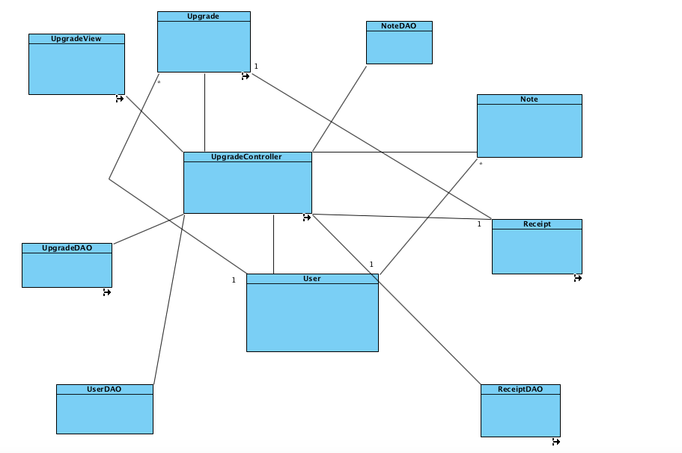

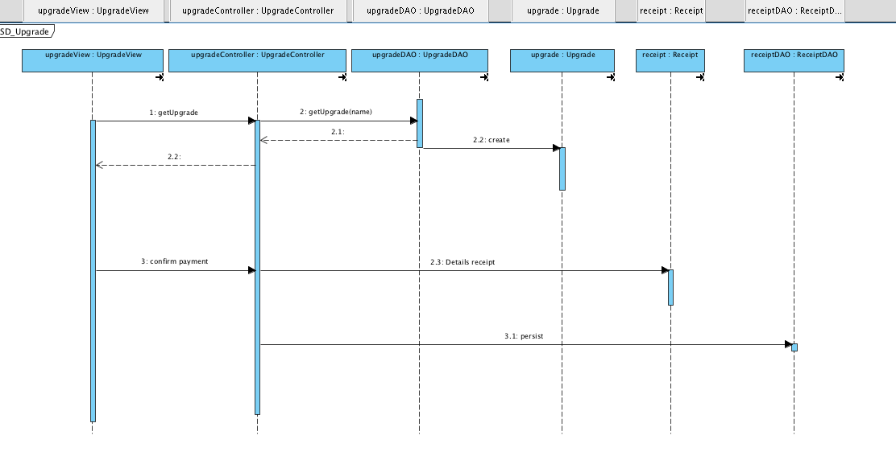

* Add note

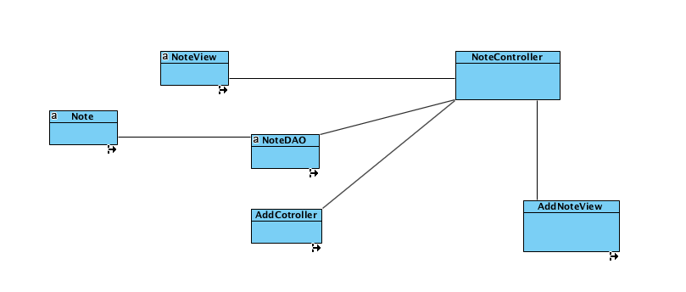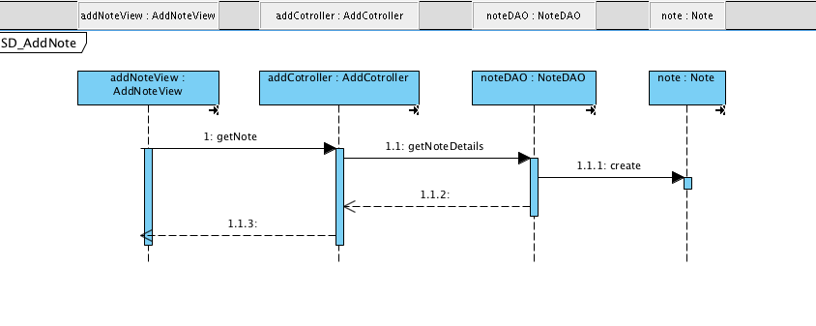

* Browse notes

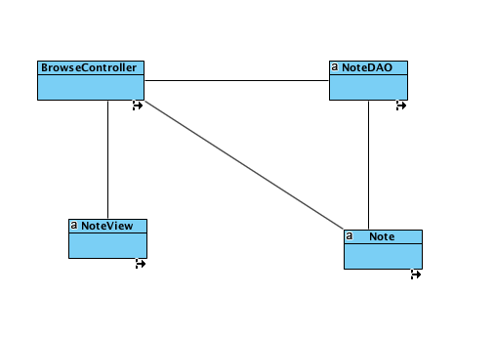

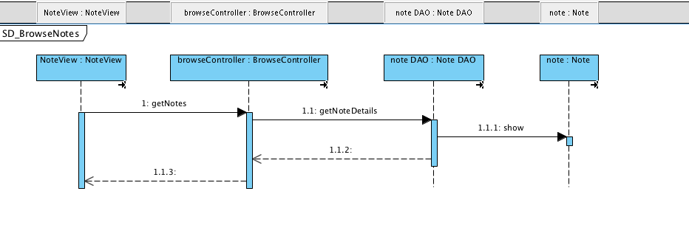

* Delete note

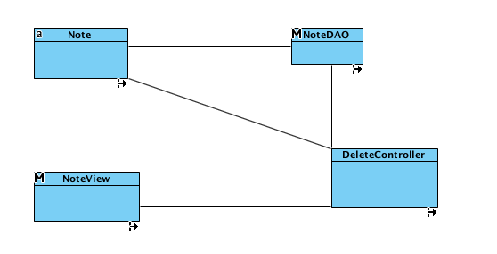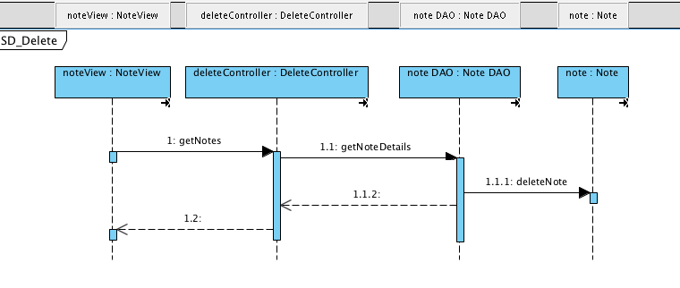

* Duplicate note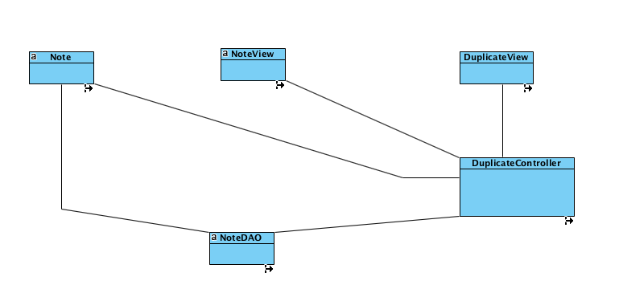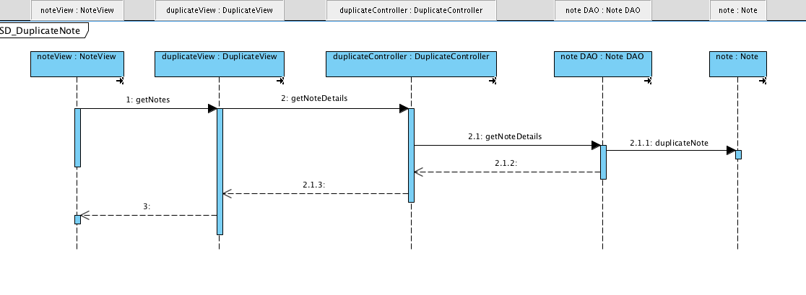
* Edit note

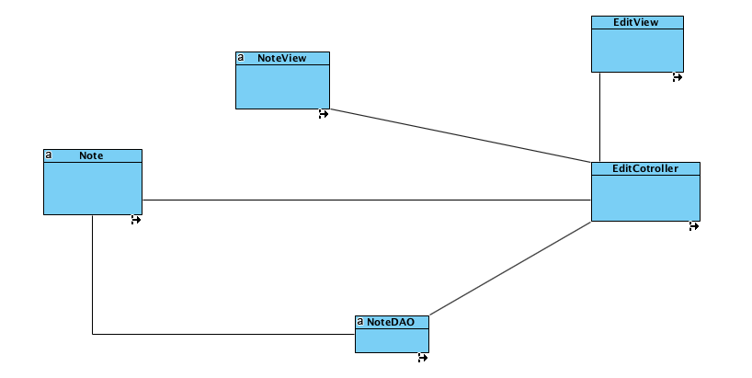

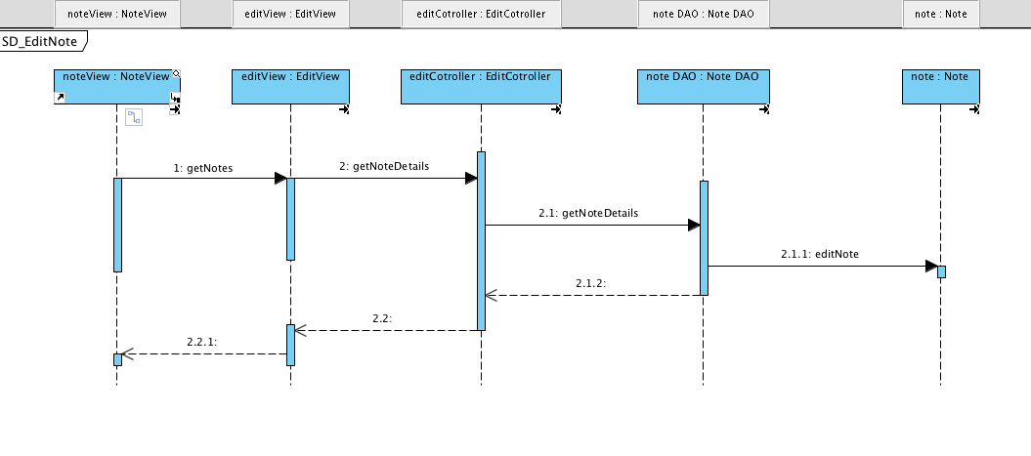

* Register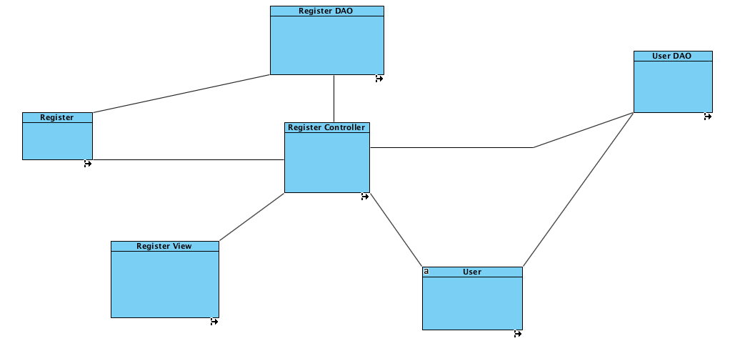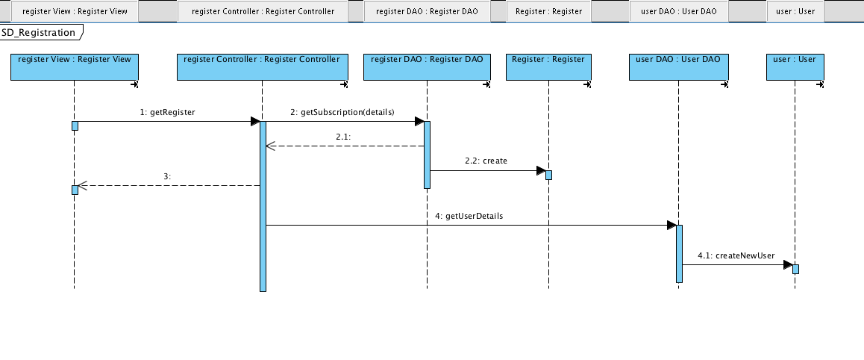
* Search note

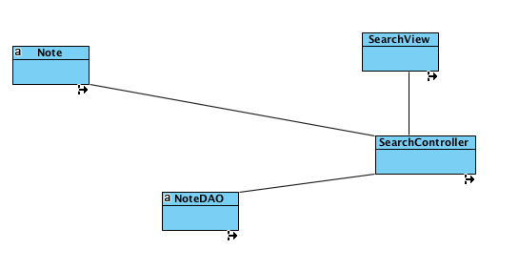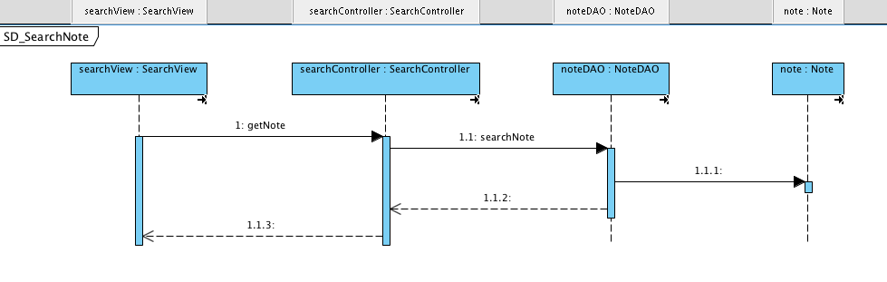

* Share note

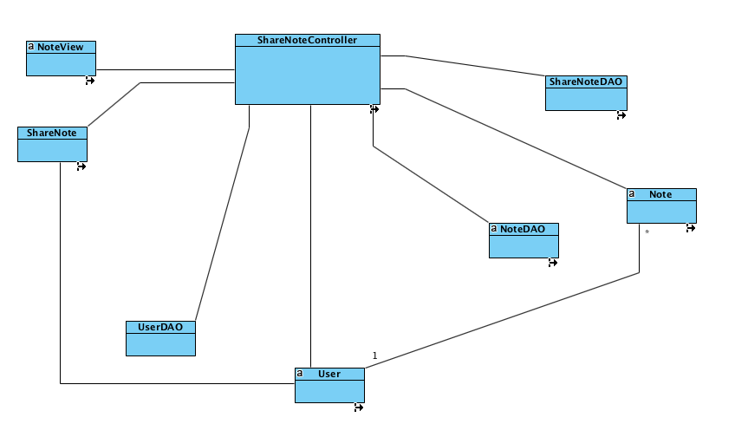

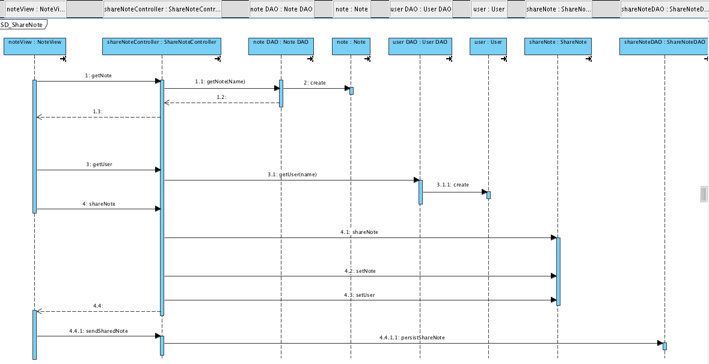

* Upload Image

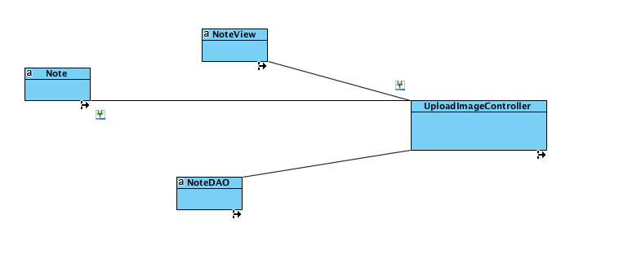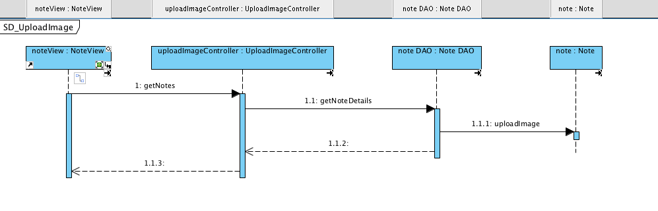

**State Machine Diagram for....**

