Training a Q-Learning Agent for a Unity ML Demo
Bachelor Thesis
A tabular reinforcement learning agent built in Unity
Abstract
This thesis presents the design and implementation of a reinforcement learning agent based on the Q-Learning algorithm, trained inside a virtual environment built with Unity. The agent learns autonomously to make optimal decisions through interaction with the environment, guided by a reward system. The work covers the core concepts of reinforcement learning, including the definition of states, actions and the reward function, as well as the training and evaluation process. The final result is an interactive Unity demo that demonstrates the practical application of the Q-Learning algorithm.

1. Introduction to Reinforcement Learning
Reinforcement learning is a branch of machine learning in which an agent learns how to behave in an environment by performing actions and observing the consequences of those actions. Unlike supervised learning, the agent is not given labelled examples of correct behaviour. Instead, it receives a scalar reward signal that indicates how good or bad each action was, and its goal is to maximise the total reward accumulated over time.
The interaction follows a loop. At every time step the agent observes the current state of the environment, selects an action according to its policy, and the environment responds with a new state and a reward. By repeating this loop many times the agent gradually discovers which actions lead to high long-term reward and which should be avoided.
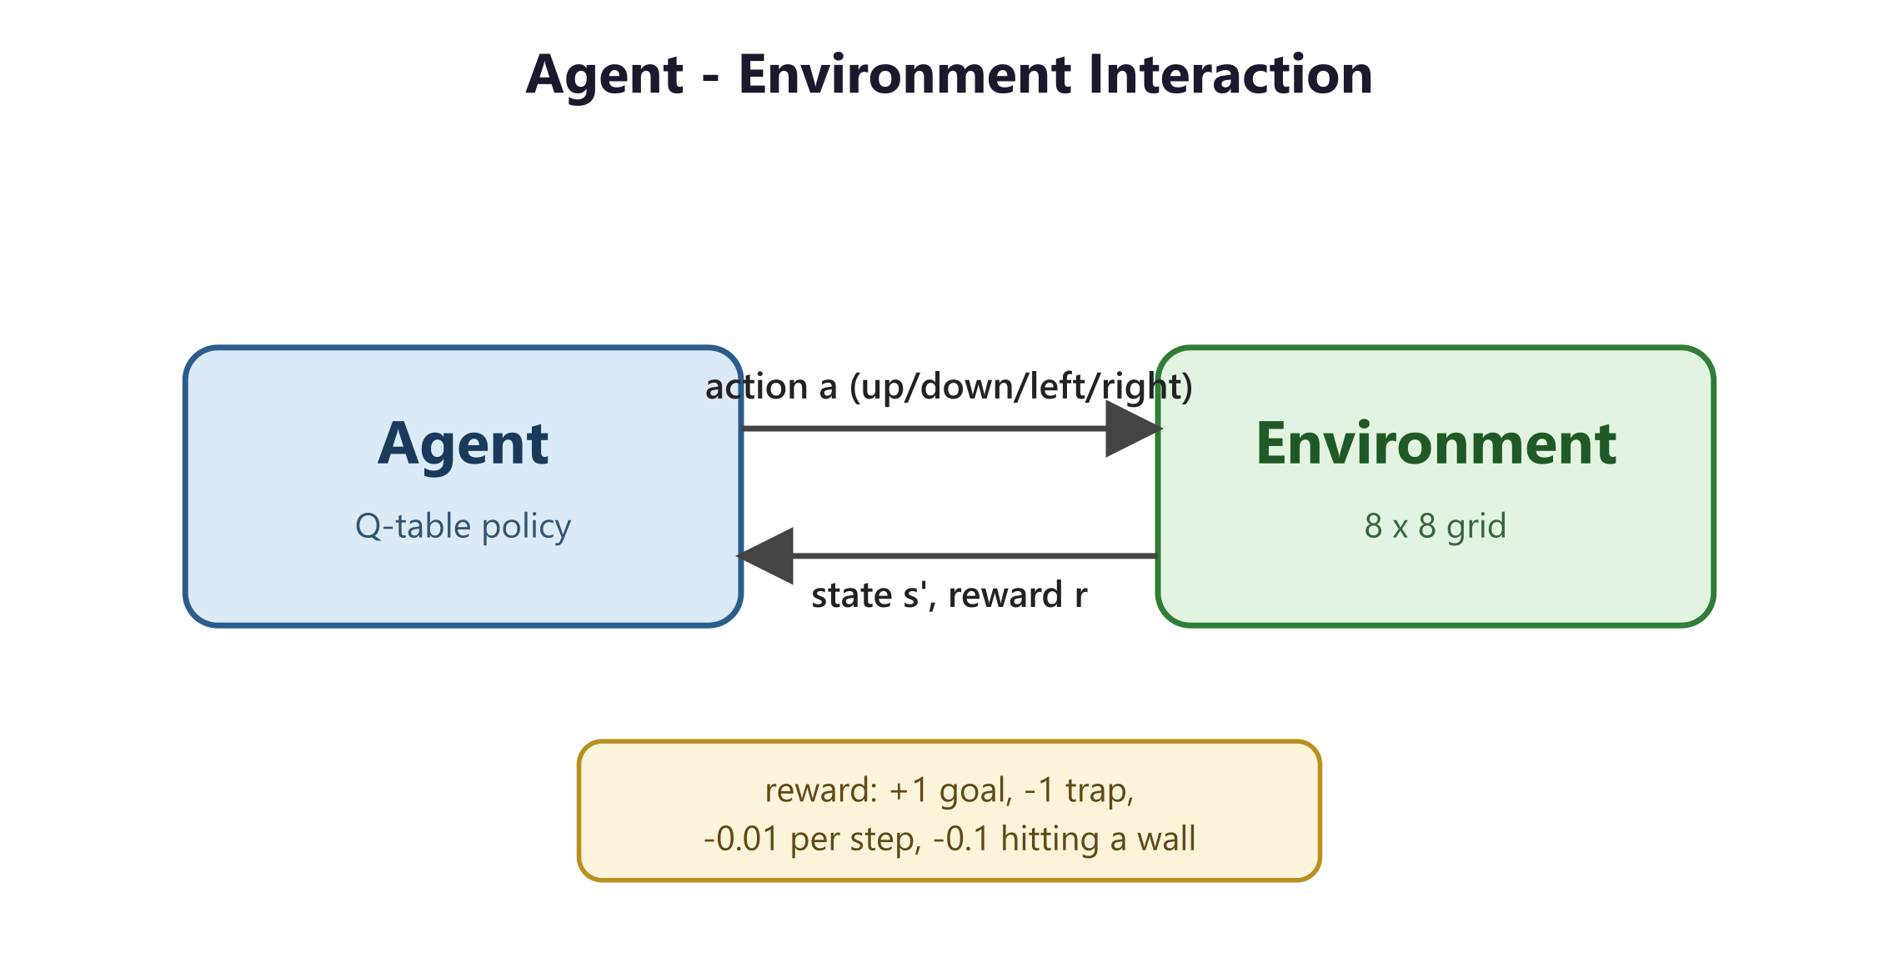
Figure 1. The agent-environment interaction loop with the state, action and reward signals.
This work uses Q-Learning, a value-based, model-free reinforcement learning algorithm. Q-Learning estimates the expected long-term reward of taking a given action in a given state, a quantity called the action value or Q-value. The agent does not need a model of the environment dynamics; it learns purely from experience. Because the environment used here is discrete and small, the Q-values can be stored exactly in a table, which makes the algorithm easy to implement and easy to explain.
The remainder of the thesis is organised as follows. Chapter 2 describes the environment in which the agent acts. Chapter 3 presents the Q-Learning algorithm and its implementation. Chapter 4 discusses the training process, the evaluation of the learned policy and the obtained results.

2. Environment Description
The environment is a grid world implemented in Unity. It consists of an 8 by 8 grid of cells, giving a total of 64 distinct states. Each state is identified by an integer index computed from the cell coordinates as index = y * width + x. The grid contains a start cell, a goal cell, a trap cell and a number of wall cells that act as obstacles. The cells are rendered as coloured cubes so that the layout is immediately readable: the start cell is blue, the goal is green, the trap is red, the walls are dark and the free floor is light grey.
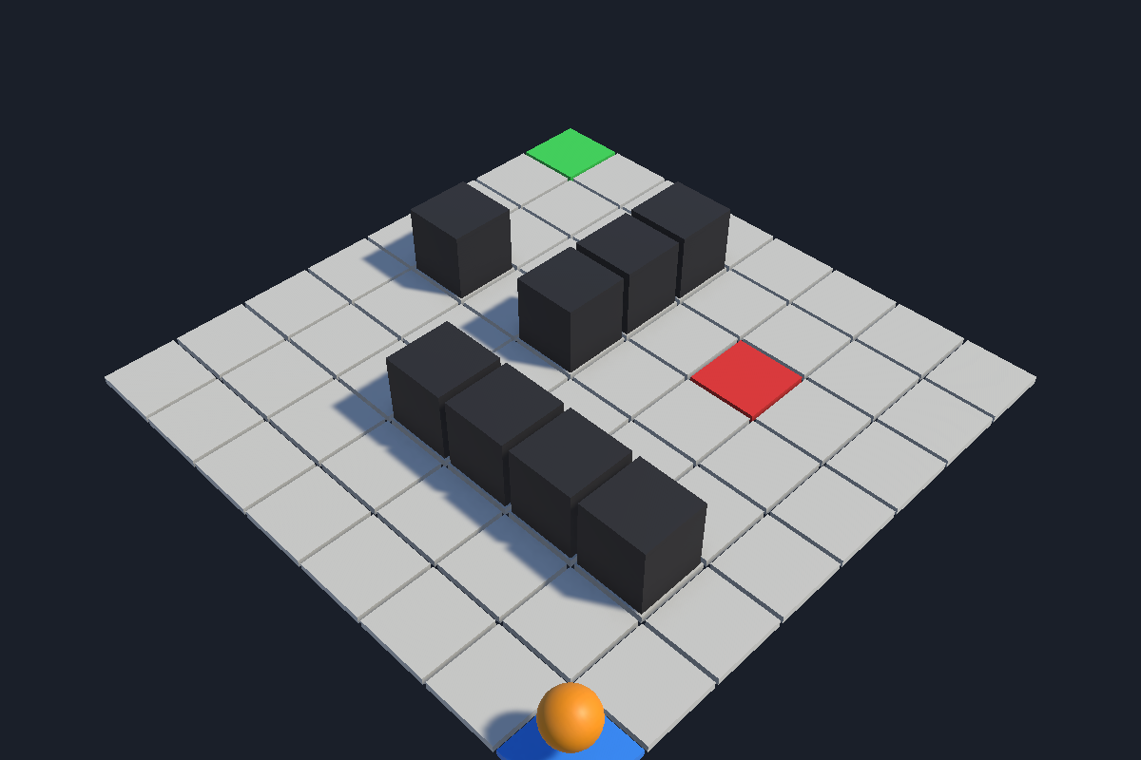
Figure 2. Perspective view of the 8 by 8 grid environment with start, goal, trap and walls.
The agent can perform four discrete actions: move up, down, left or right. The transition logic is deterministic. When an action would move the agent into a wall or outside the grid boundaries, the move is rejected and the agent stays in its current cell. Otherwise the agent moves to the neighbouring cell. An episode ends when the agent reaches the goal or steps into the trap, and it is also limited to a maximum number of steps to avoid infinite wandering during early learning.

2.1 Reward Function
The reward function encodes the task objective. Reaching the goal yields a reward of +1 and ends the episode successfully. Stepping into the trap yields a reward of -1 and ends the episode as a failure. Every ordinary step has a small negative reward of -0.01, which encourages the agent to reach the goal using as few steps as possible. Attempting to move into a wall is penalised with an additional -0.1, which discourages the agent from pushing against obstacles.
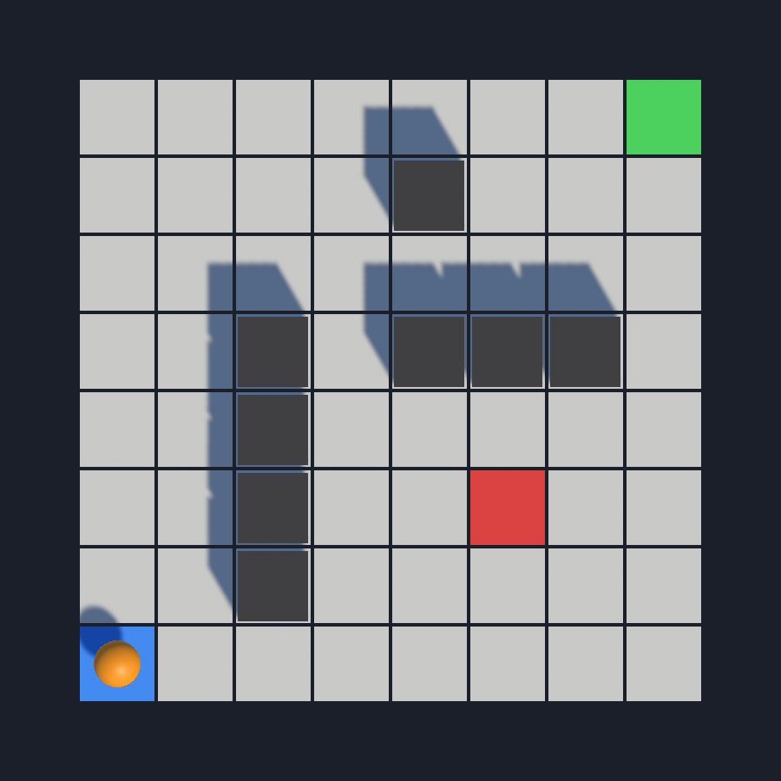
Figure 3. Top-down view of the environment at the start of an episode, with the agent (orange) on the start cell.

3. The Q-Learning Algorithm
The agent maintains a Q-table, a two dimensional array indexed by state and action. Each entry Q(s, a) stores the current estimate of the expected long-term reward of taking action a in state s. The table is initialised to zero, which means the agent starts with no knowledge of the environment.

3.1 Action Selection
Actions are selected with an epsilon-greedy policy. With probability epsilon the agent chooses a random action, and with probability 1 minus epsilon it chooses the action with the highest Q-value in the current state. This balances exploration, trying new actions to discover their value, with exploitation, using the knowledge already acquired. The value of epsilon starts high so that the agent explores widely at the beginning, and it is decayed after every episode towards a small minimum value, so that the behaviour becomes increasingly greedy as learning progresses.

3.2 Q-value Update
After each step the agent updates the Q-value of the state-action pair it just experienced using the Bellman update rule:
Q(s, a) = Q(s, a) + alpha * [ r + gamma * max Q(s', a') - Q(s, a) ]
Here alpha is the learning rate, which controls how strongly new information overrides the old estimate; gamma is the discount factor, which controls how much future rewards are valued relative to immediate ones; r is the reward received; and max Q(s', a') is the best estimated value available from the next state. When the next state is terminal, the future term is omitted and the target is simply the reward.
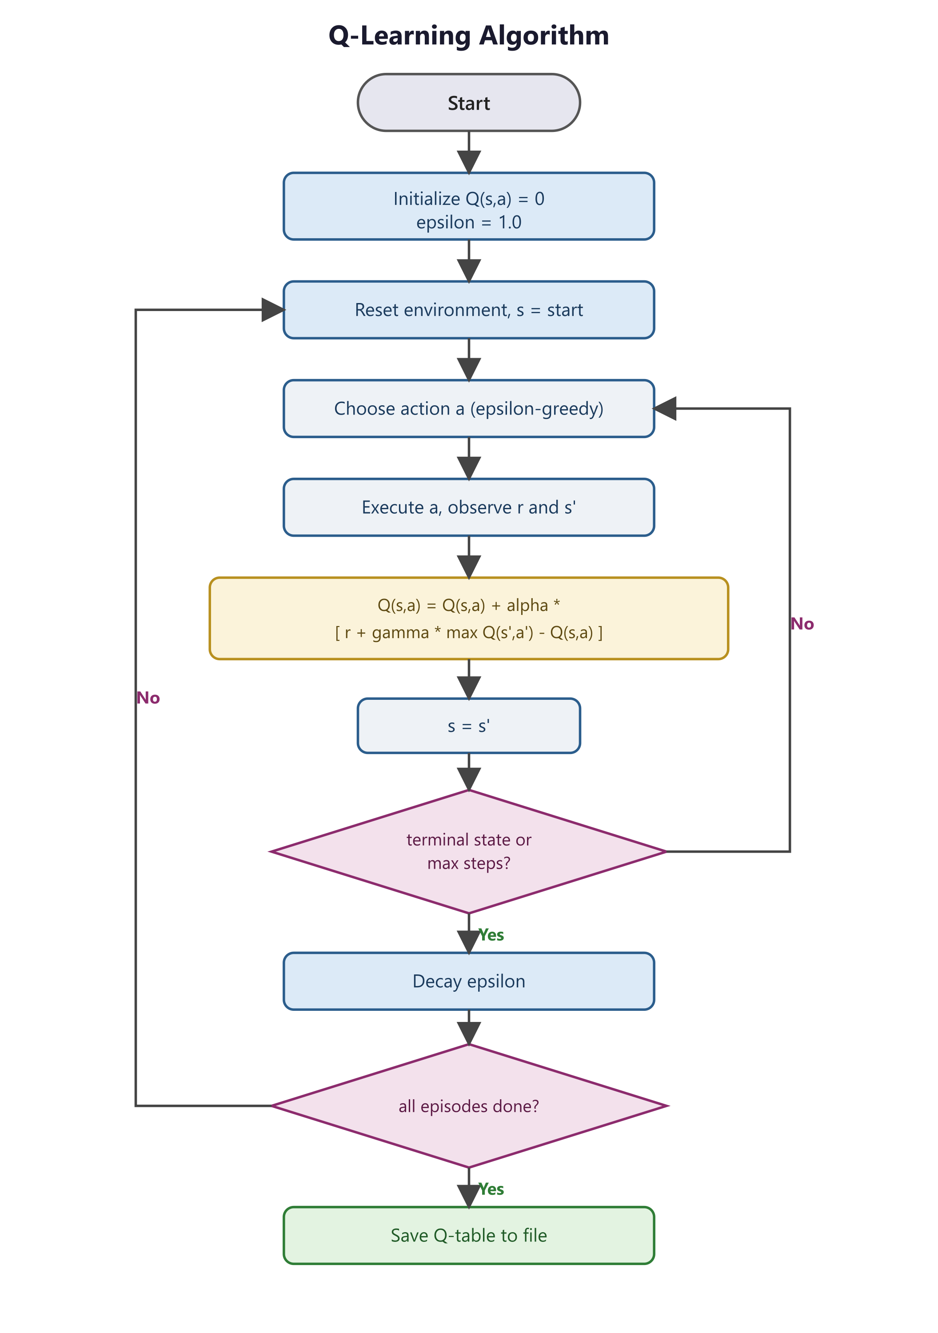
Figure 4. Flowchart of the Q-Learning training procedure.

3.3 Hyperparameters
The following hyperparameters were used for training. They are exposed in the Unity inspector so that they can be adjusted without modifying the code.
Hyperparameter | Symbol | Value
Learning rate | alpha | 0.1
Discount factor | gamma | 0.95
Initial exploration | epsilon | 1.0
Minimum exploration | epsilon min | 0.05
Exploration decay | decay | 0.995
Episodes | - | 2000
Max steps per episode | - | 200

4. Training and Evaluation
Training consists of running many full episodes. In each episode the environment is reset to the start cell and the agent repeatedly selects an action, applies it, receives the reward and the next state, and updates its Q-table. The episode ends when the agent reaches the goal or the trap, or when the step limit is reached. After each episode epsilon is decayed. The whole process is visualised in real time in the Unity demo: a moving sphere represents the agent and an on-screen panel reports the current episode, the episode reward, the number of steps, the current value of epsilon and whether the goal was reached.

4.1 Learning Progress
The learning curve below shows the reward obtained in each training episode. The light line is the raw per-episode reward, which is noisy because of exploration, and the bright line is a moving average that makes the underlying trend clear. The reward rises quickly during the first few hundred episodes and then stabilises near its maximum, which indicates that the agent has converged to a good policy.
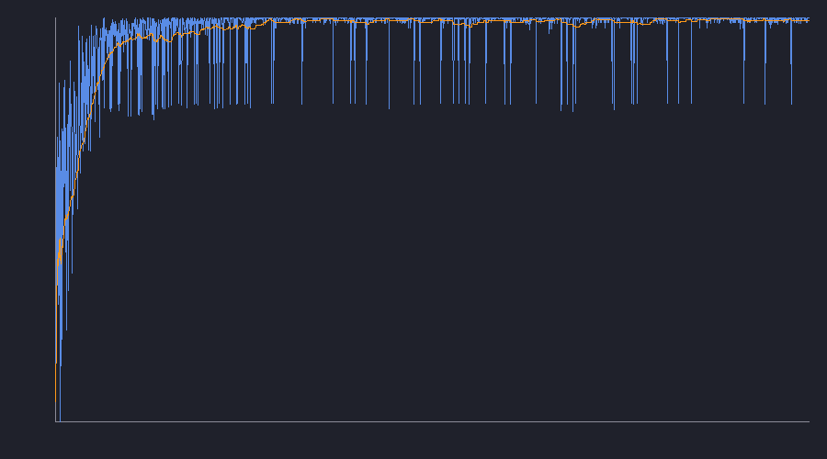
Figure 5. Reward per episode during training (raw values and moving average).
The numerical progress confirms this behaviour. Comparing the first 100 episodes with the last 100 episodes of a representative training run, the average reward increased from about -1.8 to about 0.84, the average number of steps to finish an episode dropped from roughly 57 to about 15, and the success rate rose from about half of the episodes to all of them.
Metric | First 100 episodes | Last 100 episodes
Average reward | -1.8 | 0.84
Average steps | 57 | 15
Success rate | 52% | 100%

4.2 Evaluation of the Learned Policy
After training, the Q-table is saved to a JSON file. The evaluation mode loads this saved table and runs the policy greedily, with no exploration, so that the pure learned behaviour can be measured. Running 100 evaluation episodes, the agent reached the goal in 100% of them, using on average 14 steps and obtaining an average reward of 0.87. Because both the environment and the greedy policy are deterministic, every evaluation episode follows the same optimal path, which demonstrates that the learned policy is stable. The results are exported to a CSV file for further analysis.
Evaluation metric | Value
Success rate | 100%
Average steps | 14
Average reward | 0.87

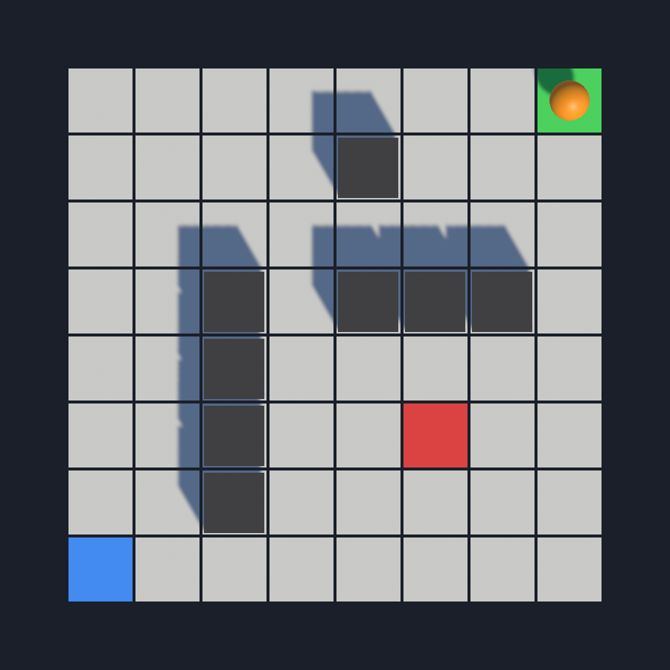
Figure 6. The trained agent reaching the goal cell following the learned policy.

4.3 Demo Architecture
The demo is organised into a small set of cooperating components. The GridEnvironment defines the states, actions, transitions and rewards. The QLearningAgent holds the Q-table and implements the epsilon-greedy policy and the Bellman update. The TrainingManager runs the episode loop, drives the visualisation and saves the results. The Evaluator loads the saved Q-table and measures the greedy policy. The ChartRenderer produces the learning curve image, and the DemoController connects the user interface buttons and the speed slider to these components.
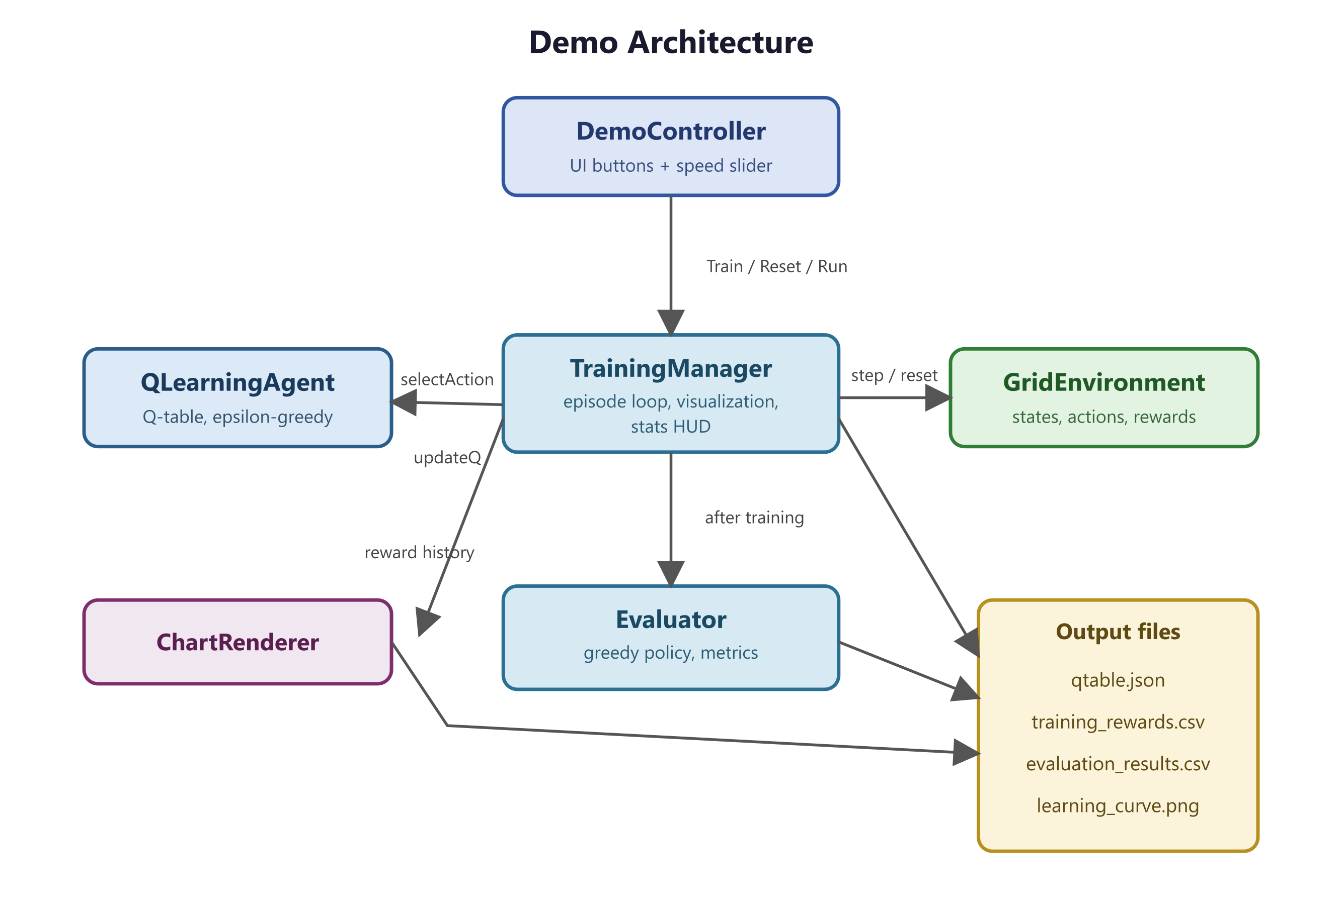
Figure 7. Architecture of the demo and the relationships between its components.
The interactive demo lets the user train the agent, reset it to an untrained state, run the trained agent using the saved Q-table, and control the simulation speed. This makes the difference between an untrained and a trained agent immediately visible: before training the agent wanders and frequently fails, while after training it moves directly to the goal along the shortest safe path.

