**08356 ACW2**

**We’re all Doomed**

**AI**

Nicholas Taylor

Matei Giurgiu

Nathan Glasper

Joshua Morley-Stone

Word Count: 464

Contents

Description of Algorithms 3

Basic Algorithm 3

Extended Algorithm 3

Evaluation of algorithms: 3

# Description of Algorithms

## Basic Algorithm

The current working AI is a very basic node to node pathfinder where the drones traverse nodes which have been read from the map layout.txt file rather than seek out the player. The characters from “*a*” to “*y”* in the txt file designate the locations of the nodes and are read into a Sorted Dictionary (AIroute), keeping the nodes in order, then translated into a list. Therefore, node “a” leads to node “b” and so on. The drones will later choose a random start point from this list and will continue to navigate from that point (e.g. if “j” is the starting point the next one will be “k”).

The drone object has two states which determines the path it will take. The “patrol” state will traverse the nodes as they appear stored in the list (“route”) incrementing one at a time until a player enters detection range for which then the drone enters “attack” state and will persistently chase the player till it is destroyed or harms the player.

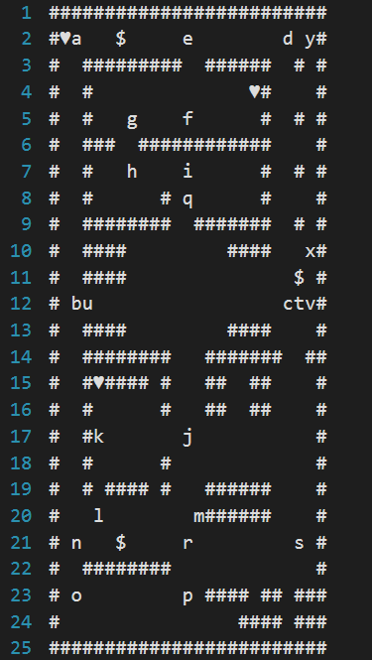

Figure 1. Map Layout file.

## Extended Algorithm

The extended algorithm attempted to be implemented for the AI in this game is taken from the A* pathfinding algorithm, -f(x) = g(x) + h(x).

This algorithm works by evaluating and comparing nodes in the list which show the least distance for the drone to reach its target (in this case the player object). “f” is the weight of the node in terms of the sum of “g”, the next possible node’s distance from the start position, and “h”, the next possible node’s distance from the player position. The node with the least “f” cost would be the next node to be visited.

# Evaluation of algorithms:

In the current release of the game only the basic AI functions without issues, as the A* method currently has the drones pacing diagonally through walls and collecting themselves in a corner of the map which isn’t ideal for the gameplay. In future the A* method could be fully implemented properly giving a more “aggressive” nature to the game where the drones will actively seek out the player rather than stumble upon them by chance. Furthermore, the A* could be adapted to enhance the AI behaviour such as add a “retreat” state to the drones for example which would involve them trying to reach the furthest point from the player when on low health. The more basic AI was kept for the submission release due to the AI behaving “more normally” than it was with the more advanced method, also the basic algorithm has a very easy way of controlling where the navigation point are placed, so certain areas can have higher density of waypoint in order to make the drones travers that area more frequently.