Design Document

[Final Version]

Separating Concerns

The project is separated in some concerns. First, the presentation concern which makes use of React Presentation, JavaScript Presentation, HTML Presentation, React Communication. Then the framework, a RESTful API in Java Spring Boot and lastly, the Logic layer which is in Java.

Why React.js?

React is a JavaScript framework for building user interfaces. I am using the React.js JavaScript framework because of the efficiency and flexibility due to its component-oriented programming style.

How is SOLID Guaranteed?

In this software application, every class follows the Single-Responsibility Principle, the Open-Closed Principle because every class does not change even if it needs to be extended. For the moment, there is no proof of the Liskov Substitution Principle. Because of the Interface Segregation Principle, I added multiple interfaces with different responsibilities. There is proof of the Dependency Inversion Principle in the REST controllers, they make use of interfaces implemented by the fake repository instead of the actual fake repository.

Technology

* **Spring Boot** ­ An open-source java micro-framework with auto configurable production-grade Spring application.
* **Gradle** - A build automation tool that controls the development process in the tasks of compilation and packaging to testing, deployment and publishing.

Spring Framework makes programming Java quicker, easier, and safer for everybody. Spring is the world’s most popular Java framework. It focuses mostly on speed, simplicity, and productivity.  
One of the many reasons to choose Spring Boot as a tool, is that it makes developing web applications with Spring Framework even faster and easier through three main capabilities:

1. Autoconfiguration  
2. An opinionated approach to configuration  
3. The ability to create standalone applications

#### Client

* **ReactJS**­ A JavaScript framework for building user interfaces

Tools

There are several tools and technologies that this project will utilize for development.

#### Server Side

* **JDK 11** - A set of tools for developing and testing programs written in Java and running on the Java platform
* **Spring Security** - A framework that handles authentication and authorization at the Web request level as well as the method invocation level
* **Auth0 Java-JWT** - An open standard (RFC 7519) that defines a compact and self-contained way for securely transmitting information between parties as a JSON object

C1 Diagram

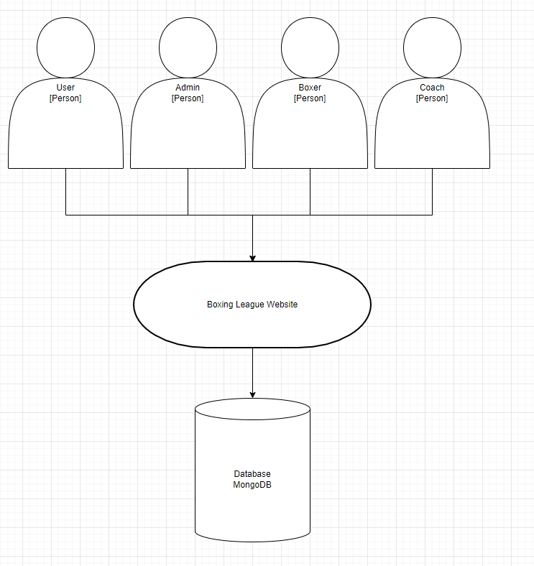

This C1 diagram shows what types of users can access the website. Normal users (viewers), administrators, boxers and coaches can access the website. They have different views, the normal user being able to access the chat, fights, weight classes and profile. The admin can access everything and CRUD everything. The boxer can see his fights, requests from coaches, his statistics, see profile information and also search for fights. The coach can see his fighters, all fighters so he can send requests to coach certain fighters and also

C2 Diagram

This C2 diagram shows what containers a user can use. The frontend is a web based ReactJS container that handles functionality by making API calls to the backend which is a Spring Boot container that fulfills the functionalities by making JSON HTTPS API calls to the MongoDB Database container.

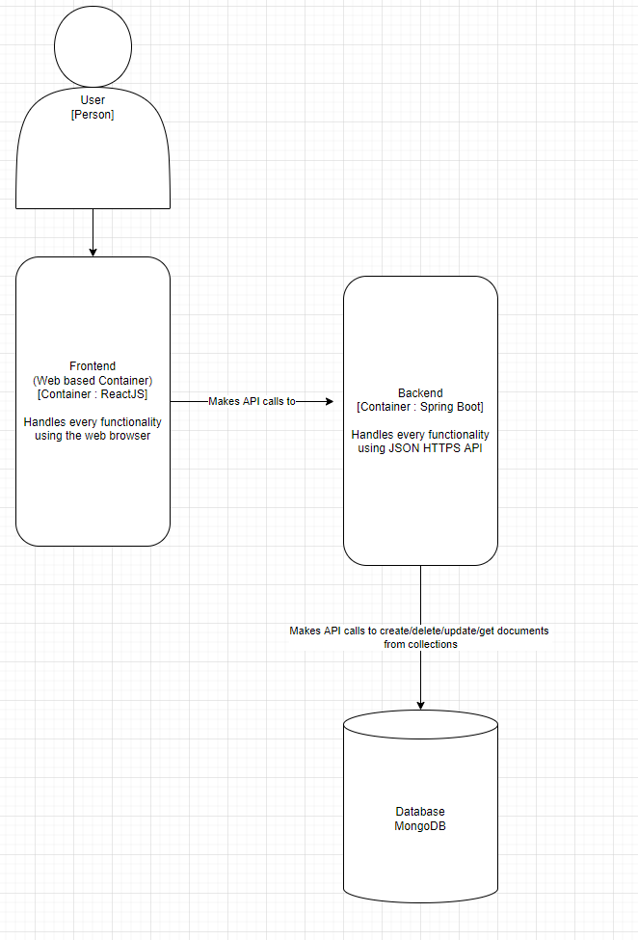

C3 Diagram

This C3 diagram shows the container composition of the backend. The frontend makes calls to the controllers, which use service interfaces implemented by the actual services which use the repositories to CRUD documents from the MongoDB database.

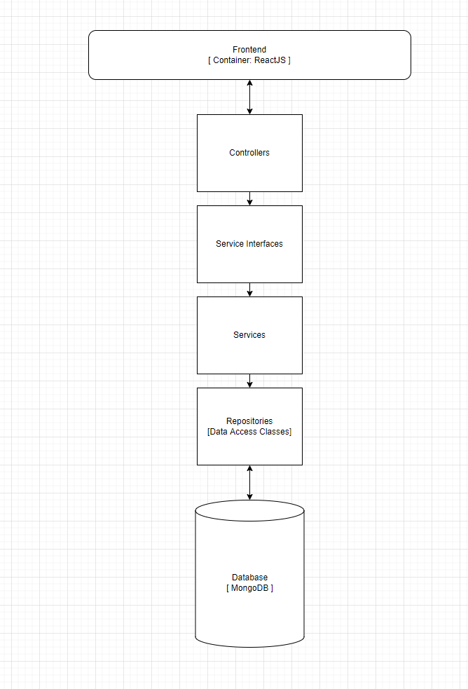

C4 Diagram

This C4 Diagram shows the data, logic and model classes in the Spring Boot backend.

CI Diagram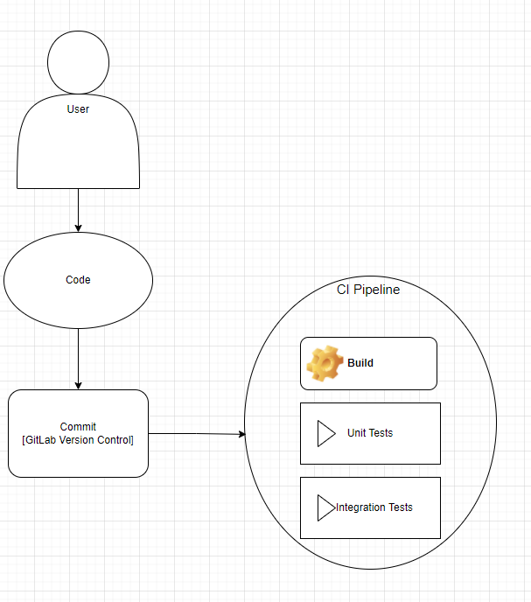

Continuous Integration is a software development practice in which developers commit their changes to the main branch. Each commit triggers an automated code build and test-sequence (including unit tests and integration tests). If a build fails, the CI system blocks is from progressing to further stages and the developer receives a report.