DESIGN THINKING DOCUMENT

Semester 4 Smart Mobile

Matei-Cristian Mitran

Bianca Onea

Contents

INTRODUCTION 3

EMPATHIZE 3

Getting to know David 3

Getting to know the topic 4

DEFINE 5

IDEATE 5

PROTOTYPING 6

TESTING 9

# INTRODUCTION

For the second assignment of the semester, we have to create an iOS mobile applicatiom which is suitable for our persona (Jamie). In order to create this project, we are using the Design Thinking process in order to come up with the best solution for our persona’s needs, problems and wishes.

## EMPATHIZE

For this assignment, we decided to be creative and create our persona and we came up with Jamie, a single dad of two children who wants to secure a future for him and his children.

Here are some relevant questions that helped us form a better idea on David’s lifestyle, goals and needs.

### Getting to know David

1. Who is David?

Jamie, a 33 years old male, is single dad of two children, who is responsible for managing a bank, being interested in finding opportunities for his and his kids’ future. He is currently living in the Netherlands and working at a well-known bank.

1. What is his job?

David is currently employed and works for a bank. He is familiar with technology but not an expert. He wishes to achieve a promotion so he can earn more money for his children.

1. How does a day in his life look like?

Jamie does not have a lot of free time because he is busy working and taking care of his children. Because he recently rented a house, he is also interested in buying the most suitable furniture for the rooms, but his free time doesn’t let him research his options as he would want to. He is often on the internet looking for potential furniture.

1. What are the goals he is trying to achieve?

Jamie’s biggest goal is to give his children the best life they can have, considering that he and the children’s mom are divorced. Furthermore, because he bought a new house, he is looking to create a good environment for his children to grow up in.

1. What is his interaction with technology?

Considering the fact that Jamie is spending a lot of time working, he is still using the internet often in a day to find the furniture for his house. Due to his little free time, he cannot go to the furniture stores to visualize it in person, so he uses the internet to do his research.

1. What are the problems he may encounter?

Considering he is a busy dad, the main problem would be the little free time. He is looking forward to moving in the new house as soon as possible, but the lack of furniture makes it harder.

### Getting to know the topic

Our topic is interior design which is quite a wide and diverse category and it became more and more popular over the years.

Considering the fact that Jamie is spending his time searching for furniture for his new house, this is a perfect fit for him.

The interior design category of applications has as a goal to help people design their homes. This is a perfect match for Jamie as he will find easier finding furniture and visualising it.

## DEFINE

After gathering all the information and observations about Jamie, our persona and our category and topic, interior design, we laid down some problem statements that will be relevant in our ideation process:

1. Jamie needs a bigger income to provide for his children.
2. Jamie needs to use more technology to feel more comfortable with it.
3. Jamie need to buy furniture for his new house he plan to move in.

We should come up with an idea for Jamie that would suit his needs, such as:

1. Find furniture.
2. Help him visualize the furniture so he doesn’t need to go to stores to see it in real life.

## IDEATE

After getting familiar with the persona and our category, we decided to put our ideas, possible attributes, the features that need to be done in order to suit our persona’s needs and how can we satisfy our persona’s wishes on a brainstorming map.

After our individual research, we put together our ideas and created a brainstorming map.

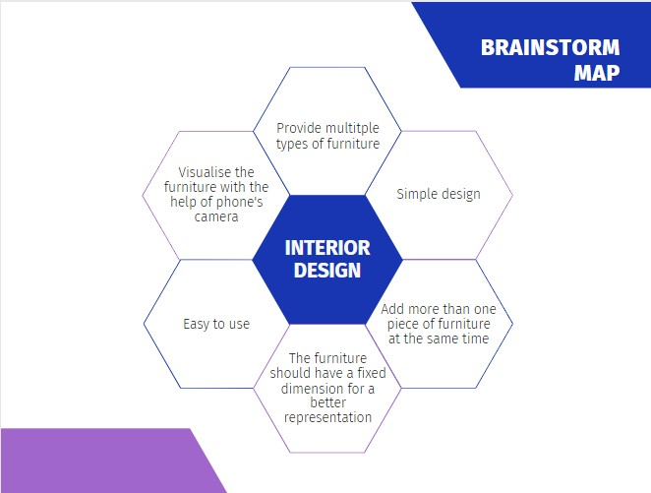

Having in mind all the previously discussed ideas and features, we decided to design an app called **VisionaryDesign**, where people can browse through the available models of furniture and categories, such as tables, chairs, beds, etc. With the help of the Augumented Reality, the user can choose a piece of furniture and place it whenever he/she wants, rotate it and visualise it in order to determine if it fits or not.

## PROTOTYPING

After discussing, laying down our ideas, what features we would want the application to have and create a first draft of the prototype, this is our first result. The prototype was made with the help of Figma.

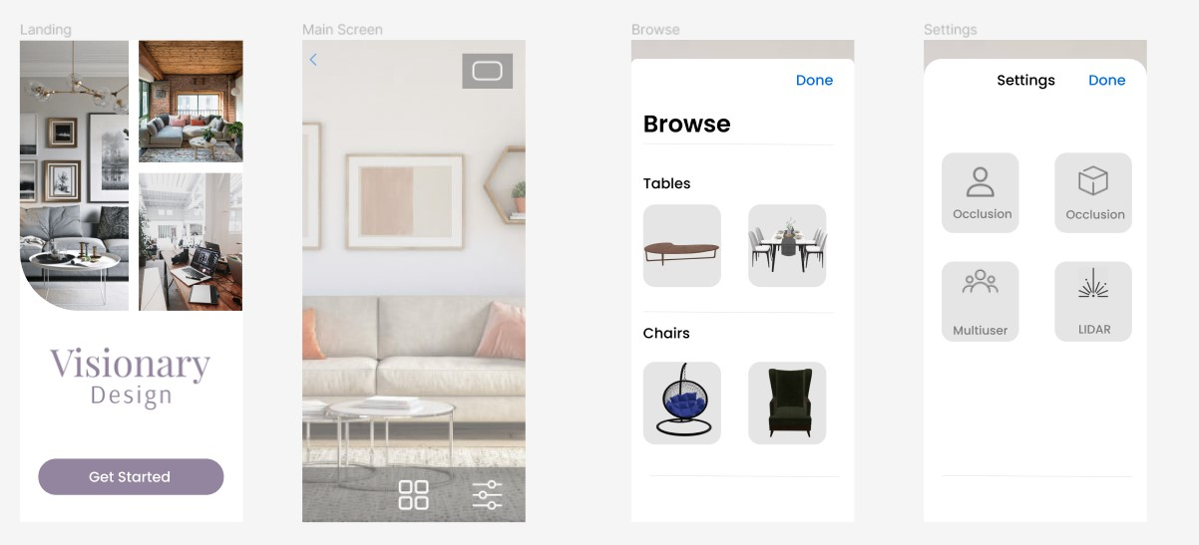

After brainstorming and testing, we made some changes and implemented them. This is our final result:

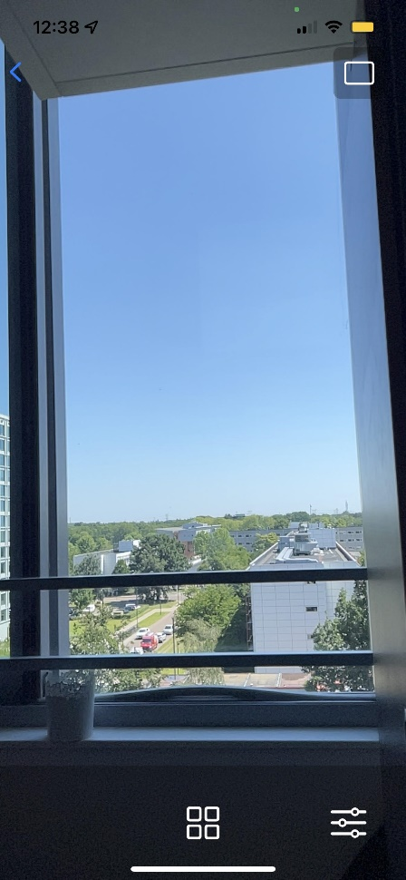1. Landing Page 2. Main Screen (1)

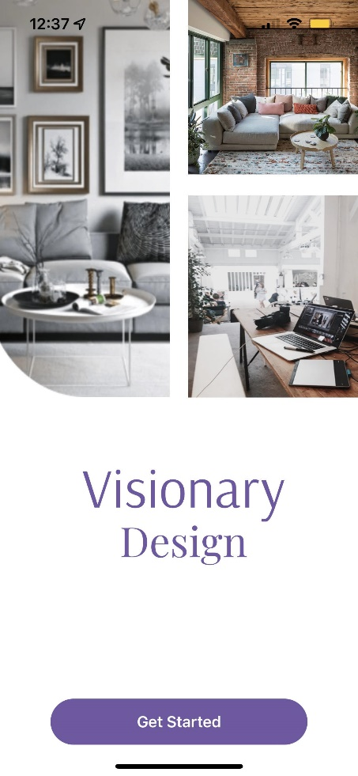

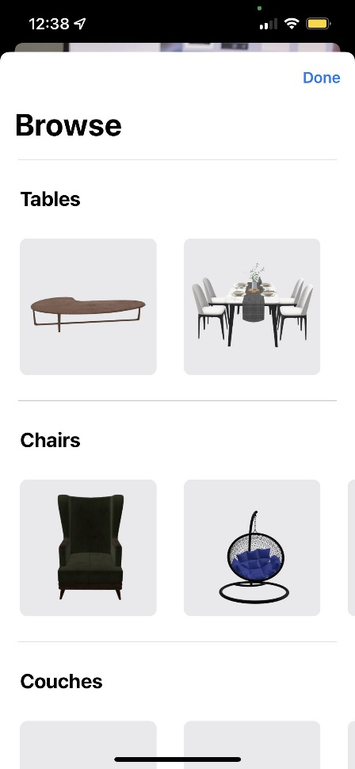3. Browse 4. Settings

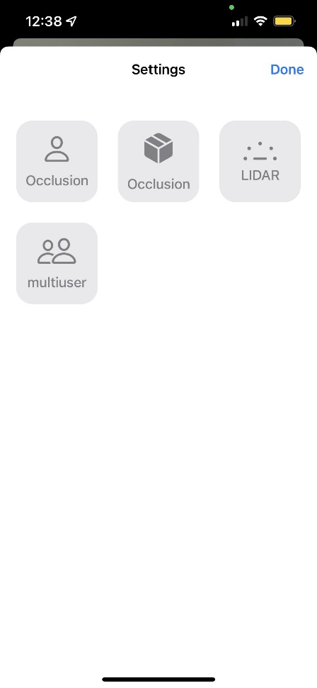

5. Main Screen (2 & 3)

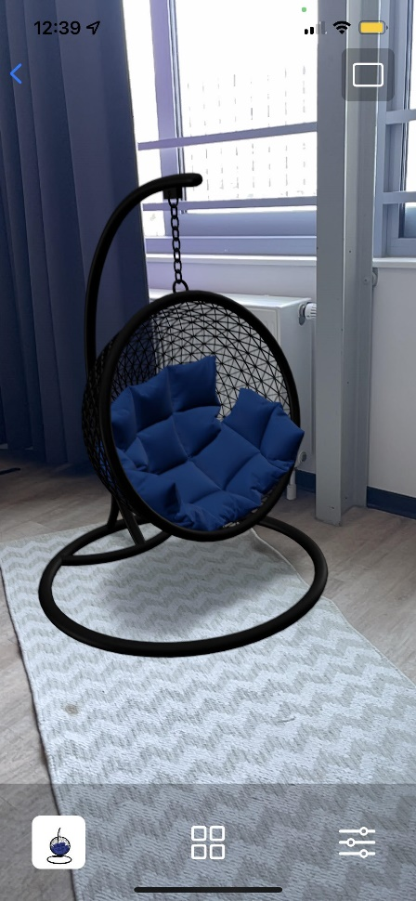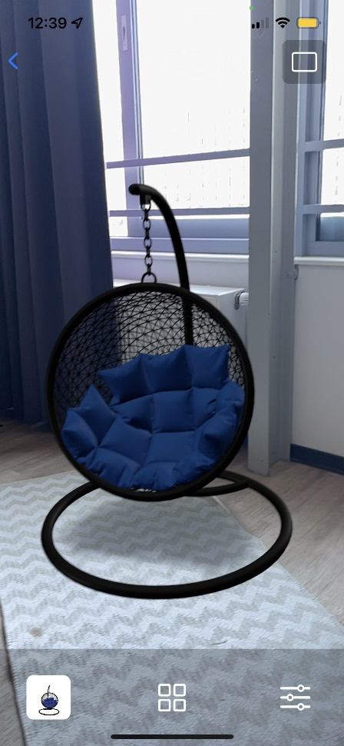

The user is welcomed by the home pages, which has a button that redirects the user to the main screen of the app, which has a button for browsing through the available furniture and another one which is for adding a setting, such as occlusion.

## TESTING

During the process of prototyping our app, we found multiple bugs or features that did not present as expected, so this was a chance to improve our work.

To make sure that our app works as we planned to and to see how we can improve, we asked Ana, one our friends to tell us her impresion about the app, what should be changed and improved.

1. Can you tell us your first impression about our app?

”I really like the app, it is friendly and easy to use. I think it’s very useful for the people who don’t have a lot of free time to go to the stores and look for furniture.’’

2. What do you like the most about our app?

”I really like the general concept of the interior design app and the fact the technology can help us nowadays save precious time, but achieve the same results.”

3. What would you improve/change?

”I would add more furniture into the app and maybe divide it into stores so the user knows which pieces of furniture are from a specific store.”