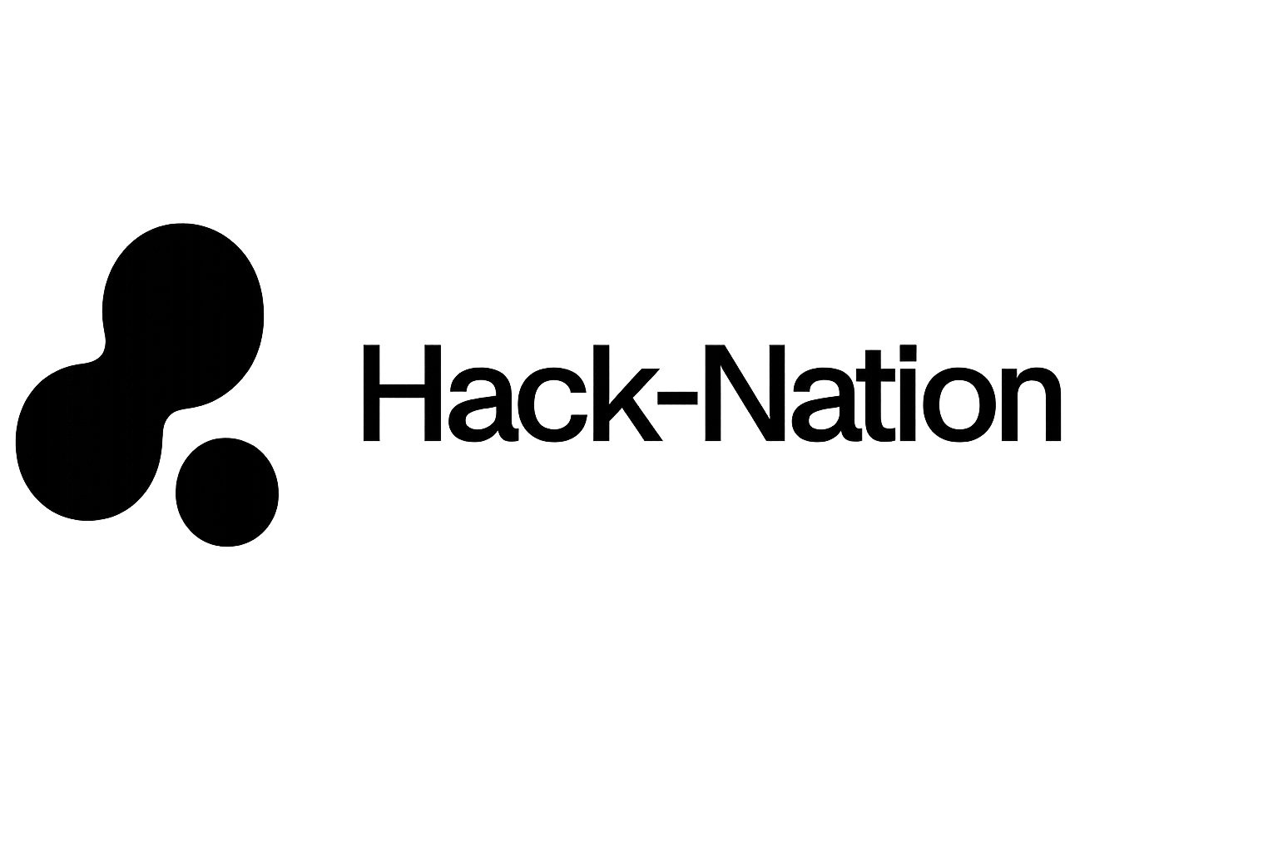
In collaboration with MIT Club of Northern California and MIT Club of Germany

C H A L L E N G E
03
· · · · · · · · · · · · · · · · · · · ·

Serving A Nation
Building Agentic Healthcare Maps for 1.4 Billion Lives

P O W E R E D B Y

databricks — Data Intelligence Platform

1. Motivation / Goal to Achieve
Motivation: In India, a postal code often determines a lifespan. While the nation boasts world-class medical hubs, 70% of the population lives in rural areas where healthcare access is a fragmented puzzle. The issue is not just a lack of hospitals. It is a discovery and coordination crisis. Patients often travel hours only to find a facility lacks the specific oxygen supply, neonatal bed, or specialist they urgently need.
With a dataset of 10,000+ medical facilities, we are moving beyond simple data entry. We are building the Reasoning Layer for Indian healthcare.
Ambitious Goal: Your mission is to build an Agentic Healthcare Intelligence System that can navigate 10,000 messy, unstructured facility reports to find hidden life-saving capabilities. Your goal is to reduce the Discovery-to-Care time to ensure that no family is left guessing where to find help.
Your agent must be able to:
- Audit Capability at Scale: Sift through thousands of unstructured notes to verify if a hospital actually has a functional ICU or just lists one.
- Identify Specialized Deserts: Locate regional gaps for high-acuity needs like Oncology, Dialysis, or Emergency Trauma.
- Navigate the Truth Gap: Reason through non-standardized facility descriptions and flag contradictions where claims do not match reported equipment.
2. Core Features (MVP)
- Massive Unstructured Extraction: Use the Databricks Data Intelligence Platform to process free-form text from 10k Indian facility records. This includes equipment logs, 24/7 availability claims, and staff specialties.
- Multi-Attribute Reasoning: Move beyond keyword search. Your agent must answer complex queries. For example: "Find the nearest facility in rural Bihar that can perform an emergency appendectomy and typically leverages parttime doctors."
- The Trust Scorer: Since there is no answer key, your agent must build a logic step that flags suspicious or incomplete data. An example is a facility claiming Advanced Surgery but listing no Anesthesiologist.
3. Stretch Goals (We know that you can do it!)
- Agentic Traceability: Provide row-level and step-level citations. If the agent recommends a facility, it must show the exact sentence in the medical report that justifies the Trust Score.
Hint: Use MLflow 3 Tracing to visualize the thought process of your agent.
- Self-Correction Loops: Implement a Validator Agent that cross-references extracted data against known medical standards. This ensures the primary agent is not hallucinating.
- Dynamic Crisis Mapping: Create a visual dashboard that overlays your agent's findings onto a map of India. Highlight the highest-risk medical deserts by PIN code.
4. Areas of Research (We don't have the answers)
- Key Questions: The Databricks for Good team is working on these questions. If you can robustly solve questions marked as "could have" or "won't have", please let us know!
- Confidence Scoring: Real world data is messy, so we are certain the dataset is not complete and has errors. How would you take this into account when framing conclusions? Can we use statistics-based methods to create prediction intervals around our conclusions?
5. Hints and Resources
Environment: This challenge is optimized for Databricks Free Edition. Use the provided serverless compute to run your notebooks and leverage the built-in Unity Catalog for data governance.
Primary Tech Stack
- Data Intelligence: Agent Bricks for Foundation Model Training and Serving.
- Agentic Engineering: Genie Code for autonomous, multi-step data tasks.
- Observability: MLflow 3 for agent observability and trace cost tracking.
- Vector DB: Mosaic AI Vector Search for high-speed retrieval across 10k rows.
Datasets
- The India 10k Dataset: A list of 10,000 medical facilities across India, including structured metadata and deep unstructured notes.
- Virtue Foundation Schema: Standardized pydantic models to help you structure your extraction.
- Link to dataset: VF_Hackathon_Dataset_India_Large.xlsx
6. Evaluation Criteria
Discovery and Verification (35%): How reliably does the agent extract data from the 10k rows? Since there is no ground truth, we value agents that double-check their own work for consistency.
Intelligent Document Parsing (IDP) Innovation (30%): How well does the solution synthesize information from messy, free-form Indian facility notes?
Social Impact and Utility (25%): Does the tool effectively identify medical deserts and provide actionable insights for NGO planners?
User Experience and Transparency (10%): Is the interface intuitive? Does it show its Chain of Thought so a human can trust the output?
7. Why It Matters
In a country of 1.4 billion people, near enough is not good enough. By building this agentic layer on Databricks, you are creating a blueprint for Equitable Healthcare. You are turning a static list of 10,000 buildings into a living intelligence network. It knows where the help is and where it needs to go.

