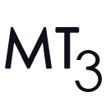

Help

Test for opening a pdf. From Java Netbeans