Heart Generator

# Introduction

Heart Generator is a Java application that allows you to draw pictures of hearts (or any other 2D graphics defined by parametric equations). It originated as a project for “Computer Art” class at Brno university of technology | Faculty of Information Technology.

The project is open source and free to use for educative purposes. The source code contains an examples of some Java 8 features, JavaFX and Nashorn JavaScript engine.

# Graphical parts

When you launch the application a default heart is generated. You can change this default heart in a left side panel. Parts of the panel are described in following sections.

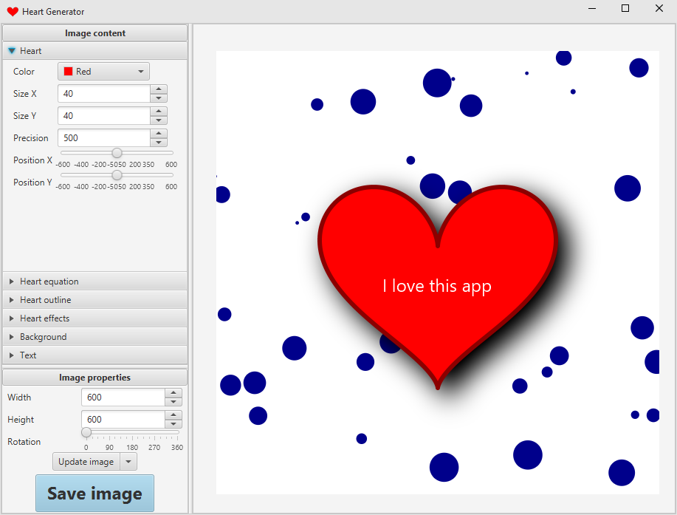

## Heart

### Basic properties

* **Color** – fill color of heart
* **Size X** – heart size on X axis
* **Size Y** – heart size on Y axis
* **Precision** – represents how many points should be computed and used to draw the heart shape (you can imagine it as a step size of parameter t used in parametric equations that define heart shape)
* **Position X** – defines relative position of the heart. Point [0, 0] is in the center of the drawing canvas
* **Position Y** – the same as “Position X” but for Y axis

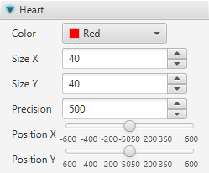

### Parametric equations

Parametric equations define a shape of the heart. You can choose from 9 pre-defined equations and modify them as you wish.

In order to draw the heart shape, you have to define max size of the parameter t. During the computation of the heart shape, the parameter goes from 0 to max size. Size of the incrementing step depends of “precision” mentioned in previous chapter.

Another thing that needs to be specified is a parametric equation for X/Y axis. You can use standard mathematical operations and functions to define the equation/s (internally Java Math class is used to make the computation).

Following list covers all supported mathematical functions + Java doc form <https://docs.oracle.com/javase/8/docs/api/java/lang/Math.html>

* **PI** – size of the pi number
* **cos** – Returns the trigonometric cosine of an angle.
* **cosh** – Returns the hyperbolic cosine of a double value.
* **sin** – Returns the trigonometric sine of an angle.
* **sinh** – Returns the hyperbolic sine of a double value.
* **tan** – Returns the trigonometric tangent of an angle.
* **tanh** – Returns the hyperbolic tangent of a double value.
* **asin** – Returns the arc sine of a value; the returned angle is in the range -pi/2 through pi/2.
* **atan** – Returns the arc tangent of a value; the returned angle is in the range -pi/2 through pi/2.
* **exp** – Returns Euler's number e raised to the power of a double value.
* **log** – Returns the natural logarithm (base e) of a double value.
* **pow** – Returns the value of the first argument raised to the power of the second argument.
* **abs** – Returns the absolute value of a double value.
* **sqrt** – Returns the correctly rounded positive square root of a double value.
* **random** – Returns a double value with a positive sign, greater than or equal to 0.0 and less than 1.0.
* **signum** – Returns the signum function of the argument; zero if the argument is zero, 1.0 if the argument is greater than zero, -1.0 if the argument is less than zero.

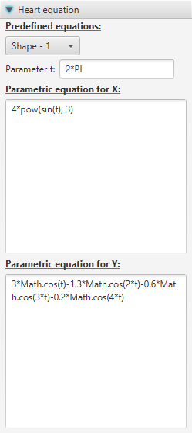

### Outline

This menu allows you to change color and width of heart’s outline.

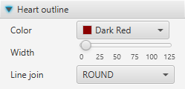

### Effects

Just play with it and you will see how it works. ;-)

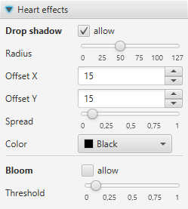

## Background

Background is a layer rendered under the heart. This menu allows you to define base color + render certain number or circular/rectangular shapes.

You can specify constrains for minimum and maximum size of the shapes + color of the shapes. Just be aware that the shapes are rendered on random positions and each time you change some parameter, the whole image will be re-rendered. That means that new random positons for the shapes will be computed. So the original background will be lost.

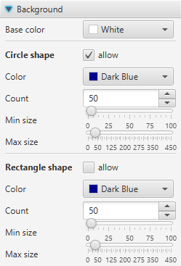

## Text

Do you want to write some text on top of the heart? This is the right place where to go. It allows you to define text, its color, position and size.

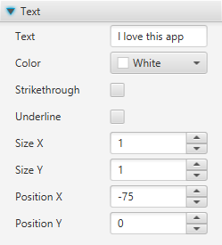

## Image properties

This menu allows you to specify image size in pixels, rotation of the image and whether the image should be updated/re-rendered each time you change some parameter.

There is also a very important button for saving the image. :-)

