PRIRODNO-MATEMATIČKI FAKULTET

INSTITUT ZA MATEMATIKU I INFORMATIKU

UNIVERZITET U KRAGUJEVCU

Studentski upis

Radio: Mentor:

Mateja Planić 81/2022 Miloš Pavković

**Dijagram komponenti**

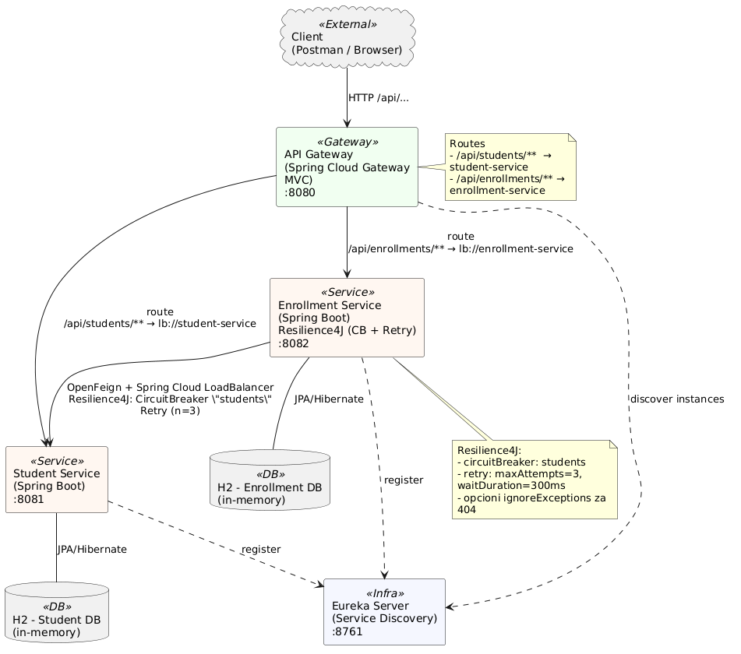

**Tabela servisa**

**Servis Port Rute Odgovornosti**

|  |  |  |  |
| --- | --- | --- | --- |
| API-GATEWAY | 8080 | GET/POST/PUT/DELETE /api/students/** - lb://student-service  --------------------------------  GET/POST/PUT/DELETE /api/enrollments/** - lb://enrollment-service | Centralna ulazna tačka; rutiranje i load-balancing preko Spring Cloud LoadBalancer-a; integracija sa Eurekom (preuzima registry, ne registruje se). |
| STUDENT-SERVICE | 8081 | POST /api/students  GET /api/students  GET /api/students/{id} PUT /api/students/{id} DELETE/api/students/{id} | CRUD nad studentima; validacija (Hibernate Validator); H2 baza (in-memory); registruje se na Eureku. |
| ENROLLMENT-SERVICE | 8082 | POST /api/enrollments  GET /api/enrollments  GET /api/enrollments/{id} PUT /api/enrollments/{id} DELETE/api/enrollments/{id}  GET /api/enrollments/{id}/details | Upravljanje upisima; agregacija detalja (poziv **student-service** preko OpenFeign-a); Resilience4j (CircuitBreaker + Retry za Feign klijenta „students”); H2 baza; registruje se na Eureku. |
| EUREKA SERVER | 8761 | (nema javne poslovne rute) UI:http://localhost:8761/ | Service discovery: registry za servise. |

**Obavezni delovi**

• Service Discovery – Eureka Server

* Jedan Eureka server + oba servisa registrovana kao klijenti.

• API Gateway – Spring Cloud Gateway o Centralna ulazna tačka; rutiranje ka servisima (/api/students/**, /api/enrollments/**).

• Dva mikroservisa

* student-service: kompletan CRUD nad Student (validacija, H2).
* enrollment-service: CRUD nad Enrollment + jedna business operacija koja poziva student-service.

• Komunikacija servis–servis – OpenFeign o enrollment-service koji koristi Feign klijent ka student-service.

• Otpornost – Resilience4j (Circuit Breaker + Retry) o Primena CB + Retry na Feign pozivu (sa kratkim fallback odgovorom ili jasnim HTTP greškama).

• Persistencija: H2 (in-memory) za oba servisa.

• Agregacioni endpoint o GET /enrollments/{id}/details (spajanje podataka iz oba servisa preko Feign poziva).