TestMP.lab.
#requirements
-HW 2x VM server konfig VM - vCPU - 2
- vRAM – 4GB
- vDisk – 50GB (separatni disk)
- vNick – 1x
- licencie = standard lic. 2x – win. Server
- apps = ADDS
DNS
Nainstalovali sme daas a DNS
Dalej ideme promote the server to DC
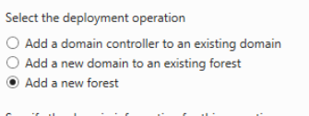Toto test
DSRM - ak nevieme vratit SID a RID (tie riesia opravnenia) a roby to ze umoznuje
obnovenie z DB object
Sluzi na to aby sme isly do recovery modu s F8 basically
Nema GUI
Po vrateni usera z recoveri DB budu nezosynchrozinovane a defaultne by sa zese vymazal.
neauthoritative; restore(default)
F
authoritative,
Menovanie domain 1. Max 15 znakov
2. Velke a male pismena
3. Cisla
4. _ , -

