Azure virtual mahines
On-demand delivery of computer resources with pay-as-you-go priciples.
IaaS
- total control over operating sys
- ability to run custom software
- to use custom hosting configuration
but u need to configure, update and maintain the software that runs on the VM
VM resources:
- size
- storage disk
- networking
nevyhnuthe veci su
- cpu
- mem
- os disk
- data disk to moze byt pod os disk
- nic
- konektivitu
- firewall
- public IP

azure virtual desktop: (side stop of information)
- tu su tvoje udaje a tu mas virtualku v claude.
- Its a desktop and application virtualization service that runs on the cloud. Enables you to use a cloud-hosted version of windows from any location
- Works across devices and operating systems, and works with apps that you can use to access remote desktops or most modern browsers

Azure containers – AKS (azure kubernetes services)
- Najväčšia úroveň kontajnerizácie

Azure functions:
- Event-driven, serverless compute option that doesnt require maintaining virtual machines or containers.
- Azure functions an event triggers wakes up a function

Azure application hosting:
Na spustenie treba azure app service
- Azure app service:
  - web apps
  - API apps
  - webjobs
  - mobile apps

azure network services:
and also virtual subnets enable azure resources, such as VMs, web apps... to communicate with each other.
These virtual networks provide the following key networking capabilities:
- Isolation and segmentation
- Internet communications
- Comm between azure resources
- Comm with on premises resources
- Route network traffic
- Filter network traffic
- Connect virtual networks

Bastion namiesto VPN alebo dirrect connect je ze: sme user na serveri a na tom sa pomocou ssh pripojime na VMku V PODSTATE TO JE JUMP SERVER.

Tvorba VMky
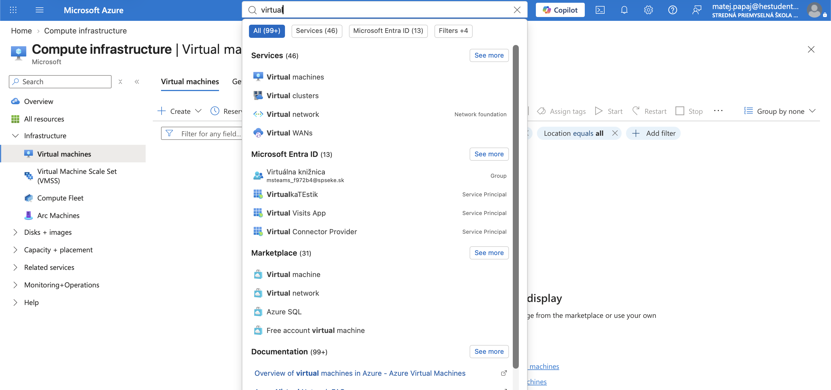
Virtual machines
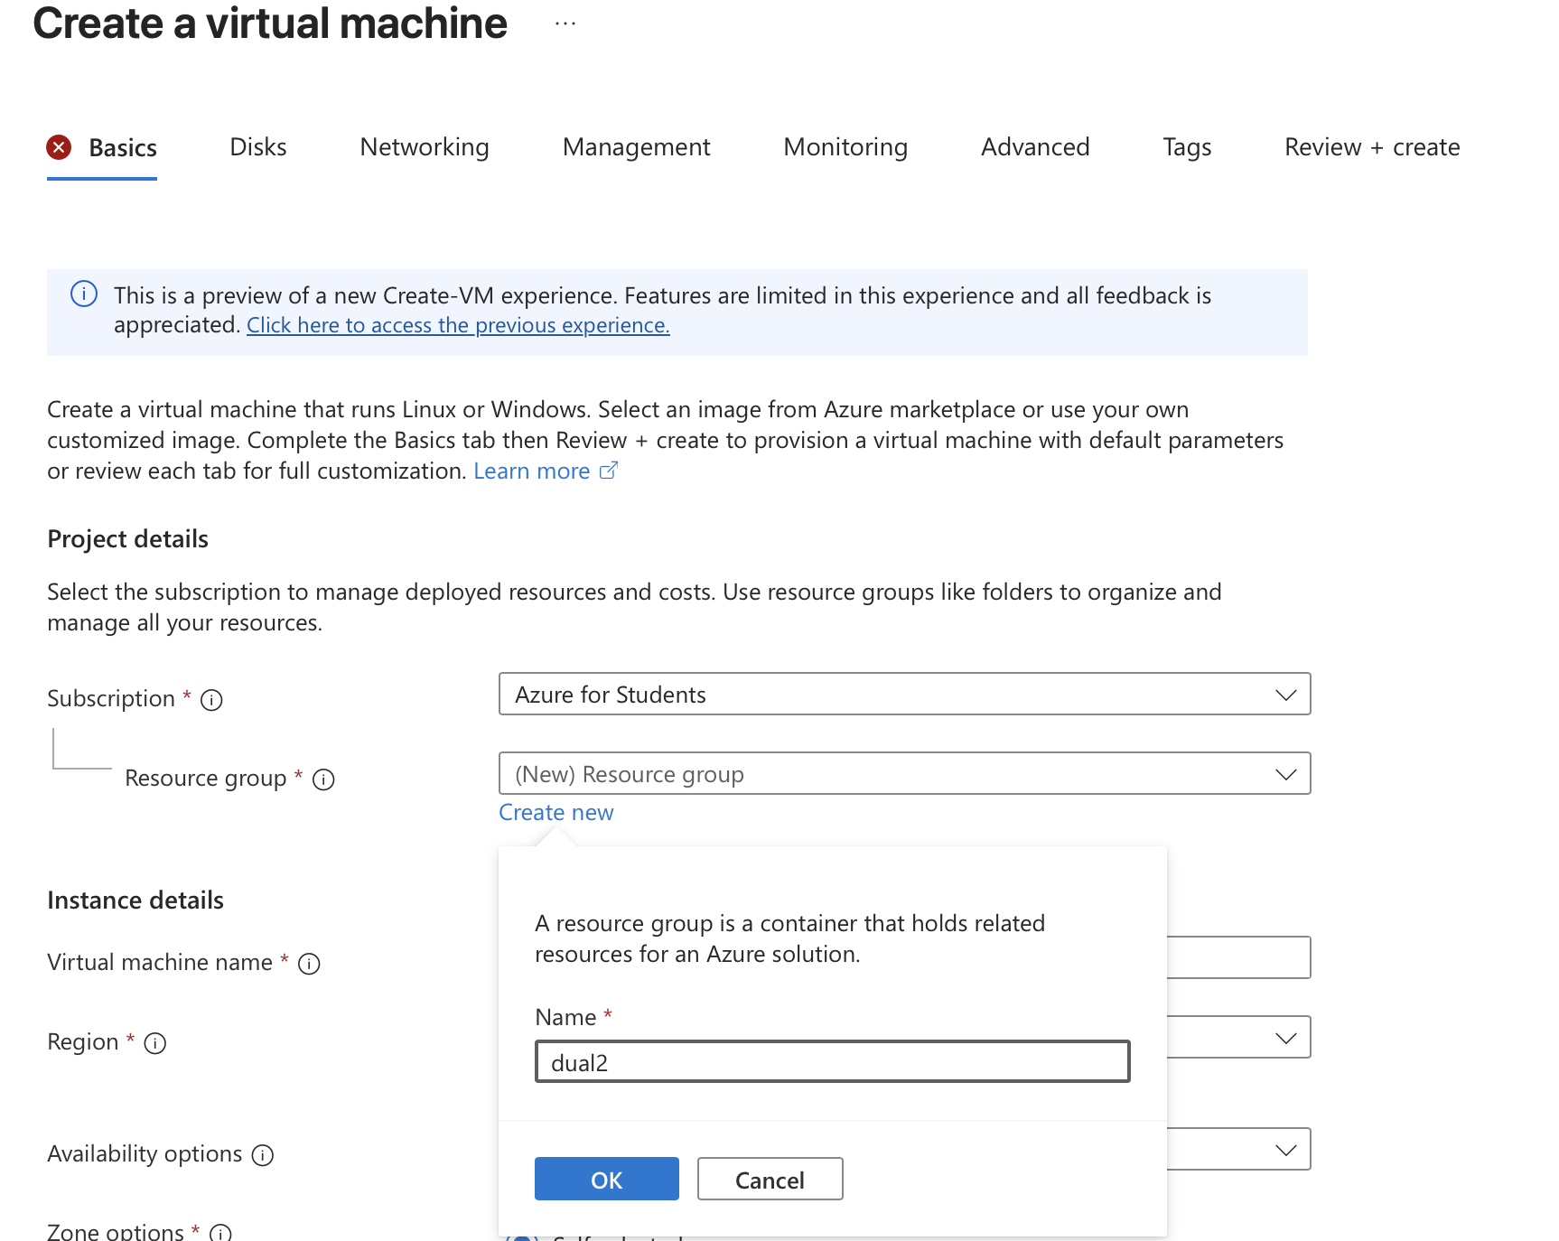
Vitvorime group resource ka ju nemame
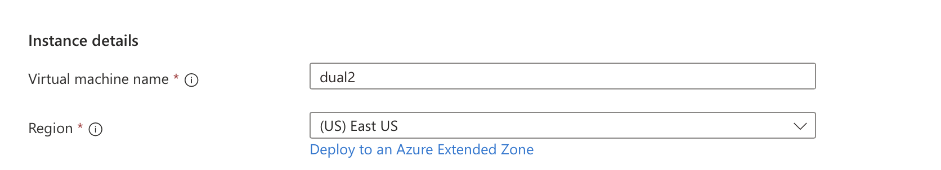
Meno a region tt co sme si poznacili
Tu nic bo to to ze bude na viaceryhc AZtach
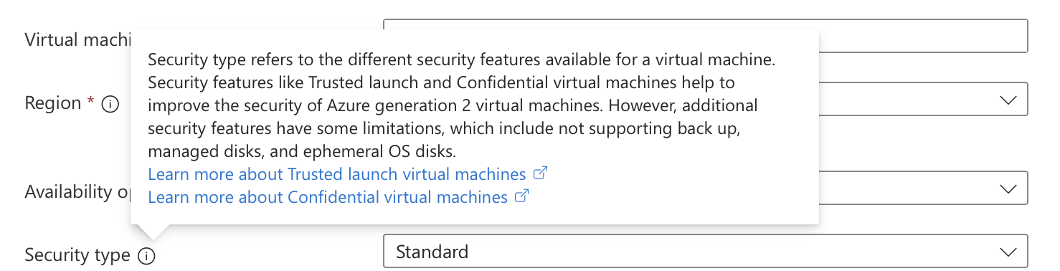
Security idk ale proste standard
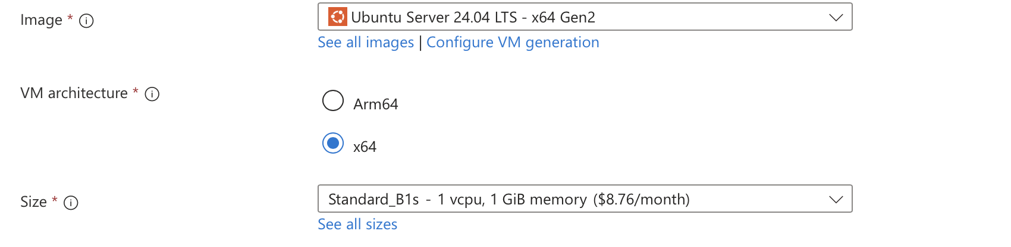
Vyberies os architekturu a size a to blbne tak mozno musis zmenit to miesto z switzerland abo co na napr francusko
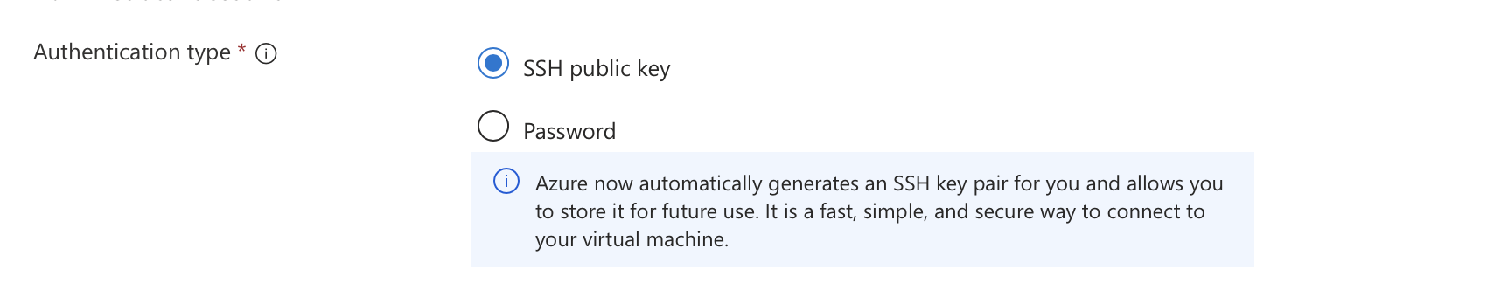
Ssh abo heslo
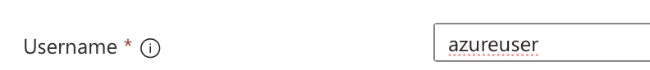
Username na machine
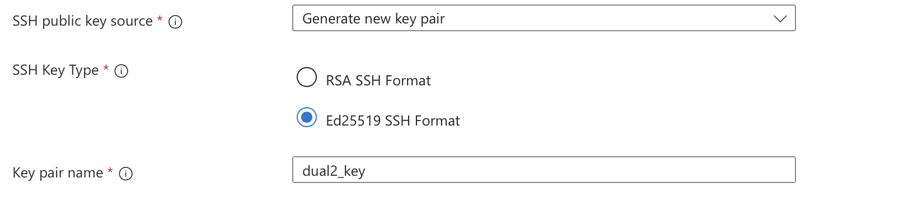tvorba ssh kluca na pripojenie
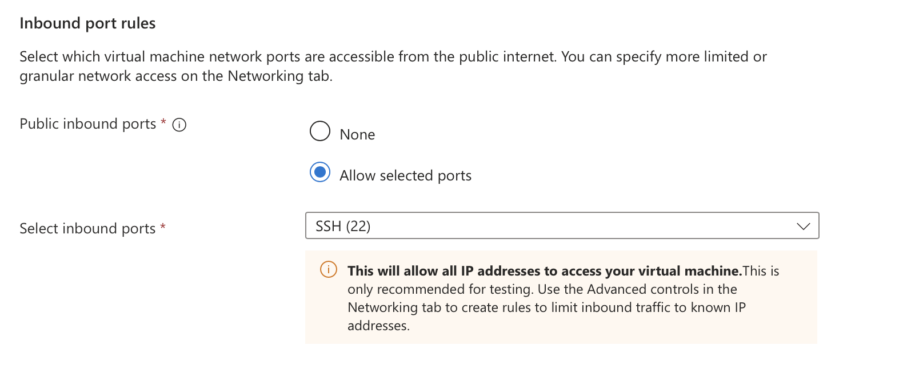toto nechas ako je

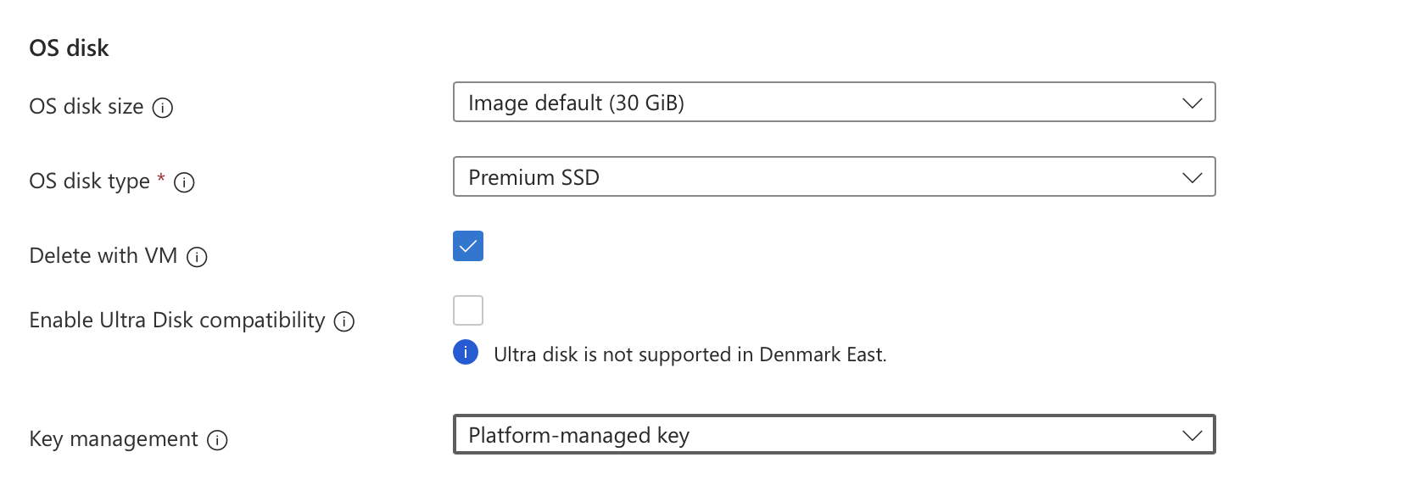
Toto na stranke disk takto platform lebo setrime (toto dole)

Dalej vytvorime disk
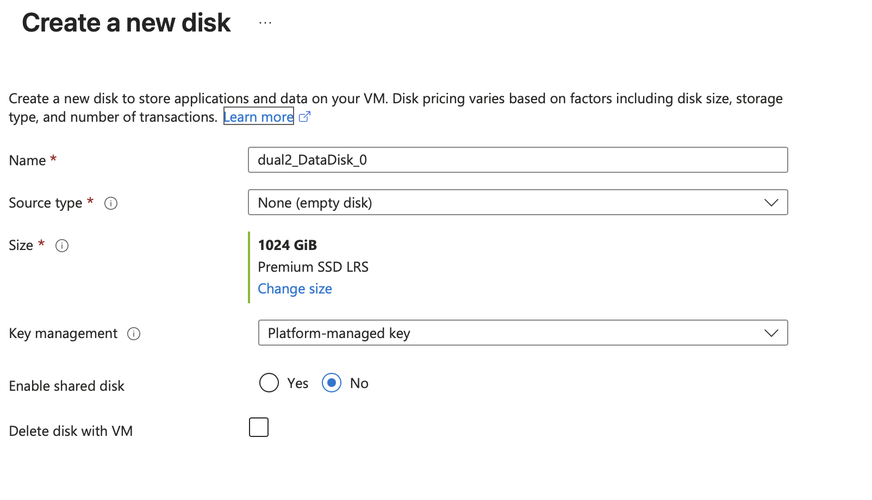

Networking takto
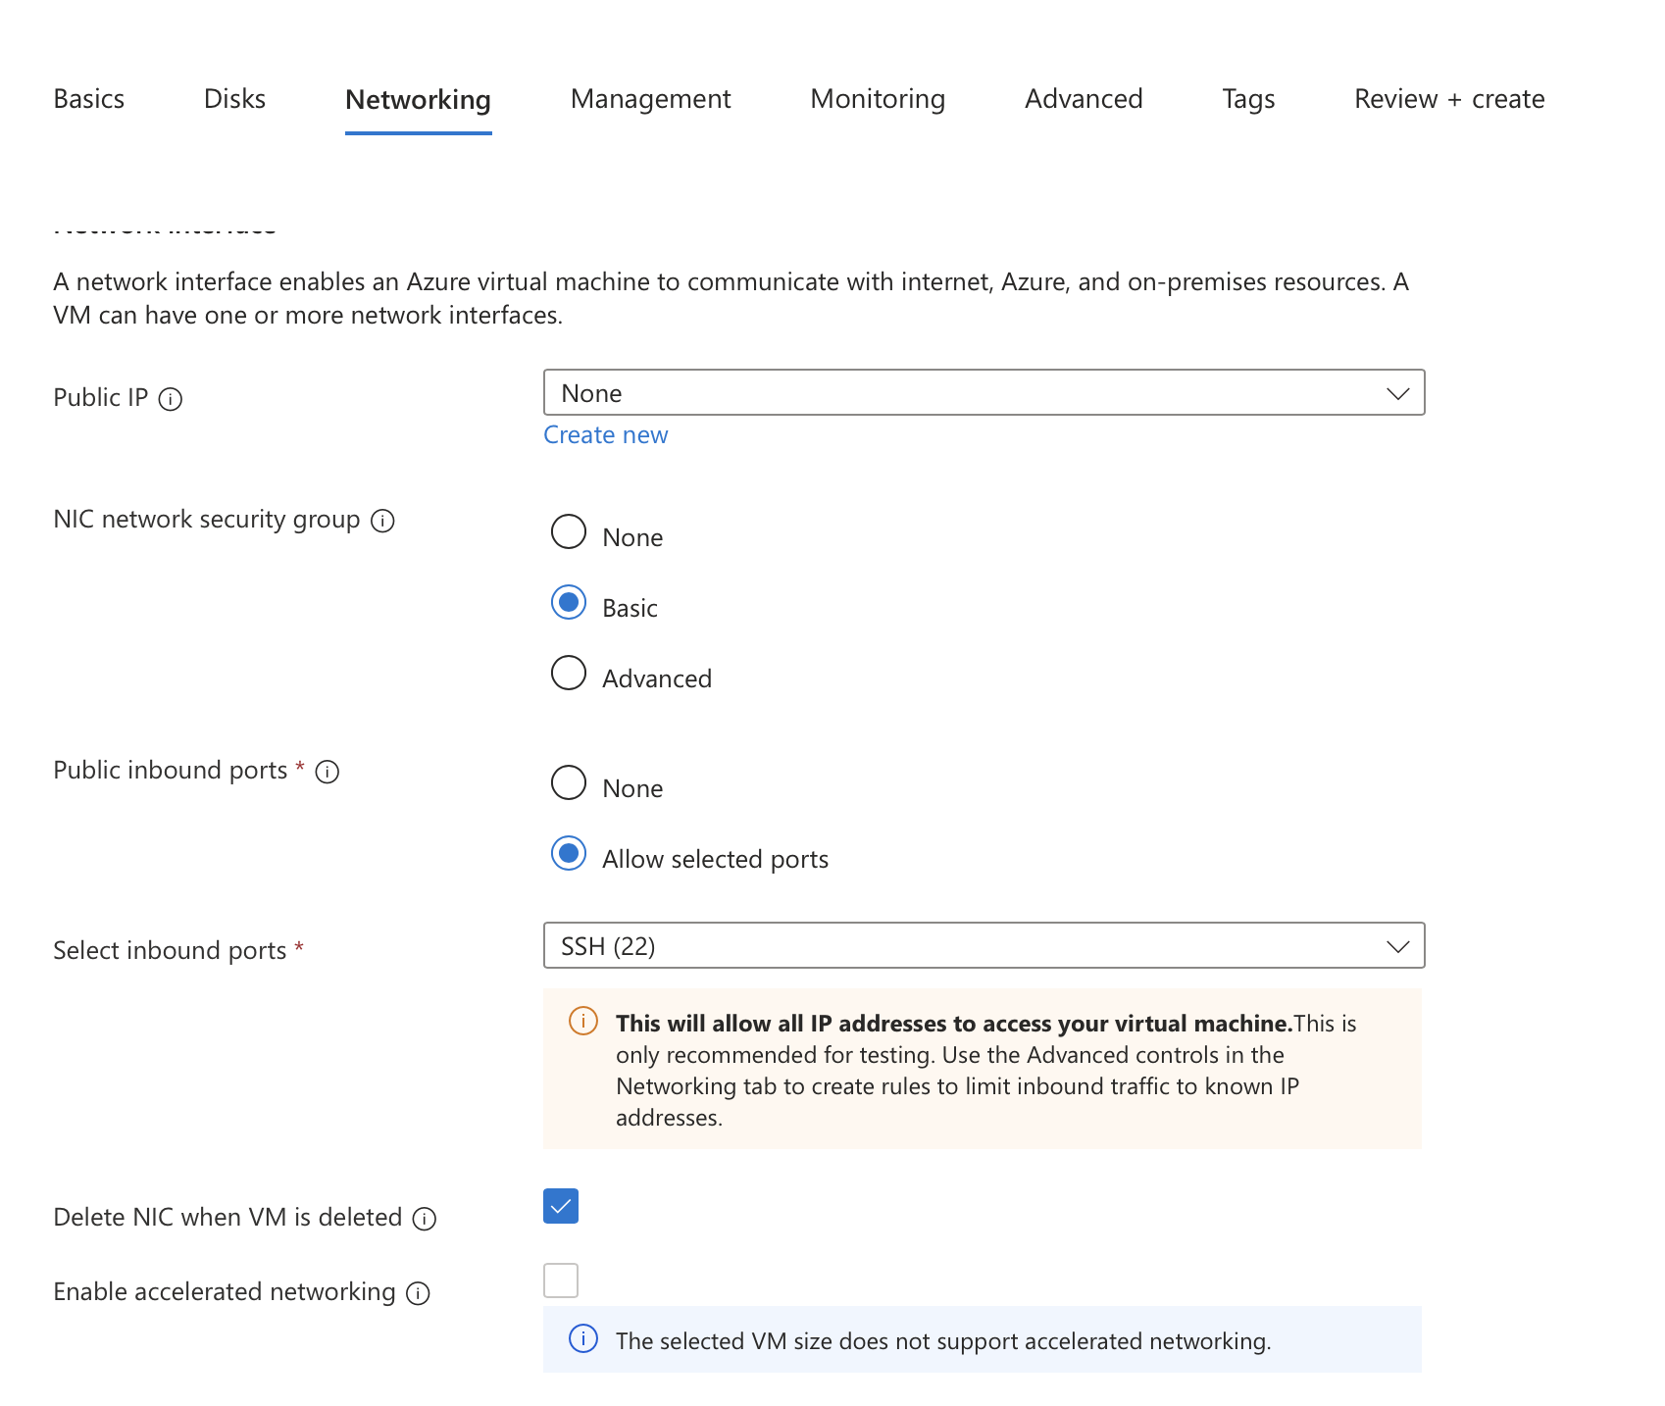

Management: ako sa prihlasujeme tam ale nic nedavame
Monitoring disable
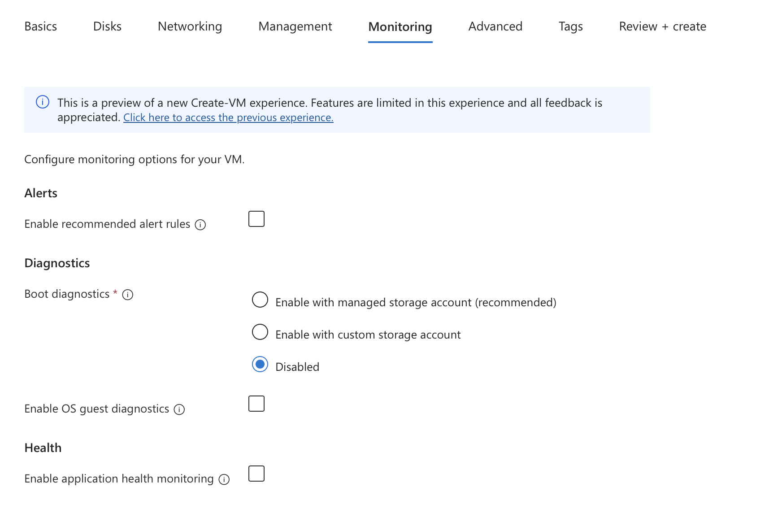

V advance su napr init scripty to tam pozes podavat. Alebo napr neaku conf machiny

Tags su tags. Manazment nice vec
A tu ptm iba das create
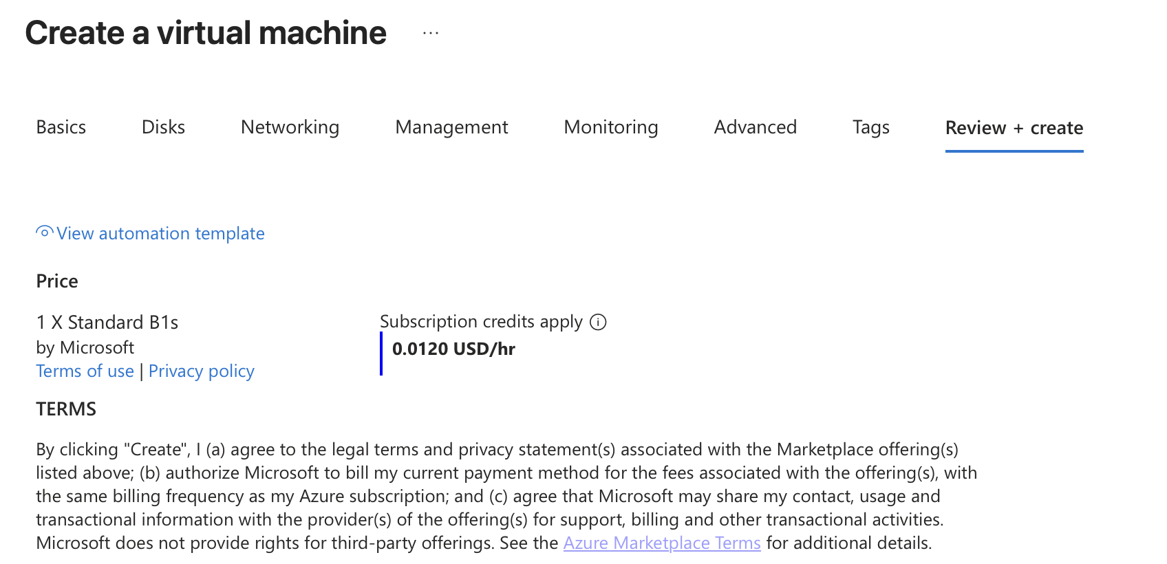

A my sme nespravili public ip ta ides public ip tam vytvoris das meno rovnake miesto a prec ddos protekcia.
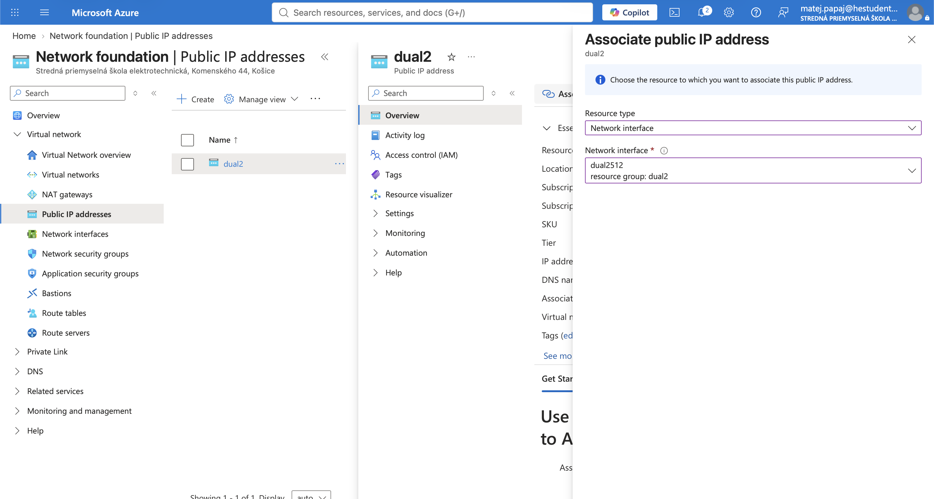
A tu ides public ip das tu co si vytvoril das associate a vyberies tu machinu

Teraz sa ide fixovat ssh ak chapem spravne
Capek zapol INbound security rules a tam potom daco urobil
Zajtra ma meniny Móric (fasa)
Hm
Uz mu to ide vsetko nastavil proste jednu rule
Nikdy som neklikal na lepsej notebookovej klavesnici, zavidim fest...

