What is git?

Git is open-source free control management

You can manage changes of files over time and can look back what they used to look like

With this we can create a new website and or branch create changes and merge it with the original

And with git we can just revert back to the version before hand.

If we screw up we can go back to previous version.

Git bash

To launch git but we can launch it in any terminal cmd, powershell 3th party terminal…

Zakl config gitu

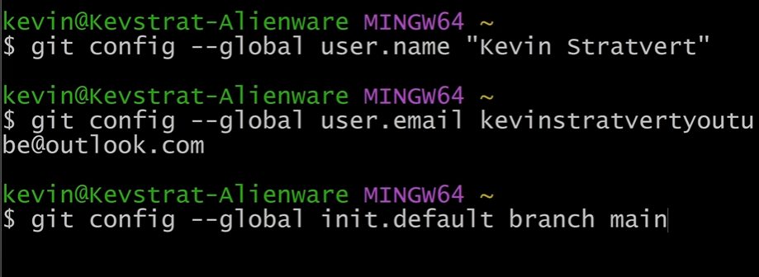

Git init Spravenie git repository

Git status info o git repository

Git add add a file to tracking git add (file…)

Git rm -cached (file) remove file from tracking

Creating txt file .gitignore in this text file we add what files it should ignore

For example “\*.txt” ignore all txt files

Git add --all -A . track all files except ignored files

Committing

Snapshot of file and how it looks now

Git commit -m “msg (hello world)” commiting

After changes

Git status will show also changes

Gif diff will show differences on what is different on files on pc and what was las gitted on git

Git add (file) put file on hold upload it but not commit put file on stage

Git restore --staged (file) this will move file from stage category to working category

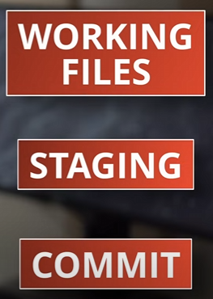

We can skip staging

Git commit -a -m “msg” this skips it

Git rm “file” removes file

Git log all commits over time

Git commit -m “msg” --amend changes the last commit to this one

Git log -p see what has actually been changed in files

Git reset (commit number) go back in time to specific git

BRANCHES

Git branch name create a new branch later we can connect it back to the main branch

Git branch shows actual branches

Git switch (branch name) change to different branch

Merge the branche to main one git merge -m “text” (branch to merge into main)

Git branch -d name branch delete a branch

Git switch -c name of branch switch and creates a new branch