TO: ME 2171 Instrumentation Lab Instructional Staff January 27th, 2026
FROM: Mateo Jaime Tecum Jacinto, Section 07- Wednesday
SUBJECT: Lab 2, Computerized Data Acquisition and Control: Digital Input/Output
1.0 Statement of Purpose
The objectives for this lab included finding the number of digital input and output lines for the DAQ hardware that is being used and determining the transfer function of the DAQ board’s digital input lines. We must also determine the transfer function for the board’s digital output lines and then create a two player reaction game from the lab instructions.
2.0 Background
The model number we used was the NI USB-6221 data acquisition device (also referred to as DAQ device) from National Instruments. The DAQ device has 20 digital input and output (I/O) lines that allow for external hardware to transfer data with LabVIEW. This lab included having both inputs and outputs, which could be demonstrated in LabVIEW alone, but using the DAQ board, the board highlights how these inputs and outputs look outside of the software. These digital lines are sorted out through different port types, which lets LabVIEW read or send digital signals if we are using the digital I/O ports (which we are).
For this lab, we used 2 switches and a buzzer. The board itself provided us with input and output ports that gave us the ability to have LabVIEW interact with the hardware we are using. Our DAQ device includes 20 digital input & output lines. In this program, we are attempting to use the digital I/O of the DAQ to see how I/O signals can be read and sent from LabVIEW. Using LabVIEW to send and receive digital information, the capabilities that LabVIEW has with other hardware can allow us to create bigger systems.
3.0 Discussion
3.1 Equipment
- LabVIEW (computer that runs LabVIEW)
- NI-USB-6221 (DAQ) board
- Siglent SDG 1022XPlus Function Generator
- Multimeter
- Buzzer
- 2 Switches
- BNC cable
- BNC adapter
- Basic wires
- Wire Strippers
3.2 Programming elements
- DAQ Assistant: one of LabVIEW’s functions that allows the measuring and generating of data with NI-DAQmx devices.
- Stacked Sequence Structure: A structure that will run one frame at a time for a program and has the data flow continuously.
- Sequence Local: Passes data between frames (from the stacked sequence structure)
- Wait until next ms multiple: Has the operating system wait a certain value, that is defined. It forces the timing to align to the defined ms value givenn.
3.3 Objective 1: Number of I/O lines
The digital input lines on the data acquisition board were 20 digital I/O lines. These lines are grouped into different ports, with each port having lines that can be used as inputs or outputs. The port types in this model have ports designed for analog outputs, analog input, & digital input/output. For this lab, the digital and timing I/O port type was used.
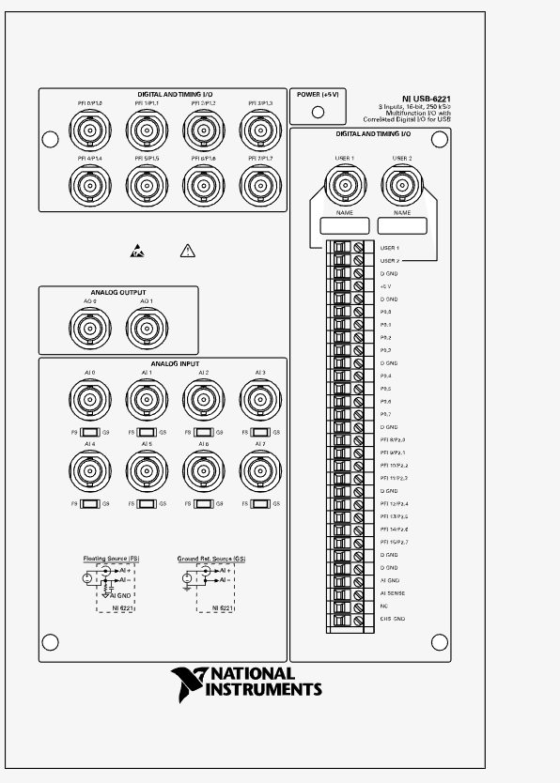
Figure 1. USB-6221 BNC Top Panel and Pinout
3.4 Objective 2: Digital Input Characteristics
Our group implemented a digital input line on Port 3 on the DAQ board(our group had complications with port 0). We then observed from LabVIEW, using the DAQ Assistant function, to see when a HIGH value was returned. For the settings on the DAQ Assistant we ensured that the DAQ Assistant was configured to Port 3. Using the Function Generator, we could then connect it to the digital input line and set an output voltage (ranged from -10V to +10V). From this, our team gradually increased the voltage and then observed the Boolean indicator on LabVIEW to determine if the value was a digital LOW or HIGH. Starting off, we increased in increments of 1V, and after determining the general range of a digital HIGH, we then started at a range below the high and increased the voltage by .1V, and then repeat once we got the HIGH again to obtain a precise value.
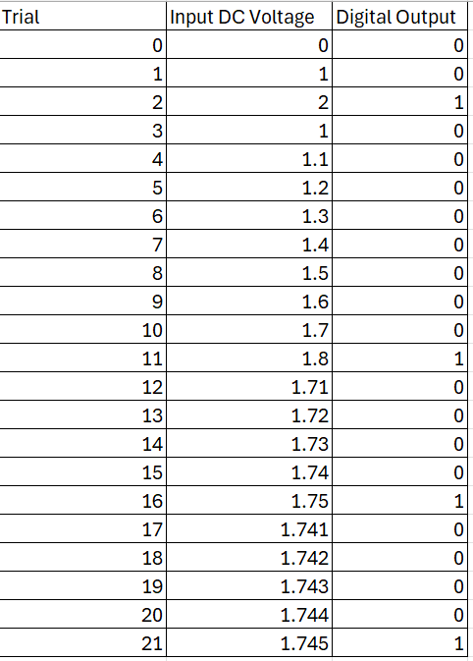
Table 1. Input Voltage (ranging from 0-2V) and Digital output of 0 or 1.

Figure 2. Digital input calibration graph of the DAQ board. Depicts input voltage versus digital output (0 or 1). The threshold voltage hits around 1.745V.
3.5 Objective 3: Digital Output Characteristics
Utilizing a second DAQ assistant on LabVIEW, configured as a digital output on another port that is connected by a BNC. Using a multimeter to measure the voltage that corresponds to each Boolean state, which would show if the voltage would return a True or False output. We recorded the a value of 0.012V as False and 5.051V for an output of True.
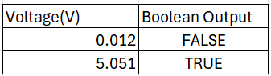
Table 2. measured digital outputs from BNC line on the DAQ board.
3.6 Objective 4. Buzzer VI game
Hardware setup
The two switches were connected between the +5V and the digital input lines were plugged into the P0.0 & P0.1 of the DAQ device. The switches will serve as the inputs of Player 1 and 2, with the buzzer being connected to ground and P0.3, that will activate when the digital output is True (the buzzer will get a Boolean signal from either switch).
Block Diagram
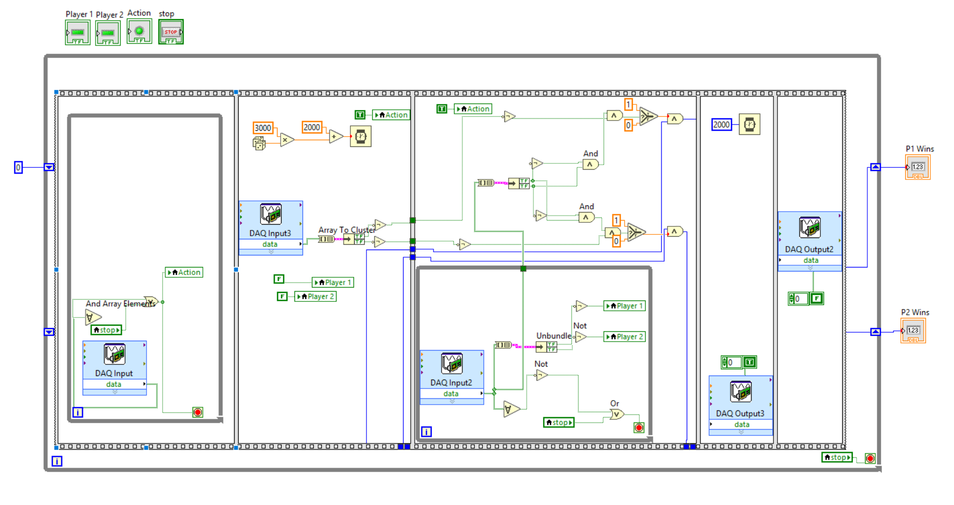
Figure 3. Block diagram of the modified buzzer game.
The block diagram of the modified buzzer game runs by the Flat Sequence Structure, which consists of 5 frames. These frames are each executed in the order from left to right, with frames 1 & 3 having while loops inside. Additionally, the entire frame structures are inside another while loop, which will run until the user chooses to stop running the game (if not the while loop allows for the game to repeat continuously). The most notable modification in this setup is the use of the shift register that is connected to the frames and keeps count of each player’s wins. Although a bit complicated, using the selector comparison function allows for the count of a win for either players, which is then used in the shift register until the while loop stops which will have the total amount of wins for each player that is shown on each player’s indicator on the front panel. The program has the shift register start with a value of 0 when the game begins.
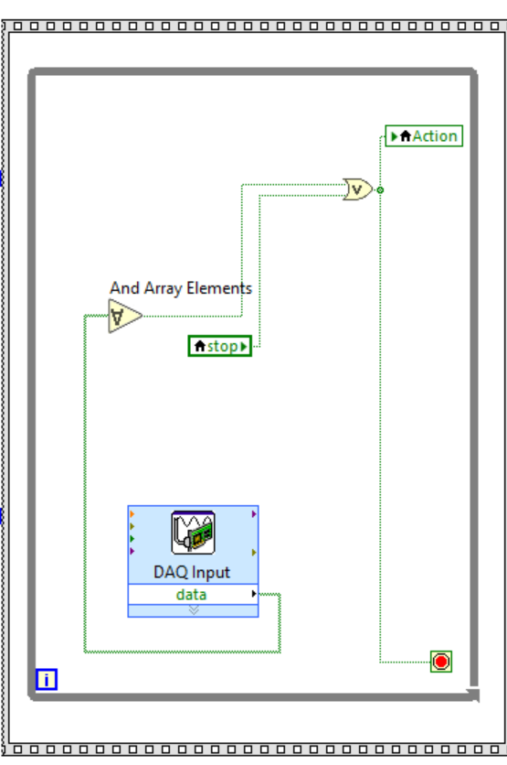
Figure 4. Closer look of frame 1
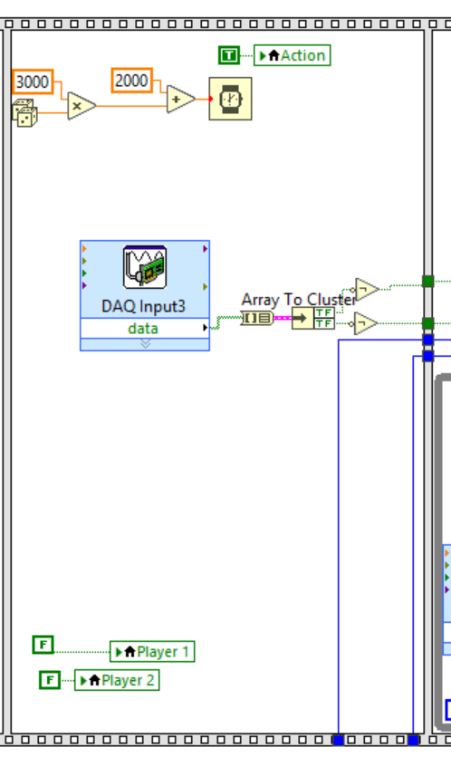
The first frame, which is executed first, is responsible for ensuring that both characters are ready, with the DAQ reading the two input line (the two switches connected to the DAQ board). Each signal will then pass through the add array element, and then an AND element that will be True when both player’s switches are closed, which results in two digital Highs. The last element in this frame is the while loop, which will keep the aforementioned elements to continue running continuously (like the DAQ reading the player’s switches), and will stop once both switches return True when closed.

Figure 5. Closer look at frame 2
The second frame is responsible for a delay that is imposed between each iteration. This delay is used in order to prevent cheating from players by generating a random number between 0-1, which has a multiplier of 3000 and adds 2000 (which makes the delay between 2-5 seconds). This makes the delay from the Action buzzer turning on to always be different in each run. A different delay for each run prevents cheating, because players can not begin the game by guessing when the action button turns on. The DAQ in this frame accepts an input value of the players and then converts the data from an array to a cluster with the next function. These then get placed into each player’s button state, and using the NOT logic, the value is the inverse of what the input is. This means that if Player 1 opened their switch before the action LED is on, then the program will know that player 1 had cheated and it will have marked Player 1’s state as False (which is later used in frame 3).

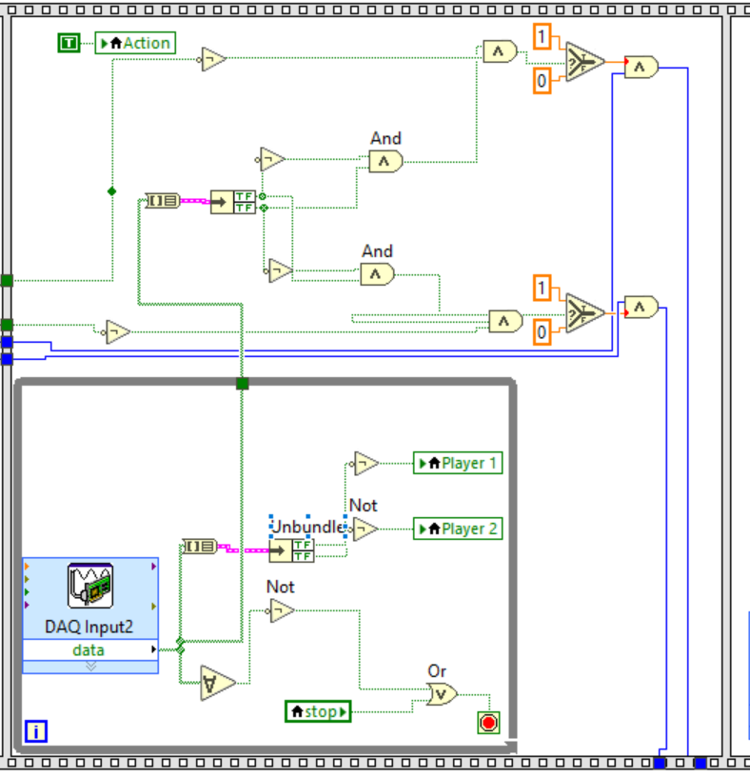
Figure 6. Closer look at frame 3
Frame 3 has the most amount of logic involved in the data flow, but the purpose of frame 3 is to record which of the two players react first and note them as a winner for the round. Additionally, from frame 2 it is ensuring that the win was achieved without cheating.
The while loop in this frame serves to make the DAQ read the input signals and will only stop once the stop button or when a player releases their switch (due to the NOT changing the data from False to True). Once a player releases their switch and the while loop ends, the program records the False and True statements of the players in that iteration and the data goes through the Array to Cluster where the data is used twice. The data for Player one goes into one AND terminal and into a NOT that is then put into the terminal of the other AND logic gate. The same is done for the data on Player two’s state. This logic gate works as it will have one player (who released their switch) have a false statement go into the NOT gate making it True, and the other player’s switch state (also True), which will have the AND gate become True, while the other player would have two False, resulting in the AND gate having a False boolean. These values are then giving one Player a value of 1 (if True) or 0 ( if false). It is important to note the AND gate before each Selector, as it requires frame 2 to have a True statement (which would mean the Player is not cheating), and the Player released their switch first in order for the player to win. The Value is then connected to shift registers that record each point (player’s win count) until the iteration stops.
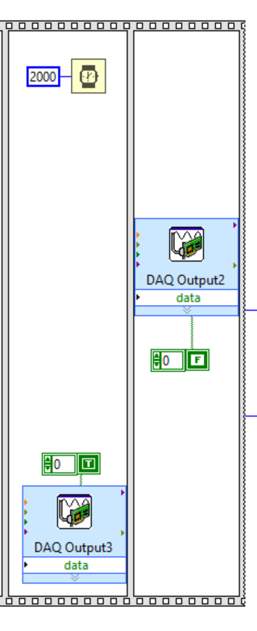
Figure 7. frames 4 and 5, On and off of the buzzer
Frames 4 and 5 deal with the buzzer that is an output signal. Frame four sends a signal at the end of the round (that is a True Boolean) to the buzzer port. This results in the buzzer turning on and sounding for a duration of 2000 ms (or 2 seconds).
Frame 5 deals with the inverse of frame 4, which is sending a false Boolean to the buzzer’s port, which results in the buzzer turning off.
Overall, after each frame is completed sequentially and the while loop outside of the Stacked Sequence Structure ends, then the values of each player’s wins that is recorded on the shift register is set to the number indicator that is displayed on the front panel.
4.0 Conclusions
The DAQ board shows nice digital I/O capabilities as it allowed LabVIEW to interact with it directly, which was connected to external hardware that could give or receive digital information(true or false). The system made in this lab directly converted the voltage signals into True and False values and used the values on the hardware. From the input voltage calibration, the input voltages measured voltages below 1.475V resulted in False values when decreasing the voltage, whilst voltages above 1.745V resulted in True when gradually increasing the voltage. For the digital output portion of the lab, the 0.012V had a False value correlated with it, while the 5.051V had a True value correlated with it.
Using LabVIEW with the DAQ board also let us use the Flat Sequence Structure, which showed to have reliable and good sequencing when the reaction game ran. LabVIEW was able to execute multiple frames sequentially and kept track of all the data(most notably the amount of player wins). Overall, using LabVIEW and the DAQ worked nicely and is straightforward when configured correctly.

