Pinched Flow Fractionation
Microfluidic Device
Design Portfolio Report
Concept design for size-based separation of polymer microbeads using a 3D-printable PFF microchannel
Mateo Tecum Jacinto
Project status: conceptual CAD/design analysis; experimental validation not included
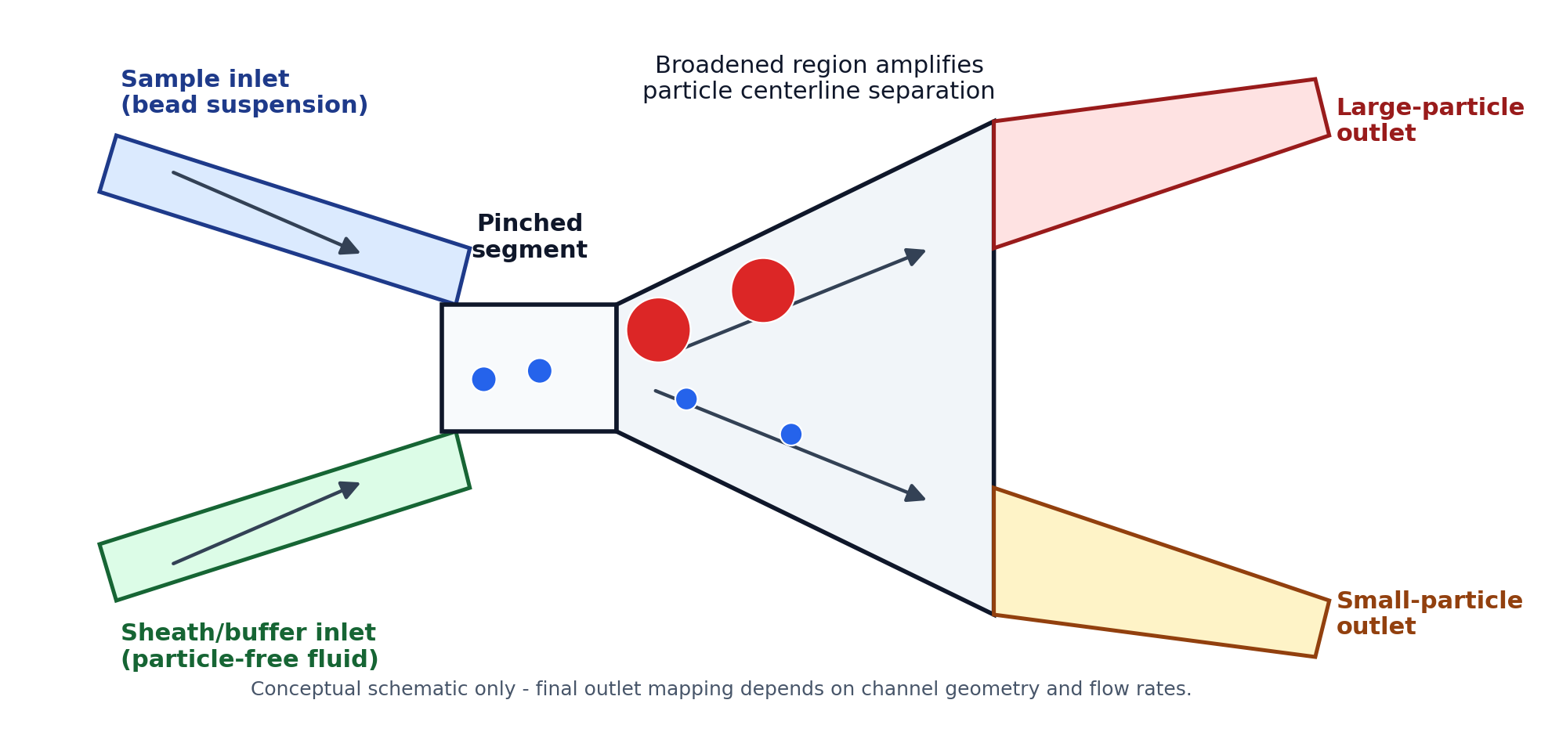
Figure 1. Original schematic of the PFF concept used for this GitHub documentation package.
Portfolio framing | Microfluidic device design, literature review, CAD-driven geometry iteration, manufacturability analysis, and validation planning.

1. Executive Summary
This project explored the design of a microfluidic device that uses pinched flow fractionation (PFF) to separate polymer beads by size. The target sample contained two bead populations: a small population around 53 micrometers and a large population around 500-600 micrometers. The design was approached as a CAD-driven microfluidics problem with attention to the PFF mechanism, 3D resin-printing constraints, channel geometry, outlet selection, and post-processing.
The strongest engineering contribution is the design process: translating a literature-based passive sorting mechanism into a printable device concept, then iterating the geometry to reduce unnecessary channel complexity. The project should be presented as a conceptual design and technical analysis, not as a validated separator, because the available work does not include experimental bead-count data or measured separation efficiency.
Main deliverables produced or documented:
- Literature-based explanation of the PFF separation principle.
- Device architecture with sample inlet, sheath/buffer inlet, pinched segment, broadened region, and two outlet paths.
- Design iteration from a complex multi-outlet concept toward a simpler two-outlet architecture.
- Manufacturing notes for resin 3D printing, minimum feature size, optical inspection, and parylene coating.
- Validation plan for future flow testing and bead separation measurement.

2. Background: Why Pinched Flow Fractionation Works
Pinched flow fractionation is a passive microfluidic separation method that uses laminar flow and channel geometry rather than an external field. A particle-containing liquid is introduced alongside a particle-free sheath or buffer liquid. The buffer stream squeezes the sample stream toward one sidewall inside a narrow pinched segment, aligning the particles by forcing their centers into size-dependent lateral positions.
When the flow exits the pinched segment and enters a broader channel, the streamlines spread. Larger particles have centers farther from the wall than smaller particles, so their trajectories are displaced differently. This creates lateral separation downstream and allows the particle streams to be routed toward different outlets.
The literature emphasizes that PFF performance depends strongly on flow-rate ratio, width of the pinched segment, outlet/broadened-channel width, transition geometry, and the relative size difference between particle populations. Low Reynolds number, steady-state laminar flow, no-slip boundary conditions, and limited particle-wall interactions are important assumptions for the basic model.

3. Design Requirements and Constraints
Requirement / constraint | Design implication | Portfolio note
Small bead population | Approximately 53 micrometers. | Useful for showing size contrast and separation target.
Large bead population | Approximately 500-600 micrometers. | Creates a major clogging and channel-depth constraint.
Passive sorting method | Use sheath flow and channel geometry instead of external electric/magnetic/acoustic fields. | Shows understanding of microfluidic passive-separation methods.
Resin 3D-printing resolution | Minimum reliable feature size was treated as about 85 micrometers. | Important manufacturability limitation; do not overclaim true micro-scale precision.
Optical inspection | Device footprint and transparency should support microscope observation. | Supports validation with bead tracking and outlet counts.
Post-processing | Parylene coating considered for surface consistency after printing. | Mention as a proposed treatment, not as proven performance data.

4. Proposed Device Architecture
The final concept is intentionally simple. It uses two inlets, a narrow alignment region, a broadened separation region, and two outlets. The simplified architecture is easier to explain, easier to fabricate, and easier to validate than the initial multi-outlet concept.
- Sample inlet: carries the bead suspension into the device.
- Sheath/buffer inlet: squeezes the sample flow against a wall in the pinched segment.
- Pinched segment: aligns particles and sets the initial centerline offset.
- Broadened region: expands streamlines so the size-based centerline difference becomes large enough to collect.
- Two outlet paths: collect streams enriched in smaller or larger particles, depending on geometry and flow-rate ratio.

5. Design Iteration and Engineering Decisions
The first design direction used multiple outlet channels to separate particles across several positions. That approach increased the number of flow paths but also introduced unnecessary variability. For a proof-of-concept device separating two bead populations, extra outlets would make the device harder to print, harder to analyze, and harder to troubleshoot.
The revised design used an expanded/broadened region and removed the middle outlet path, reducing the design to two outlets. This made the device more specialized for binary size separation and better matched the actual goal of separating small beads from large beads. The design also used angled inlet and outlet transitions to avoid abrupt geometry changes that could disturb flow or increase dead zones.
This iteration is the clearest story for a GitHub portfolio: start with a broad concept, identify the engineering issue, simplify the design, and document the manufacturability tradeoffs.

6. Analytical Model and Feasibility Check
A common PFF relationship models the effluent position of a particle center as a function of pinched-segment width, particle diameter, and outlet/broadened-channel width. In simplified terms, the downstream separation between two particle centerlines scales with the particle diameter difference and with the expansion ratio between the outlet width and the pinched-segment width.
This means that a narrower pinched segment and a wider broadened region can amplify lateral separation. However, the geometry cannot be chosen only from the equation. The channel must still physically pass the largest particle population, and the flow must remain stable enough for predictable separation.
For this specific project, the 500-600 micrometer bead population is the major feasibility constraint. A final design should verify that the channel depth, constriction width, outlet width, and connector geometry can pass the largest beads without clogging. If a preliminary constriction is smaller than the largest bead, that version should be treated as an iteration that needs redesign rather than a final manufacturable geometry.

7. Manufacturing and Post-Processing Considerations
- CAD platform: Fusion 360 was used to plan the geometry and make iterative changes before fabrication.
- Fabrication method: resin 3D printing was selected for rapid prototyping and design iteration.
- Resolution limit: small channel features must be designed above the printer/resin minimum feature size and checked after printing.
- Surface roughness: resin printing can leave layer artifacts that affect microfluidic flow and particle-wall interactions.
- Parylene coating: proposed as a thin coating to improve surface consistency and protect the resin channel surfaces.
- Dimensional shift: coating thickness and resin curing can change effective channel dimensions, so final dimensions should be verified.

8. Validation Plan for Future Work
Step | What it would show
Leak and flow test | Run dyed water or buffer through the inlets to check bonding, leaks, trapped air, and visual flow stability.
Single-particle-population test | Flow small beads and large beads separately to verify that neither population clogs the device and to observe baseline outlet routing.
Mixed-bead separation test | Run mixed beads through the device and record outlet distributions under microscope.
Quantitative separation metric | Count particles from each outlet and calculate enrichment, purity, and recovery for each bead population.
Iteration | Adjust flow-rate ratio, pinched-segment width, transition shape, or outlet geometry based on measured results.

9. Limitations and Honest Portfolio Framing
The available work is strongest as a design and documentation project. It should not be presented as a working device unless fabrication and experimental bead-count data are added later.
The large-particle population makes this project more challenging than many standard microfluidic examples. That challenge can actually strengthen the portfolio story if it is framed as a design-risk identification problem: the device must balance PFF amplification with practical channel clearance, print resolution, and clogging prevention.
For GitHub, the recommended framing is: conceptual design, literature review, CAD iteration, manufacturability analysis, and validation plan.

10. Skills Demonstrated
- Microfluidics fundamentals: laminar flow, particle focusing, passive separation, and outlet routing.
- Engineering design process: requirements, constraints, iteration, simplification, and risk analysis.
- CAD and prototyping: Fusion 360 design planning for resin 3D printing.
- Manufacturability thinking: feature size, channel depth, post-processing, and optical inspection constraints.
- Technical communication: converting a concept into a structured GitHub-ready project report.

References
Yamada, M., Nakashima, M., & Seki, M. (2004). Pinched Flow Fractionation: Continuous Size Separation of Particles Utilizing a Laminar Flow Profile in a Pinched Microchannel. Analytical Chemistry, 76(18), 5465-5471. https://doi.org/10.1021/ac049863r
Sajeesh, P., & Sen, A. K. (2014). Particle separation and sorting in microfluidic devices: A review. Microfluidics and Nanofluidics, 17, 1-52. https://doi.org/10.1007/s10404-013-1291-9
Maurya, A., et al. (2022). Microfluidics geometries involved in effective blood plasma separation. Microfluidics and Nanofluidics, 26(10). https://doi.org/10.1007/s10404-022-02578-4
Takagi, J., Yamada, M., Yasuda, M., & Seki, M. (2005). Continuous particle separation in a microchannel having asymmetrically arranged multiple branches. Lab on a Chip, 5, 778-784.

