First delivery numerical processes

Code linking: <https://github.com/MateoAg1/Procesos-Numericos->

<https://colab.research.google.com/drive/1Obo2cWbvdhn5qHcgxPX9HDi1YcTUs8LJ>

Selected applications of each of the methods:

Bisection method: The bisection method is a numerical methods technique used to find roots of functions. This technique has numerous applications in different fields of engineering. We will focus on explaining its applications in production and mechanical engineering:

Production engineering/industrial engineering:

1. The bisection method can be used to determine the break-even point in goods and services. With this we can calculate the point at which revenues equal total costs in the short run.

Using the bisection method we can calculate this point at which revenues and total costs intersect.

Mechanical Engineering:

1. Using the bisection method we can determine the maximum load that a structure can support. Using a function that relates the load to the deformation of the structure, we can find the point at which the deformation reaches a maximum value.

2. Another application can be to determine the optimum value of the resonant frequency of a mechanical system.

Our chosen application of the bisection method applied to real life is ; Application of the bisection method to find an equilibrium point of goods and services.

The break-even point helps us to evaluate the profitability of a business, since by finding the crossing point between the revenue and cost functions we can calculate how much the company must sell to generate profits and make it a profitable company. At the same time, contingency strategies can be developed in fortuitous cases of low seasons and periods where low sales are expected. Other applications of the break-even point in companies are to evaluate the growth of the company in the short and medium term and to verify by means of this (having previous data) how profitable a business is.

Translated with www.DeepL.com/Translator (free version)

"The break-even point is established through a calculation that serves to define the moment in which the income of a company covers its fixed and variable expenses, that is, when you manage to sell the same as you spend, you neither win nor lose, you have reached the break-even point"( https://www.salesforce.com/mx/blog/2021/11/punto-de-equilibrio-que-es-y-como-calcularlo.html).

The break-even point has different ways of calculating it. Doing this calculation by means of numerical methods and using software such as phyton or Matlab saves us a lot of time that translates into a decrease in productivity, facilitates the process and guarantees the elimination of the human error factor in the calculation. We also save us from having to purchase software to calculate the point or go to third parties.

Application Data:

Markland Manufacturing is looking to increase capacity by solving a bottleneck operation by adding a new piece of equipment. Two suppliers submitted proposals.

The fixed costs for proposal A are $50,000 and, for proposal B, $70,000. The variable costs for A are $12.00 and for B are $10.00. The revenue generated by each unit is $20.00. "https://www.plandemejora.com/ejercicios-resueltos-punto-de-equilibrio/"

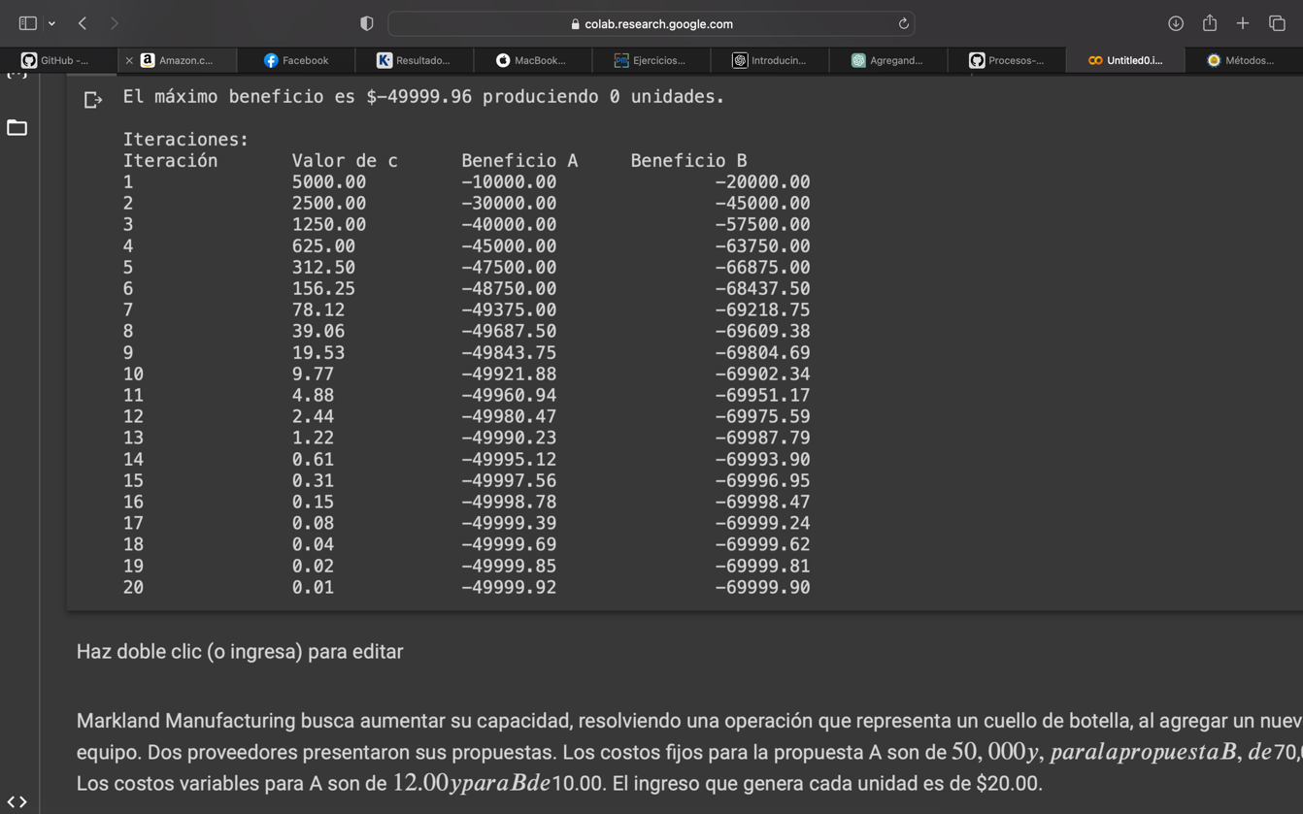

False rule method:

The false rule method is a method that serves us to find an approximation of the root of a continuous function. It is also known as the inverse linear interpolation method. For this method we will focus on applications in mechanical engineering since it is where this method has better applications.

The chosen real life application of this method is an application to find the solution to a physical system problem ; We will find the natural frequency of an undamped mass-spring system.

Application data:

If we place a 5 kg mass on a spring, the spring elongates 10 cm. We release the mass 8 cm below the equilibrium position. What is the equation of motion assuming simple harmonic motion (Take the approximate value of g = 10 m/s).

Newton's method:

Newton's method or Newton-Raphson method is a method of numerical analysis used to find roots of a real function. Another of its functions is to find the maximum or minimum of a function and to find the zeros of the function.

Application Data:

The equation shown has a root in [1,2], since f(1)=-5 and f(2)=14.

Show the partial results of the Newton-Raphson algorithm with a tolerance of 0.0001.f(x)=x3+4x2−10=0f(x)=x3+4x2−10=0

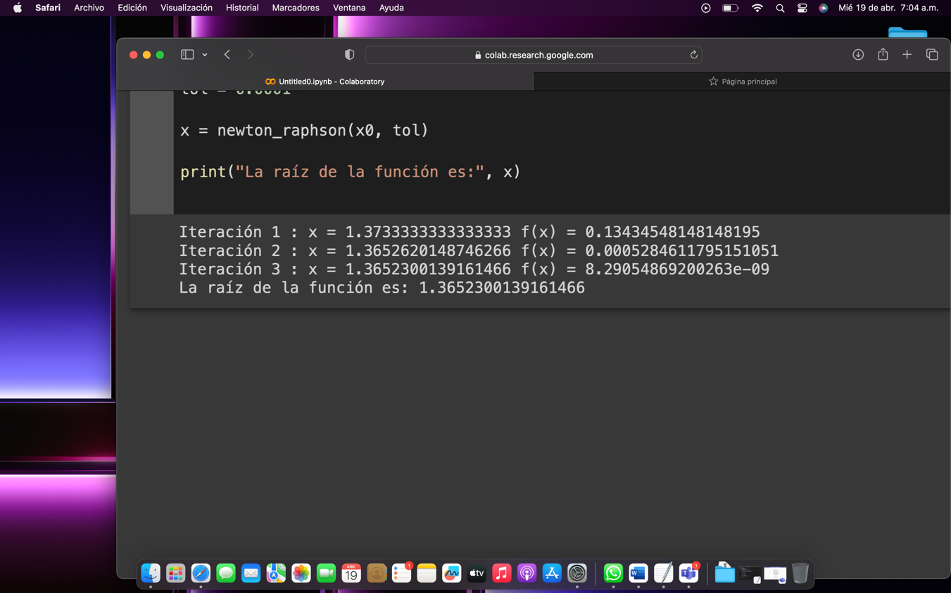

Secant method:

In numerical analysis the secant method is a method for finding the zeros of a function iteratively.

"It is a variation of the Newton-Raphson method where instead of calculating the derivative of the function at the study point, keeping in mind the definition of derivative, the slope is approximated to the straight line joining the function evaluated at the study point and at the point of the previous iteration. This method is of special interest when the computational cost of deriving the study function and evaluating it is too high, making Newton's method unattractive (https://www.urp.edu.pe/pdf/id/2555/n/app).

For this method, an interesting application applied by two master students in gas engineering was found. It deals with the development of a product which covers common areas between the engineering studies of the members of this group. This application method is about applying the secant method in the design of a spherical tank to store liquefied petroleum gas; https://www.youtube.com/watch?v=_TlvFzgqcFU.

Application data:

We have the equation of a power curve describing the relationship between wind speed (v) and the power generated by a wind turbine (P):P = 0.5 * rho * A * Cp * v^3

where rho is the air density, A is the area swept by the turbine blades and Cp is the power coefficient. We want to calculate the wind speed required to generate a power of 1000 kW, knowing that rho=1,225 kg/m^3, A=100 m^2 and Cp=0.4.

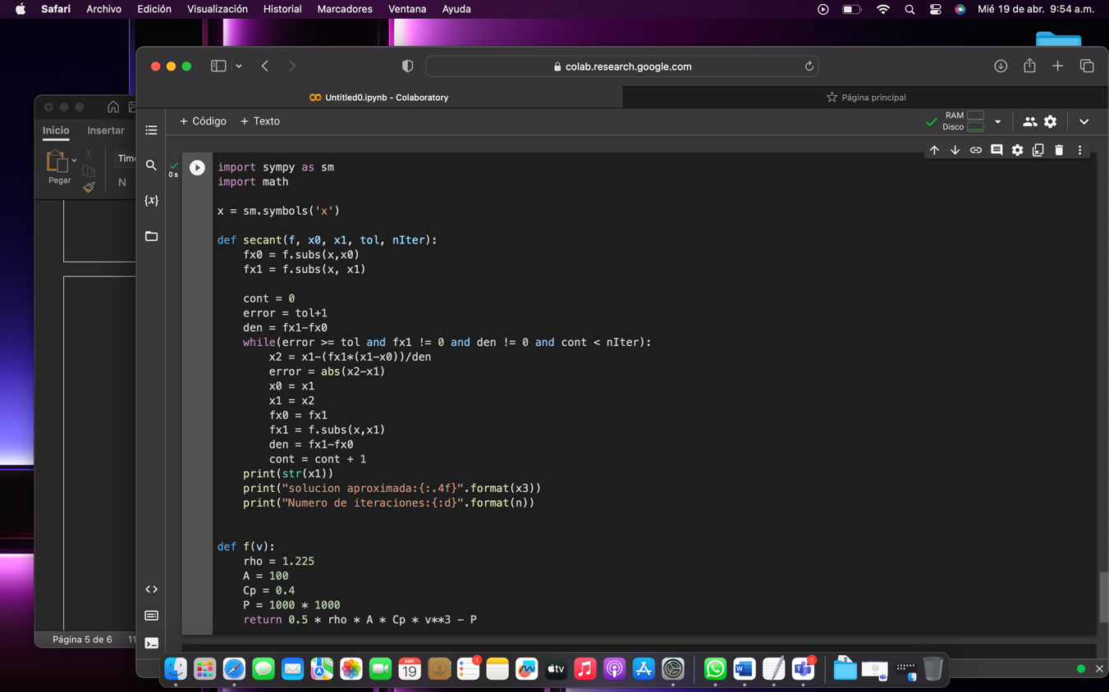

Gaussian elimination method:

With this method we can solve linear programming problems that are extremely common in industry. In the area of production engineering or industrial engineering we study the resolution of linear programming problems in the field of decision models or operations research. Here we make frequent use of Gaussian elimination to find solutions to logistic problems in companies.

Linear programming problems are mainly based on maximizing or minimizing the objective function. So we will apply this method to solve logistic problems where it is required to maximize Z and find the optimal production( Maximize utility).

Application data:

Total pivoting method:

We will use this method basically for the same as the Gaussian elimination method; Optimize linear programming problems. In this case we will focus on minimizing the objective function (Minimize Z).

Application data.