|  |
| --- |
|  |

**Software Requirement Specification**

**Project: Integrated Environmental Management System "SIMA" for the management of environmental projects of the environmental consulting company Biosigma Ambiental**

Revision 2.0

|  |
| --- |
|  |

|  |  |
| --- | --- |
| Insertando imagen... | May |

# Document Summary Sheet

|  |  |  |  |
| --- | --- | --- | --- |
| **Date** | **Revision** | **Author** | **Verified quality department.** |
| 01/05/2025 | 2.0 | Mateo Llumigusin, Gabriel López, Mateo Medrandada |  |

Document validated by the parties on:

|  |  |
| --- | --- |
| By the client | By the supplier company |
|  |  |
|  |  |

**Content**

DOCUMENT SHEET 2

1. INTRODUCTION 5
   1. Purpose 5
   2. Scope 5
   3. Personnel involved 5
   4. Definitions, acronyms and abbreviations 5
   5. References 6
   6. Summary 6
2. OVERVIEW 7
   1. Product Outlook 7
   2. Product functionality 7
   3. User characteristics 8
   4. Restrictions 8
   5. Assumptions and dependencies 9
   6. Foreseeable evolution of the system 9
3. SPECIFIC REQUIREMENTS 9
   1. Common interface requirements 9
      1. User interfaces 9
      2. Hardware interfaces 9
      3. Software interfaces 9
      4. Communication interfaces 10
      5. Functional requirement 1 10
      6. Functional requirement 2 10
      7. Functional requirement 3 10
      8. Functional requirement 4 11
   2. Non-functional requirements 11
      1. Performance 11
      2. Usability 11
      3. Availability 12
      4. Security 12
      5. Maintenance 12
4. APPENDICES 13
   1. Supplementary specifications 13

**Introduction**

This document describes the SIMA (Integrated System for Environmental Management) software requirements specification for the web service focused on the management, visualization and updating of environmental projects by the company "Biosigma. CIA. LTDA", which presents problems in showing its users the projects with the files and maintains a rudimentary data saving process in the cloud, where it is confusing and difficult to view and find the generated projects.

* 1. **Purpose**

This document seeks to define the functional and non-functional requirements for the web service requested by the company "Biosigma. CIA. LTDA." This is intended to make the project registration and viewing processes, as well as the attached project documents, more efficient.

* 1. **Scope**

The system must allow for the creation, editing, and deletion (logical deletion) of projects, environmental plans, monitoring plans, and activities, as well as the ability to view these documents and information in an organized and easily accessible manner, with simple user management using a profile that will have access to certain parts of the system, depending on the permissions granted.

* 1. **Personnel involved**

|  |  |
| --- | --- |
| Name | Gabriel López |
| Role | Member of the elicitation team. |
| Professional category | Software Engineer |
| Responsibilities | Monitor and manage tasks throughout the elicitation phases. |
| Contact information | [gmlopez11@espe.edu.ec](mailto:aaespin3@espe.edu.ec) |
| Approval |  |

|  |  |
| --- | --- |
| Name | Mateo Llumigusin |
| Role | Member of the elicitation team. |
| Professional category | Software Engineer |
| Responsibilities | Follow-up on proposed tasks. |
| Contact information | msllumigusin[@espe.edu.ec](mailto:yachiliquinga1@espe.edu.ec) |
| Approval |  |

|  |  |
| --- | --- |
| Name | Mateo Medranda |
| Role | Member of the elicitation team. |
| Professional category | Software Engineer |
| Responsibilities | Follow-up on proposed tasks. |
| Contact information | mdmedranda1[@espe.edu.ec](mailto:brquispe@espe.edul.ec) |
| Approval |  |

* 1. **Definitions, acronyms and abbreviations**

|  |  |
| --- | --- |
| ***Name*** | ***Description*** |
| **User** | Person who will use the system to manage processes |
| **CHASM** | Integrated System for Environmental Management |
| **ERS** | Software Requirements Specification |
| **RF** | Functional Requirement |
| **RNF** | Non-Functional Requirement |
| **FTP** | File Transfer Protocol |
| **CRUD** | Principle for creating, reading, updating, and deleting data |

* 1. **References**

|  |  |  |  |  |
| --- | --- | --- | --- | --- |
| ***Reference*** | ***Qualification*** | ***Route*** | ***Date*** | ***Author*** |
| *(IS 1998)* | *Requirements Specification according to the standard*  *IEEE 830* | [*https://www.fdi.uc*](https://www.fdi.ucm.es/profesor/gmendez/docs/is0809/ieee830.pdf)[*m.es/profesor/gme*](https://www.fdi.ucm.es/profesor/gmendez/docs/is0809/ieee830.pdf)[*ndez/docs/is0809/i*](https://www.fdi.ucm.es/profesor/gmendez/docs/is0809/ieee830.pdf)  [*eee830.pdf*](https://www.fdi.ucm.es/profesor/gmendez/docs/is0809/ieee830.pdf) | *08/22/2008* | Ucm.es |

* 1. **Summary**

1. **Introduction**

The project is visualized and conceptualized, defining the what, how, where, how, and why of the system to be implemented. The project's limits and scope are also defined to establish a realistic and achievable project objective.

1. **General Description**

Here, the project's functions are generalized, as well as a general description of this system. The main functions requested will be specified, as well as an explanation of the BIOSIGMA workflow, from which it will be abstracted to complement the system to be created.

1. **Requirement**

This section is the most important of the document. It describes how the system functions will be managed, what requirements are essential at the beginning of development, and what requirements must be ready to continue with the next steps, specifying how the system will adapt to these requested needs.

# Overview

## Product Outlook

The Biosigma web system's primary purpose will be to manage project files, organizing and simplifying each project and its component. This system will have the following features:

1. **Autonomy:**The SIMA web system will operate without external APIs, ensuring high efficiency and performance.
2. **Architecture:**The system will have a certain level of difficulty, using design frameworks such as Bootstrap 5.0 and its libraries, as well as AJAX data submission libraries, and other libraries for ease of use.

## Product functionality

**Figure 1. Use Case Diagram**

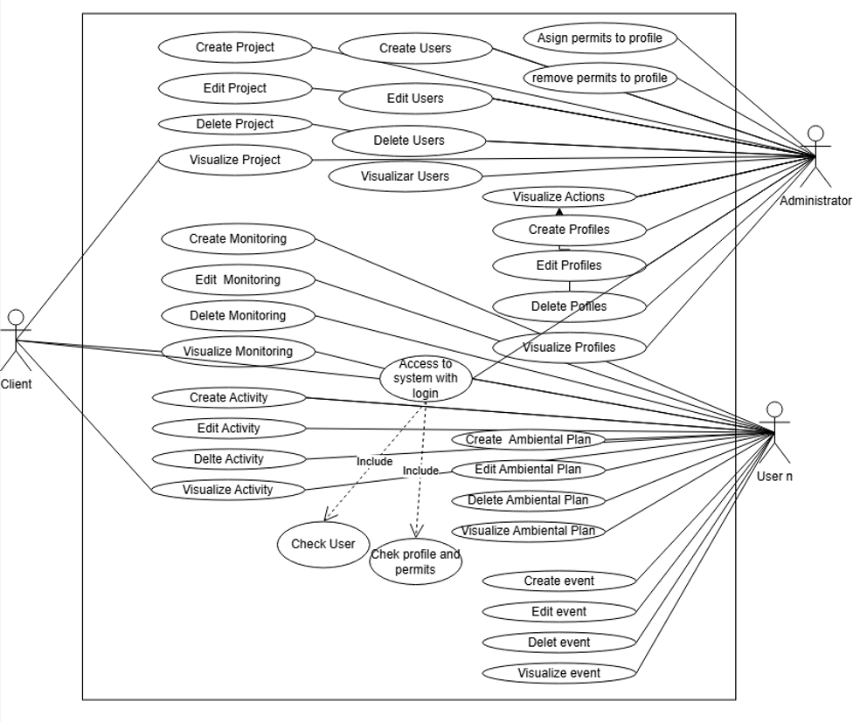

**Note 1: Use case diagram from the consulting processes**

For a better understanding of the system, it will consist mostly of input forms and stored data view forms, with the following sections.

1. **Projects Section:**

Here you will see the projects, completed or in progress, with access to generate a new income, managed only by the administrator

1. **Project management section:**

It is a tool that will allow users, especially workers, to manage everything about a project, managed by tabs within a project with the following parts, activities, monitoring, locations, environmental plans and attached files.

1. **Calendar section:**

In this section you can see upcoming company events, between milestones of certain projects, as well as reminders generated by users.

1. **Control section:**

In this section, supervisors and administrators will see a control of the actions performed by users to review processes performed and activity in the system.

## User characteristics

|  |  |
| --- | --- |
| User type | Representative of Biosigma |
| Training | Level of administrative training and experience in business management. |
| Skills | Make business decisions, manage resources, and oversee processes at Biosigma  Knowledge of environmental, legal and scientific consulting procedures |
| Activities | Define requirements, monitor project progress, and make important decisions about the development and  implementation of project activities and procedures. |

|  |  |
| --- | --- |
| User type | Supervisor: Responsible for managing problems and suggestions |
| Training | Training in administration and management of ecological procedures in projects. |
| Skills | Knowledge of environmental consulting procedures, specializing in the technical aspects of resolutions. |
| Activities | Manage documentation, manage communication  between clients and technical team, and assist in administrative solutions for documents to be generated from projects |

|  |  |
| --- | --- |
| User type | Technician: Personnel responsible for field research and reporting |
| Training | Technical training in field research, with experience in conducting surveys and environmental considerations. |
| Skills | Technical skills in equipment installation, technical troubleshooting, and form creation |
| Activities | Carry out measurements with the necessary equipment, generate reports for documentation in the environmental plan and activities carried out |

|  |  |
| --- | --- |
| User type | Biosigma Clients |
| Training | Training in administration and management of a particular company, with little knowledge of ecological processes |
| Skills | Knowledge of business and other areas related to the type of company I belong to |
| Activities | Review the progress of the creation of the environmental plan and Bisogma recognition projects. |

## Restrictions

Restrictions arising from system design and development include:

* Specific and legal regulations: The system must have a data storage protocol such as the GDPR, for storing personal data in force within Ecuador, as well as other legal regulations in the country.
* Software Restrictions: The software must be compatible with a Dropbox file management system, with connection to legacy projects within the platform.

## Assumptions and dependencies

Some of the key assumptions for this project include:

* Hardware Availability: It is assumed that the hardware necessary to implement the system will be available and compatible with the developed software.
* Operating System Compatibility: It is assumed that the current operating systems used by the company, in this case Windows 10-11, will continue to be supported with website updates.
* Human Resources Availability: It is assumed that the development team, technical support have some knowledge in technology

## Foreseeable evolution of the system

Regarding the future evolution of the system, the following improvements and expansions are anticipated:

* Feature Updates: New features are expected to be added based on changing business needs and user feedback.
* Support for New Technologies: As new technologies develop, new methods of data storage will become available, such as the cloud and a database for users' personal data.
* Maintenance and Security: There will be a continuous focus on maintaining system security against new threats, which may include regular patching and security reviews, as well as security protocols for sending and generating system data.

# Specific requirements

## Common interface requirements

This section will specialize in detailing the handling of the user interfaces with the system, in order to have a useful and enriching experience of having its interaction.

### User interfaces

The "layout document" visually shows the page, colors, and how the data entry sections will look in the system, as well as user conveniences.

### Hardware interfaces

The system must be able to run efficiently on both high- and low-end computers, and it must also be optimized for efficient documentation generation.

### Software interfaces

The system will be compatible with current web browsers and will utilize their components to optimize the user experience. It will be compatible with Google Chrome, Mozilla Firefox, Microsoft Edge, Safari, and derivatives, ensuring that visual and functional elements, such as buttons, menus, and forms, function correctly. The definition of the specific libraries and frameworks the system will utilize will be included, such as support for HTML5, CSS3, Bootstrap, and JavaScript.

### Communication interfaces

To manage and send data from the system to the database, it will be necessary to use transmission protocols such as HTTPS, FTP, TCP/IP, among others, optimized for efficient and rapid data transfer and upload.

## Functional Requirements

### Functional requirement 1

|  |  |  |  |
| --- | --- | --- | --- |
| Requirement number | RF1 | | |
| Requirement name | User and Profile Management | | |
| Guy | ☑ Requirement | ☐ Restriction | |
| Source of the requirement | Interview with the manager of BIOSIGMA | | |
| Priority of the requirement | ☑ High/Essential | ☐ Average/Desired | ☐ Low/Optional |

**Requirement description:**

The system must allow the creation of custom profiles that restrict access to different sections of the web system by assigning permissions. The Administrator profile (with all permissions enabled) and Client profile (with permissions limited to viewing only the corresponding project) must be preloaded.

Permissions must be aligned with the CRUD operations of the system records. That is, specific permissions must be defined for each section, such as: permission to insert projects, permission to update projects, permission to delete projects, and permission to view projects.

### Functional requirement 2

|  |  |  |  |
| --- | --- | --- | --- |
| Requirement number | RF2 | | |
| Requirement name | Login | | |
| Guy | ☑ Requirement | ☑ Restriction | |
| Source of the requirement | Interview with the manager of BIOSIGMA | | |
| Priority of the requirement | ☑ High/Essential | ☐ Average/Desired | ☐ Low/Optional |

**Requirement description:**

The system must include a login based on a username and password. The login form will only contain these two fields, and end users will not be allowed to create accounts. Access will be restricted to those with credentials provided by the company.

### Functional requirement 3

|  |  |  |  |
| --- | --- | --- | --- |
| Requirement number | RF3 | | |
| Requirement name | Creating customer accounts | | |
| Guy | ☑ Requirement | ☐ Restriction | |
| Source of the requirement | Interview with the manager of BIOSIGMA | | |
| Priority of the requirement | ☑ High/Essential | ☐ Average/Desired | ☐ Low/Optional |

**Requirement description:**

The system must allow the administrator user, or someone with the corresponding permission, to record a customer's data, including first name, last name, and ID number. From this information, the system will automatically generate a username by combining the customer's first and last name using a predefined algorithm.

When creating a new user, the initial password will be the user's ID. However, the system must require the user to change this password upon first logging in to ensure data security.

In addition, when creating the user, it should allow the corresponding profile to be assigned intuitively.

### Functional requirement 4

|  |  |  |  |
| --- | --- | --- | --- |
| Requirement number | RF4 | | |
| Requirement name | Project management | | |
| Guy | ☑ Requirement | ☐ Restriction | |
| Source of the requirement | Interview with the manager of BIOSIGMA | | |
| Priority of the requirement | ☑ High/Essential | ☐ Average/Desired | ☑ Low/Optional |

**Requirement description:**

The web system must allow the entry of a new project through a form that records: Project code, Project name, Start date, End date and a field to enter the link to a shared DROPBOX folder so that the files in this tool can be viewed through the API.

The goal of using DROPBOX is to allow customers to view the content without requiring additional settings such as logins or accounts in DROPBOX.

### Functional requirement 5

|  |  |  |  |
| --- | --- | --- | --- |
| Requirement number | RF5 | | |
| Requirement name | Environmental plan management | | |
| Guy | ☑ Requirement | ☐ Restriction | |
| Source of the requirement | Interview with the manager of BIOSIGMA | | |
| Priority of the requirement | ☑ High/Essential | ☐ Average/Desired | ☐ Low/Optional |

**Requirement description:**

Within the web system, each project must allow the registration of multiple environmental plans using a form. This form must collect the following data: Code, Name, Start Date, End Date, Type (Mitigation, Compensation, Monitoring), and the project to which it belongs.

### Functional requirement 6

|  |  |  |  |
| --- | --- | --- | --- |
| Requirement number | RF6 | | |
| Requirement name | Management of environmental plan activities | | |
| Guy | ☑ Requirement | ☐ Restriction | |
| Source of the requirement | Interview with the manager of BIOSIGMA | | |
| Priority of the requirement | ☑ High/Essential | ☐ Average/Desired | ☐ Low/Optional |

**Requirement description:**

Each environmental plan must allow for the management of multiple activities. These activities can be recorded using a form that compiles the following information: Name, Description, Start Date, End Date, and Status (In Progress, Completed, Cancelled). In addition, a responsible person must be assigned for each activity.

### Functional requirement 7

|  |  |  |  |
| --- | --- | --- | --- |
| Requirement number | RF7 | | |
| Requirement name | Location management for each project | | |
| Guy | ☑ Requirement | ☐ Restriction | |
| Source of the requirement | Interview with the manager of BIOSIGMA | | |
| Priority of the requirement | ☑ High/Essential | ☐ Average/Desired | ☐ Low/Optional |

**Requirement description:**

Each activity will have a location with information such as: name, latitude, longitude, province, and description. Additionally, this location can be part of multiple activities. This allows for more detailed records of the most important locations within the project.

### Functional requirement 8

|  |  |  |  |
| --- | --- | --- | --- |
| Requirement number | RF8 | | |
| Requirement name | Monitoring management | | |
| Guy | ☑ Requirement | ☐ Restriction | |
| Source of the requirement | Interview with the manager of BIOSIGMA | | |
| Priority of the requirement | ☑ High/Essential | ☐ Average/Desired | ☐ Low/Optional |

**Requirement description:**

The system must allow for the creation of monitoring reports, including the description, date of completion, a minimum of 5 and a maximum of 10 images, and observations. The files must be able to be viewed later along with the monitoring report.

### Functional requirement 9

|  |  |  |  |
| --- | --- | --- | --- |
| Requirement number | RF9 | | |
| Requirement name | Visualization of projects, plans, activities and monitoring | | |
| Guy | ☑ Requirement | ☐ Restriction | |
| Source of the requirement | Interview with the manager of BIOSIGMA | | |
| Priority of the requirement | ☑ High/Essential | ☐ Average/Desired | ☐ Low/Optional |

**Requirement description:**

The system must allow viewing projects, plans, activities and monitoring in an intuitive interface, with access to attached files (.jpg, .png, .pdf, .doc, .xls, among others).

### Functional requirement 10

|  |  |  |  |
| --- | --- | --- | --- |
| Requirement number | RF10 | | |
| Requirement name | Traceability of system actions | | |
| Guy | ☑ Requirement | ☐ Restriction | |
| Source of the requirement | Interview with the manager of BIOSIGMA | | |
| Priority of the requirement | ☑ High/Essential | ☐ Average/Desired | ☐ Low/Optional |

**Requirement description:**

The system must record every action performed by users (create, modify, cancel) on projects, plans, activities and monitoring for audit and control purposes.

### Functional requirement 11

|  |  |  |  |
| --- | --- | --- | --- |
| Requirement number | RF11 | | |
| Requirement name | Dual confirmation for deleting/updating projects | | |
| Guy | ☑ Requirement | ☐ Restriction | |
| Source of the requirement | Interview with the manager of BIOSIGMA | | |
| Priority of the requirement | ☑ High/Essential | ☐ Average/Desired | ☐ Low/Optional |

**Requirement description:**

To delete or update a project, confirmation from the employee and confirmation from a designated supervisor will be required.

### Functional requirement 12

|  |  |  |  |
| --- | --- | --- | --- |
| Requirement number | RF12 | | |
| Requirement name | Business calendar with reminders | | |
| Guy | ☑ Requirement | ☐ Restriction | |
| Source of the requirement | Interview with the manager of BIOSIGMA | | |
| Priority of the requirement | ☑ High/Essential | ☐ Average/Desired | ☐ Low/Optional |

**Requirement description:**

The system should allow for the creation of reminders in an integrated calendar to notify users of business-related events.

### Functional requirement 13

|  |  |  |  |
| --- | --- | --- | --- |
| Requirement number | RF13 | | |
| Requirement name | Activity progress meter | | |
| Guy | ☑ Requirement | ☐ Restriction | |
| Source of the requirement | Interview with the manager of BIOSIGMA | | |
| Priority of the requirement | ☑ High/Essential | ☐ Average/Desired | ☐ Low/Optional |

**Requirement description:**

The system should display a progress bar based on the number of completed activities (out of a total of 15), although this does not represent the completion of the project. This bar should be visible next to the project on the home page.

### Functional requirement 14

|  |  |  |  |
| --- | --- | --- | --- |
| Requirement number | RF14 | | |
| Requirement name | CRUD and logical deletion for key entities | | |
| Guy | ☑ Requirement | ☐ Restriction | |
| Source of the requirement | Interview with the manager of BIOSIGMA | | |
| Priority of the requirement | ☑ High/Essential | ☐ Average/Desired | ☐ Low/Optional |

**Requirement description:**

The system should allow for the creation, editing, and deletion (logically) of projects, plans, monitoring, activities, and reminders, while preserving data integrity.

### Functional requirement 15

|  |  |  |  |
| --- | --- | --- | --- |
| Requirement number | RF14 | | |
| Requirement name | Security and encryption of personal data | | |
| Guy | ☑ Requirement | ☐ Restriction | |
| Source of the requirement | Interview with the manager of BIOSIGMA | | |
| Priority of the requirement | ☑ High/Essential | ☐ Average/Desired | ☐ Low/Optional |

**Requirement description:**

The system must ensure the security of personal information by using mechanisms such as password encryption and other data protection measures.

## Non-functional requirements

### Performance

|  |  |  |  |
| --- | --- | --- | --- |
| Requirement number | RNF-001 | | |
| Requirement name | Request capacity | | |
| Guy | ☑ Requirement | ☐ Restriction | |
| Source of the requirement | Interview with the manager of BIOSIGMA | | |
| Priority of the requirement | ☑ High/Essential | ☐ Average/Desired | ☐ Low/Optional |

**Requirement description:**

The system must support a high level of simultaneous user requests, so it must respond quickly and efficiently. This requirement ensures that the system performs well under load, meeting customer expectations and ensuring adequate performance.

### Usability

|  |  |  |  |
| --- | --- | --- | --- |
| Requirement number | RNF-002 | | |
| Requirement name | Intuitive and easy-to-use system | | |
| Guy | ☑ Requirement | ☐ Restriction | |
| Source of the requirement | Interview with the manager of BIOSIGMA | | |
| Priority of the requirement | ☑ High/Essential | ☐ Average/Desired | ☐ Low/Optional |

**Requirement description:**

The system must have an intuitive and easy-to-use environment. Users will be able to complete common tasks quickly. The environment should also be easy to learn, allowing users to navigate more comfortably and easily complete registrations with a minimum of 3-5 clicks.

#### Performance

|  |  |  |  |
| --- | --- | --- | --- |
| Requirement number | RNF-003 | | |
| Requirement name | Performance | | |
| Guy | ☑ Requirement | ☐ Restriction | |
| Source of the requirement | Interview with the manager of BIOSIGMA | | |
| Priority of the requirement | ☑ High/Essential | ☐ Average/Desired | ☐ Low/Optional |

**Requirement description:**

The system must guarantee a response time of less than 2 seconds for the most common operations, such as browsing, information loading, and record management, ensuring a smooth user experience.

### Platform compatibility

|  |  |  |  |
| --- | --- | --- | --- |
| Requirement number | RNF-004 | | |
| Requirement name | Platform compatibility | | |
| Guy | ☑ Requirement | ☐ Restriction | |
| Source of the requirement | Interview with the manager of BIOSIGMA | | |
| Priority of the requirement | ☑ High/Essential | ☐ Average/Desired | ☐ Low/Optional |

**Requirement description:**

The system will be designed primarily for use on desktop or laptop computers, with a low priority on adapting to mobile devices, optimizing the experience for large screens.

#### Maintenance

|  |  |  |  |
| --- | --- | --- | --- |
| Requirement number | RNF-005 | | |
| Requirement name | Ongoing maintenance | | |
| Guy | ☑ Requirement | ☐ Restriction | |
| Source of the requirement | Interview with the manager of BIOSIGMA | | |
| Priority of the requirement | ☑ High/Essential | ☐ Average/Desired | ☐ Low/Optional |

**Requirement description:**

The system must be continuously maintained after its implementation and release to the public to ensure good service throughout its designated lifespan. This requirement must also guarantee security during any required upgrades or repairs.

# Appendices

This section shows the links to each document created for this delivery.

## Supplementary specifications

<https://github.com/MateoMedranda/ESPE202550_CrimsonCode/tree/main/02-Requirements>