**Laboratory Exercise 1:**

**Fuzzy Systems**

*CI 21/22*

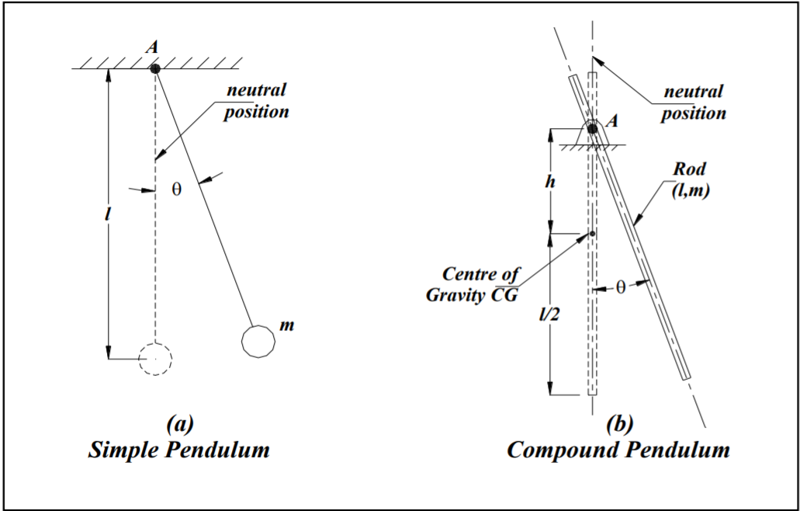

**Authors**: *Ramon Mateo, Benet Manzanares*

Index

**Introduction** **3**

**Membership functions** **3**

**Rules** **3**

**Results** **4**

**Incrementing the output membership functions** **4**

# Introduction

In this practice we have implemented a compound pendulum using Simulink and MATLAB fuzzy toolbox. For this purpose, we had to define the Simulink model for the system and a Mamdami-based fuzzy controller for the thrust system. Since the Simulink model and the inputs of the fuzzy system were predefined in the statement of work, our job was focused on the definition of the rules and output of the fuzzy controller.

In the following sections these features will be described, along with the obtained results and an additional experiment changing the output membership functions.

# Membership functions

The aim of the fuzzy controller in the pendulum system is to compute the thrust that has to be applied in order to stabilize the rod at the desired angle. To this end, this thrust is defined using three membership functions which, in our case, will be named Low, Medium and High. The figure below shows the shape and disposition of these functions:

[THRUST MEMBERSHIP FUNCTIONS FIGURE]

As can be seen, the three fuzzy sets use a [USED_TYPE (for example, trimf)] type membership function.

# Rules

In order for the fuzzy controller to be exhaustive, a rule for each combination of inputs is required. Consequently, since there are three membership functions for each of the two inputs, a total of 9 rules need to be defined. In the following, all rules are listed:

[RULES LIST]

# Results

In this section, the behaviour of the pendulum system resulting from defining the fuzzy controller of the Simulink model as has been previously specified is discussed.

Concretely, we have performed two simulations during 80 seconds with the following conditions:

* **Test 1:** theta_ref = 20 and thrust = 0.123
* **Test 2:** theta_ref = -10 and thrust = -0.062

In the following,

# Incrementing the thrust membership functions

a