Computational Vision 2021-2022

**Welcome class** to the laboratory session of the **Computation Vision** course!!! Over the sequence of exercises, you will get familiar with coding the different concepts of computer vision. Every session would closely follow the concepts that have been learnt in your theory sessions.

# Ecosystem

All the exercises would be programmed using Python. Python is a versatile language which offers a very simple syntax making it faster for programming prototypes. Python has a wide range of libraries for various tasks. During the initial weeks of this course, we would get introduced to **NumPy** (Numerical Python), **skimage** (Scikit-Image), **sklearn** (Scikit-Learn) and matplotlib. During the last part of the course, we would get introduced to **Keras framework with tensorflow backend**. For all the exercises, we would rely on **Google Collaboratory** for the coding environment.

# Google Collaboratory

Google Colab is a free jupyter-based notebook environment that runs on Google Cloud. It provides various inbuilt python libraries and it also offers ability to install any package. Colab notebooks are saved in your Google Drive. You would be able to create new notebooks, download notebooks as .py or .ipynb files and also share notebooks just as you do with any document in Google drive. The most attractive feature of Colab is the free to use GPU service (we would use this in later sessions).

To start using Colab, visit [**https://colab.research.google.com**](https://colab.research.google.com). Using the popup at the home screen, you can create a new python notebook, or upload notebooks from Google Drive **(we would use this option)** or Github.

**A short tutorial on Google Colab:** [**Google Colab Tutorial**](https://www.tutorialspoint.com/google_colab/index.htm)

**Complete reading the tutorials on the above page, as it will help you to fasten your coding.**

# Getting started

* Download the zipped folder from CampusVirtual
* Unzip the folder

There are two ways to run Google Colab:

1. Without necessarily Google account:
   1. Run in your browser: colab.research.google.com/
   2. Upload the notebook (.ipynb files)
2. With Google account:
   * Upload the folder to your Google drive
   * You will find .ipynb files in the uploaded folder
   * **Right click the file and select ‘Open with’**
   * Select Connect more apps. In the GSuite MarketPlace, search for colaboratory and Install the app
   * Now when you right click on the notebook, it would give the option to open the file in Google Colaboratory.

# Mounting drive to your notebook

You can mount your drive to your notebook (this allows you to access the files in your drive - Also it is important to save files to your drive)

* When you open your notebook your left pane would be as below:

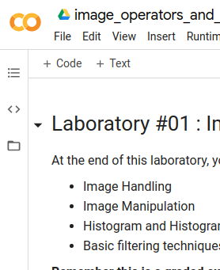

* Click the Files button (The last option in the left pane)

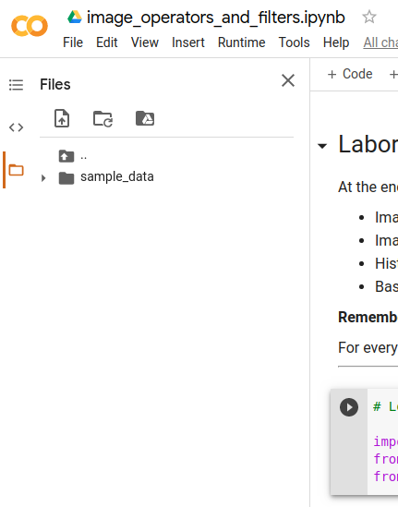

* You will find a new cell as below. Click on the URL and allow “Google Drive File Stream wants to access your Google Account” to get an authorization code. Copy the code and paste it in the box below and press enter.

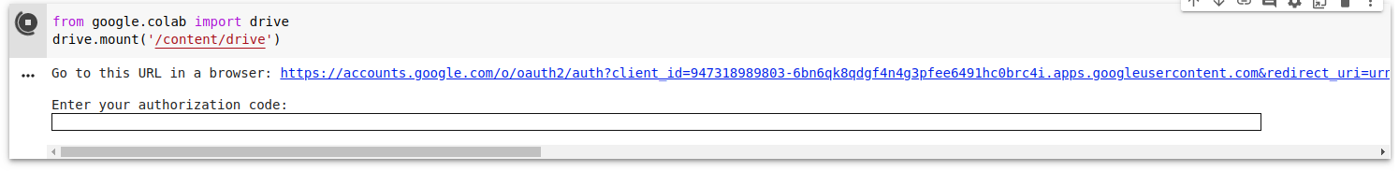

* Once the code is validated, you would have the below output



* Now when you look at the ‘Files’ option, you would find the drive accessible. For knowing the path of the file, you are looking for, right click on the file and select Copy Path. Please note that you need to specify the output files in a similar way.

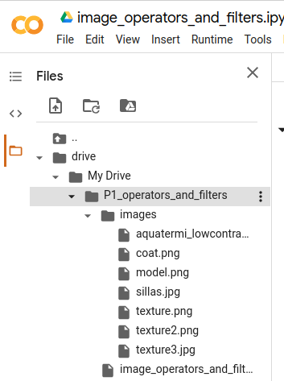

# Completing Practical Exercises

1. All lab exercises would be uploaded in CampusVirtual.
2. **Every session would have a lab component attached** (if the class does not have a corresponding lab, it would be notified earlier).
3. Colab offers sharing of files. You can share the same file with your partner **(The lab exercises have to be done in pairs).**
4. Upload the lab exercises to your Google Drive (Strongly encouraged to do this option - as this would allow you to collaborate with your partner and also would be easy to communicate doubts with the teachers).
5. Your notebooks will have **two types of exercises - descriptive and programming**. For programming solutions, you would have to use the cells to provide answers.

Programming cells look like this:



Descriptive answers look like this:



Feel free to create as many cells as you want to provide clear answers.

**Make sure you add comments to your code and provide sufficient explanation to your answers.**

1. Remember to clean up code before submission.
2. After completing your exercises, download the notebooks as .ipynb (along with output files, if any)
3. Zip the downloaded files and rename the zip as P#_Student1_Student2.zip. For example, to submit P1, you will have your file name as P1_Laura_Bhalaji.zip. If you are submitting P1 and P2 together, name the file as P1_P2_Laura_Bhalaji.zip.
4. Upload the zipped file back to the portal for evaluation.

**Please remember to complete the exercises on time. Any delay in uploading the files would cause a penalty.**