**Specification of business processes**

**1. Business processes**

## **Student Research Project Management**

### **General description of the business process and performance metrics**

The Student Research Project Management process involves organizing, tracking, and evaluating student-led or faculty-supervised research projects within an academic institution. It ensures that research activities are well-structured, efficiently managed, and aligned with institutional goals.

**Goals:**

1. **Increase in Research Output** – Ensure that the number of research publications, presentations, or completed projects by students and faculty increases by at least 2% per semester, compared to the average of previous 2 semesters.
2. **Enhance Student Participation in Research** – Achieve a 7% per semester increase in the number of students engaged in research activities, compared to the average of previous 2 semesters.

Performance Metrics & Analytical Challenges:

#### 1. Research Output Metrics:

* Number of successfully completed student research projects.
* Number of research papers submitted and published.

#### 2. Student Participation & Engagement:

* Number of students involved in research projects.
* Percentage of students completing research projects successfully.

### 3. Research Project Management & Efficiency Metrics

* Average time taken to complete a research project.
* Percentage of projects completed within the proposed timeline
* Number of research projects abandoned or delayed.

**Typical questions:**

* What is the number of successfully published final research papers?
* Which professors are the best based on the success of the projects they supervise?
* How many students participate in research projects?
* What is the success rate of research projects across different departments?

### **Data:**

* Primary Source: University’s Learning Management System (LMS), which logs courses, research components, and student participation.
* Secondary Source (Excel or CSV): A manually maintained database of student research projects, their topics, and their outcomes.

**2. Scenarios of analytical problems**

#### 

#### **Why did student enrollment increase or decrease this year?**

1. Compare the number of students enrolling in different programs this year and last year.
2. Compare the number of international students enrolling this year and last year.
3. Does the specialization chosen by the student affect enrollment trends over the years?

#### **Why did a research project succeed or fail?**

1. Compare the number of researchers involved in successful and unsuccessful projects.
2. Compare the research output (papers published, patents filed) of projects
3. Which professors lead the most successful research projects?
4. Compare the number of students involved in research projects this year and last year.
5. Compare the success rate of research projects in small and large research teams.

**3. Data needed for analytical problems**

#### **Analytical Problem: "Why did a research project succeed or fail?"**

*1.Compare the number of students involved in research projects this year and last year.*

* Number of student researchers – ResearchProject table, student and ResearchProject relation
* Year of research – ResearchProject table, column *Start_Date and End_Date*

*2.What is the research output in relation to the experience level of the lead researcher*?

* Lead researcher’s years of experience – Professor table, column *Experience*
* Number of publications from the project – Publication table, ResearchPRoject and Publication relation

*3. Compare the average duration of successful and unsuccessful research projects.*

* *Project duration – ResearchProject table, columns: Start_Date and End_Date*
* *Project success status – ResearchProject table, column: Status*

*4. How does the publication rate vary by research field?*

* *Research field – ResearchProject table, column: Research_Area*
* *Number of publications – Publication table, ResearchProject and Publication relation*

*5. Analyze the impact of laboratory conditions on research success.*

* Laboratory condition rating *– Laboratory table, column: Condition_Score*
* Project success status *– ResearchProject table, column: Status*

#### **Analytical Problem: "Why did student enrollment increase or decrease this year?"**

1. Compare the success rate of research projects in small and large research teams.

* *Number of researchers in the project – Participants and ResearchProject tables, deduce from the relationship*
* *Project success status – ResearchProject table, column status*

2. Compare the number of researchers involved in successful and unsuccessful projects.

* Number of researchers – Participants table, get information from relation with ResearchProject
* Project success status – ResearchProject table, column *status*

### *3. Compare the number of enrollments based on department*

* *Total student enrollments per department – Participants table, Department table*

### *4. Evaluate whether there has been an increase or decrease in the number of active professors this year compared to last year.*

* *Professor_Department table: To know where professors are assigned.*
* *Professor table: Use Experience and other details if needed.*

### *5. Compare the number of successful research projects completed this year with last year.*

* *Research Project table: Look at Status (Successful, Ongoing, Failed) and End_Date for completion year.*

### 

### 

### 

### 

### 

### 

### 

### 

### 

### 

### 

### ***Query Requiring Additional Data Sources (Without Changing Business Process)***

*Analyze the impact of financial aid on student enrollment trends.*

* *Financial aid received per student – FinancialAid table, column: Aid_Amount*

### Total student enrollments per department *– ResearchProject table, Department table*

### ***Query Requiring Additional Data That Can Only Be Gathered by Changing Business Processes***

*Investigate the influence of career counseling on student enrollment and retention.*

* *Student participation in career counseling sessions – New data collection required in CareerCounseling table*
* *Student retention rate per department – StudentRetention table, column: Retention_Rate*
* *Year of enrollment and retention – StudentEnrollment table, columns: Enrollment_Year, Retention_Year*

**4. Relational database: information about faculty workers**

### **Specialization -** Stores details about academic specializations currently available at our university.

* **Specialization_ID** (INT): Unique ID for specialization
* **Name** (VARCHAR): Specialization name - BK, business key
* **Study_Field** (VARCHAR): Field of study

### **Faculty_Member -** Stores information about faculty members at the university, we include only members that are currently studying and professors that are working at our university.

* **University_ID** (INT): Unique ID for faculty member - BK, business key
* **First_Name** (VARCHAR): First name
* **Last_Name** (VARCHAR): Last name
* **Email** (VARCHAR): University email address
* **Publications_Count** (INT): Number of successful publication

### **Student -** stores information about students that are currently studying at our university.

* **Enrollment_Year** (YEAR): Year of enrollment

### **Professor -** stores information about professors that are currently working at our university.

* **Employment_Start_Date** (YEAR): The year when the professor started teaching in university
* **Degree** (VARCHAR): Ph.D, Sc.D, D.Eng, M.Sc etc.

### **Department -** Stores information about current university departments (by current I mean fully functional and working).

* **Department_ID** (INT): Unique ID for the department
* **Department_Name** (VARCHAR): Name of the department - BK, business key
* **Location** (VARCHAR): Department location

**Specialization** (***Specialization_ID***, Name, Study_Field)

**Faculty_Member *(University_ID***, First_Name, Last_Name, Email, Publications_Count, **Specialization_ID FK** REF SPECIALIZATION)

**Student** (**University_ID PK FK REF Faculty_Member,** Enrollment_Year)

**Professor** (**University_ID PK FK REF Faculty_Member,** Experience, Degree)

**Department** (***Department_ID***, Department_Name, Location)

**Student_Department** (**University_ID** REF STUDENT, **Department_ID PK** REF DEPARTMENT)

**Professor_Department** (**University_ID** REF PROFESSOR, **Department_ID PK** REF DEPARTMENT)

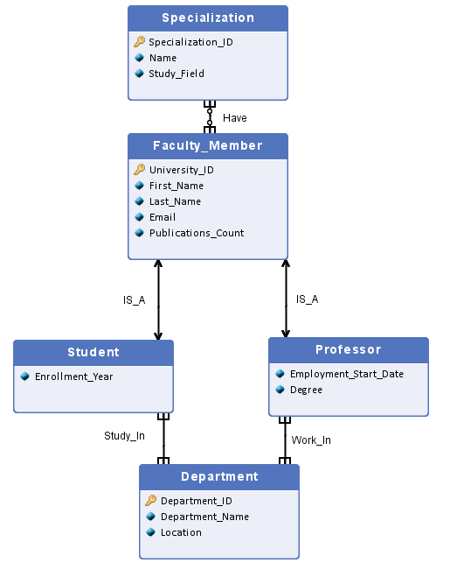

**Definition and documentation of relationships:**

Faculty Member - Specialization (Have)

* Relationship Type: One-to-Many (M:M)
* Description: A faculty member can have multiple specializations, and a specialization can belong to multiple faculty members.

Faculty Member - Student (IS_A)

* Relationship Type: Generalization (Inheritance)
* Description: A student is a specific type of faculty member and inherits its attributes.

Faculty Member - Professor (IS_A)

* Relationship Type: Generalization (Inheritance)
* Description: A professor is a specific type of faculty member and inherits its attributes.

Student - Department (Study_In)

* Relationship Type: Many-to-One (M:M)
* Description: Many students can be enrolled in one department, and each student can belong to multiple departments.

Professor - Department (Work_In)

* Relationship Type: Many-to-One (M:M)
* Description: Many professors can work in one department, and each professor can be associated with many departments.

**5. Excel: Information about research projects**

| ***Publication -*** Stores information about academic publications that has ever been made at our university | |
| --- | --- |
| Publication_ID (INT) | Unique ID for the publication |
| Title (Varchar) | Publication Title, BK - business key |
| Author_Full_Name (Varchar) | Full name of the author of the publication |
| University_ID (INT) | Unique ID of the author, in case the author is no longer working at our university we give NULL value |
| Type (ENUM) | Type of publication (Journal Article, Book, Patent, Magazine Article, Technical Report) |
| Publication_Date (DATE) | Date of publication |

| ***Research Project -*** Stores details about research projects that are either finished (both failed and successful) or in progress within the university | |
| --- | --- |
| Project_ID (INT) | Unique ID for the project |
| Title (Varchar) | Project title, BK - business key |
| Description (Varchar) | Information about the project goals and resources |
| Start_Date (Date) | Date of the beginning of the project |
| End_Date (Date) | Date of the end of the project |
| Research_Area (Varchar) | Discipline in which research is conducted |
| Status (ENUM) | Current state: Successful, Ongoing, Failed |
| University_ID (INT) | Unique ID for supervising professor |

| ***Research Lab -*** *Stores information about research laboratories that are currently available at our university and information about their conditions* | |
| --- | --- |
| ID (INT) | Unique ID of the building |
| Lab Location (Varchar) | GPS Location of the building |
| Name (Varchar) | Unique name of the building, BK - business key |
| Condition Status (Enum) | Status of the lab condition (Good, Fair, Poor, Under Maintenance, Closed) |
| Last Maintenance Date (Date) | Last maintenance date |

| ***Participants -*** Information about which faculty members participate in research project | |
| --- | --- |
| University_ID (INT) | Unique identifier used at university (we link it with the Faculty_Member table from relational schema, it will be a 1 to 1 relationship). If the person is no longer working at our university we give it NULL value |
| Project_ID (INT) | Unique identifier of a research project |
| Role (Varchar) | A very short description of a role a given person has in a project, BK - business key. |