Zadanie 5
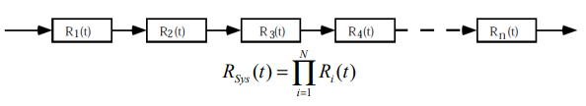
Zadanie 6
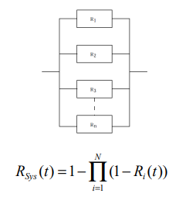
Fc = = Fi + R1 = 1
Zadanie 7
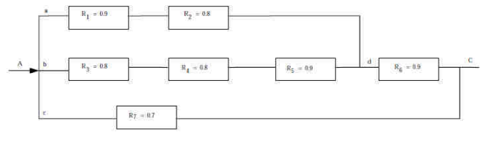
1) Ra = R1 * R2
2) Rb = R3 * R4 * R5
3) Rc = 1 – (1 – Ra)(1 – RB)
4) Rd = Rc * Re
5) Re = 1 – (1 - Rd)(1 - Rb)
Re = 1 – (1-RcR6)(1-R7) = 1 – (1–(1-(1-Ra)(1-Rb))R6)(1-R7)=1-(1-(1-(1-R1R2)(1-R3R4R5))R6)(1-R7) = 0,937
Zadanie 8
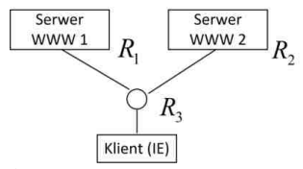
Rs = 1-(1-R1)(1-R2)
Rc = R3 * Rs = R3 * (1-(1-R1)(1-R2) = 0,975
Rc = R3 * (1-(1-R1)(1-R2)(1-R4)) = 0,998 * (1 – 0,85^3) = 0,994 > 0,98

