Writing in the Air: Measuring and Mitigating Domain Shift in Handwritten Digit Recognition
Programming with Python, Fall 2026 - course project report (Class 2202, Project Group 7)
Student | Student ID | Class
Roman Prokhorov | 1820269083 | 2202
Mateusz Dobry | 1820269126 | 2202
Kirill Riabkov | 1820269096 | 2202
Kacper Żuchowski | 1820269127 | 2202

1. Introduction
Digit classifiers trained on MNIST [1] reach more than 99% accuracy on the MNIST test set, yet it is rarely checked what happens when the same model is given digits from a different source. Such a change of input distribution between training and deployment is called domain shift or dataset shift [3, 4]. We study it in a concrete setting: digits written in the air in front of a webcam. The hand is tracked with MediaPipe Hands [2], the fingertip trajectory is drawn on a virtual whiteboard, and the picture is passed to a classifier trained only on MNIST. The problem matters because air-writing is a natural touchless input method [5], and because the same effect - a good benchmark score that does not transfer - appears in any machine-learning system that is deployed on data collected differently from its training set. The project therefore applies AI and data analysis to a problem from our own field of study, computer science: it combines computer vision, machine learning and statistical evaluation of a human-computer interface.
Our approach has three parts: (i) a working gesture-controlled whiteboard that produces digit images; (ii) an own dataset of 807 in-air digits, never used for training in the main experiment, which serves as a pure test set for zero-shot transfer from MNIST; (iii) a controlled ablation in which three preprocessing steps (stroke-thickness normalisation, centre-of-mass centering, and both together) are added one at a time in front of three MNIST-trained models, with training augmentation tested as an alternative remedy.
Main findings. A small CNN drops from 99.33% on MNIST to 96.53% on our digits (a gap of 2.80 points, 5.2 times more errors). Preprocessing that makes our images statistically more similar to MNIST closes the gap completely: 99.46% with all steps, within noise of the MNIST accuracy. Centering contributes most (67.8% of the gap); thickness normalisation alone does not give a statistically significant gain. Training augmentation designed to imitate our domain did not help and was worse than preprocessing (97.19%).

2. Method

2.1 System overview
Figure 1 shows the pipeline. A mirrored webcam frame is processed by MediaPipe Hands [2], which returns 21 hand landmarks. Simple rules on which fingers are extended select the mode (draw, move, erase, finish); the index fingertip is smoothed with a 5-point moving average and drawn with a fixed 12 px anti-aliased pen on a 960×540 canvas. On a finish gesture, the drawing is cropped with a 20 px margin and stored as an unresized PNG; the same crop is later fed to the preprocessing pipeline, so the dataset and the live demo use identical inputs.
Data collection. Each of the four team members recorded their own digits with our collection tool (collect_data.py), using the built-in webcam of their own laptop. Every writer drew each digit 20 times in their natural writing style; one writer recorded a few extra samples, giving 807 images (80–85 per class). Images are stored raw, without resizing to 28×28, so every preprocessing variant starts from exactly the same files. Because each writer used a different camera and room, capture conditions differ between writers but are fixed within a writer. The same whiteboard also runs as a live demo (whiteboard.py --predict) that shows the predicted digit, the top-3 classes and their confidence whenever the hand pauses, using the CNN with full preprocessing.
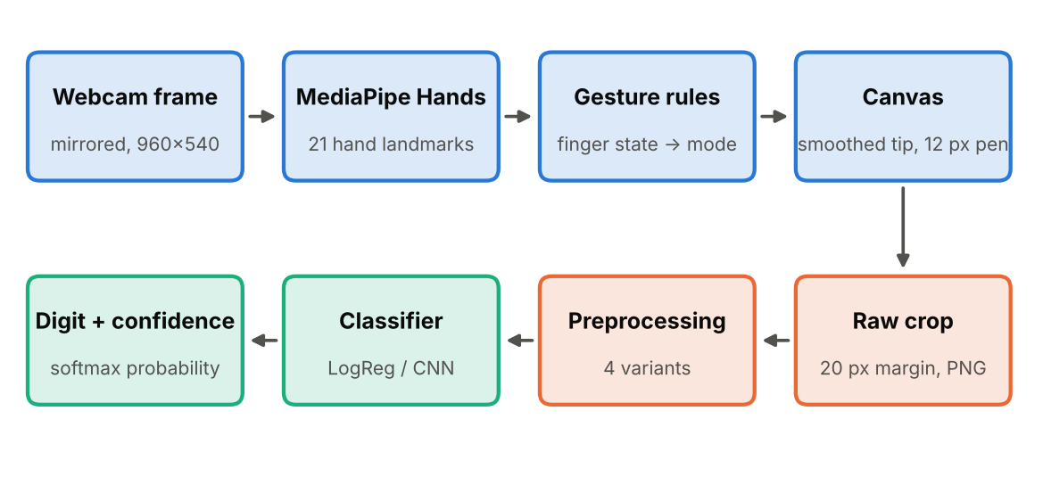
Figure 1. System pipeline. Blue: capture and drawing; orange: image preparation; green: recognition.

2.2 Models and why these were chosen
We compare three MNIST-trained models. Multinomial logistic regression (scikit-learn [12], 7,850 parameters) is the classic linear baseline and is expected to be the most fragile. A small CNN (PyTorch [13]; three Conv–BatchNorm [8]–ReLU–MaxPool blocks with 32/64/128 channels, dropout 0.3 [9], one linear layer; 104,426 parameters) represents the standard approach to MNIST [1]. We deliberately use a small CNN rather than a larger state-of-the-art architecture: MNIST is saturated (differences between top models are below 0.5 point), and our question is about the input distribution, not about model capacity. A third model, the augmented CNN, has the same architecture but is trained on augmented digits (dilation with a 2×2 or 3×3 kernel in half of the images, a random affine warp with rotation ±10°, scale 0.9–1.1 and shift ±2 px, and elastic distortion [7] in half of the images) that try to imitate in-air writing.
Training settings are the same for both CNNs: Adam [10], learning rate 10⁻³ with cosine annealing [11], 8 epochs, batch size 128, a 54,000/6,000 train/validation split of the MNIST training set, and the last checkpoint is used (no selection on any air-written data). Every configuration is trained with three seeds (42, 43, 44) on CPU.
Implementation and reproducibility. The code is written in Python 3.11 with library versions pinned in requirements.txt (PyTorch, scikit-learn, OpenCV, MediaPipe, NumPy, pandas, SciPy, Matplotlib). All random seeds are fixed in config.py. The experiments are run with train.py (training), ablation.py (zero-shot ablation, fine-tuning and leave-one-writer-out), analysis.py and metrics_analysis.py (figures, statistics) and error_analysis.py; every table and figure in this report is read from the files these scripts write to results/ and figures/. The full run was done on a laptop CPU.

2.3 Preprocessing steps (own implementation)
Starting from the raw crop, the following steps are implemented and can be switched on independently. Minimal (baseline): the crop is cut to its bounding box, scaled so that the longer side is 20 px, padded to 28×28, and standardised with MNIST statistics. Thickness: after Otsu binarisation [6], the stroke width is estimated from the distance transform on the skeleton and the image is rescaled by dilation/erosion to a target ratio of 0.12 of the longest bounding-box side; this value was derived from MNIST geometry (strokes ≈ 2.4 px in a 20 px box) and fixed before any experiment. Centering: the centre of mass is moved to the image centre, as in MNIST. Full: thickness and centering together. Figure 2 illustrates the steps.
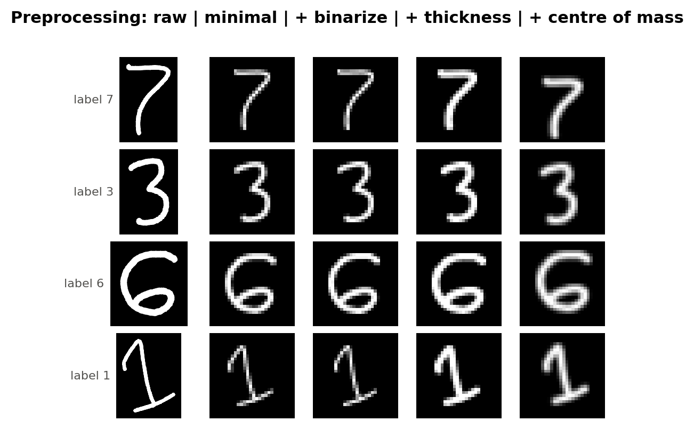
Figure 2. Preprocessing steps for four example digits (raw, minimal, binarised, thickness-normalised, centred).

2.4 Why these steps: a measured domain gap
Before choosing the steps we measured how our images differ from MNIST (Table 1). Our strokes are much thinner (median 0.90–1.55 px against 2.44 px) and fill a smaller fraction of the image (median 0.052–0.081 against 0.130), because the fixed 12 px pen on a 960×540 canvas becomes thin once a large hand-drawn digit is scaled down to 20 px. This directly motivated the thickness step.
Table 1. Own dataset (807 digits, 80–85 per class) compared with MNIST. Stroke width in pixels of the 28×28 image, fill ratio = share of ink pixels. MNIST statistics use a random sample of 2,000 test images.
Source | Images | Median stroke width | Median fill ratio
MNIST | 2,000 (test sample) | 2.44 | 0.130
Kacper | 200 | 1.55 | 0.073
Kirill | 200 | 1.39 | 0.070
Mateusz | 200 | 1.46 | 0.081
Roman | 207 | 0.90 | 0.052

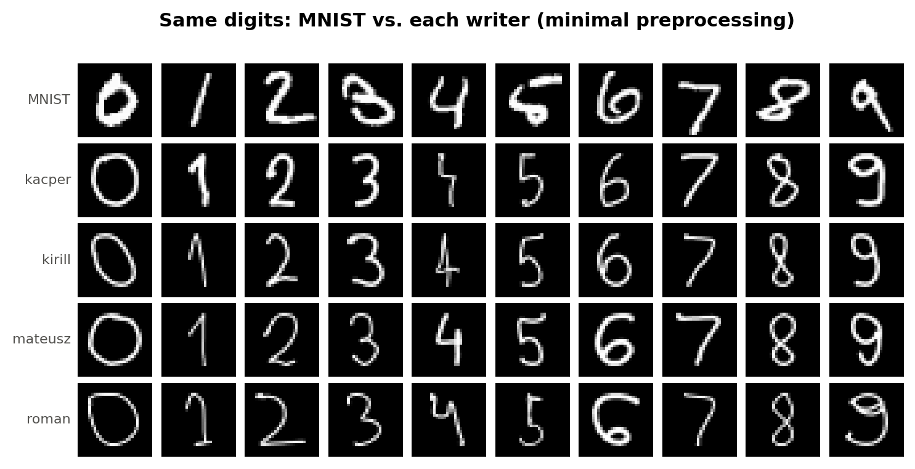
Figure 3. The same digits as written by each of the four writers, compared with MNIST (top row).

2.5 Own contributions and reused components
Reused external components: MNIST data [1], MediaPipe Hands [2] for landmark detection, scikit-learn [12] for logistic regression, PyTorch [13] for the CNN, and the elastic-distortion idea from [7]. Implemented by the team: the gesture rules and whiteboard, the data-collection tool and the 807-image dataset, the preprocessing steps and their switchable pipeline, the augmentation, the training and evaluation code, the ablation and statistical analysis (the gap closed metric is our own definition), and all figures in Sections 2–3 except where stated.

3. Experimental Results and Analysis

3.1 Data and evaluation protocol
Data. The test set is our 807 in-air digits (about 80 per class, collected by four writers) and is never used for training in the main experiment; we call this zero-shot transfer. MNIST models are also evaluated on the 10,000 MNIST test images. Criteria. Accuracy and macro-F1, reported as mean ± sample standard deviation over three training seeds. Uncertainty on our data is given by 95% percentile-bootstrap intervals [14] (2,000 resamples, over images and seeds jointly). Paired comparisons use the exact McNemar test [15] per seed with Holm correction [16] over 8 comparisons. We define gap closed = (acc(variant) − acc(minimal)) / (acc(MNIST) − acc(minimal)); 100% means MNIST-level accuracy. With only 807 images and 3 seeds, differences below roughly 1 point should be treated with caution.

3.2 Performance on MNIST
Table 2. MNIST test set (10,000 images), mean ± std over 3 seeds, in %.
Model | Parameters | Accuracy | Macro-F1 | Train time
Logistic regression | 7,850 | 92.35 ± 0.06 | 92.23 ± 0.06 | 51 s
CNN | 104,426 | 99.33 ± 0.02 | 99.33 ± 0.02 | 262 s
CNN + augmentation | 104,426 | 99.12 ± 0.06 | 99.12 ± 0.06 | 308 s
On MNIST the models behave as expected, and the augmented CNN is only slightly worse than the plain CNN (99.12% against 99.33%). Learning curves (Figure 4) show that the plain CNN fits the training set almost perfectly (train accuracy 99.8%), while the augmented model trains on harder data (train accuracy 97.2%) and reaches a similar validation accuracy.
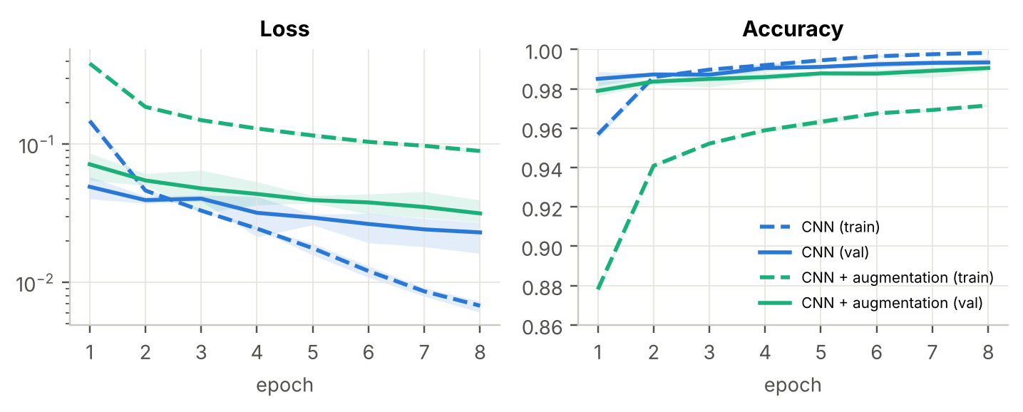
Figure 4. Learning curves (mean of 3 seeds; bands show the minimum and maximum). Dashed: training, solid: validation.

3.3 Zero-shot transfer and preprocessing ablation
Table 3. Zero-shot accuracy on our 807 digits, in % (mean ± std over 3 seeds). MNIST reference: logistic regression 92.35, CNN 99.33, augmented CNN 99.12.
Model | Preprocessing | Accuracy | 95% CI | Macro-F1 | Gap closed
Logistic regression | minimal | 55.47 ± 1.17 | [52.1, 58.8] | 52.13 ± 1.09 | -
 | thickness | 63.28 ± 0.26 | [60.1, 66.6] | 59.63 ± 0.44 | 21.2%
 | centering | 74.56 ± 0.68 | [71.7, 77.5] | 72.93 ± 0.61 | 51.8%
 | full | 79.97 ± 0.26 | [77.4, 82.7] | 79.41 ± 0.31 | 66.4%
CNN | minimal | 96.53 ± 0.43 | [95.5, 97.5] | 96.54 ± 0.44 | -
 | thickness | 97.48 ± 0.29 | [96.4, 98.4] | 97.48 ± 0.28 | 33.9%
 | centering | 98.43 ± 0.38 | [97.6, 99.2] | 98.43 ± 0.37 | 67.8%
 | full | 99.46 ± 0.14 | [99.0, 99.8] | 99.46 ± 0.14 | 104.6%
CNN + augmentation | minimal | 94.34 ± 1.08 | [92.9, 95.8] | 93.77 ± 1.41 | -
 | thickness | 94.96 ± 1.30 | [93.5, 96.3] | 94.52 ± 1.63 | 13.0%
 | centering | 97.56 ± 0.29 | [96.5, 98.4] | 97.51 ± 0.30 | 67.4%
 | full | 97.19 ± 0.73 | [96.1, 98.2] | 97.08 ± 0.79 | 59.6%

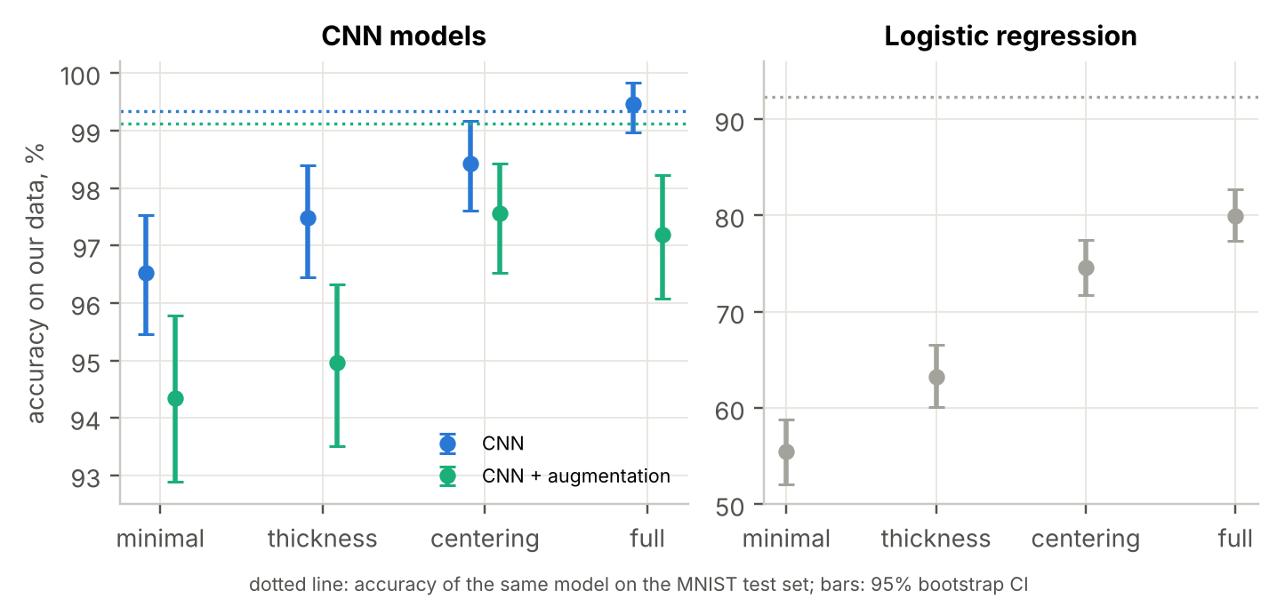
Figure 5. Accuracy on our data per preprocessing variant with 95% bootstrap intervals; dotted lines show MNIST accuracy of the same model.
Domain shift is real and large for the linear model. Logistic regression falls from 92.35% on MNIST to 55.47% on our data; the CNN loses only 2.80 points (to 96.53%). Preprocessing helps every model. For the CNN, accuracy rises monotonically from 96.53% (minimal) to 97.48% (thickness), 98.43% (centering) and 99.46% (full); the full pipeline is above the MNIST accuracy of 99.33% by a margin that lies within noise (gap closed 104.6%). For logistic regression the full pipeline lifts accuracy by about 24.5 points to 79.97%, but a gap of 12.4 points remains, so a linear model cannot fully profit from the preprocessing.
Statistical support (Table 4). The effects of centering and of the full pipeline against minimal are significant in all three seeds. Thickness alone is not significant in any seed (Holm-adjusted p = 0.06–1.0). Going from centering to full is significant in two of three seeds. These tests treat each seed separately and the images come from only four writers, so they describe this dataset rather than writers in general.
Table 4. Exact McNemar tests with Holm correction (adjusted p per seed 42 / 43 / 44) and number of seeds with p < 0.05.
Comparison | Accuracy, % | Adjusted p (3 seeds) | Significant
cnn/minimal → cnn/thickness | 96.53 → 97.48 | 1.000 / 0.106 / 0.058 | 0 of 3
cnn/minimal → cnn/centering | 96.53 → 98.43 | 0.026 / 0.015 / 0.037 | 3 of 3
cnn/minimal → cnn/full | 96.53 → 99.46 | <0.001 / <0.001 / <0.001 | 3 of 3
cnn/thickness → cnn/centering | 97.48 → 98.43 | 0.032 / 0.167 / 0.960 | 1 of 3
cnn/centering → cnn/full | 98.43 → 99.46 | 0.032 / 0.107 / 0.021 | 2 of 3
cnn/full → aug/full | 99.46 → 97.19 | <0.001 / <0.001 / 0.037 | 3 of 3
cnn/minimal → aug/minimal | 96.53 → 94.34 | 0.001 / 0.107 / 0.960 | 1 of 3
logreg/minimal → logreg/full | 55.47 → 79.97 | <0.001 / <0.001 / <0.001 | 3 of 3

3.4 Where the errors come from
With minimal preprocessing the CNN makes 24 errors on 807 digits (seed 42), dominated by 6 → 5 (7 cases) and 1 → 7 (6 cases); with full preprocessing only 3 errors remain (Figure 6). Per-class F1 of the weakest classes changes from 0.930 (class 1), 0.932 (7) and 0.949 (5) to 0.985, 0.990 and 0.998. Visual inspection of misclassified samples (Figure 7) suggests that many are genuine writing-convention differences rather than blur: a "1" with a flag stroke resembling 7, a "6" with a flat top resembling 5, and hooked "9"s. This is our interpretation of the images and was not tested separately.
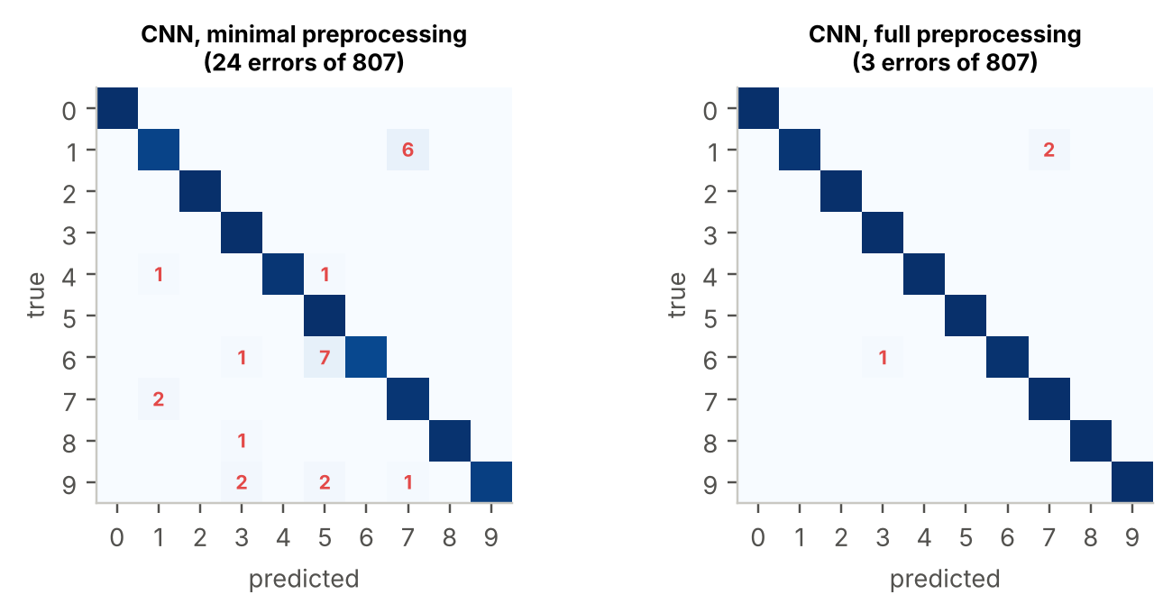
Figure 6. Confusion matrices of the CNN (seed 42); error counts in red, colour shows row-normalised share.
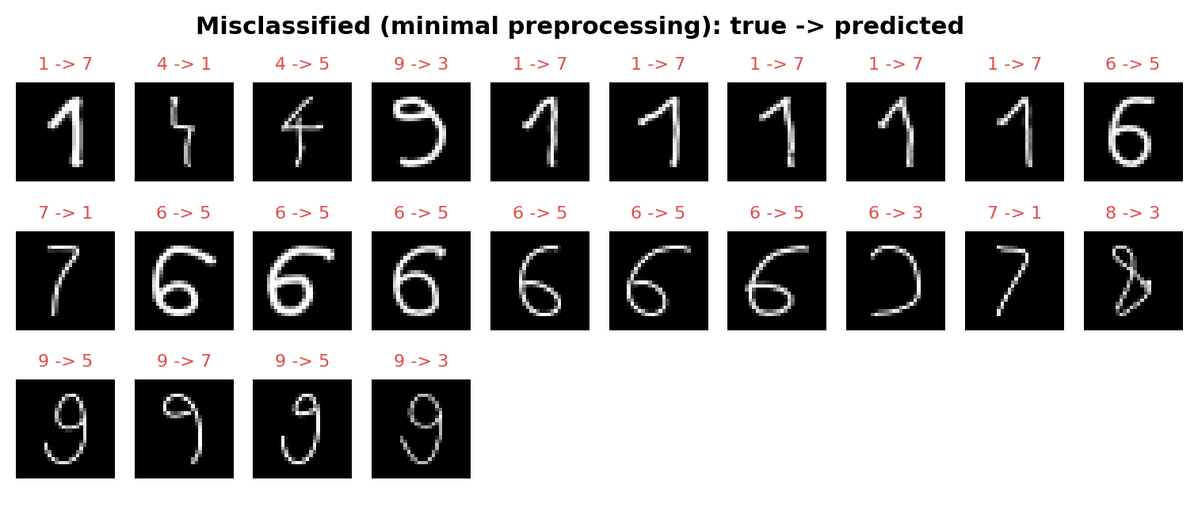
Figure 7. Examples of digits misclassified by the CNN under minimal preprocessing.

3.5 Which step matters, and for whom
Centering closes 67.8% of the CNN gap, thickness 33.9%. The thickness effect is concentrated in one writer: the writer with the thinnest strokes (median 0.90 px, Table 1) gains 8.0 images per seed, while the other three writers together change by -0.3 images (Figure 8). This is consistent with thickness normalisation mainly repairing unusually thin strokes, but it is based on one writer and should be read as a hypothesis. With full preprocessing the per-writer differences nearly vanish (99.0–99.8%).
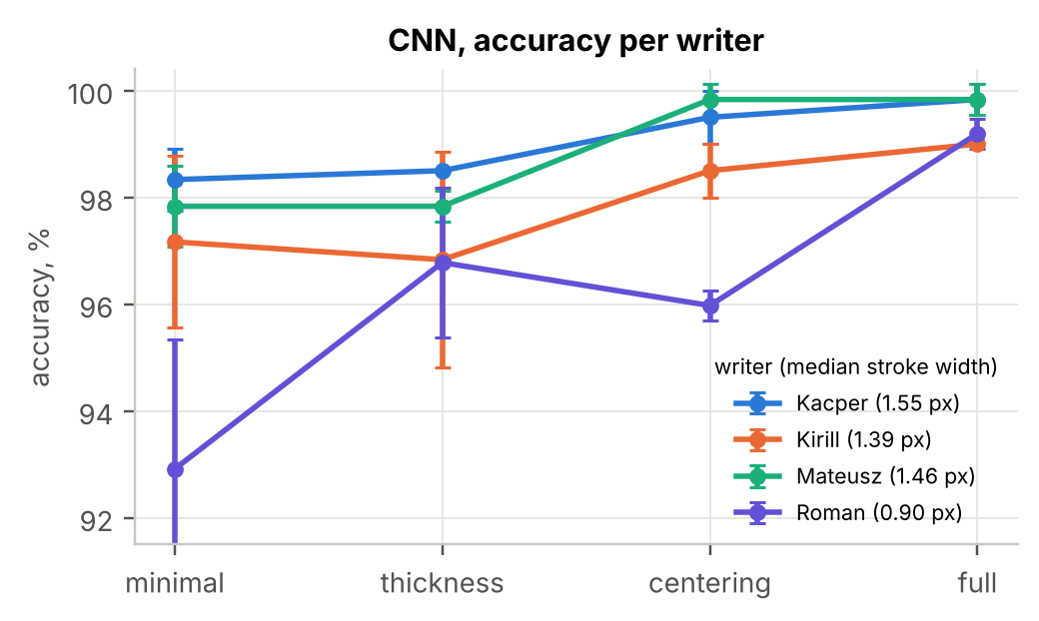
Figure 8. CNN accuracy per writer and preprocessing variant (mean ± std over 3 seeds).

3.6 Augmentation as an alternative
Augmentation did not substitute for preprocessing. The augmented CNN is worse than the plain CNN with minimal (94.34% vs 96.53%) and full preprocessing (97.19% vs 99.46%); the latter difference is significant in all three seeds (Table 4). Of its errors at full preprocessing, 95.6% are in class 1 (mostly 1 → 7). A possible explanation is that our dilation made the augmented MNIST strokes thicker than real MNIST (median 3.24 px against 2.44 px) rather than matching our thinner strokes, which would be an over-correction in the wrong direction; we did not run an experiment that isolates this cause. Examples of augmented images are shown in Figure 9.
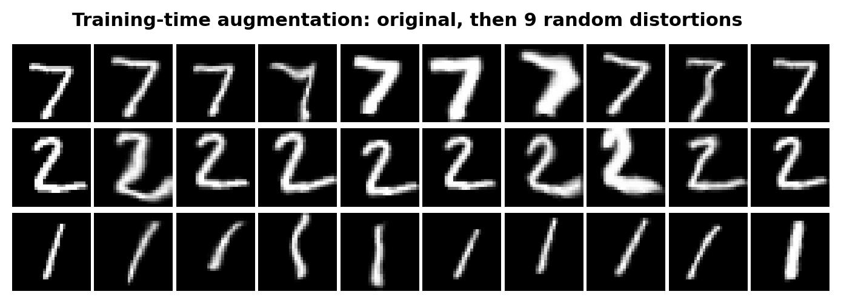
Figure 9. Original MNIST digits and their augmented versions.

3.7 Robustness to the stroke-ratio hyperparameter
The target stroke ratio was fixed at 0.12 before the experiments. Sweeping it (Figure 10) shows a plateau between 0.08 and 0.12 (99.38%–99.46%, mean over 3 seeds) and a small drop at 0.14 (99.26%), with lower accuracy for very thin (0.06: 98.97%) and very thick strokes (0.18: 98.51%). The value is therefore not finely tuned, and results are not sensitive to it within a reasonable range.
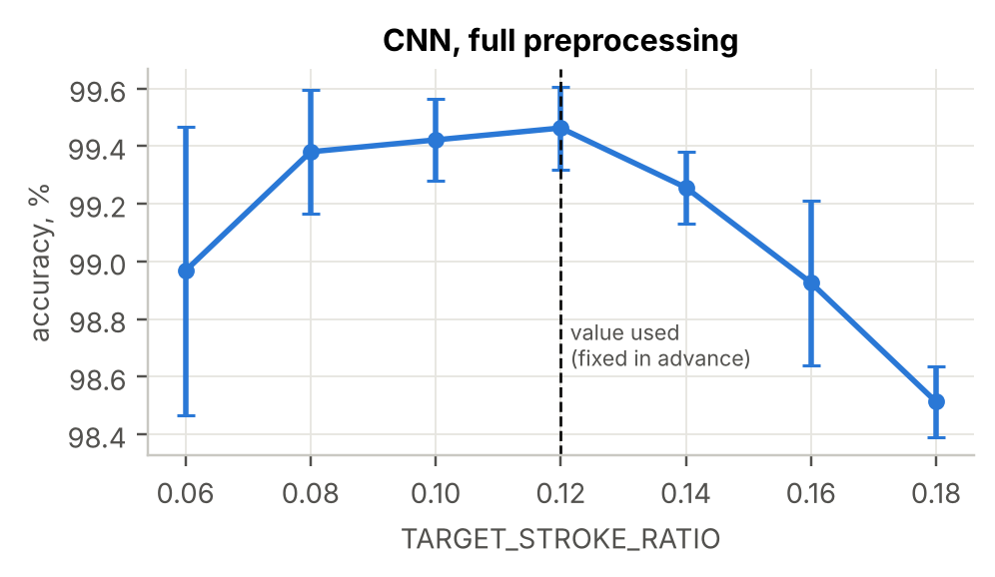
Figure 10. Accuracy of the CNN with full preprocessing for different target stroke ratios (mean ± std, 3 seeds).

3.8 Fine-tuning and leave-one-writer-out
We also checked how much the remaining gap shrinks when air-written data are used for training. Fine-tuning (Adam, learning rate 10⁻⁴, 15 epochs, batch 32, stratified 70/30 split of our data, 243 test images) brings the CNN from 99.86% to 100.00%, and the augmented CNN from 96.84% to 99.86%. In the leave-one-writer-out experiment (fine-tuning on three writers, testing on the fourth) the held-out accuracy of the CNN with full preprocessing rises from 99.0–99.8% to 99.4–100%. These experiments are at the ceiling: before fine-tuning the CNN makes about 0.3 errors on 243 images, so zero errors afterwards is not informative (the 95% upper bound for zero errors in 243 trials is about 1.2% by the rule of three [17]). Their only clear message is that fine-tuning repairs the augmented model, whose errors are systematic.

4. Discussion and Conclusion
Findings. A model that is nearly perfect on MNIST loses up to 37 points (logistic regression) or 2.8 points (CNN) on in-air digits. The shift can be measured (Table 1) and largely removed by two simple, interpretable preprocessing steps; with them the CNN matches its MNIST accuracy on our data without any air-written training data. Centering is the more important step; thickness normalisation helps mostly for the writer with the thinnest strokes.
Original contributions. The complete air-writing pipeline and dataset; a controlled, seed-averaged ablation with confidence intervals and paired tests rather than a single accuracy number; the gap closed metric that makes variants comparable across models; and the negative result that imitating the target domain by augmentation was worse than normalising the input.
Strengths. All preprocessing choices were fixed before looking at results, the dataset is never used for model selection in the main experiment, all configurations are repeated with three seeds, and every number in this report is read from the result files produced by the code.
Limitations. The dataset is small (807 digits) and comes from four writers, each with one laptop webcam, so conclusions about other people, cameras and drawing speeds are not guaranteed. The three seeds measure training randomness but not the writer sampling. Some conclusions are hypotheses: the cause of the poor augmentation result, the role of pen size relative to digit size, and the visual error interpretation. Fine-tuning and leave-one-writer-out are at the ceiling and cannot rank methods. The ablation tests each step alone and both together, but only in one order within the full pipeline (thickness before centering), so the effect of the order is not measured.
Lessons and future work. Checking the input statistics of a new domain before modelling was more useful than adding model capacity. Next steps are: collecting more writers and a larger test set; testing augmentation that makes strokes thinner instead of thicker; trying formal domain-adaptation methods [18]; and using the stroke trajectory (which the whiteboard already records) rather than only the final image.
Author contributions. All four members collected their own part of the dataset. Mateusz Dobry implemented most of the code (whiteboard, collection tool, preprocessing, models, training and experiment pipeline) and trained the models. Kirill Riabkov led the statistical evaluation and the analysis of the results (confidence intervals, significance tests, per-writer and sensitivity analysis). Roman Prokhorov assisted with the statistical analysis and wrote the report. Kacper Żuchowski contributed to every part of the project, from code and experiments to analysis and the report.

5. References
[1] Y. LeCun, L. Bottou, Y. Bengio, P. Haffner, "Gradient-based learning applied to document recognition," Proceedings of the IEEE, vol. 86, no. 11, pp. 2278–2324, 1998.
[2] F. Zhang et al., "MediaPipe Hands: On-device real-time hand tracking," arXiv:2006.10214, 2020.
[3] J. Quiñonero-Candela, M. Sugiyama, A. Schwaighofer, N. D. Lawrence (eds.), Dataset Shift in Machine Learning, MIT Press, 2009.
[4] S. Ben-David, J. Blitzer, K. Crammer, A. Kulesza, F. Pereira, J. W. Vaughan, "A theory of learning from different domains," Machine Learning, vol. 79, pp. 151–175, 2010.
[5] M. Chen, G. AlRegib, B.-H. Juang, "Air-writing recognition - Part I: Modeling and recognition of characters, words, and connecting motions," IEEE Trans. Human-Machine Systems, vol. 46, no. 3, pp. 403–413, 2016.
[6] N. Otsu, "A threshold selection method from gray-level histograms," IEEE Trans. Systems, Man, and Cybernetics, vol. 9, no. 1, pp. 62–66, 1979.
[7] P. Y. Simard, D. Steinkraus, J. C. Platt, "Best practices for convolutional neural networks applied to visual document analysis," Proc. ICDAR, 2003.
[8] S. Ioffe, C. Szegedy, "Batch normalization: Accelerating deep network training by reducing internal covariate shift," Proc. ICML, 2015.
[9] N. Srivastava, G. Hinton, A. Krizhevsky, I. Sutskever, R. Salakhutdinov, "Dropout: A simple way to prevent neural networks from overfitting," JMLR, vol. 15, pp. 1929–1958, 2014.
[10] D. P. Kingma, J. Ba, "Adam: A method for stochastic optimization," Proc. ICLR, 2015.
[11] I. Loshchilov, F. Hutter, "SGDR: Stochastic gradient descent with warm restarts," Proc. ICLR, 2017.
[12] F. Pedregosa et al., "Scikit-learn: Machine learning in Python," JMLR, vol. 12, pp. 2825–2830, 2011.
[13] A. Paszke et al., "PyTorch: An imperative style, high-performance deep learning library," Advances in NeurIPS 32, 2019.
[14] B. Efron, R. J. Tibshirani, An Introduction to the Bootstrap, Chapman & Hall, 1993.
[15] Q. McNemar, "Note on the sampling error of the difference between correlated proportions or percentages," Psychometrika, vol. 12, pp. 153–157, 1947.
[16] S. Holm, "A simple sequentially rejective multiple test procedure," Scandinavian Journal of Statistics, vol. 6, no. 2, pp. 65–70, 1979.
[17] J. A. Hanley, A. Lippman-Hand, "If nothing goes wrong, is everything all right? Interpreting zero numerators," JAMA, vol. 249, no. 13, pp. 1743–1745, 1983.
[18] Y. Ganin, V. Lempitsky, "Unsupervised domain adaptation by backpropagation," Proc. ICML, 2015.

