Rise of the Phoenix
Written by artificial intelligence

Table of Contents
Chapter 1: The Lantern in the Mist
Chapter 2: A Healer's Bargain
Chapter 3: The Outcast of House Reese
Chapter 4: Quinn at the Hollow Gate
Chapter 5: The Ember Reborn

Chapter 1: The Lantern in the Mist
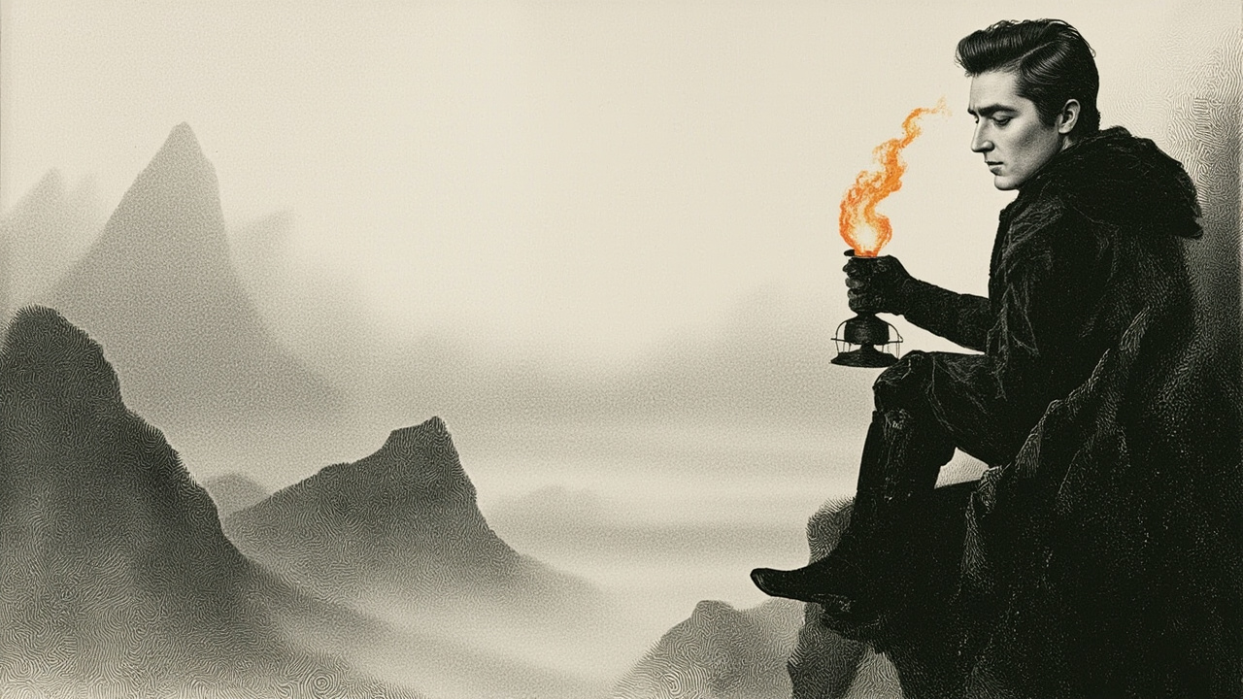
The flame will not obey me. I cup my hands around the glass and breathe, willing the wick to catch, and it does what it always does — flickers obediently orange, licks the oil, settles into its small patient vigil. The sanctuary keeps no other fire. Only this. The lantern hanging on the iron hook at the mouth of the cleft, where the mountain opens its mouth to drink the dawn. I have trimmed this wick since I was small enough to stand on the flat stone and reach. I have watched the mist pour down the slopes each morning like water over the rim of a bowl, pooling in the valley until the pines floated in it and the sky and the world below were two different greys separated by our small bright speck.
The elders call it the watching fire. They call it the marker. They tell us, on the days they speak at all, that as long as the flame burns, the sanctuary is hidden. As long as the flame burns, the world beyond the mist does not see us. I have never asked what happens if it goes out. There are questions one does not ask in the mist.
My fingers are cold. The glass is colder. I lower my hands and step back, and the flame burns as it has always burned, a small domestic orange, the color of hearthstones and soup and the rind of the late-autumn pears Sister Wren brings up from the lower orchards. A color I know.
Today the mist tastes of iron.
I turn my head. The path behind me, the one that climbs up from the sleeping huts to this little shelf of rock, is empty. The elders keep their own hours. Wren will be in the kitchens already, humming to herself as she kneads, the way she has hummed since before I was born, the same three notes over and over like a bird that has forgotten how to end its song. Brother Ash will be in his stone circle above, walking the perimeter with his staff, tapping each cairn. He does this every morning whether the mist is thin or thick. He says the cairns listen.
I wait.
A bird starts somewhere in the pines — a single clear note that hangs in the air like a needle held up to the light. Then another, answering. Then a third that is not an answer but an argument. I almost smile. Almost. My hands are still cold and the taste of iron is on my tongue and something in the small of my back has begun to pull, the way a held breath pulls when you have held it too long.
"Cameron."
I do not startle at the voice. I have known since I was seven that when an elder wants you, you feel them before you hear them, like a change in the weather inside your own chest. I turn.
It is Sister Maren, the oldest of them. She moves down the path the way smoke moves, without seeming to use her legs. Her face is a folded map. Her eyes are the color of the pond when the ice first thins.
"You taste it too," she says. It is not a question.
I nod. I have no words for it. I have never had words for things like this. The elders speak in weather and birds and the small pains of the body; I have always been the child who understood the fire and the wick and the glass, the child whose hands knew how to keep a flame alive.
"Sit," she says, and points to the flat stone. I sit. She remains standing, though I can see in her face that standing costs her. The mist curls around her ankles like a cat.
She does not speak at first. She watches the flame. I watch her watching it. The dawn comes on slowly, as it always does up here, the light not arriving so much as accumulating in the air, a slow reluctant giving-in. The pines darken. The valley fills. Somewhere below, a bell I have never heard rings once and stops.
"There is a vision," Maren says.
My hands close on my knees. I have been waiting for this sentence since I was old enough to know what it meant. We are taught that visions come to the elders, not to us. We are taught to tend the fire, walk the paths, keep our small holdings. We are taught that the world outside is a wound that has not closed.
"Whose?"
She looks at me. The look has weight. It is the look of a woman deciding whether to set down something she has carried for a long time.
"Yours," she says. "It came to me. It came through the stone under my feet while I slept, and it wore your face."
The taste of iron is stronger. My tongue is a metal thing in my mouth.
"Show me," I whisper.
She closes her eyes. Her hands, which I have never seen tremble, tremble now at her sides. The mist around her ankles thickens and rises, and in it — I do not know how else to say this — I see.
Not with my eyes. My eyes are open. I see with something older, something behind the eyes, the way you hear a song in your head and know it is not your thought. A room. A small room, low-ceilinged, with a window that looks out onto nothing I recognize. A bed of heather. A hand — smaller than mine, a child's hand — turning a coin over and over between its fingers. The coin is dark. The coin is older than the hand. On the coin, in metal that has been polished by generations of thumbs, a single ember. Not the flame of our lantern. A different kind of ember. A sleeping one.
Then — and this is the part that makes me grip my knees until the bones ache — a sound. A voice. My mother's voice, or the ghost of it, the way a bell heard from the next valley is still the bell but changed. The voice says a word I cannot make out. The voice says my name.
The mist breaks. Maren exhales. I am on the stone and my hands are on my knees and my face is wet and I did not feel myself weeping.
"The family ember," Maren says, softly, as if the words themselves are afraid. "There is one. There has always been one. We did not tell you."
The mist moves between us. The lantern flame moves with it, leaning, recovering, leaning again.
"Why," I say. The word is a stone I throw at her feet.
She does not pick it up. "Because the ember sleeps. Because to wake it is to be seen. Because your family, Cameron — your family chose the mountain, and the mountain chose them, and the choosing was not a small thing. It was a door closed. To open it again — "
"Is to be seen," I finish. "Yes. I have heard the teachings."
"You have heard the shape of them," she says, and there is no reproach in her voice, only a tired kind of truth. "The shape is not the whole."
I look at the lantern. The flame is leaning again, recovering, leaning. It has done this a thousand times in my keeping. It has never done anything else.
"Where," I say. Not a question. The word a hand reaching.
"The vision did not show me. Only the ember. Only the voice. Only your name."
I stand up. My knees are stiff. The dawn has finished arriving. The valley is full of white and the pines float in it and the lantern hangs in its iron mouth and the flame burns its small domestic orange, the color of everything I have ever known.
Maren watches me. Her face does not change. Her eyes do.
"If I go," I say, "the lantern."
"Yes."
"If I take the lantern."
"The path will know you. The path was made for feet like yours."
I reach up. The iron hook is cold under my fingers. The glass is cold. The flame leans into my palm as if it has been waiting for this particular warmth all its small obedient life.
I lift it from the hook.
In my hand, the flame turns gold.
Not orange. Not the hearthstone, not the pear-rind, not any color I have a name for. A deep, unblinking gold, the color of the sun seen through honey, the color of the coin in the vision's dark hand. It burns without smoke. It burns without sound. It throws no shadow. The mist parts around it as if it has been told to, and through the parting I see, for the first time since I was carried up here as an infant in someone's arms, the path.
It begins at my feet and runs into the white. It is made of flat stones, set close, mossed at their edges, older than any elder I have known. It goes down.
Maren makes a small sound. It might be a word. It might be her breath catching on a name. I do not look at her. If I look at her I will stay. If I stay I will tend the wick tomorrow and the day after, and the flame will be orange, and the mist will taste only of water, and I will never hear my own name spoken in a voice I almost remember.
I step onto the path.
The stone is warm under my boot. The gold flame leans ahead, not into my hand now but forward, as if it has somewhere to be. The mist closes behind me like a door. I do not look back. I will not look back. The lantern is in my hand and the path is under my feet and somewhere down there, in a room I have not yet seen, a hand is turning a coin, and a voice is waiting to finish saying my name.

Chapter 2: A Healer's Bargain
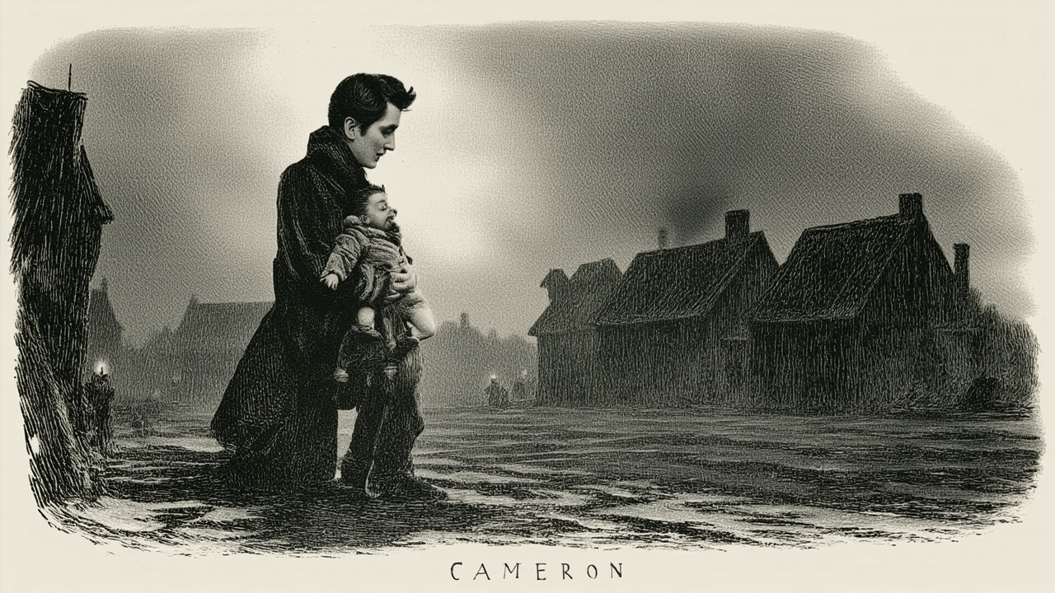
The lantern tugs me downhill through fog so thick it has a texture, a woolen closeness that catches on my coat sleeves and tries to stay. I walk, and the path walks with me, and somewhere beneath the soft give of moss and the crunch of old gravel, I think I can feel a town waiting. The air changes first: woodsmoke, wet stone, the faint copper tang of something alive. Then light bleeds upward through the mist, not at a street, but at the suggestion of one.
The village assembles itself around me in pieces. A gutter runs along the lane, dark with rain that has only just stopped, and the lanterns strung between the crooked rooftops are still dripping. Doors lean on their hinges. Shutters hang half-cordial, half-moody, as if unsure whether to welcome or warn. Somewhere a dog barks twice and thinks better of it. A woman on a step watches me pass and says nothing, only pulls her shawl tighter as if I have brought the cold in with me.
I have walked half the length of the single crooked street before I understand what I am seeing. The crossroads mark the center: four lanes meeting at a well that has no bucket, only a stone lid grown over with moss. The lanterns are thickest there, and the light pools on the wet mud in overlapping coins. A few men are gathered at the corner beneath an awning that sags with old rain, and they look up at me the way strangers are looked at everywhere, with a half-second calculation: harmless or not, worth noticing or not.
They decide I am not.
I lower myself onto the edge of the well and let the lantern rest on my knee. The gold flame has gone small and patient, a sleeping coal. I flex the hand that was not burned and find that I am more tired than I had any right to be, as if the path had borrowed something from me and forgotten to give it back.
A child is crying somewhere close.
It takes me a moment to place it. Not the usual bright complaints of hunger or want. This is a thin, threading sound, and it comes from an alley just behind the awning where the men are talking in low voices about a horse that won't come. I rise without deciding to. The lantern does not tug me this time. It only brightens, a little, as if curious.
The alley smells of old fish and newer blood.
A boy is sitting against a wall with a gash across his palm that has been bound badly with a strip of apron. A woman kneels beside him, pressing the cloth tighter, murmuring in a language that is not quite any language I know, the words curving up at the ends like questions. The boy's face is the color of tallow, and his eyes are too bright in the way that means he has lost more than he should.
I step forward, and a man steps out of the shadow and blocks me.
He is taller than I am by a head and broader by half, and his hand is already raised, palm out, in the universal gesture of stop or I will make you stop. His coat is road-worn, his beard trimmed close, and his eyes have the patient weariness of someone who has dealt with strangers before and has not enjoyed it.
"Nothing here for you, friend," he says. The friend is a courtesy and nothing more.
"He is bleeding," I say, because it is the obvious thing, and because sometimes obvious things are useful.
"He is being seen to."
A shadow moves behind his shoulder. A hand appears at his elbow and rests there lightly, and the man stops as if a line has been drawn through him. The owner of the hand steps around him into the lantern-light, and I have my first look at Taylor.
She is younger than I expected, or older than I expected, in the way some people are where age does not seem to be the relevant fact about them. Her hair is dark and short and rain-flattened against her temples. Her coat is patched at the elbows with the careful patience of someone who intends to keep wearing it. Her eyes, when they find mine, are the pale green of river water where the current is slow. She does not smile.
"Bleeding is a thing that happens," she says, and her voice is low and amused and not a little tired. "It is rarely the end of the world."
"The boy—"
"The boy is my nephew. The boy is also a liar and a climber and the heir to every scrape his father ever survived. He climbed a fence. The fence won." She glances at him with a fondness so rough-edged it could cut. "I will see to him. I would not mind an audience, if you have nothing better to be."
She does not wait for my answer. She kneels in the mud beside the boy, and her hands are steady in a way that tells me she has done this before, and that doing it has cost her something. The woman who was binding the wound pulls away as if relieved of a weight. Taylor unwraps the apron strip with two fingers and a thumb, and the gash on the boy's palm yawns open, deep, slick, a mouth that wants to keep speaking.
"Will it scar?" the boy asks, very small.
"Almost certainly," Taylor says. "You can tell people a dragon did it, if you like."
He does not laugh. He is too frightened for that. She takes his hand in hers, and she looks at the wound for a long moment, and I see something move across her features that is not quite pity and not quite anger. It is the face of someone who is about to pay a bill they have already paid a hundred times.
"Taylor," the big man warns, low. "Not here."
She does not answer him. She closes her eyes.
Nothing happens for a heartbeat. Two.
Then the air over the wound goes thin and bright, as if a window has been opened into a colder country. The gold flame in my lantern leans hard toward them, then steadies. The boy gasps, his free hand clutching at nothing, and his face, which had been the color of tallow, flushes suddenly, vividly, painfully pink. The wound is closing. I can see it. The lips of the gash are drawing together like a mouth deciding whether to speak, and beneath them, new pink flesh is braiding itself into being, and the blood stops as if a tap has been turned.
Taylor's face has gone the color of rain.
Her breath is coming in short, careful pulls, the kind of breath one takes when breathing has become a project rather than a habit. Her shoulders curve. She is still holding the boy's hand. She has not let go. The wound is a thin white line now, no more, a comma on the page of his hand.
She opens her eyes. She lets his hand go as if it has grown hot.
"That," she says, and her voice has lost its amusement and found something harder in its place, "is done."
The boy looks at his palm and makes a sound that is half laugh, half sob. The woman gathers him against her. The big man steps forward and offers Taylor his arm with a gentleness I did not think his hands were capable of, and she takes it, and the two of them stand for a moment like wrestlers after a bout, spent and upright.
I am still holding my lantern. The gold flame is humming against my palm.
"You," Taylor says, without turning her head. "You have the look of a man who has questions he thinks are polite."
"I have the look of a man who will watch a man climb a fence and not warn him," I say. "I am not in a position to judge."
Something moves at the corner of her mouth. Not a smile. The sketch of one.
"I am going to find a roof that is not dripping," she says. "You may follow at a polite distance, or you may stay and interrogate my nephew, who is a terrible liar but an honest one, which is almost the same thing."
I follow. It is, I tell myself, the only direction that has been offered.
The inn is low and crooked and warm, and the woman behind the counter knows Taylor by name and the big man by name and looks at me the way people look at weather they did not order. We are shown to a table by a fire that has the decency to be actually burning. Taylor sits with the careful grace of someone who is holding herself together with posture. The big man—her brother, I will learn, though not tonight—orders a pot of something that smells of cinnamon and regret.
I wait until the cups are poured and the brother has stepped away to speak with the innkeeper before I speak.
"You took that wound into yourself," I say.
Taylor looks into her cup. She drinks. She sets the cup down with the precision of someone placing a loaded weapon on a table.
"I took it into myself," she says. "I have done it before. I will do it again. It is a useful thing to be able to do, and it is a costly thing to be able to do, and these are two facts which do not, in the end, contradict each other."
"And the cost?"
"Stays with me." She lifts one shoulder. "It is not a conversation I owe a stranger in an inn."
"No," I say. "But I am a stranger with a lantern that points, and it pointed me to a village, and the village has you in it. I am curious whether that is coincidence or arithmetic."
She looks at me then, fully, and I feel the weight of it. There is no mysticism in her gaze. She is simply looking, the way a woman looks at a man who has said something that needs to be measured.
"The phoenix," she says, very quiet, "is older than the roads and younger than the stones. It burns where it chooses and dies where it must and rises where it can. The stories say it is a bird. The stories are liars. It is a debt. A debt that passes from hand to hand, and at each hand it costs more, and at each hand it is paid, and when the last hand is reached—" She stops. She drinks again. "The last hand has not been reached."
"And you are one of the hands."
"I am a hand." She sets the cup down. "I am trying not to be the last one."
The fire pops. A log settles into itself. Somewhere outside, the lanterns creak on their lines in a wind that has no other purpose.
"You are walking somewhere," she says, and it is not a question.
"I am being walked somewhere."
"There is a difference, but it is small." She turns the cup in her hands. "The road north is bad. There are people on it who will not wish you well. There is a man on it who is collecting debts of a particular kind, and he is closer than he should be."
"I have heard of him."
"Then you have heard more than most. The road is shorter with company. The company is shorter with road." She meets my eyes again. "I am offering a bargain, not a friendship. I will walk with you as far as the next crossroads. You will not ask me to heal what I have not offered to heal. You will not speak of what you saw in the alley to anyone who was not there. In return, I will not leave you to the road, which is more than I have offered anyone in a long time."
"And the bargain if I say no?"
"Then you walk alone, and I drink my cup, and we both pretend the other was a kind of weather."
I look at the lantern in my hand. The gold flame leans, just slightly, toward her.
"Your bargain," I say. "Accepted."
She nods once, the way a person nods when a contract has been signed and the ink is still wet. Her brother returns and looks at me and looks at her and decides, with the resignation of long experience, that whatever has happened is her doing and will be her undoing, and that he will be there for the undoing, as he has always been.
We drink our cups. The fire burns down. The inn empties by degrees, the way inns do, with small partings and small promises and the soft closing of doors. At some point I rise to look out the window at the lane, and Taylor passes behind me toward the stairs, and her shadow on the wall is wrong.
It is her shadow, and it has two outlines. It is one shape, drawn over a great distance, and the two shapes do not quite agree. They hold for a single heartbeat, the second a half-step behind the first, like a traveler who has paused to look back. Then they are one again, and she is at the stairs, and I am standing with my lantern and a question I will not ask tonight.
The gold flame burns steady in my hand. The road will be there in the morning. I am not ready for the morning. I am going to have the morning anyway.

Chapter 3: The Outcast of House Reese
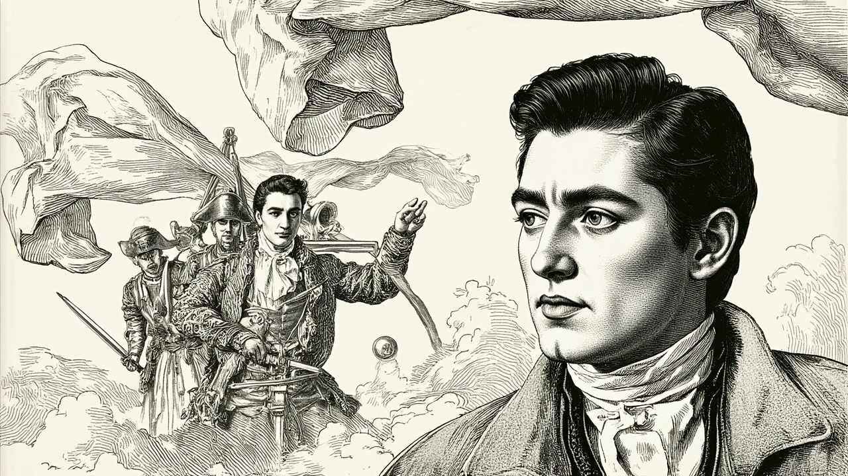
The road gives up its silence somewhere past the second milestone, where the gravel ends and a paved causeway begins, and a town rises out of the morning like a thrown handful of color. Banners the red of pomegranate skin hang between the timbered houses. The air smells of spiced honey and frying dough and the green, wet breath of the canal that cuts the square in half. I have been walking since the stars went out, and my legs have opinions about it.
I lower myself onto a stone bench beside the fountain and set my lantern between my feet. The gold flame is smaller now, the size of a child's fist, and it gives off a warmth I do not trust. I unwrap the last of the bread I bought at the last town and tear it into pieces small enough to pretend I am full.
A child runs past me trailing a kite shaped like a heron. A woman leans from a window and calls his name, and her voice has the particular sharpness of a mother who has called it twice already. Somewhere a dog barks at a drum, and the drummer does not stop. I eat my bread and let the noise wash over me like a bath I have not earned.
It is, I decide, the most ordinary place I have ever stood.
I should be relieved. I am suspicious.
I fold the empty cloth and tuck it into my pack and look up at the banner above the fountain's brim. A crowned hare, very proud of itself. Beneath it, a painted notice of the weekly market, and beneath that, another notice, and another, each pinned over the last as if no one could agree which warning mattered most. I read them from the bench. I have nothing better to do. One warns against pickpockets. One forbids the sale of unlicensed ferrets. One offers a reward for the return of a pearl earring lost during the summer fete, which I suspect was a gift from a husband who is no longer a husband.
I am reading the ferret notice a second time because I am not proud when a shape moves at the corner of my eye, and I look up, and a man is sitting beside me on the bench. He was not there a moment ago. He has the lean, dark-eyed look of someone who has learned to move through a crowd the way a coin moves through a hand, and he is smiling at me as if we are old friends who have just run into each other by the most improbable of chances.
"You," he says, "are reading the ferret notice with the face of a man who has never thought about ferrets once in his life."
"I have thought about ferrets," I say, "exactly as much as the law allows."
He laughs, and the laugh has edges. He is younger than I first thought, though he wears his age the way a cardsharp wears a coat — carelessly, and with an eye on the cut. His clothes are good. Not new, but good, and altered in small ways a tailor of quality would do to disguise their origin. The cuffs are taken in. The collar is raised. The buttons have been replaced with cheaper ones, which is the one mistake no one makes by accident. He wants to look less like himself than he is.
"You are a long way from anywhere," he says, "with a pack that has seen better days and a lantern that does not belong in this part of the world."
"My lantern," I say, "goes where I go."
"A bold claim for a lantern." He tilts his head. "I am Reese."
"Cameron."
"Cameron." He tastes the name. "Cameron who walks alone with a gold light and reads about ferrets. There are two men at the baker's stall by the fountain who have been watching you for the length of a conversation. I thought you might like to know."
I do not turn my head. I learned that lesson at some point in a life I do not always remember writing. "Are they mine?"
"They are not yours in the way you mean. They are the kind of men who are everyone's and no one's. They sell quiet and they buy trouble." He stretches his legs out, crosses them at the ankle, and picks a thread off his sleeve. "They were asking the baker if the man by the fountain was your own."
"And the baker?"
"The baker said he had not seen me in his life and went back to his buns."
I risk a glance. The two men are standing at the stall as described, and one of them is eating a bun with the focused attention of a man who is also watching me in the shape of a man who is not. They are broad in the shoulder and careful in the hand, and I do not like the way the smaller one's weight holds.
"Why," I say, "are you telling me this?"
"Because I have a use for a man who walks alone," he says. "And I would rather the use not be spoiled by a pair of knuckle-draggers with a letter of marque from some lordling who cannot tell his enemies from his ledgers."
"You have a use for me," I say. "And I have not yet had breakfast."
"Then breakfast is the first use." He stands and offers me a hand, and the hand is clean and the nails are trimmed and the gesture is so perfectly the gesture of a gentleman that I take it because refusing would be more interesting than I want to be. "There is a place two streets over that does an egg in a cup that will make you forget the name of your own mother."
"I am fond of my mother's name."
"Then it will not take long to recover it."
We leave, and the leaving is its own small performance. He walks to the left of me and a half-step behind, which is the position of a servant in a household I would like to know more about. I match my stride to his without deciding to, and we cut through the crowd the way a pair of scissors cut cloth, smooth and without snags. The two men at the stall are still deciding whether to follow when we turn the corner, and by the time they decide, we are gone.
The egg is as advertised. I eat it. He drinks something dark and hot that smells of anise and does not seem to cheer him. The room is small and the ceiling is low and the proprietor is a woman of indeterminate age who calls him sir and does not seem surprised to see him, which suggests he has been here before, which suggests the knuckle-draggers were not wrong to be looking.
"Now," he says, setting down his cup, "you may ask."
"I will ask one thing," I say. "Why did you help me?"
He considers this with the gravity of a man who is considering whether to answer it. "Because," he says, "I have been watching you since the second milestone. You walk like a man carrying something he does not understand, and you stop at milestones, and you do not stop at inns. A man who does not stop at inns is either a fool or a man on business he cannot talk about. I do not like to see fools on the road. They make the rest of us look bad."
"And the business?"
"That," he says, "is the question you did not ask." He smiles, and the smile has edges, and the edges have edges. "You have a lantern that burns gold. You have a pack that is empty of everything except the lantern. You are not a tinker, not a priest, not a peddler. You are a man with a question, and the question has a shape I recognize."
"I do not know what shape you recognize."
"You recognize it too," he says. "You have been carrying it since I sat down. The shape of a thing you are looking for that does not want to be found." He leans forward, and his voice drops, not to a whisper but to the register of a man who is used to being overheard. "I knew a man once who carried a shape like that. He was the most celebrated leader of my house, and the most celebrated leader of any house for a hundred years, and he had a way of looking at a problem until the problem agreed to be something else."
"Your house."
"House Reese." He says it the way a man sets down a glass he has been holding for too long. "I am the second son, which is to say the spare, which is to say the mistake. My elder brother is everything a first son should be, and I am everything his friends are not. I was raised to command. I was not raised to be commanded. I left. They did not ask me to come back. I have not asked them to ask."
"You left a house," I say, "to sit on benches and watch strangers."
"I left a house," he says, "to find what the house would not let me. A man named Quinn — Edmund Quinn, of House Quinn, formerly of everywhere that mattered — is hunting a thing along a trail I have been following for three months. He has been hunting it for a year, by every report. He has emptied his house's goodwill and spent half its silver and broken the friendships his father built, and he has not found it, because he is looking for it the way a man looks for a key he is certain he dropped under the lamppost. He will not look under the bed. He will not look in the dark."
"And you?"
"I am looking in the dark." He looks at me, and the look is a hand laid flat on a table. "I have nothing to sell you, Cameron, and I have nothing to buy. I have a pair of legs and a head that does not stop, and I have a question I cannot answer alone. The question has a shape. The shape is what you are carrying."
I look at the gold flame in the lantern at my feet. It does not answer. It never answers. But it is a little steadier, and steadiness, in my experience, is its own small kind of yes.
Before I can answer, a shout goes up in the square outside. Not the shout of a brawl. The shout of a small, sharp surprise. A child has climbed the fountain to reach a kite and has knocked a handful of papers loose from the post. They flutter and cartwheel in the morning wind, and a few of them drift through the open window and land on the floor between us, and one of them lands on my knee, face up, and the face on it is unmistakable.
Quinn.
A broadside. A woodcut. The line of the jaw, the set of the brow, the particular and infuriating tilt of the head. The notice beneath it offers a reward for information leading to his whereabouts, and the seal at the bottom is not the seal of House Quinn. The seal at the bottom is the seal of a court I do not recognize, and the date is two days old.
I look up, and Reese is looking at me, and the edges of his smile have folded away into something I would call seriousness if I were the kind of man who used the word.
"It seems," he says, "the question has found us."
I turn the broadside over in my hand. The back is blank except for a single line in a clerk's cramped script, and the line is a name I have heard twice in my life, and both times the telling came with a warning.
The gold flame, in my pack at my feet, gutters once, and goes steady again.

Chapter 4: Quinn at the Hollow Gate
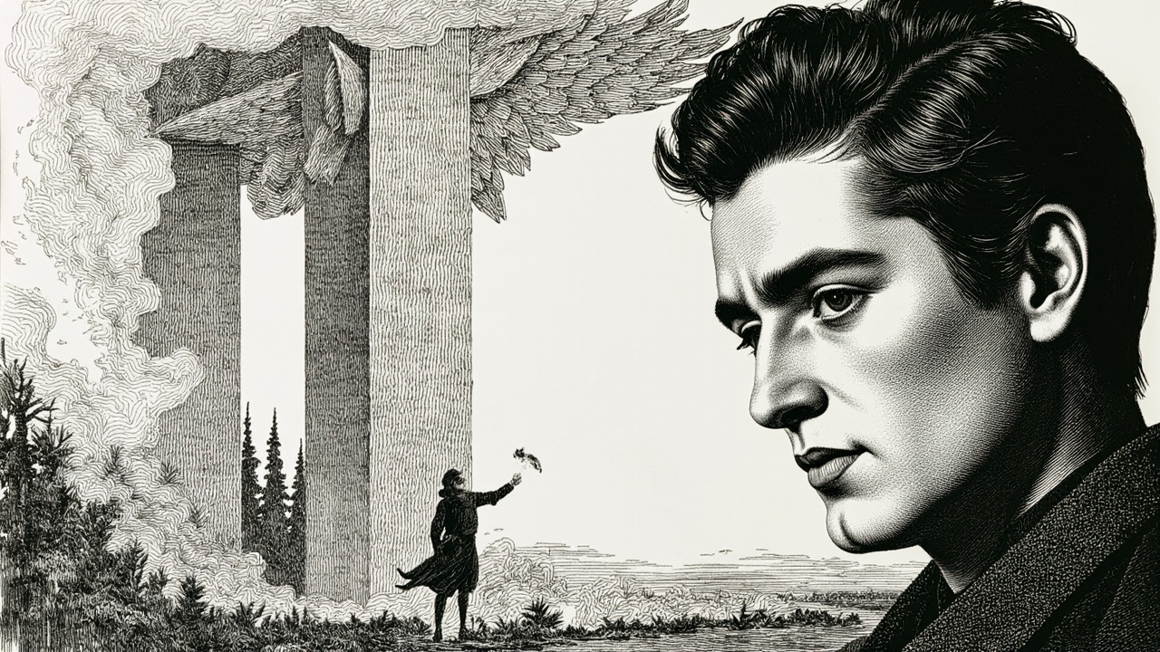
The name on the back of the broadside sits in my palm like a coal. Doran Vael. I have not spoken it aloud since I was seventeen and my mother pressed her thumbnail into the soft underside of my wrist and said, Never to strangers. Never for sport. And never, Cameron, never to anyone who asks twice.
Reese is watching me the way a man watches a fuse.
We have walked three hours past dawn, through the thinning air of the high country where the pines grow crooked and the moss hangs from them in pale, defeated beards. Now the forest has stopped being a forest and started being a memory of one. The trees here are black to their roots, standing in rows like the ribs of something that died standing up. The air smells of nothing, which is its own kind of smell — the smell of having been burned so thoroughly that even the ghost of green has given up and gone home. Somewhere ahead, through the gray pillars of the trunks, the sky has the bruised orange of a held breath.
The Hollow Gate is smaller than I expected. Two upright stones, shoulder high, and a lintel across them carved with a pair of wings that might once have been phoenix wings or might once have been the wings of anything at all. Ash has settled into the grooves. At the base of the left stone, a single sprig of something yellow-green is pushing up through the char, swaying in a wind I cannot feel at my face.
And there, on the flat stone bench set into the right-hand upright like a shelf, a man is sitting as though he has been there since the fire went out.
He is younger than I had pictured. That is the first thing I notice, and it annoys me, that my picturing should have been wrong. He wears a coat the color of wet bark and his hands are bare despite the chill, and he is turning something over and over between his fingers, some small dark thing I cannot make out from this distance. When he hears us — he must hear us, we are not being quiet — he does not startle. He lifts his head and looks at me the way a man looks at the door he has been expecting to open.
Cameron, he says.
My name in his mouth. Not a question. Not a surprise.
I stop. Reese, two paces behind me, stops too, and I can feel him not drawing his knife by the effort it is costing him.
Quinn rises. He is tall and narrow and moves the way a man moves when he has spent a long time conserving his body for one specific effort. The small dark thing in his hands disappears into his coat. He comes down off the bench in two easy steps and stands between the two upright stones, framed by the wing-carving, and waits for me the way a key waits for the lock it was cut for.
You know my name, I say.
I know your grandfather's, he says, and the gold flame in my pack at my feet gives a single startled leap against the leather like a small animal startled from sleep. So I know yours by inheritance if nothing else.
Beside me, Reese breathes out a low sound that is not quite a word. I do not look at him. I am looking at Quinn, and Quinn is looking at me, and between us the burning forest ticks and ticks with its slow dry sound.
My grandfather is a story I was told, I say, and then I add, because it seems to matter, and because Reese is here and I would have Reese hear it from my mouth and not from Quinn's, He died before I was born. In the fire. The one that took the rest.
Yes, Quinn says. He says it the way you say yes to a thing that is true and also true of something larger than the thing named.
He steps toward me then. One step. The wrong number of steps, the kind of step that lets you decide. I do not decide. I hold my ground and I let him close the distance to where I can see that his eyes are the color of creek water and tired in a way that sleep will not fix.
There is a legend, he says, and his voice has gone quieter, which is worse than if it had stayed at the level of a man greeting a stranger at a gate. It is the voice of a man who is about to put something down he has been carrying too long. The legend says there was a family in these hills that had hold of a flame that could not be put out. Not by water. Not by earth. By nothing but the keeping of a promise between the flame and the family, a promise that had to be renewed by blood, by name, by the small and faithful things. The flame was called the Phoenix, though it was older than the word for it. And the family —
Vael, I say.
He inclines his head. The tilt of a man conceding a turn he had meant to take himself.
The family, he says, the family did not tend the flame out of love. Not at first. They tended it because the flame was the thing standing between the burning in the forest and every living thing past it. The forest, you see, does not stop at its own edge. It wants. And the Phoenix was the bargain that kept it wanting no further.
I think of the yellow sprig at the base of the left stone. I think of the gold at my feet that has not gone out since my mother pressed it into my hand with her dying year.
You are saying, I say, and I find I am smiling in a way that is not a smile, you are saying that my family were not keepers of a treasure. They were tenders of a leash.
I am saying, Quinn says, and his creek-water eyes do not move from mine, that the leash broke. And the family, when it broke, did something. They did not flee. They did not fight. They did what a family does when the bargain fails and the fire is at the door.
He pauses. I wait. The forest ticks.
They chose, he says.
The word lands wrong in my ears. Chosen, to me, is the word for dinner, the word for a side of the road, the word for a card to play. It is not the word for the thing that took my mother and my aunts and the long line of Vaels I never met and turned them into a story told with warnings.
Chose what, I say.
Each other, Quinn says. And the Phoenix. They chose to bind it with the last of themselves so that it would not go wholly loose.
I feel my weight shift onto my back foot. I did not mean for it to. Beside me, Reese has gone very still in the way men go still when they have understood something and have not yet decided what they think of it.
That is the legend, I say.
That is what is left of it, Quinn says. The legend and the broadside and your mother's fire and the gate we are standing at, which is older than the family and which the fire respects because the fire was here first.
I look past him at the Gate. The wings carved into the lintel. The yellow sprig. The bench he had been sitting on, which now that I look at it has words chiseled into its face, worn almost smooth, in a script I do not read.
And Doran Vael, I say. The name on the back of the broadside. What was he to them.
Quinn's mouth does a thing that is not quite a smile and not quite the opposite of a smile. He reaches into his coat and brings out the small dark thing he had been turning in his hands, and holds it out on his flat palm between us.
A feather. A phoenix feather, if such a thing can exist, and if I am the kind of man who believes it can. It is the length of his hand and no wider than his thumb and it is the color of ash after rain. At its tip, where the barb should have been brightest, there is a faint line of orange that still, if I squint, might be warm.
This is all that remains, Quinn says.
My hand has started to lift without my permission. I put it down at my side.
Of Doran, I say.
Of the fire, Quinn says. Of the binding. Of what was promised and kept and broken and re-kept. This is the feather the Phoenix shed when the last of the Vaels laid themselves into the bargain. It is the proof. It is also, he says, and now his voice thins to a wire, the warning.
I do not take the feather. I stand with my hand at my side and I look at it on his palm, and I feel the gold at my feet lean against the inside of my boot as though listening through me.
You want me to take that, I say, and take up whatever debt they took up.
I want, Quinn says, and for the first time something in his face is not steady, something in it is the face of a man asking, I want you to understand that the Phoenix is not a gift. It is a guardianship. And the guardianship is not over the flame.
Then over what, I say.
He looks at me a long moment. Then his eyes move, just once, past my shoulder to Reese, who is standing there with the knife finally in his hand after all, low against his thigh, the way a man holds a thing he is hoping he does not have to use.
He looks back at me.
Over the fire's appetite, he says, and what it will want when it gets hungry enough.
I hear Reese draw a breath and hold it. I hear the forest tick. I hear, very faintly, the gold at my feet laugh, the way a flame laughs when it has heard a story it has told before and is pleased to hear it told again.
And I look at the feather on Quinn's palm and I do not take it, and I do not tell him I will not, and I let the not-taking stand between us like a held breath, and the breath stretches, and stretches, and does not break.

Chapter 5: The Ember Reborn
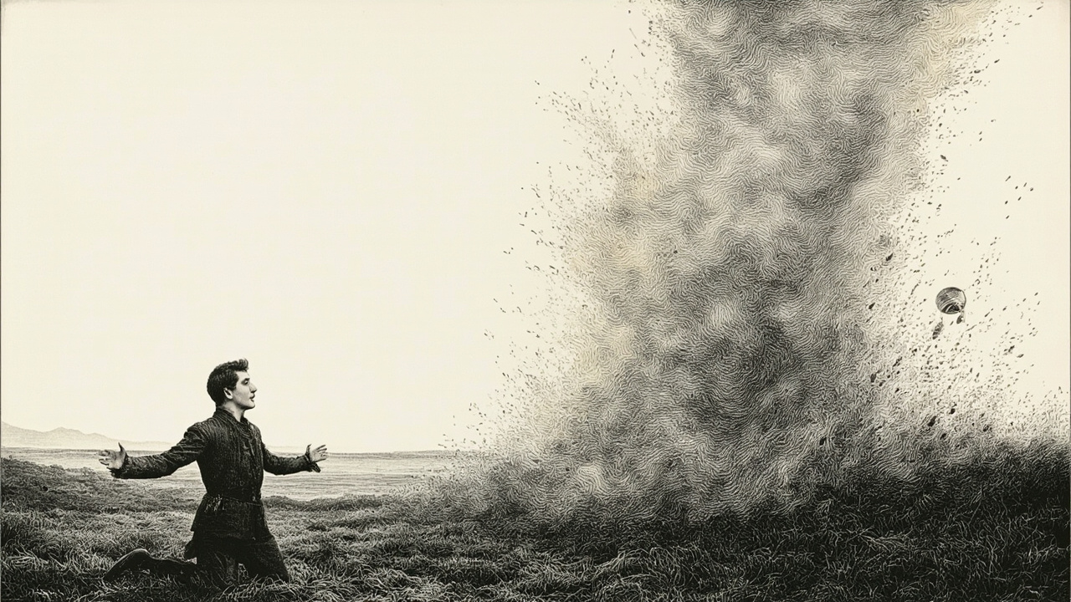
The gold laugh comes again, and this time I will not pretend I do not hear it. It burbles up through the ash like something newborn, bright and rude and unkillable, and I think, absurdly, of the way Lily used to gargle puddle-water at the pond and then shriek at the taste of it, outraged and delighted and alive. My chest does something sharp. I open my mouth to call her name into the gray and find I cannot, because Taylor is at my elbow, and Taylor is shaking, and Taylor needs me here more than Lily needs me there.
"I can take it," Taylor says, low and ruined, as if to the beak of his boot. "I want to take it."
I take his wrist. The bones of it are bird-light, trembling, and I realize with a quiet shock that they always were — that all of us have been carrying too much for too long, and no one thought to ask who was smallest. Father would have asked. Father asked after the pitchers of milk and the kindling and the names of every cousin on the hill, but he never once asked Taylor what he was carrying. He carried the name. He carried the firstborn's weight in a body that did not want it. Of course he is shaking.
"You can choose to," I say, because I will not make this for him. I will not, even now. "It has to be given, Taylor. You know that. You've always known that."
"We can't all be so clever, Cameron." His laugh is a wet, startled thing. "You and your moral philosophy."
Reese has begun to keen. The sound is not a cry — it is older than crying, a register the throat learns only in extremis, and it goes out over the ash like a rope thrown to a drowning man who is already at the surface. He is circling the feather where Quinn has laid it on a flat stone, and his hands move in the air above it as if he has just remembered he has hands and wants to be sure they can still give something. I see what he is doing before he does. I have known Reese forever. I have been known by him forever. We do not have to speak.
"Quinn," Reese says, finally, and his voice is the keening still, just bent into words. "The ember. I would like to be useful to it. Show me how."
Quinn — old, wry, improbable, standing in the ruin of a morning he has outlived too many times — inclines his head. "You will need to kneel," he says, "and you will need to mean it."
Reese drops to his knees in the ash with a muffled thump. The dust plumes up around his shins, golden, and does not settle. It drifts upward through his borrowed coat, into his hair, into the open O of his mouth, and he does not cough. He lets it in. I have never seen my brother so still and so open at once. The ash settles over his eyes, his cheekbones, the soft part of his throat where his pulse leaps, and he glows from the inside like a paper lantern.
"It wants to know why," Quinn says, almost a whisper. "Tell it why."
"Because I have nothing," Reese says, and I hear what he means: nothing left to protect, nothing he will not spend, nothing that is more his than it is the world's. "Because I am tired of holding doors shut."
The ember on the flat stone shivers. It does not rise — it spreads, the way spilled water spreads, but upward, thinning into a sheet of light that drapes itself over Reese's shoulders like a shawl. He bows his head into it. The sheet sinks through him, and his body tilts, and I think, for one awful instant, he has gone. Then he breathes out, and the breath is gold.
I will not pretend I am not afraid. I am afraid the way you are afraid at the edge of a pool when you have not swum in years, and the water is dark, and someone you love is already in it. I step forward. The ash gives under my boots like fresh snow. Taylor steps with me, shoulder to shoulder, and Quinn — Quinn, who has been old since before any of us was born — Quinn smiles at us both as if we have done something he has been waiting a long time to see.
"It will want to know you now," Quinn says. "Both of you. It cannot be carried by one alone. It will buckle a single spine."
"I am not alone," I say, and I take Taylor's hand in mine, and I take Quinn's feather from the flat stone with the other. I press my thumb into the quill until a thin bright line of red wells up, and the gold leaps to it the way a cat leaps to a warm lap. The feather drinks. I feel the warmth roll up my arm and into my chest, and it is not burning — it is remembering. It is remembering every hearth we ever sat around, every hand we ever held across a fire, every winter we got through because we got through it together.
Taylor makes a small sound. I look at him. The ash on his cheekbones has begun to move, lifting off him in slow spirals as if drawn toward something behind him. "It's warm," he says, surprised. "I thought it would hurt."
"It only hurts when you hold it wrong," Quinn says.
The spirals thicken. They coalesce. Somewhere just past Taylor's shoulder, the air begins to thicken too, and to fold, and to take on the unmistakable suggestion of a face.
I will not describe them as they step out. I will not count their years or name the gray in their hair. I will say only this: my mother is laughing, and the laugh is small, and it is unmistakable, and it is the laugh of my youngest sister, Lily, who is ten and was ten and will be ten again only in the way the dead are anything — which is to say, in the way we refuse to let them be gone.
She is holding our father's hand. He is holding our mother's. Our mother is holding the hand of no one in particular, because she always did that, she always reached out for the next person whether she knew them or not, and now she is reaching for me. I drop to my knees in the ash to be shorter than her. I have been taller than her for two years now. I have not been able to bear it.
"There you are," she says, and the words land on my head like snow.
I cry, then, the way a child cries, the way I have not cried since before the gate closed and the years began to add up wrongly. Taylor cries too. I hear him beside me, and I do not turn my head, because if I turn my head I will have to explain to my mother's ghost that her eldest son has been afraid of his own name for a decade and a half, and I do not want to waste a single second of having her hand on my hair to do it.
The gold has stopped spreading. It has gathered itself into a low bank of light at our feet, hissing softly, pleased, contained. The ember is not in any of us now. It is in the space between us, and that is why it is quiet. That is the secret Quinn has been keeping for longer than any of us has been alive. It is the secret the family never knew to ask, and the one that will let us put it down.
Lily's laugh rises again, bouncing off the gold, off the ash, off the low morning sun that has finally crested the ridge and is pouring through the broken gate like water through a broken dam.
"More," she says, imperious, ten, radiant, mine. "Tell it again. Tell it again."

