# 1. Installing curl

## 1.1 Installing on Windows (recommended method for Windows)

In Windows OS you can install Cygwin. This is Unix-like environment and command-line interface for Windows. Visit <https://cygwin.com/install.html> and download executable file and run it.

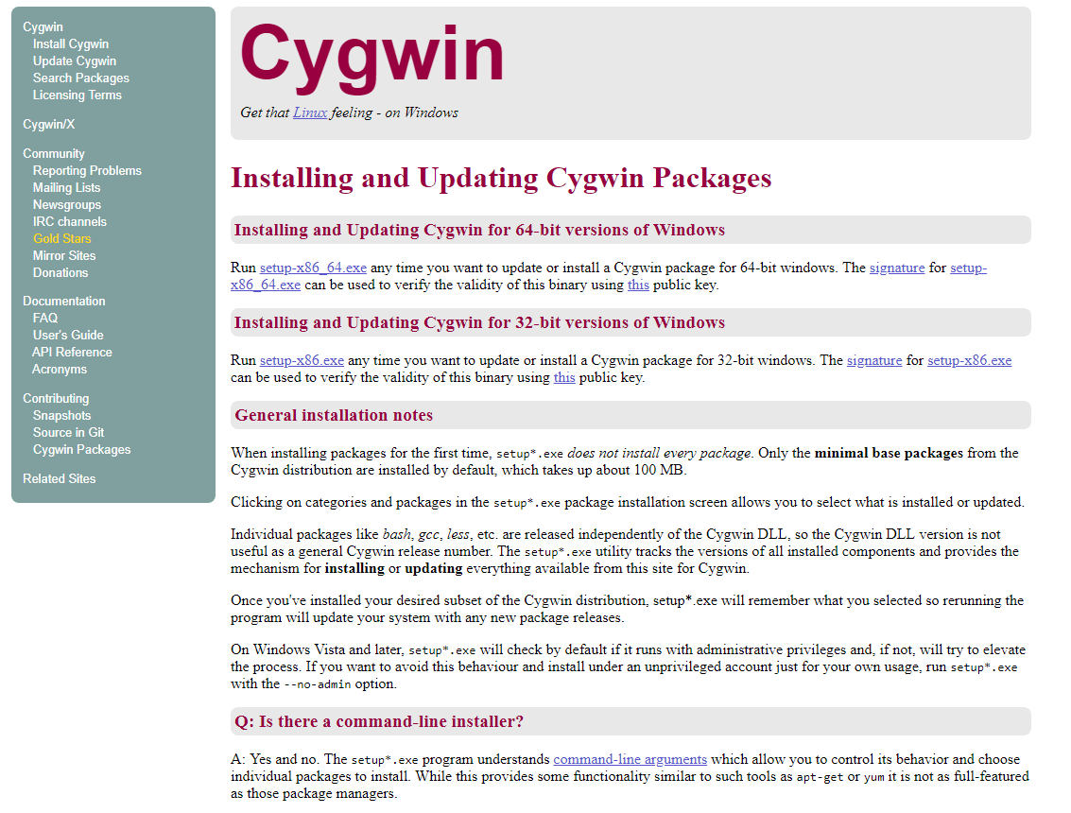

After running setup simply go through setup.

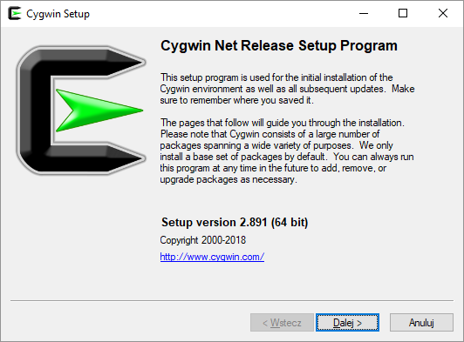

Click next.

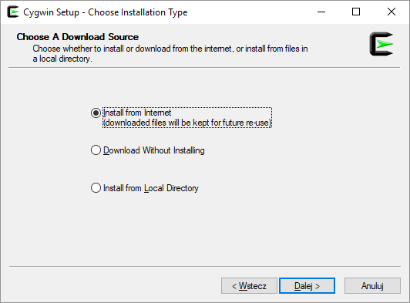

Click next.

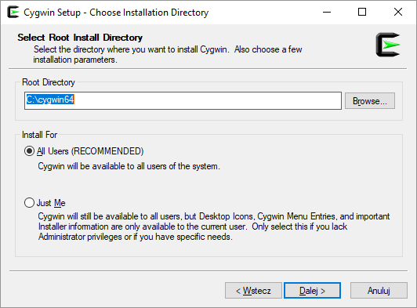

Click next.

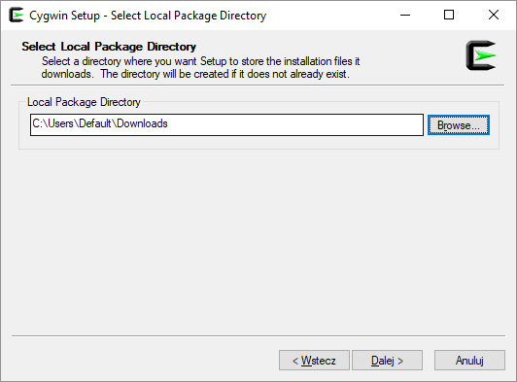

Click next.

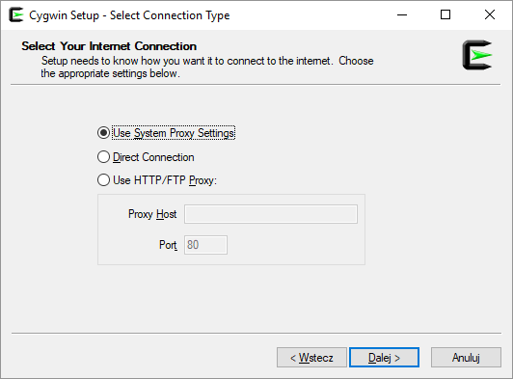

Click next.

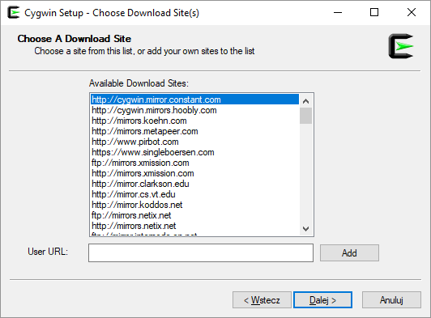

Click next.

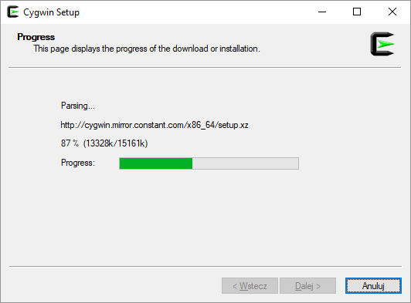

After succesful download hold on for a moment and select curl in below window.

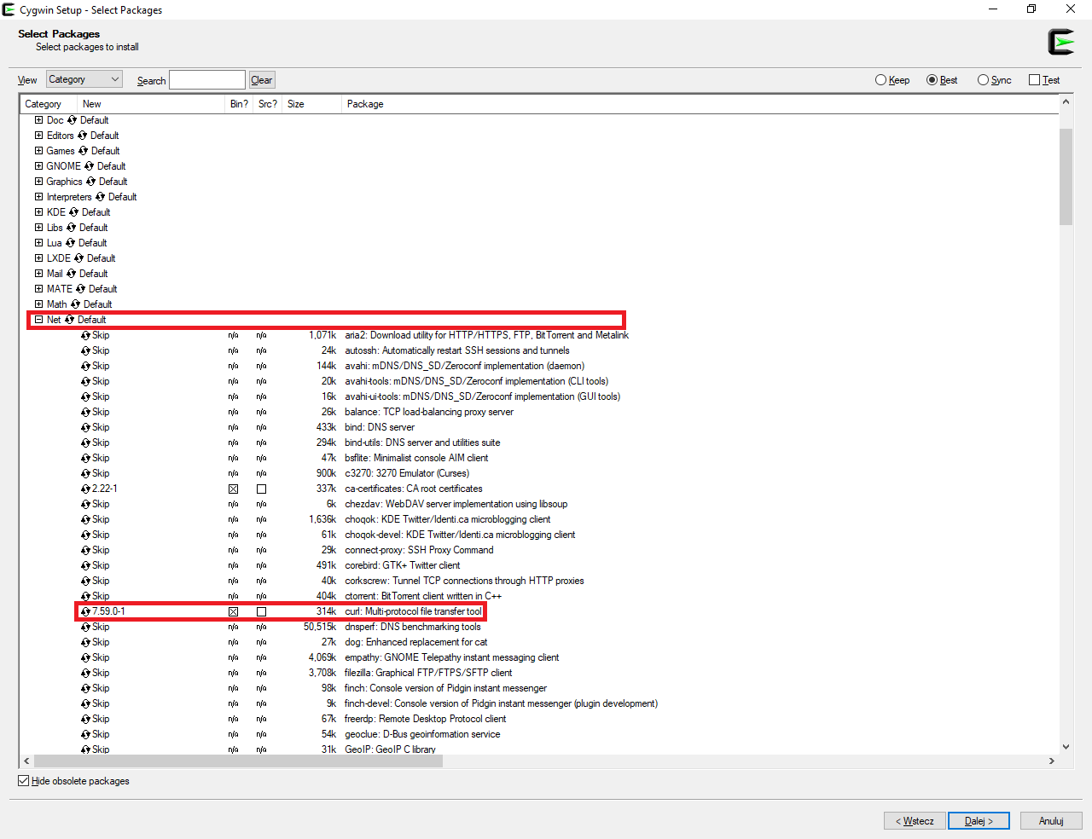

Simply expand „Net” tree and click on curl row. Make sure that checkbox binary is selected.

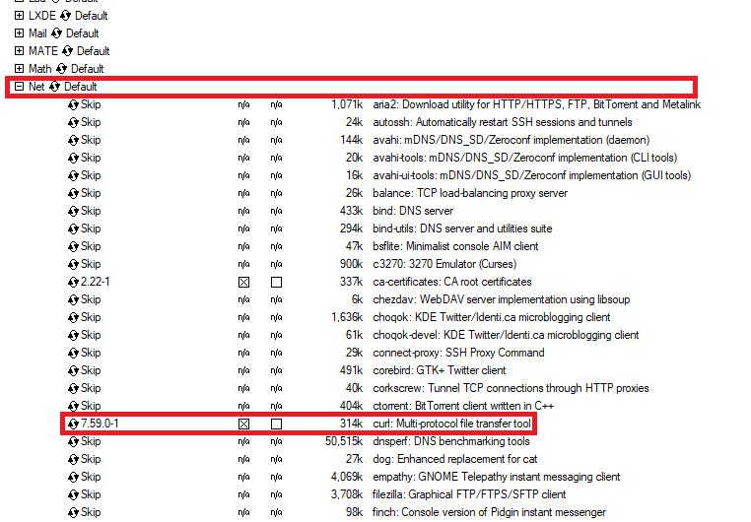

Click next.

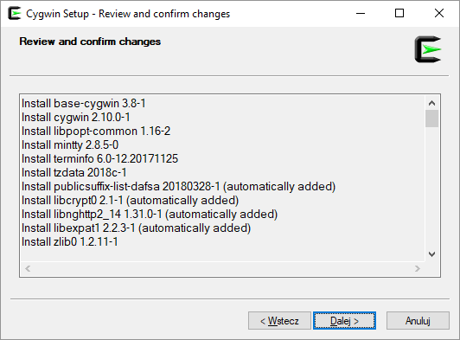

Click next

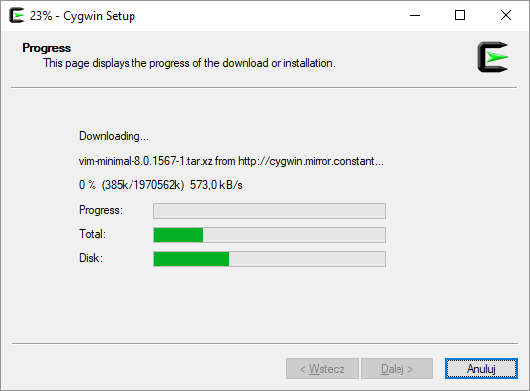

Wait for completed downloading.

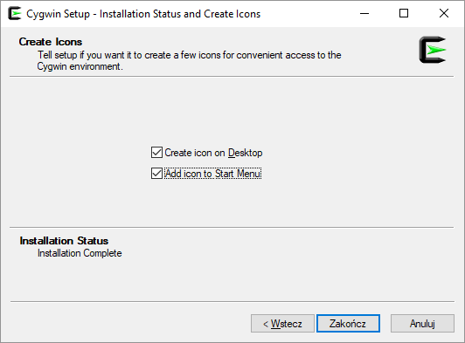

Click finish.

Now you can run Cygwin Terminal and check if curl is working properly by typing „curl” in command window…

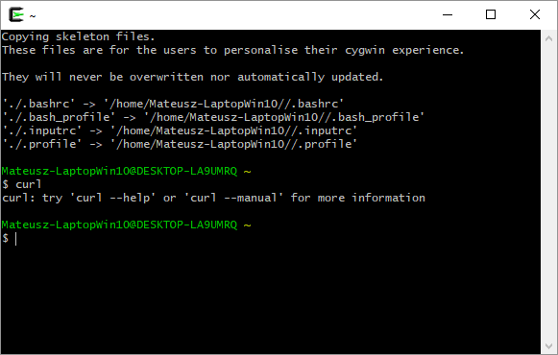

## 1.2 Standard curl installing

You can also install curl by downloading sources from curl webpage. Curl executable for many OS is available on page <https://curl.haxx.se/dlwiz/?type=bin>.

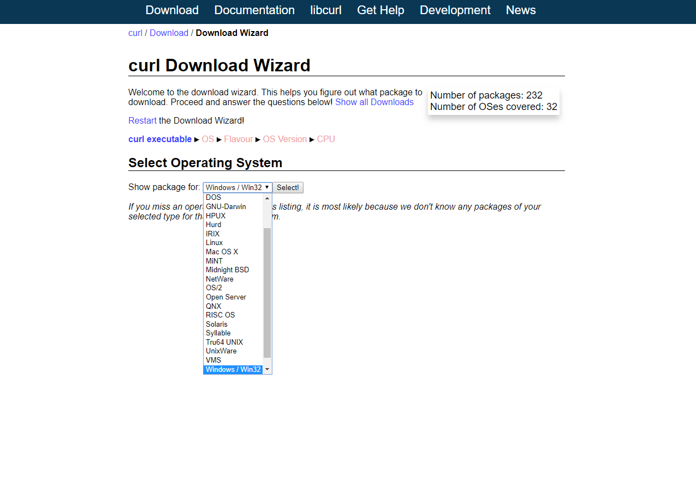

For more information about installation and other issues visit <https://curl.haxx.se>.

# 2. Running project

You have to check if Java (version 8) is installed on your PC by visiting <https://www.java.com/en/download/installed8.jsp>. If you don’t have it you have to download from <https://www.java.com/en/download>.

You can simply run project from cmd in directory with *RelayrCzujniki.jar  
(directory RelayrCzujniki_jar)* and typing:

*java -jar RelayrCzujniki.jar --url <pathToYamlFile>*

I recommend to test if project works properly by running:

*java -jar RelayrCzujniki.jar --url* [*https://raw.githubusercontent.com/relayr/pdm-test/master/sensors.yml*](https://raw.githubusercontent.com/relayr/pdm-test/master/sensors.yml)

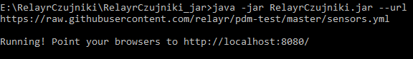

Now you can test server by sending requests via curl.

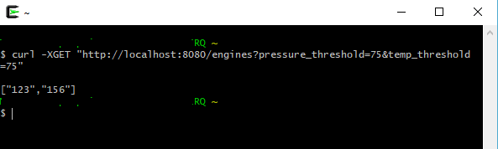

Above get request and one post request to server is available in *example_commands.txt.*

# 3. Testing project

I prefer to run test using you favourite IDE. All unit tests can be found in directory:

*RelayrCzujnikiProject\src\test\java*

# 4.Contact with me

Any questions? Please send e-mail to me:

*t.mateusz10@gmail.com*