02. Pirate Quest
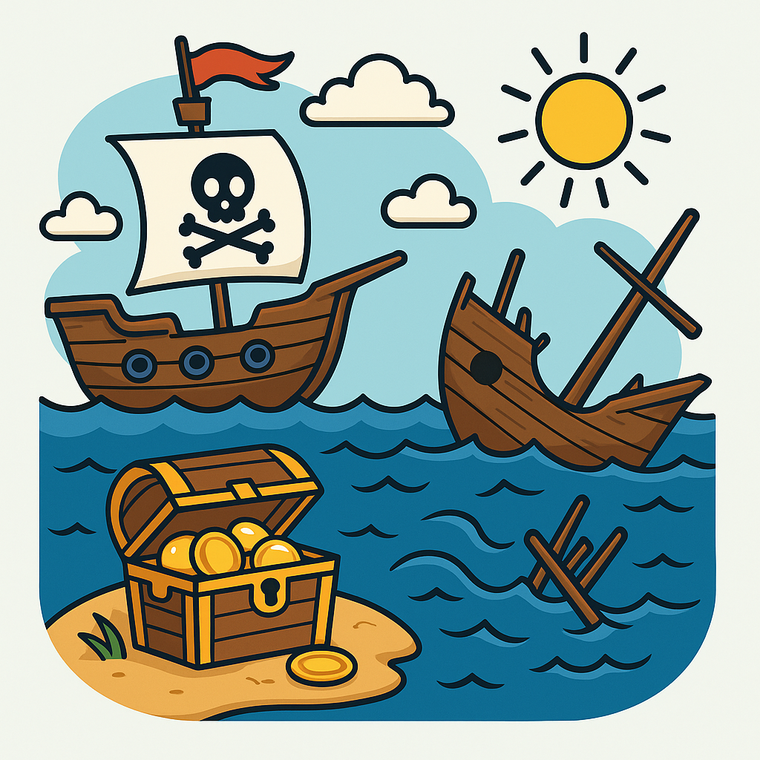
In this task, you will implement a simplified version of a grid-based pirate adventure. The mission unfolds on a square sea map, where a pirate ship must collect all hidden treasure chests while avoiding damage from sea monsters and using a magical charm.
You will be given an integer N for the size of the square map (grid). The next N lines describe the sea map. The pirate ship 🏴‍☠️is marked with 'S' and starts at a random location.
Your goal is to guide the ship to collect all treasure chests ('*' 🪙) while avoiding monsters ('M' 🦑) and using charms ('C' 💎) for durability restore.
The ship starts with 100 durability. It can move in four directions ( up, down, left, and right) or end the journey with the "stop" command.

Sailing Rules
- On the first move, the ship's 🏴‍☠️starting position is marked with a dot'.'.
- Landing on a dot'.' means calm waters - nothing happens.
- Landing on a treasure '*' 🪙collects it and the cell becomes '.'
  - The total count of remaining treasures is decreased by 1.
Hint: Count all treasures at the beginning of the game.
- Landing on a charm 'C' 💎grants a one-time restore of 25 units of additional durability.
  - The charm cell becomes '.'.
  - Remember not to exceed the maximum durability of 100 units.
  - Only the first encountered charm can be used during the voyage (even if the ship lands on more). Further charms have no effect and are wasted.
- Landing on a monster 'M'🦑:
  - Reduces ship durability by 25.
  - The monster cell becomes '.'.
  - Four monster encounters can sink the ship (0 durability), unless a charm is collected in between.
- Moving outside the map wraps the ship to the opposite side (edge wrapping).
Example: Sailing above the top row places the ship at the bottom of the same column.

End of Voyage
The voyage ends if:
- The ship collects all treasures 🪙.
- The ship's durability drops to 0 (shipwreck 💀).
- The captain issues the "stop" command to retreat.

Input
- An integer N representing the square grid (sea map) size.
- The next N lines represent each row of the map.
- Following are direction commands or command "stop", each on a new line.

Output
- If the ship's durability reaches zero (0), print:
"Shipwreck! Last known coordinates ({row}, {col})"
- If all treasures are collected, print:
"Yo-ho-ho! All treasure chests collected!"
- If the captain ends the voyage before collecting all the treasure, print:
"Retreat! Some treasures remain unclaimed."
- Following print:
  - In all cases:
"Ship Durability: {remaining_durability}"
- If some treasure remains unclaimed, print (otherwise skip it):
"Unclaimed chests: {count}"
- Finally, print the final sea map, with the pirate ship's last location marked with 'S'.

Constraints
- The square grid (sea map) size will be in the range of [2-8] inclusive.
- Commands will always be valid (up, down, left, right, stop).
- Initial ship position 'S' is guaranteed.
- At least one treasure '*'.
- At least one monster 'M'.
- Zero or more charms 'C'.
- Calm water marked with '.'.

Examples
Input | Output
3  S*.  .M.  ..*  right  down  down  right  stop | Yo-ho-ho! All treasure chests collected!  Ship Durability: 75  ...  ...  ..S
4  ..SC  M**M  *MMM  *.**  right  right  right  up  left  left  left  up  right  right  right  left  up  stop | Shipwreck! Last known coordinates (1, 0)  Ship Durability: 0  Unclaimed chests: 2  ....  S**M  ....  ....
5  ..M..  CC**M  S*M**  .C.**  **..*  up  right  down  right  down  left  stop | Retreat! Some treasures remain unclaimed.  Ship Durability: 75  Unclaimed chests: 9  ..M..  ..**M  ...**  .S.**  **..*

