03. Game Studio
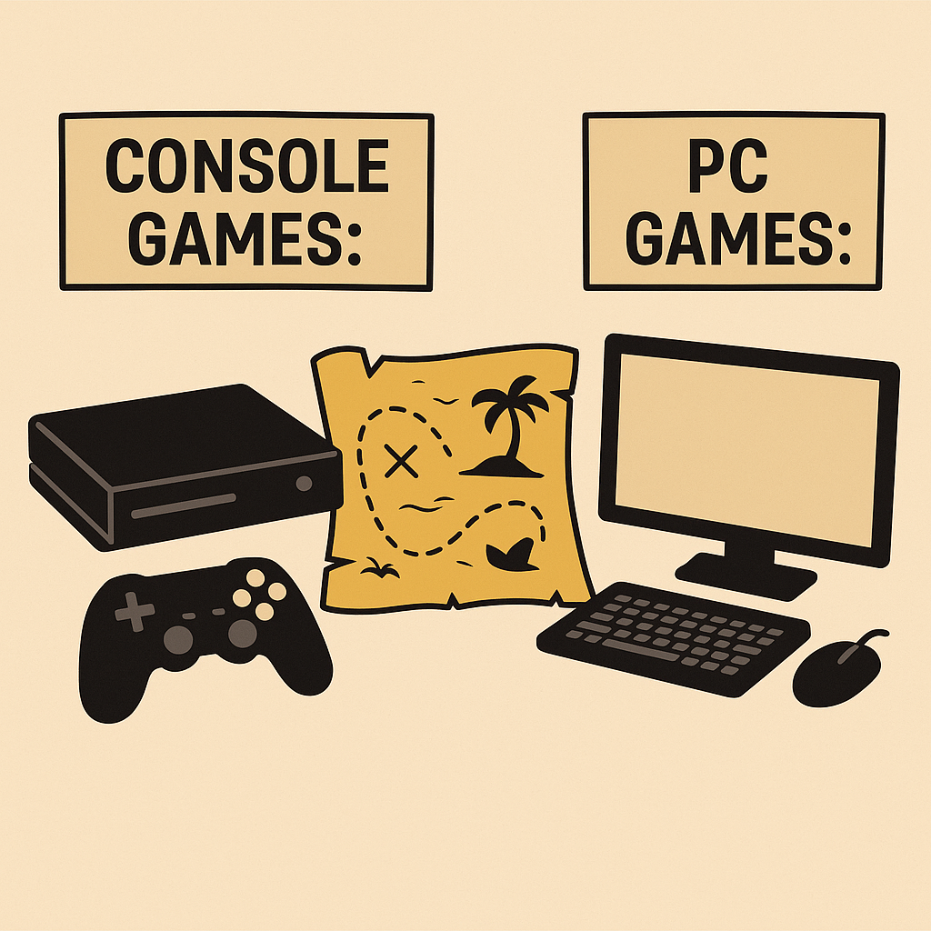
The game development studio is preparing its upcoming announcements and needs help sorting its video game projects by platform and release schedule.
Write a function named sort_games() that takes a variable number of arguments (tuples) and keyword arguments (key-value pairs).
The function is designed to help sort games by platform and release schedule.

Arguments
The function takes:
- A variable number of tuples, representing early registrations. Each tuple contains:
- A platform: "console" or "pc" (string) as a first element. See the Examples section.
- A unique game title (string) as a second element.
- A variable number of keyword arguments, each representing finalized release IDs:
- The key is the unique release ID in string format.
Example: "March_15_2025_001", "June_21_2025_009", etc.
- The value is the game title (string), which matches one of the titles in the tuples.

Function Logic
- Categorize the games based on platform using the tuples:
                - Console Games
- PC Games
- Match the game titles with their release IDs from the keyword arguments.
- Sort the games:
- Console games: sort by release ID (alphabetically ascending).
- PC games: sort by release ID (alphabetically descending).
- Format the output:
- If there are console games, start with the heading: "Console Games:"
- Prefix each game info with ">>>" (three right angle brackets).
- If there are PC games, follow with the heading: "PC Games:"
- Prefix each game info with "<<<" (three left angle brackets).
- Trim the last part of the release ID to get the release date.
Example: Release ID "March_15_2025_001" shall be trimmed to "March_15_2025".
Hint: Do not trim the release IDs beforehand, otherwise the sorting might be influenced.
- Omit the heading if the category has no games. See the Examples section.
- In the end, return the output as a multi-line string, described below.
Note: Submit only the function to the Judge system.

Input
- There will be no input from the console, only arguments passed to your function.

Output
- The output should look like this (each line should be in a new row):
- Console games are listed first (if any), followed by PC games (if any).
- The release dates are derived from the release IDs.
"Console Games:
>>>{release_date}: {game_title₁}
...
>>>{release_date}: {game_title_{n}}
PC Games:
<<<{release_date}: {game_title₁}
...
<<<{release_date}: {game_title_{n}}"

Constraints
- Tuples will always come before keyword arguments.
- Each tuple contains a valid platform and title.
- All game titles are unique and appear once in the release schedule.
- Each game will have a valid and unique release ID.
- At least one tuple and one release ID will always be provided.

Examples
Input | Output
print(sort_games(  ("console", "Echo Dive"),  ("pc", "Quantum Drift"),  June_22_2025_001="Quantum Drift",  March_15_2025_002="Echo Dive",  )) | Console Games:  >>>March_15_2025: Echo Dive  PC Games:  <<<June_22_2025: Quantum Drift
print(sort_games(  ("pc", "Iron Comet"),  ("console", "Jungle Quest"),  ("console", "Cyber Realm"),  ("pc", "Neon Skyline"),  ("console", "Blade Echo"),  ("pc", "Sky Frontier"),  April_12_2025_002="Neon Skyline",  July_01_2025_004="Cyber Realm",  July_01_2025_002="Blade Echo",  December_31_2024_007="Jungle Quest",  April_12_2025_005="Iron Comet",  February_14_2025_009="Sky Frontier",  )) | Console Games:  >>>December_31_2024: Jungle Quest  >>>July_01_2025: Blade Echo  >>>July_01_2025: Cyber Realm  PC Games:  <<<February_14_2025: Sky Frontier  <<<April_12_2025: Iron Comet  <<<April_12_2025: Neon Skyline
print(sort_games(  ("console", "Jungle Quest"),  ("console", "Cyber Realm"),  ("console", "Blade Echo"),  July_01_2025_004="Cyber Realm",  July_01_2025_002="Blade Echo",  December_31_2024_007="Jungle Quest",  )) | Console Games:  >>>December_31_2024: Jungle Quest  >>>July_01_2025: Blade Echo  >>>July_01_2025: Cyber Realm
print(sort_games(  ("pc", "Iron Comet"),  ("pc", "Neon Skyline"),  ("pc", "Sky Frontier"),  April_12_2025_002="Neon Skyline",  April_12_2025_005="Iron Comet",  February_14_2025_009="Sky Frontier",  )) | PC Games:  <<<February_14_2025: Sky Frontier  <<<April_12_2025: Iron Comet  <<<April_12_2025: Neon Skyline

