Using walks on a medical graph to diagnose patients
David Pitt

This week, I read through the paper “Interpretable Disease Prediction based on Reinforcement Path Reasoning over Knowledge Graphs”, by Sun et al. The key advance of this paper was the construction of a new way to conceptualize and quantify the flow of information through a graph structure. Instead of using message-passing neural network (MPNN) layers to propagate information through the graph, the authors construct a mathematical object (“agent”) to walk along the graph to simulate the flow of information. The model is trained using a reinforcement-learning approach, and over time learns to walk across the graph to find the most likely disease nodes associated with each patient.

Procedurally, the agent starts at a patient node on the knowledge graph, and through an iterative Markov Decision Process, learns to walk to the most important events:
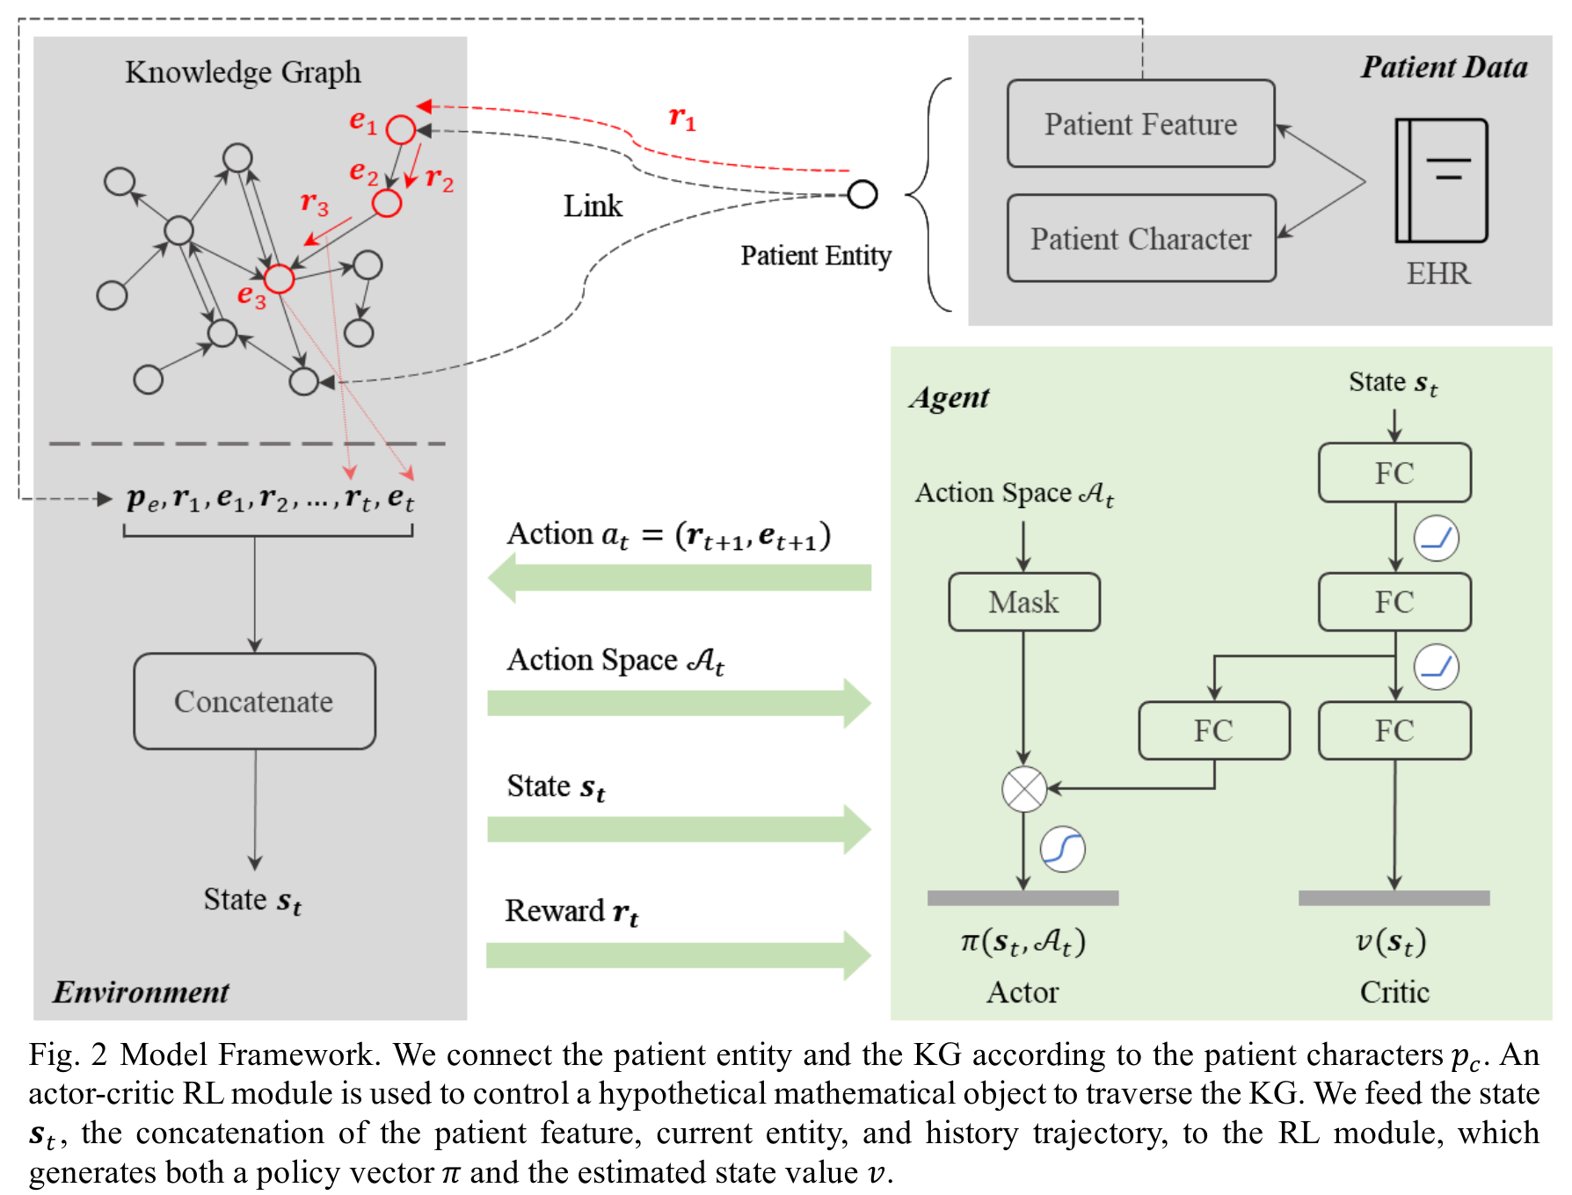
This represents an advance in the field of recommender systems – more specifically, the core goal of this model is to produce “interpretable” results that can be understood by a human user. The MDP has state space s_t = (p_e, e_t, h_t), where p_e represents the agent’s initial patient representation, e_t represents the current representation at time t, and h_t represents the historical trajectory of the agent. The authors use a fully-connected layer to learn a representation of each state, which is then used to calculate a reward that is positive if an action lands the agent on an event that occurs later in the patient’s future. Over time, the agent learns to walk to the nodes most likely to contain future diseases according to the parameters of the model.
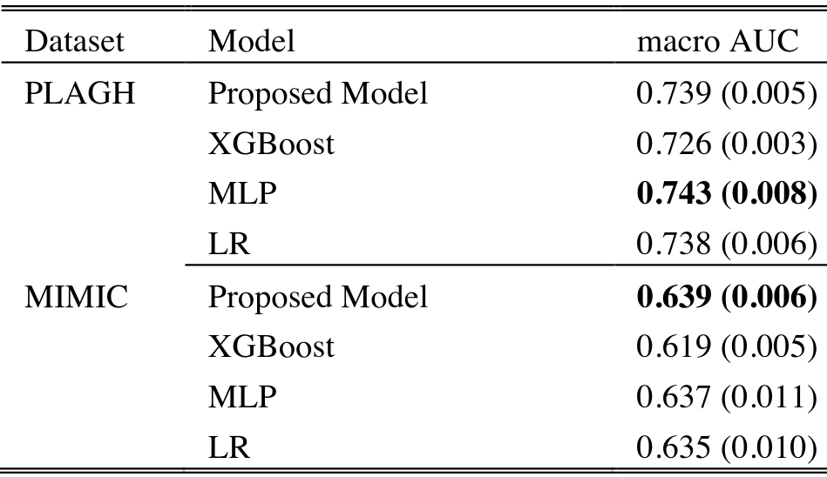
Once parameters are learned, the model can be used for inference to find the optimal “policy” for a patient entity on the knowledge graph. Implementing this policy will generate a walk that contains disease nodes, representing the agent’s “diagnosis” of the patient. This model is then tested on the MIMIC-III dataset, and achieves the following accuracy:

