Lab 9 Name: ________________________________

Calculus 1 Name: ________________________________

Name: ________________________________

Name: ________________________________

For the next set of problems, sketch the graph of a function with the given characteristics.

1. 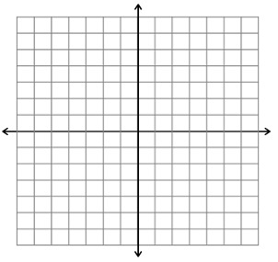 $f'(0)=f^{'}\left(2\right)= f^{'}\left(4\right)=0$

$f^{'}\left(x\right)>0$ if $x<0 or 2<x<4$

$$f^{'}\left(x\right)<0 if 0<x<2 or x>4$$

$f^{''}\left(x\right)>0 if 1<x<3$

$$f^{''}\left(x\right)<0 if x<1 or x>3$$

$f^{'}\left(x\right)>0 for all x≠1$

Vertical asymptote $x=1$



$f^{''}\left(x\right)>0 if x<1 or x>3$

$f^{''}\left(x\right)<0 if 1<x<3$

1. For the next set of problems, sketch the graph of the derivative and second derivative for the provided functions (you may sketch on top of the provided functions).

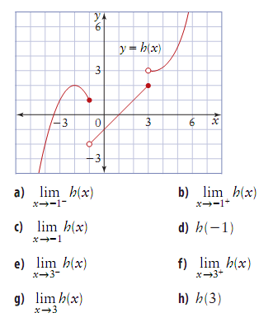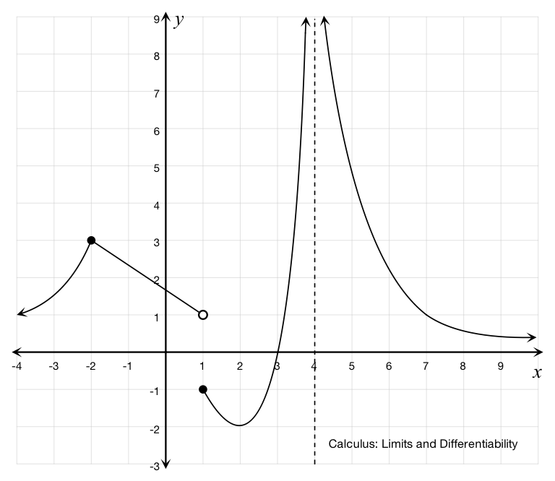

1. Coughs are way more scientific than what they feel like. For example, a cough is an involuntary action when something is lodged in your throat, and involves the thrusting upward of the diaphragm, alongside a contraction of the trachea. This allows for air traveling up through the trachea to reach a greater velocity, to help expel the lodged item from your throat. The relation between the contraction of your trachea and the velocity of the air can be modeled by the equation

$$v\left(r\right)=k\left(r_{0}-r\right)r^{2} \frac{1}{2}r_{0}≤r≤r_{0}$$

Where $k$ is a constant and $r_{0}$ is the normal radius of the trachea. (Note: the bounds exist because the body restricts the constricting of the trachea beyond a certain point so you don’t suffocate. You go, human body!) What value of $r$ produces an absolute maximum in this interval?

1. (5) Dec: $\left(-∞,\frac{27}{64}\right)$

Inc: $\left(\frac{27}{64},∞\right)$

Rel min: $\left(\frac{27}{64}, 8.6836\right)$

C-up: $\left(∞,0\right)∪(0,∞)$

No inflection point

1. (7) Dec: $\left(-.86775,0\right)∪\left(0,12.6043\right)$

Inc: $\left(-∞,-.86775\right)∪(12.6043,∞)$

Rel max: $(-.86775,-16.1176)$

Rel min: $(12.6043,-4929.69)$

C-up: $\left(0,1.09234\right)∪(9.27875,∞)$

C-down: $\left(-∞,0\right)∪\left(1.09234,9.27875\right)$

Inf pt: $\left(1.09234, -11.984\right), (9.27875,-3153.54)$

1. (3)
2. (3)
3. (2)
4. (5)

$$V\left(r\right)=kr_{0}r^{2}-kr^{3}$$

$$V^{'}\left(r\right)=2kr_{0}r-3kr^{2}=0$$

$$r=\frac{2}{3}r_{0}$$

$$V^{''}\left(r\right)=2kr_{0}-6kr$$

$$V^{''}\left(\frac{2}{3}r_{0}\right)=negative$$

$$V\left(\frac{1}{2}r_{0}\right)=\frac{k}{8}r_{0}^{3}$$

$$V\left(r_{0}\right)=0$$

$V\left(\frac{2}{3}r_{0}\right)=\frac{4k}{27}r_{0}^{3}$ (Abs. Max)