|  |
| --- |
| **INFO2320 Assignment 1 Section 01 Team 04**  *By signing below, I certify that I have fully complied with the INFO2320 Code of Honor.*  Student 1: Danni Huang  Student 2: Khachig Kerbabian  Student 3: Shakir Hansrod  Student 4: Brittany McNabb |

1. **Individual VP Lab** (20% of A1 mark for each member / presenter)

Complete the table below after each member has completed their VP lab. Fill out the location (e.g., Zoom, MS Teams) and date & time, where the demo was completed. *Members must sign their own name.*

|  |  |  |
| --- | --- | --- |
| **Team Member**  (Presenter) | **Location, Demo Date and Time** | **Certified By**  (another team member) |
| 1.Khachig Kerbabian | Zoom, 30th Sep 2021 11:00 Am | Danni Huang |
| 2.Danni Huang | Zoom, 30 Sep 2021 | Khachig Kerbabian |
| 3. |  |  |
| 4. Brittany McNabb | Zoom, 1st October, 2021 | Shakir Hansrod |

1. **Team Assignment 2** (80% of A1 mark)

**Task 1: VPRU Agile Project Charter**

1. **System Objectives**

* VPRU is an online travel service that books spring break trips to resorts for college students.
* VPRU requires a new information system to replace the current travel booking software product, which has missing functionality and is no longer supported by the vendor.
* The new system must continue to support the three existing subsystems: __updated booking information__, __resort information updated__, and _travel information for booked__.
* VPRU recently decided to add a new __social networking features__ subsystem to enhance the student experience __before__, ___during__, and __after__ the trip.
* The new system must provide an extensive set of reports and that can be viewed and printed.

1. **Project Roles/Responsibilities**

**Client Staff**

* Wayne Powell, VPRU Operations Manager: Project Sponsor, responsible for approving the project initially and then approving deliverables as the project proceeds;
* Meyer Tanuan, VPRU Analyst: Project Contact / Domain Expert, responsible for working with the Technical Staff to manage the project on a day-to-day basis; also responsible for providing information and answering questions.

**Technical Staff**

* Khachig Kerbabian, Senior Software Developer Scrum Master responsible for facilitating scrum meetings and activities; removes obstacles of the Development team;
* Danni Huang, Business Analyst / QA Product Owner responsible for business analysis and software testing;
* Shakir Hansrod, Senior Software Developer Development Team Member responsible for developing the back-end services (API) of the system;
* Brittany Mcnabb, Software Developer Development Team Member responsible for developing the UI of the system.

1. **Business Benefits**

* The new Resort Relations subsystem will __ increase the sales by 50% year over year _;
* The Student Booking subsystem will _correct, current information and images about resorts __;
* The Accounting and Finance subsystem will __ ensure accurate calculation of deposit, refund, fully paid and damage calculation __;
* The Social Networking subsystem will _ increase bookings __.

1. **Requirements**

**4A. Preliminary Functional Requirements**

**4B. Non-functional Requirements**

|  |  |
| --- | --- |
| **Usability requirements** | * The system must be easy for the user to learn and use |
| **Reliability requirements** | * The system must be backed up regularly |
| **Performance requirements** | * Response time must not exceed 5 seconds |
| **Security requirements** | * Network and data security |

1. **Project Team Critical Success Factors**

* Project contacts must be readily available to answer questions and provide feedback for the technical staff
* The project sponsor must take timely decisions when project milestones are reached
* The product owner must be co-located and work with the development team on a daily basis
* Project contacts must be available to attend product demonstrations and provide feedback to the technical staff
* The development staffing level and development staff time commitment must not drop

1. **Preliminary Technical Architecture:**

**The technical architecture selected was** Preliminary Technical Architecture

* 1. **Development environment**
* Justinmind, Visual Paradigm
* C#, Visual Studio, WinForms
* Existing developer PCs and laptops running Windows 10
  1. **Server Production Environment**
* Microsoft Cloud
* Microsoft Azure
  1. **Client Production Environment**
* Existing client PCs
* Laptops running Windows 10

**Task 2: Workflow / Activity Diagram**

**2A. Business Process: VPRU Acquire Vacation Package Provider**

**We identify prospects because we will no longer allow bookings for a room with a free range of dates, and we need to replace the previous agreements to only offer discounted vacation packages. Adding a new resort account to help customers to look up and book our vacation packages. Generating resort account to the resort manager. Adding resort details help it look good to VPRU customer.**

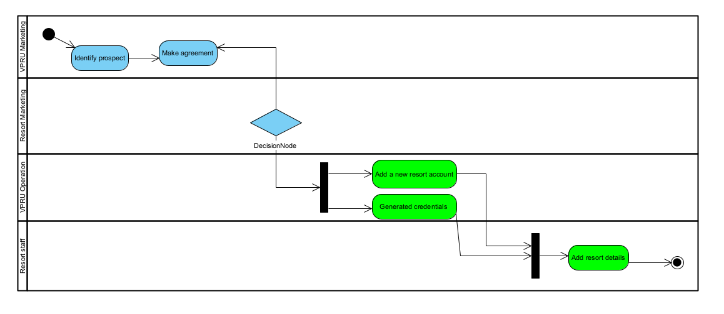

**2B. Business Process:** **Resort Provide Vacation Package Voucher**

**We provide discounted vacation packages to VPRU customers, and we expect VPRU will help increase our occupancy rates in 2021 and beyond. We assemble vacation package vouchers to approve if the voucher needs to be editing.**

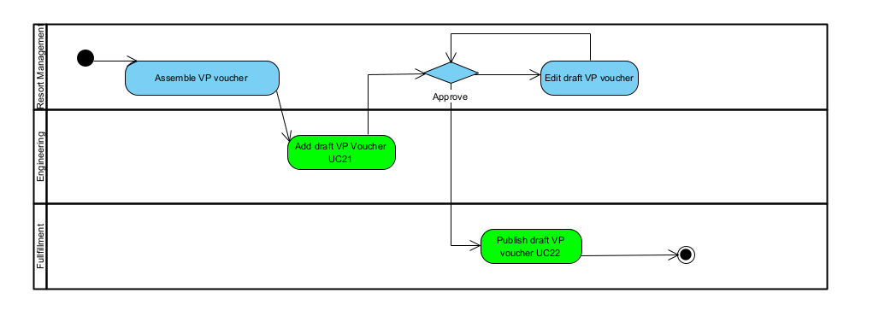

**Task 3: Event Table with Use Cases**

**S1. VPRU Resort Relations Subsystem Event Table**

|  |  |  |  |  |
| --- | --- | --- | --- | --- |
| **Event Type** | **Event Name** | **Use Case ID** | **Actor(s)** | **Use Case** |
|  |  |  |  |  |
|  |  |  |  |  |
|  |  |  |  |  |

**S2. VPRU Vacation Booking Subsystem Event Table**

|  |  |  |  |  |
| --- | --- | --- | --- | --- |
| **Event Type** | **Event Name** | **Use Case ID** | **Actor(s)** | **Use Case** |
| External | |  | | --- | | Resort staff add VP voucher to the VPRU system | | **UC21** | Resort Staff | Add draft VP voucher |
| External | The resort manager publishes the draft VP voucher | **UC22** | Manager | Publish draft VP voucher |
| External | Customer create account must have an account number, cardholder name, card expiry, billing phone number and billing address | **UC41** | Customer | Create account |
| External | Customer reserve VP voucher | **UC42** | Customer | Reserve VP voucher |
| Temporal | Time to send a reminder to pay the remaining balance | **UC43** | Timer | Send reminder |

**Task 4: Use Case Diagram (UCD)**

**S1. VPRU Resort Relations Subsystem Use Case Diagram**

**S2. VPRU Vacation Booking Subsystem Use Case Diagram**

